OrderBy
System Design Document
Hyperlocal shop-ordering platform — architecture, components, flows and design decisions
v1.0 · July 2026 · Status: pre-launch

1. Product overview
OrderBy connects customers with neighbourhood shops (kirana, pharmacy, restaurant, and more). Customers browse nearby shops, order for delivery or pickup, chat with shopkeepers and pay by UPI, card, cash or udhaar (running credit ledger). Shopkeepers manage inventory, orders and subscriptions; the platform earns through shopkeeper subscription plans.

Target users & market
- Customers: urban Indian neighbourhoods, starting in Kolkata. UI in English, Hindi and Bengali.
- Shopkeepers: small shops that today take orders over phone/WhatsApp — the app replaces the notebook (khata) they already keep.
- Admins: internal ops team — shop approval, KYC, plans, refunds, support, monitoring.

Business model
- Shopkeeper subscriptions (trial / monthly / yearly + admin-issued custom offers) collected via Razorpay, with GST invoicing.
- Future levers already modelled in the schema: shop-funded advertisements and platform offers.

2. System architecture
Three Expo/React-Native clients talk to a thin Django gateway. All business logic lives in PostgreSQL stored procedures — the API authenticates, validates, and calls SPs; Supabase provides the database, realtime, storage and OTP auth.
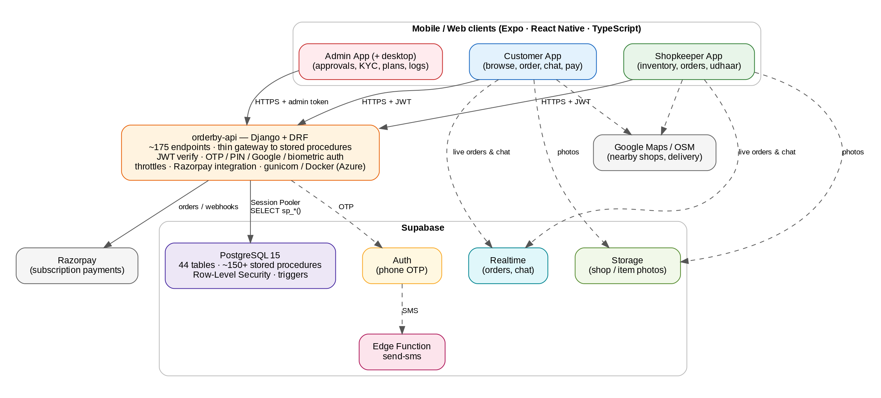

Why this shape
Decision | Rationale | Trade-off accepted
Logic in stored procedures | One source of truth used by 3 apps; atomic order/stock/payment transitions; no ORM drift; SQL Editor deploys. | Migrations are hand-ordered; SP versioning needs discipline (see _audit_deployed_sps.sql).
Thin Django gateway | Central auth (JWT/OTP/PIN/Google/biometric), throttling, Razorpay webhooks — kept out of the DB. | Extra hop; must stay stateless to scale horizontally.
Supabase (managed Postgres) | Realtime + Storage + Auth bundled; zero DB ops pre-launch; RLS as defence-in-depth. | Vendor coupling; connection limits managed via Session Pooler.
Expo / React Native | One TypeScript codebase per app for Android + iOS + web; EAS builds; OTA updates. | Native-module patches needed (expo-notifications patch script).

3. Component design

3.1 Customer app
- Nearby-shop discovery by GPS radius (sp_get_nearby_shops v2: distance, delivery flags, ratings); Google Maps or free OSM tiles.
- Cart → order placement with coupons/platform offers, scheduled delivery, delivery instructions.
- Live order tracking and chat via Supabase Realtime; reviews after delivery; udhaar balance view; support threads.

3.2 Shopkeeper app
- Inventory CRUD with multilingual names, per-item photos (plan-limited), stock tracking with automatic movements audit.
- Order workflow: accept → ready → dispatch (delivery OTP) → delivered / payment handshake; udhaar khata debits & repayments.
- Subscription purchase (Razorpay) and custom-offer acceptance; dashboards from monthly sales archive.

3.3 Admin app
- Shop approval + KYC review (Aadhaar / PAN / GST flags), block/restore, force delete with audit logging.
- Plan management, custom offers, refunds, invoice export (per-FY numbering), GST rate setting.
- Monitoring: central app_logs sink from all apps + API, OTP status, support chat.

3.4 orderby-api (Django + DRF)
- ~175 endpoints, one per stored procedure — REST-ish paths under /api/, admin routes under /api/admin with a separate SHA-256 token auth.
- Auth surface: phone OTP request/verify, PIN set/verify, Google link, biometric device-secret enrol/exchange, token sync.
- Stateless; DB access only through the least-privilege role; deployable as Docker/gunicorn (Azure config present).

3.5 Supabase
- PostgreSQL 15: 44 tables, RLS policies, triggers (updated_at), pg_trgm search indexes, citext.
- Realtime publication: orders, chat_threads, chat_messages — apps subscribe directly.
- Storage buckets for shop/storefront/item photos; Edge Function send-sms for OTP delivery.

4. Data design
Full model in the companion OrderBy_ER_Diagram.docx (44 tables). Key conventions:
Convention | Detail
Money in paise | All amounts are INTEGER paise (₹1 = 100). No floats anywhere in money paths.
UUID keys | gen_random_uuid() PKs; users.id aligns with Supabase auth.users.id.
Snapshot pattern | order_items copies name/unit/price at purchase; item deletion can never corrupt history.
Dual identity | One phone can be customer + shopkeeper; unified via shops.owner_id → users.id (migration 84).
Idempotent migrations | Every file is safe to re-run (IF NOT EXISTS / ON CONFLICT / DO blocks).
Audit everything | stock_movements, admin_audit_log, subscription_payments ledger, app_logs.

5. Security design
Layer | Mechanism
Customer/shop auth | Phone OTP (Supabase + send-sms) with per-phone daily throttle & sticky blocks; PIN auth; Google sign-in link; biometric device secret; single-device push token.
Identity hardening | Stable-key login anchoring (migration 99), phone-uniqueness constraints, no phantom phone users, unified identity.
Admin auth | Separate admin_users with bcrypt passwords, SHA-256 session tokens, OTP password reset, full audit log.
API → DB | Least-privilege DB role (migration 75); all access via SECURITY DEFINER SPs; JWT (HS256) verified against SUPABASE_JWT_SECRET.
Row-Level Security | RLS on user-facing tables as defence-in-depth behind the SP layer; realtime RLS fix (101).
Abuse controls | DRF throttles + per-phone lockouts via shared cache table; delivery OTP for handover; payment amount checks on refunds.
KYC | Aadhaar / PAN / GST capture with verification flags, admin reviewer tracking, verified badge; KYC security fix (33).

6. Key flows

6.1 Order lifecycle
- Customer places order (sp_place_order): validates stock, applies coupon/offer, snapshots items, decrements stock atomically, writes stock movements.
- Shopkeeper accepts → ready → out_for_delivery (optionally assigned to a delivery partner) → delivered; every step timestamped and pushed over Realtime.
- Delivery handover verified by delivery OTP; completion rule finalises payment status; cancellations restock automatically and notify both sides.

6.2 Payment handshake & udhaar
- For cash/UPI on delivery, a two-sided handshake records who confirmed payment and when (migration 58).
- Udhaar: order total (or part) recorded as a debit against the customer's khata; repayments recorded as credits — shop and customer both see the running balance.

6.3 Shop subscription purchase
- Shopkeeper picks a plan (or accepts a custom offer) → API creates a Razorpay order → row in subscription_payments (status created).
- On capture (verify + webhook, whichever lands first) the SP activates shop_subscriptions, carries over remaining days, and reconciles inventory limits.
- Expiry → 7-day grace → features lock (inventory gating); invoices numbered per financial year with GST.

7. Non-functional design
Concern | Approach today | First upgrade when needed
Performance | SP round-trip per request; trigram + partial indexes; Session Pooler (CONN_MAX_AGE=60). | PgBouncer sizing, read replica for discovery queries, API-side caching of lookups.
Observability | app_logs sink (level, context, stack) from all 3 apps + API; admin log viewer; health endpoint reports table/SP counts. | Structured metrics (Prometheus/Grafana or Azure Monitor), Sentry for crashes, uptime alerts.
Reliability | Managed Supabase backups; idempotent migrations; smoke-test SQL suite; E2E auth test. | PITR verification drills, staging environment, blue-green API deploys.
Compatibility | OTA updates via Expo; postinstall notification patches. | Version-gate old clients via minimum-version check at API.

8. Known limitations & deliberate debt
- Single-region, single database — right for launch; Phase-3+ scaling steps are specified in the Growth Roadmap.
- Migration numbering has parallel-history duplicates (two 70s, 83s, 104s…) — consolidated and documented in OrderBy-Main-DB queries/README.md.
- Soft references (subscription_payments.offer_id / subscription_id) trade FK safety for flexibility — reconciliation SPs cover the gap.
- SMS OTP is a single provider path via one Edge Function — add a fallback provider before scale marketing pushes.
- No automated CI test-suite for SPs yet — smoke-test files exist and should move into CI (see roadmap Phase 1).

