

Smartphone application in phonegap
M2C’s Electric Vehicle Smart Charger
Daniel Bönström

Fakultet
Datavetenskap
Bachelor, 180 credits
Handledare: Hugh Melvin, Donald Ross
Examinator: Namn
Date: 2014-06-xx3
Table of Contents
1. Introduction 2
2. Background 2
MC2 3
Phonegap 5
The application 6
3. Project Design and Implementation 7
4. Results / Evaluation 7
5. Conclusion 7
References 7
Appendices 7

Fix all of the sources. They are in the text. Just needs to be written in a standard way

1. Introduction
- Project goal and motivation
- Project summary & overview - the "red thread"
- Project results (brief summary)
- Dissertation Layout

2. Background
- Introduce problem area / give relevant background info
- Introduction - Explain WHY you are doing this study
- Information - Background / your study in the wider context
- Similar work (projects, systems etc.)
- Summary - for this chapter
Most industrialized countries are trying to increase the generation of clean and renewable energy where one of the more used energy source are wind power. While wind power has the benefit of being clean the draw back is the non constant supply of wind. This poses a problem for companies such as ESB Networks and Eirgrid. [specification from M2C]
ESB Networks and Eirgrid are responsible for the coordination and distribution of electricity within the Irish electrical grid. To allow more wind generated electricity on the grid the wind's variability has to be considered and managed so as to maintain adequate system frequency control. Common strategies to cope with this are to reserve generation capacity during periods of low wind also know as spinning reserve. Spinning reserve means that there are other sources of energy, often idle, connected to the grid that can replace, on short notice, the expected energy output of the wind farm in the case of no or little wind. While the use of spinning reserve is a solution it costs money to have facilities only to deal with this issue. Another approach is to dynamically change the load on the grid to match the wind generation capacity.
As electrical vehicles are becoming more common and gain a bigger share of the market of vehicles they also increase the load on the network. If ESB Networks could control and redirect energy requiring devices like electric vehicles to use the electric grid during a time when the wind is abundant it would ease the load during the more critical times of the day. [specification from M2C] Forcing a remote control on the equipment might feel as an intrusion of privacy by the user and is likely not a solution.
“A system could be developed whereby the chargers could use a statistical model to switch on/off based on the frequency of the supply. A statistical model element is required to prevent clusters of chargers switching in/out in a localised area at the same time, putting strain on the local LV (low-voltage) network. Such a model would require extensive testing, and while it would provide a solution, the ESB would have no visibility or direct control of the ‘switchable load’.”
[Specification from M2C]

MC2
M2C are Ireland’s leading manufacturer of electric vehicle chargers.
“The M2C charger can be used as a domestic or commercial charger. The charger is capable of relaying charging data via a range of communication modules such as WiFi, Ethernet and GSM.” [http://www.m2c.ie/products/]

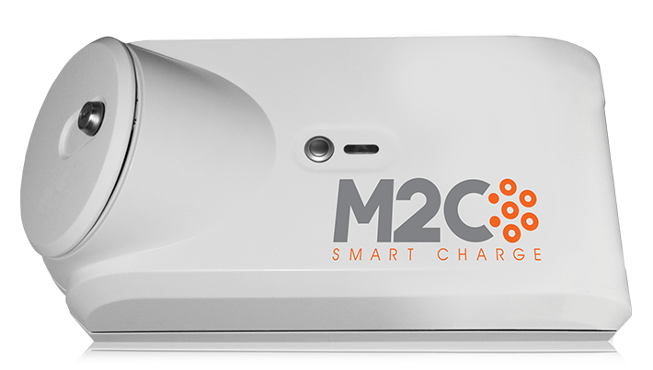Figure 1: M2C electric vehicle charger, [http://www.m2c.ie/products/]

Description | Rated Current (Ampere) | Voltage | Socket type | Phase
Residential | 16 | 220/240 | 2 | 1
Commercial | 16/32 | 220/240 | 2 | 1/3
Portable | 8/10 | 220/240 | 2 | 1
Table 1: M2C charger specification [http://www.m2c.ie/products/]
Features
The charger can communicate through the wireless local area network (WLAN), Ethernet or the global system for mobile (GSM).
Equipped with a timer to allow the user benefit from the cheapest possible rate of electricity when charging.
Protection against water ingress.
Various safety measures against voltage and tampering with the connections
[http://www.m2c.ie/products/]
To allow user interaction with the charger M2C decided that a smart-phone application would be ideal to meet the requirements. The purpose of the application is to visualize to the user various statistics like power usage, car charge rate and to customize the settings of the charger. Settings such as to set at what time the vehicle should be fully charged. The last feature is particularly important as it will determine if the charger can vary the charge rate while the vehicle is attached. As was mentioned earlier, the increase in electric vehicles place an extra load on the grid. If the vehicle can be charged anytime during the given time period that would allow the ESB network to ease the load during the most critical time.
To let ESB know when the user is planing to use the vehicle the charger has to be connected to the home network, that also has to be connected to the internet. The charger can then communicate with the ESB mainframe computer which in turn schedules an appropriate time to charge the vehicle.

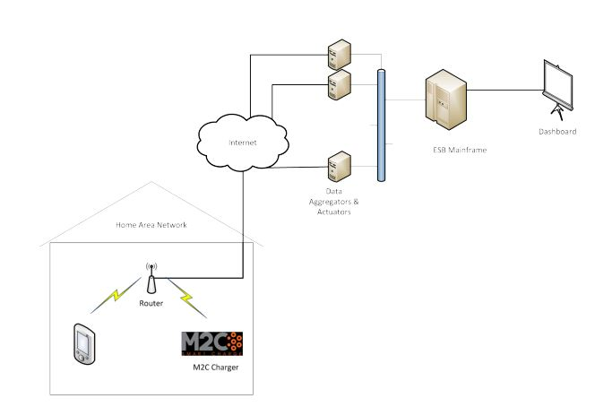Figure 2: Load control architecture

PhoneGap
The application will, as according to the specification, be using PhoneGap.
“PhoneGap is an open source solution for building cross-platform mobile apps with standards-based Web technologies like HTML, JavaScript, CSS. “ [http://phonegap.com/about/faq/]
PhoneGap was donated in October 2011 to the Apache Software Foundation under the name Apache Cordova. Cordova is used interchangeably with PhoneGap in many instances but it should be noted that PhoneGap is a distribution of Cordova. Currently, the only difference between the two are the name, which may or may not change in the future. [http://phonegap.com/2012/03/19/phonegap-cordova-and-what%E2%80%99s-in-a-name/]
With PhoneGap a developer can access each device functions like camera, accelerometer or geolocation with javascript. Accessing the phones geolocation will be used as an example to show what the code looks like:
Navigator.geolocation.getCurrentPosition( geolocationSuccess
[geolocationError],
[geolocationOptions]);
This will automatically grab the phones current location independent of what kind of operatingsystem the phone is running.
Worth noting is that PhoneGap is not compatible with PHP, ASP, JSF, JAVA etc. It may only implement what was listed previously. If the application need to access backend services it is possible to use network protocols like XmlHTTPRequest or Websockets. [http://phonegap.com/about/faq/]
The PhoneGap API and documentation are available at docs.phonegap.com.
The developer creates a web application and includes the tools provided from PhoneGap if there is a need to interact with the device specific functions. To run the application on the device PhoneGap creates a package that are built by each systems proprietary tools. Since each device implements system calls differently these calls has to be specified for each system. This is not something the developer has to think about since the PhoneGap interface will handle the call to the systems API.
[phonegap essentials 2012]
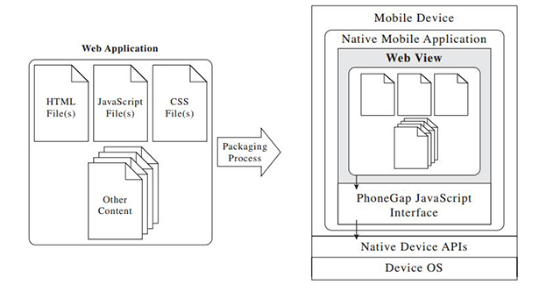Figure 3: Slightly modified picture from phonegap essentials 2012

The application
I was going to write about the application here but I think I will put that in the design instead.

3. Project Design and Implementation
- Design - Present your project design in general
- Information - Give details here (possibly several sub-sections)
- Implementation - Present your project implemetion in general
- Information - Give details here (possibly several sub-sections)
- Summary - for this chapter

4. Results / Evaluation
- Introduction - Summarise your main results
- Give details of the results
- Best presentation? (text, tables, diagrams?)
- Implementation Evaluation - your results against your expectations
- Summary - for this chapter

5. Conclusion
- Conclusion
- Project Evaluation
- Problems - How would you do this the next time?
- Future work

References

Appendices

