**Machine Learning NLP Price Negotiation**

**Chatbot**

**High Level Design Documentation (HLD)**

**Project for: - iNeuron (Machine Learning NLP Price Negotiation Chatbot) By:-**

**- Sarampenta Praveen**

**Content**

1. **Abstract**
2. **Introduction**
   1. **Why this High Level Document (HLD)?**
   2. **Scope**
3. **Description**
   1. **Problem Perspective**
   2. **Problem Statement**
   3. **Proposed Solution**
   4. **Solution Improvement**
4. **Requirements**
   1. **Requirements**
   2. **Tools / Software requirements**
5. **Data requirements**
6. **Constraints**
7. **Assumptions**
8. **Design flow**
9. **Logging & Error Handling**
10. **Performance Evaluation**
    1. **Page Load Time**
    2. **Response Time**
    3. **Error Rate**
    4. **Mobile Performance**
11. **Conclusion**
12. **Abstract:**

This project focuses on the development of a Machine Learning Natural Language Processing (NLP) Price Negotiation Chatbot, employing various technologies to enhance its functionality. The chatbot utilizes Dialogflow as an interface for seamless communication between the backend and frontend, providing a user-friendly experience. The Cassandra Database is employed to efficiently store login details, track product availability, and preserve negotiated prices and entire conversation histories.

The backend of the chatbot is powered by Python Flask, ensuring robust and scalable performance. To facilitate accessibility across devices, NGROK is employed to run the chatbot as an HTTPS server. This setup allows users to engage in price negotiations and product inquiries effortlessly, while also enabling the system to store and retrieve pertinent information for a streamlined user experience. The amalgamation of these technologies forms a comprehensive solution for an intelligent, efficient, and adaptable price negotiation Chatbot.

1. **Introduction:**

This project introduces a Machine Learning Natural Language Processing (NLP) Price Negotiation Chatbot designed to facilitate seamless and intelligent communication between users and an e-commerce platform. Leveraging the power of Dialogflow for intuitive interactions, Cassandra Database for efficient data storage, and Python Flask for a robust backend, the chatbot enables users to negotiate prices, inquire about product availability, and engage in conversations effortlessly. The use of NGROK ensures accessibility across devices, making the chatbot a versatile and user-friendly solution for enhancing the online shopping experience.

* 1. **Why this High level Design Documentation?**

The purpose of High Level Documentation is to (HLD) is to add the necessary detail to the current project description to represent a suitable model for coding. This document is also intended to help detect contradictions prior to coding, and can be used as a reference manual for how the modules interact at the high level.

The HLD will:

* Present all of the design aspects and define them in detail.
* Describe the user interface being implemented.
* Describe the hardware and software interfaces.
* Describe the performance requirements.
* Include design features and the architecture of the project.
* List and Describe the non-functional attributes like:
* Security
* Reliability
* Maintainability
* Portability
* Reusability
* Application compatibility
* Resource utilization
* Serviceability
  1. **Scope**.

The HLD Documentation presents the structure of the system, such as the database, architecture, layers, application flow (Navigation), and the technology architecture. The HLD uses non-technical and mildly technical terms which should be understandable to the administrators of the system.

1. **Description**
   1. **Problem Perspective and 3.2. Problem Statement**

The existing system relies on manual price negotiations between customers and sales representatives, leading to inefficiencies, errors, and inconsistency. This approach is time-consuming and can result in lost sales opportunities, customer dissatisfaction, and increased operational costs. The goal of the price negotiation chatbot project is to automate this process, providing a streamlined and consistent experience. The chatbot will handle customer inquiries regarding pricing, product features, discounts, and terms, negotiating within predefined parameters. This automation will enhance customer experience, free up sales reps for strategic tasks, and ultimately boost sales and satisfaction levels.

**3.3 Proposed Solution.**

The proposed enhancements to the features a Machine Learning NLP Price Negotiation Chatbot designed to facilitate seamless communication between users and an e-commerce platform. The chatbot employs Dialogflow for natural language interactions and utilizes a Cassandra Database to securely store login details, manage product availability, and record negotiations. The system ensures secure user authentication and offers a user-friendly interface for effective engagement. However, the existing system primarily focuses on improving the online shopping experience through price negotiations and product inquiries.

**3.4. Solution Improvements.**

* **Backend Integration:** Enhance with real-time data and functionalities like user authentication and order processing.
* **Advanced User Experience:** Implement features such as product recommendations and personalized profiles for enriched interaction.
* **Performance Optimization**: Continuously optimize for faster load times and smoother interactions.
* **Security and Localization**: Strengthen security measures and support multiple languages for enhanced user trust and accessibility.

1. **Requirements**
   1. **Hardware Requirements:-**

A working computer to code with active internet connection.

* 1. **Tools / Software Requirements:**
* Account in Dialogflow (<https://dialogflow.cloud.google.com/>).
* Python 3.11. ( python.org )
* NGROK application downloaded based on the operating system (https://ngrok.com/download).
* Account created in the Cassandra Database (https://astra.datastax.com/).
* Necessary Python libraries: TensorFlow, NLTK, Flask, json, cassandra, hashlib, datetime
* Integrated Development Environment (IDE) such as Visual Studio Code or PyCharm.
* Web browser for testing and interacting with the frontend.
* Operating System: Compatible with any OS, including Windows, mac OS, and Linux

1. **Data Requirements.**

Data requirements are essential for managing the core functionalities of your ecommerce application, including product listings, user interactions, cart management, order processing, chatbot connection and providing relevant information to users. Depending on the specific needs of your application, you may need to expand or customize these data requirements further.

1. **Constraints**.

The web application should be user friendly so that without knowing any technical information user should be able to use our predictive system.

1. **Assumptions**.

The main objective of the project ecommerce app is to provide users with a seamless and enjoyable shopping experience, facilitating easy browsing, selection, and purchase of products while ensuring security, reliability, and convenience.

1. 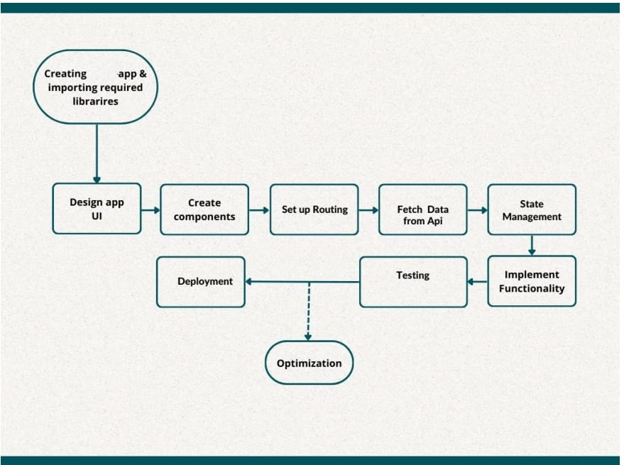**Design Flow.**
2. **Logging & Error Handling**.

Every important step is logged within the system that runs internally; it basically shows us the data time of each process which is done with our system. It provides us with logging information for end to end web applications. The logging which we have done in the above process helps us to handle the error because the error is being logged in log files (every time we run code) so that the developer can rectify it.

1. **Performance Evaluation.**
   1. **Page Load Time:**

Measure the time it takes for your app's pages to load. This includes both initial page load and subsequent interactions.

* 1. **Response Time:**

Evaluate the responsiveness of your app by measuring the time it takes for the server to respond to user actions, such as adding items to the cart or updating product filters.

* 1. **Error Rate:**

Monitor the occurrence of errors and exceptions in your app, including server errors, client-side errors, and network-related issues. Aim to minimize error rates to ensure a smooth user experience.

* 1. **Mobile Performance:**

Assess the performance of your app on mobile devices, including load times, responsiveness, and usability. Ensure that your app delivers a consistent experience across different screen sizes and devices.

1. **Conclusion**

In conclusion, our Price Negotiation Chatbot project represents a convergence of cutting-edge technologies to redefine the e-commerce landscape. The utilization of Machine Learning and Natural Language Processing in Dialogflow empowers users with an intuitive and responsive interface, allowing for dynamic price negotiations and inquiries about product availability. The integration of Cassandra Database ensures efficient and reliable data storage, enabling the seamless retrieval of user interactions, product details, and negotiation histories.