**Machine Learning NLP Price Negotiation**

**Chatbot**

**Low Level Design Documentation (LLD)**

**Project for: - iNeuron (Machine Learning NLP Price Negotiation Chatbot) By:-**

**- Sarampenta Praveen**

**Context**

1. **Abstract**
2. **Introduction**
   1. **Importance of High Level Document (LLD)?**
   2. **Scope**
3. **Architecture**
   1. **Architecture Design**
   2. **User Interface (UI) flow**
   3. **Tools / Software used**
   4. **Data Handling**
   5. **Error Handling**
4. **Conclusion**
5. **Abstract:**

This project focuses on the development of a Machine Learning Natural Language Processing (NLP) Price Negotiation Chatbot, employing various technologies to enhance its functionality. The chatbot utilizes Dialogflow as an interface for seamless communication between the backend and frontend, providing a user-friendly experience. The Cassandra Database is employed to efficiently store login details, track product availability, and preserve negotiated prices and entire conversation histories.

The backend of the chatbot is powered by Python Flask, ensuring robust and scalable performance. To facilitate accessibility across devices, NGROK is employed to run the chatbot as an HTTPS server. This setup allows users to engage in price negotiations and product inquiries effortlessly, while also enabling the system to store and retrieve pertinent information for a streamlined user experience. The amalgamation of these technologies forms a comprehensive solution for an intelligent, efficient, and adaptable price negotiation Chatbot.

1. **Introduction:**

This project introduces a Machine Learning Natural Language Processing (NLP) Price Negotiation Chatbot designed to facilitate seamless and intelligent communication between users and an e-commerce platform. Leveraging the power of Dialogflow for intuitive interactions, Cassandra Database for efficient data storage, and Python Flask for a robust backend, the chatbot enables users to negotiate prices, inquire about product availability, and engage in conversations effortlessly. The use of NGROK ensures accessibility across devices, making the chatbot a versatile and user-friendly solution for enhancing the online shopping experience.

* 1. **Why this Low level Design Documentation?**

The goal of LLD or low-level design document (LLD) is to give the internal logical design of the actual program code for Price Negotiation Chatbot. LLD describes the class diagrams with the methods and relations between classes and program specs. It describes the modules so that the programmer can directly code the program from the document.

* 1. **Scope of (LLD)**

Low-Level design (LLD) is a component-level design process that follows a step-by-step refinement process. This process can be used for designing data structures, required software architecture, source code and ultimately, performance algorithms. Overall, the data organization may be defined during requirement analysis and then refined during data design work.

1. **Architecture** 
   1. **Architecture Design**

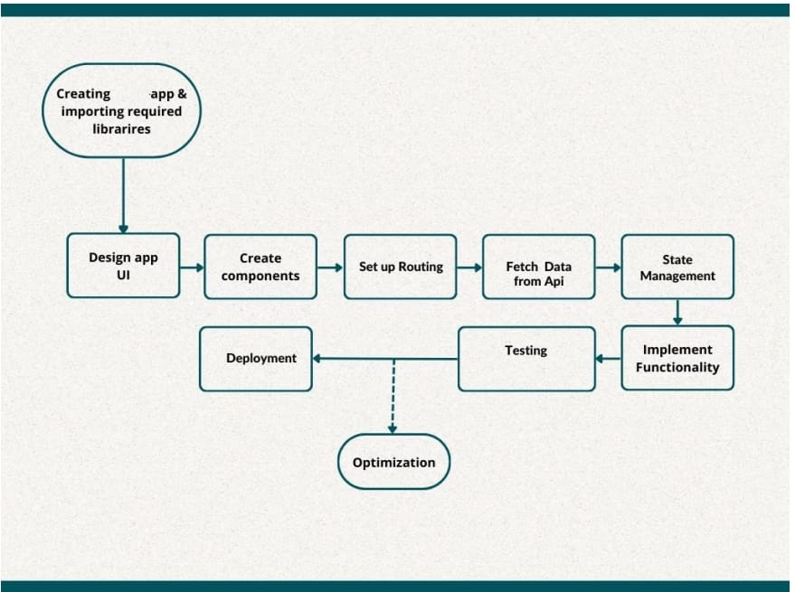

* 1. **User Interface (UI) flow**

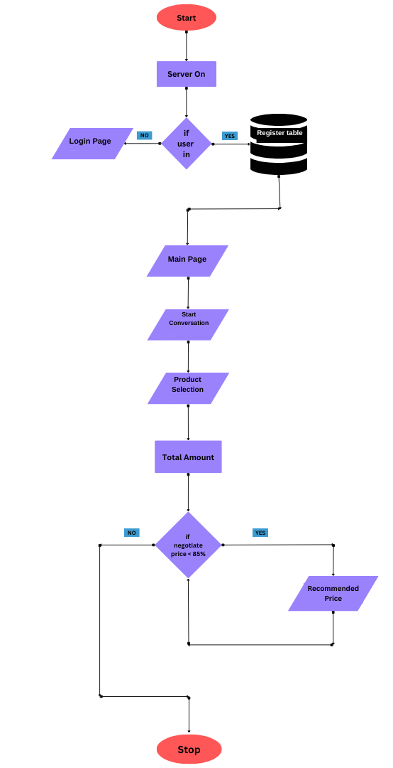

* 1. **Tools / Software used**
* Account in Dialogflow (<https://dialogflow.cloud.google.com/>).
* Python 3.11. ( python.org )
* NGROK application downloaded based on the operating system (https://ngrok.com/download).
* Account created in the Cassandra Database (https://astra.datastax.com/).
* Necessary Python libraries: TensorFlow, NLTK, Flask, json, cassandra, hashlib, datetime
* Integrated Development Environment (IDE) such as Visual Studio Code or PyCharm.
* Web browser for testing and interacting with the frontend.
* Operating System: Compatible with any OS, including Windows, mac OS, and Linux
  1. **Data Handling**
* Utilizing Dialogflow API for Flask connection for responses.
* Context API provides a centralized state management.
* NGROK is used to convert the flask’s HTTP server to HTTPS service.
* Flask frame work is easy to use and make get responses from frontend.
  1. **Error Handling**

Every important step is logged within the system that runs internally; it basically shows us the data time of each process which is done with our system. It provides us with logging information for end to end web applications. The logging which we have done in the above process helps us to handle the error because the error is being logged in log files (every time we run code) so that the developer can rectify it.

1. **Conclusion**

In conclusion, our Price Negotiation Chatbot project represents a convergence of cutting-edge technologies to redefine the e-commerce landscape. The utilization of Machine Learning and Natural Language Processing in Dialogflow empowers users with an intuitive and responsive interface, allowing for dynamic price negotiations and inquiries about product availability. The integration of Cassandra Database ensures efficient and reliable data storage, enabling the seamless retrieval of user interactions, product details, and negotiation histories.