**Wireframe Machine Learning NLP Price Negotiation**

**Chatbot**

**- Sarampenta Praveen**

**Content**

1. **Abstract**
2. **Output**

2.1. Login Page

2.2. Home Page

2.3. Start Conversation

2.4. New Order

2.5. Adding items to cart

2.6. Billing

2.7. Price Negotiation

2.8. Finalizing Amount

1. **Abstract:**

This project focuses on the development of a Machine Learning Natural Language Processing (NLP) Price Negotiation Chatbot, employing various technologies to enhance its functionality. The chatbot utilizes Dialogflow as an interface for seamless communication between the backend and frontend, providing a user-friendly experience. The Cassandra Database is employed to efficiently store login details, track product availability, and preserve negotiated prices and entire conversation histories.

The backend of the chatbot is powered by Python Flask, ensuring robust and scalable performance. To facilitate accessibility across devices, NGROK is employed to run the chatbot as an HTTPS server. This setup allows users to engage in price negotiations and product inquiries effortlessly, while also enabling the system to store and retrieve pertinent information for a streamlined user experience. The amalgamation of these technologies forms a comprehensive solution for an intelligent, efficient, and adaptable price negotiation Chatbot.

1. **Output** 
   1. Login page

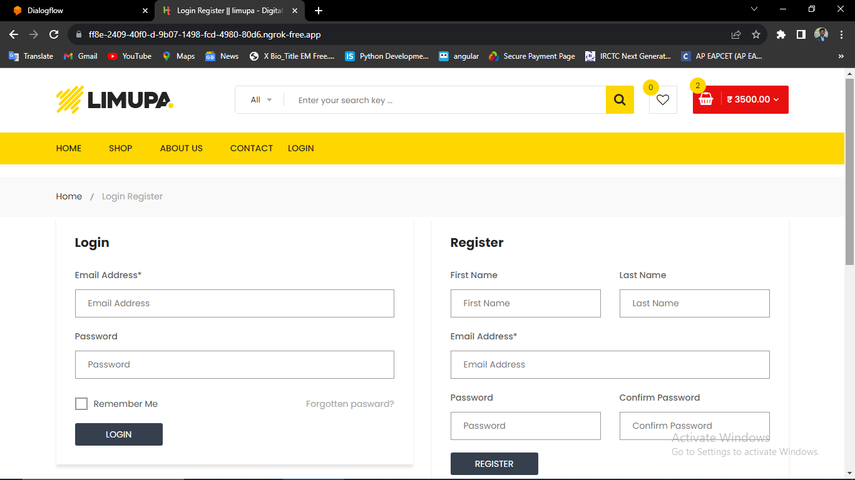

* 1. Home page

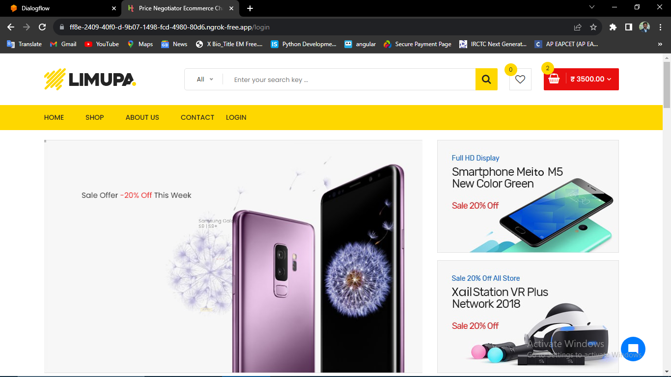

* 1. Start conversation

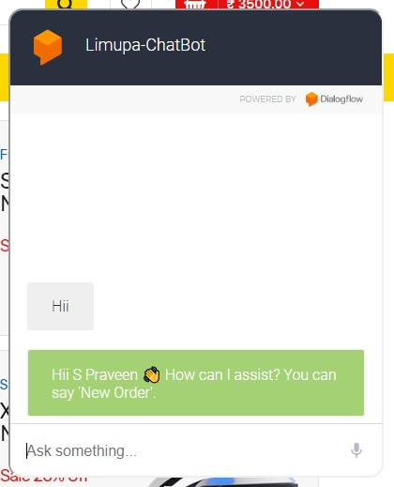

* 1. New order

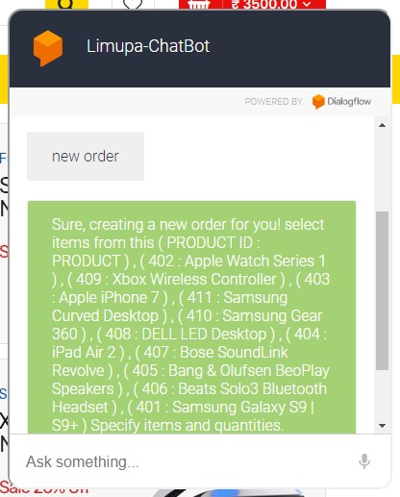

* 1. Adding items to Cart

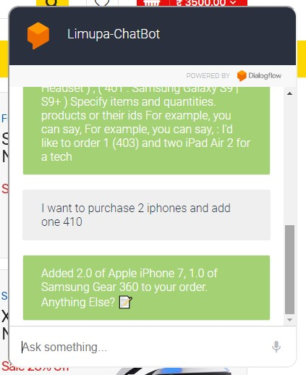

* 1. Billing

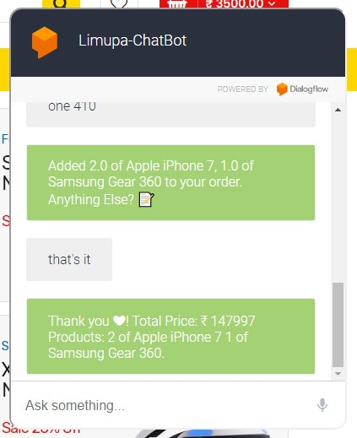

* 1. Price Negotiating

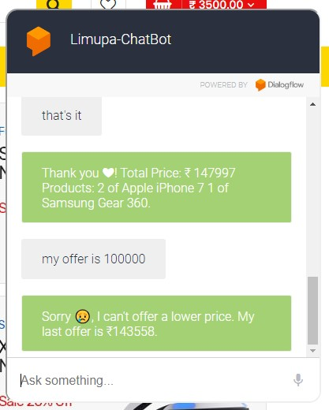

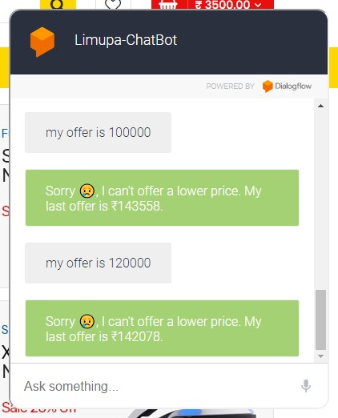

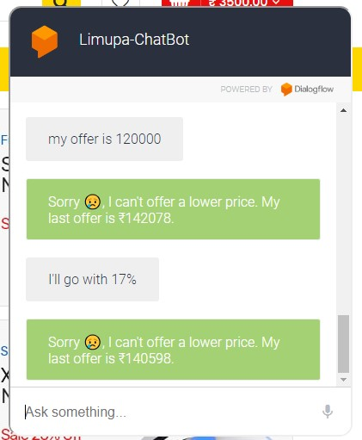

* 1. Finalizing amount

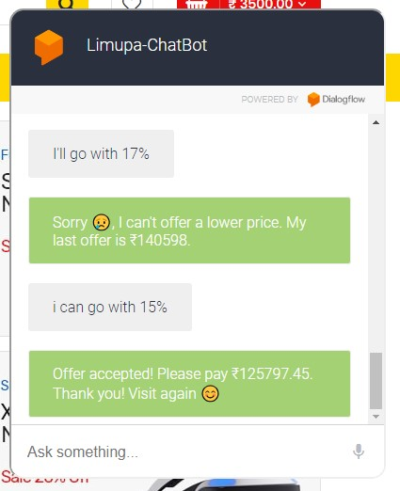

**Thank You**