Brenton Dupee
Dice Roller program documentation

Purpose
This program is a prototype of a dice rolling program that will be used in a Dungeons and Dragons character creator, with the purpose of rolling for statistics.
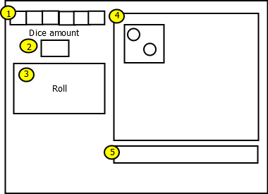
Feature Description
- Dice selection. User will be able to select from one of the following dice: d2, d4, d6, d8, d10, d12, and d20 to roll. The selected option will appear compressed compared to surrounding options. As of this time, the user will be able to select one and only one option.
- The user will enter the amount of dice to roll, the dice being rolled depending on the dice selected in 1. The user will enter the amount using numeric integers in a text box, from 1 to 9 available dice.
- Roll button. If user has entered all available options correctly, the program will roll dice, the results of which will be displayed in 4 and 5. If the options are not correct, an error message will be displayed asking for clarification.
- The graphical output of a successful roll. An appropriate PNG of each result will be displayed in the field.
- The text result. The result will print the total amount and type of die rolled, the individual results, and the total. For example:
4d12: 3, 7, 1, 11 = 22

