|  |  |  |  |
| --- | --- | --- | --- |
|  | D = 0 | D = 200 | D = 510 |
| Beta = 0 | **C:\Users\Andrea\AppData\Local\Microsoft\Windows\INetCache\Content.Word\Elab_d=0_beta=0_baboon.bmp**  **Beta = 0, d = 0** | **C:\Users\Andrea\AppData\Local\Microsoft\Windows\INetCache\Content.Word\Elab_d=510_beta=0_baboon.bmp**  **Beta = 0, d = 200** | **C:\Users\Andrea\AppData\Local\Microsoft\Windows\INetCache\Content.Word\Elab_d=200_beta=0_baboon.bmp**  **Beta = 0, d = 510** |
| Beta = 1 | **C:\Users\Andrea\AppData\Local\Microsoft\Windows\INetCache\Content.Word\Elab_d=0_beta=1_baboon.bmp**  **Beta = 1, d = 0** | **C:\Users\Andrea\AppData\Local\Microsoft\Windows\INetCache\Content.Word\Elab_d=200_beta=1_baboon.bmp**  **Beta = 1, d = 200** | **C:\Users\Andrea\AppData\Local\Microsoft\Windows\INetCache\Content.Word\Elab_d=510_beta=1_baboon.bmp**  **Beta = 1, d = 510** |
| Beta = 5 | **C:\Users\Andrea\AppData\Local\Microsoft\Windows\INetCache\Content.Word\Elab_d=0_beta=5_baboon.bmp**  **Beta = 5, d = 0** | **C:\Users\Andrea\AppData\Local\Microsoft\Windows\INetCache\Content.Word\Elab_d=200_beta=5_baboon.bmp**  **Beta = 5, d = 200** | **C:\Users\Andrea\AppData\Local\Microsoft\Windows\INetCache\Content.Word\Elab_d=510_beta=5_baboon.bmp**  **Beta = 5, d = 510** |

Sharpening effect

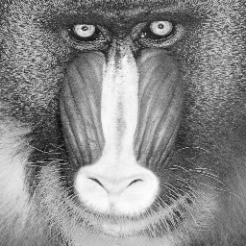 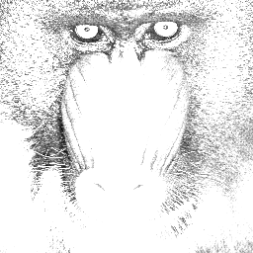

d = 0, Beta = 5

Smoothing effect



d = 0, Beta = 0,02

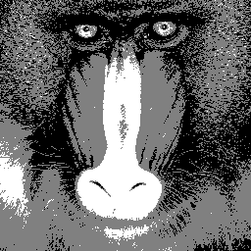

|  |  |  |
| --- | --- | --- |
| C:\Users\Andrea\AppData\Local\Microsoft\Windows\INetCache\Content.Word\baboon.bmp | d = 0, Beta = 5  **Sharpening filter** | C:\Users\Andrea\AppData\Local\Microsoft\Windows\INetCache\Content.Word\Elab_d=0_beta=5_baboon.bmp |
| C:\Users\Andrea\AppData\Local\Microsoft\Windows\INetCache\Content.Word\baboon.bmp | d = 0, Beta = 0,02  **Smoothing filter** | C:\Users\Andrea\AppData\Local\Microsoft\Windows\INetCache\Content.Word\Elab_d=0_beta=0.02_baboon.bmp |