In this video I'm going to share the top five programming project ideas to get a job now. I'm also going to share the worst programming project idea that every single student does. Trust me, you might have even done this project already.

The first programming project idea is… wait, this isn't good enough. I need more input. Got it. I'm going to pack my bags, fly to Dubai, RIP internet-made coder out of his comfy bed and make him give some ideas too.

Wait, what was the question? Programming projects especially first project. If you're more of a beginner, a good place to start is with something that you can finish in even a weekend. But it's still going to be interesting and it's even going to help you in your real life. And one thing that I talk about a lot is Python automation scripts—essentially, automate your life. One example is a script to clean up your desktop automatically. Have a script running at all times so that whenever you download a file, instead of going into a downloads folder, it's automatically going to be sent to the appropriate folders depending on the file type. Another example is a Python script to automate your Google calendar. Set a script to track the time that you spend programming and it will automatically create events into your Google calendar.

If I recommend you just pick a task that you would like to automate on your computer and figure out a way to automate it using Python. Still not good enough? I'll call Tech with Tim. Tim, come to Thomas's.

So one of my favorite project ideas is to do something that integrates with hardware. I always had fun kind of working with robotic Raspberry Pi's. Do something with the Internet of Things where you're actually interacting with real world sensors. A project I built was a script that automatically preheated my coffee maker every morning 10 minutes before I was gonna wake up so right when I walked downstairs, I had instant coffee. Another cool one that I did was essentially a facial recognition script that was running on my Raspberry Pi that allowed me to determine who was walking through the hallway of my house, and I could see who was coming up to my door. It would give me a notification—it's kind of a Raspberry Pi security system of sorts.

So the number one worst website idea of all time is a portfolio website. Now, hear me out. You should have a portfolio website, but you shouldn't build it as a side project. Now on the surface it seems like a great idea. I need a website to show off my work, why don't I build it? The problem with trying to make your own portfolio website is that you end up spending more than half the time just designing it, and then we come up with a bad design which reflects poorly on us. It actually hurts us in the application process. Then you'll spend your other half of the time trying to fix annoying HTML CSS bugs that you're not even going to need on the job most of the time. People get caught up in this and they don't even end up finishing the portfolio website.

The solution is web hosting. I actually partnered with Hostinger for this video so that I could show you how to build a kick-ass portfolio website. Okay, now I logged in here to Hostinger. Let's go ahead and get our free domain. I'm going to put my full name, Jason Levi Goodison, my full name, claim.domain. Now get a .com because people have an inherent bias for .com. It just looks more legitimate—not .me, not .io, get .com. Fill out your information, obviously mine's blurred here, and bang! Look at that, immediately I have a cool domain.com. I'm already halfway into looking legitimate.

Let's build our first website. I recommend going with the business plan for a few reasons. The first is obviously the free domain, which you're gonna need. The second is it's optimized for WordPress. The third would be the free email. Everybody else is going to be emailing from their school account, so if you can email from your own private domain, that just makes you look way more legit. Another is unlimited SSL certs—so if you see that little lock icon next to the URL, that's an SSL cert. You don't have one of those, your website honestly looks sketchy. But it's surprisingly hard to get one of these when you're coding your own website. You have to go through the whole flow, buying it, setting up the DNS records correctly. Something's going to go wrong. It's just way easier to use Hostinger's.

Add coupon code json10, apply. Sweet, and I'm gonna get it for 48 months because I know that I'm going to need this indefinitely. Alright, so I purchased it. Now let's set up our first website. Building it myself? Sure, I need help, at least that's what my ex says. AI website builder, I didn't even know they had this. A cool sleek website that displays coding projects. Create website.

Building the website my portfolio project one, project two, project three. Wow, I like this vibe a lot actually. About me, get in touch. This is pretty much everything I need, right? It's not perfect so I'll go ahead and change it exactly how I like it—it'll take me 10 minutes.

So let's go through the website really quickly. First, I put a banner. All of the logo splashes, I think, will grab people's attention: Y Combinator, Waterloo, Microsoft. If you have any logos, put them on only if they'll make you look more legitimate. Scroll down. I put a bit of personality; I put a picture of myself, completely AI-generated headshot—I've never gotten a good photo taken of me in my entire life. Scroll down even more. I have my portfolio. I describe them in a human-like way. I describe the impact, like who's actually using the projects. I put good images that I've spent a long time taking and this looks pretty legitimate. So I'm going to click go live and there you go. Go to JasonLeviGoodison.com, you can check out my portfolio website. This is the display of you to an employer—you want it to look ultra premium, ultra legitimate. So spend time on it and maybe even ask some design friends to help you with the design elements. And because you're not coding it, it'll take 10 minutes to do a third project.

A project that every single programmer should have in their repertoire is a full-stack application. The purpose of this is to understand the front end and the back end, specifically how these two communicate. Ideally, you'll also have state management and interact with some kind of API. A great example of this is a personal finance tracking app—actually allow you to connect your bank account to the application to track your finances. You can have the right things to interact with CSV files, to interact with your transactions. The stack that I recommend myself is Django for the back end because it's really fast. On the front end, I recommend React. But if a personal finance app is not interesting to you, another example is a simple e-commerce application. It's a bit more simple but it's going to give you a lot of good practice with some of the basics like user authentication, React state, interacting with databases and a bunch of other things.

The next type of project I typically recommend to people is something to do with game development. So a lot of the games that I built, stuff like Tetris, Pac-Man, even something like Tic-Tac-Toe can be a great project. However, if you want to do something a little bit more complicated, try to do something that involves physics simulation. So what I did recently on my channel was a planetary simulation that was pretty cool, but another more complicated one I did was actually a mini golf game. What you did is you kind of hit a ball with a different amount of power and I used projectile motion to actually get the ball to kind of go up and down using gravity and bouncing, all of that kind of stuff, I built into the app. So if you can make a game, go ahead and try that out.

So all of those projects run the gamut from beginner to more advanced, but all I care about for the fifth project idea is that people are actually using it. So now that I'm starting to hire for my startup, the first thing I do when I see a project is see is this a real project, do people actually use this, is it helping people's lives? I love Tim's example of having something make him coffee every morning because that's something that he uses. If you could build a project that 10 people are using, 100 people are using, 1,000 people are using, then when it comes to technical stuff I'm probably not going to have to interview you as heavily because I know that you can build things that people actually want. Anybody can learn to code, but are you a problem solver? That's what I want to see in your projects.

So the project I did that hit this requirement is I was a poor college student and I lost access to Spotify. So instead of paying for Spotify, I wrote a script that scraped all of my songs from Spotify, searched them on YouTube, got the URL and then used a library to download the MP3 which I then uploaded onto my phone. Although it is slightly illegal, I think a few people in interviews called it out as a really interesting project and we talked about it and bonded over it. So essentially there are two ways that you could build a project: either you're trying to learn a specific skill, which is what Thomas and Tim have talked about today, or you could be trying to set yourself apart. And I think that once you've gotten the basics down, building a project that real people are using that solves a real problem, that's the way to do it. That's the way to set yourself apart from all of the other students.

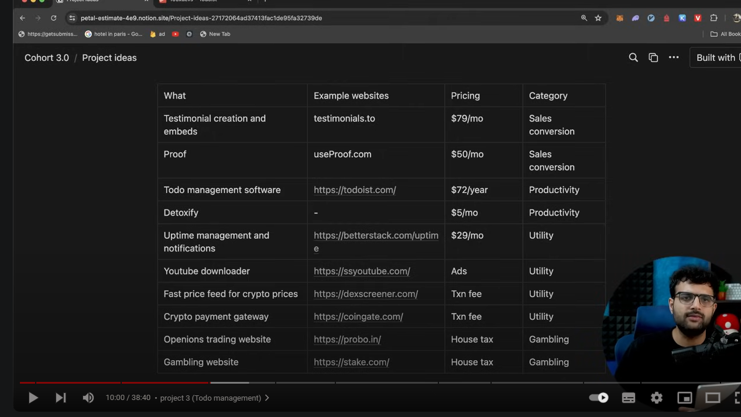

Intro: All right, read through this tweet. Toist has made more than $100 million in total revenue in the last few years. A simple to-do application—something you might have been building for a long time—can actually scale to a lot of revenue if built right. In this video, I'm going to talk about 10 such product ideas. These are good things to put on your resume, these are good things to generally build as businesses, only if they are built with a lot of polish. The problem with building your own project is since it does not reach a lot of users, you don't get user feedback, you never iterate, and hence I would urge if you're thinking of building one of these then please make it incredibly polished. Half of the battle is making the product usable than you know just building it out and putting it out there. Without any further ado, let's get into the first project idea.

Project number one is a testimonial creation and embeds website. A good example of this is testimonials. If you go to this website it says get testimonials from your customers with ease. It basically gives you a widget like this that you can embed on your website. It also does the hard work of gathering all of this feedback from your users. So the UX looks as follows: you sign up on the website, you reach a dashboard like this, and you can create a new space. Every landing page, every website that you have can be a fresh space. Let me create one for, let's say, one of my websites.

All right, I've created a new space for one landing page of mine and now I get this link that I can send to my customers to gather their feedback. If you go to this testimonials. 2/ 100x devs landing page you will see something like this. It asks you to review the course or, you know, whatever you're selling. You can either record a video or write a textual feedback. Let me quickly write some simple feedback for this website.

All right, this is how my end customers would review the product that I'm selling and now I can track all of my reviews on my testimonials dashboard. If I go here and look at this space that I had created, when I open this page I can see all the reviews that have been made and the ones that I really like, the ones that I want to showcase on my end website, I can just like them or, you know, add them to my wall of fame. And then I can embed this wall of fame on my website. I can pretty much choose the best ones that I find and then create a wall of fame, choose the layout of how I want it to look like—let's say, you know, something pretty standard. And then, you know, it gives me some JavaScript code that I can add to my website and that will embed that specific testimonial or bunch of testimonials to my website.

Let me quickly show this in action. If I go to replate, create a fresh HTML CSS and JavaScript reppel, paste the code over here and run it again, you will see the review comes here on my end website. Now this website could be anything—it could be my main website, my product website, whatever. All I had to do was add three lines of code and all the reviews that my students or users have sent can appear on this website. Now you might ask, "Who's even paying for this? This is such a simple product." But in the end, the simplicity doesn't matter. It's about how much value does it provide to the end user, which a product like this provides a lot of value. Feedbacks have generally been seen to, you know, increase conversion rates by a lot, which is why people don't mind paying $50 per month for something like this. The founder of this company actually built the product in public, which means they were initially sharing their revenues and they had a decent user base paying for this product purely because it's a very nice pull for any, you know, marketer who's selling a digital product. That's the first product.

If you look at the tech stack, it's not too hard to build. You probably need a simple website, which can be a [**Next.js**](https://next.js/?form=MG0AV3)website so that it has both front end and back end. You need another review gathering website which can also be [**Next.js.**](https://next.js/?form=MG0AV3)The only big thing over here is whenever a user comes and provides a review it needs to go into some video pipeline because the user is expected to record a video over here sometimes before submitting it. So you need some sort of a video processing pipeline. You can also outsource this to someone. There are a bunch of companies that do this. For example, M would let your end users record a video and let you store them in your own object stores or store it on Max object stores, just give you a link that you can eventually use.

Other than that, there's nothing too hard to build here. Polishes do matter, of course. Your final review board that you're letting users embed on their website needs to be extremely pretty and you need to give the users a bunch of layouts that they can choose from. Other than that, fairly simple product. The more polish you build it, the more integrations you add over here, the more places you let the user embed websites: create React components, Next components, SW components—make it as easy as possible for a user to embed. This is, you know, what differentiates this product from any competitor, but a very small niche product to build. With that, let's move to the second one. All right, the next product is called use [**proof.com.**](https://proof.com/?form=MG0AV3)It's a YC-backed company that gives you...

Project 2 (Proof): Social proof for your digital products. It's again a, you know, sales and marketing sort of product. It's a SaaS which lets you show notifications like these: for example, 13 people started a free trial in the last 24 hours verified by Proof, or 79 people are currently viewing this website verified by Proof. Proof becomes the central authority for actually verifying how many people are currently on this website or how many people have recently signed up on this website so that whenever you're selling something, for example, you know, there's someone who's selling a, whatever, crypto cheat sheet like this and whenever their user comes on their final cart product or cart page is when you create some sort of a FOMO by showing them XYZ people are currently trying to buy this.

You might have seen this fairly often on course selling websites or any digital product selling website. It leads to higher conversions, which is why marketers love to integrate these on the website. It's again a one-line integration, and all you have to do as the developer is, number one, build a website very similar to [**useproof.com**](https://useproof.com/?form=MG0AV3)where a user can come and, you know, give their website's URL. For example, let's say our website is [**cryptosheets.com**](https://cryptosheets.com/?form=MG0AV3)and the website gives you back a pixel code. A pixel code is basically, you know, a script that you can add to your front-end page. So what you have to do is take this pixel and integrate it in your own codebase, in the [**cryptosheets.com**](https://cryptosheets.com/?form=MG0AV3)codebase. Just bring the pixel and put it over here.

Now, anytime a user signs up, anytime there's a form that looks like a sign-up form and someone clicks on a submit button, the Proof system understands someone has recently signed up and let's say if, you know, 30 such events happen, then everyone who's on the cart page will get a notification that says 30 people signed up in the last, let's say, 30 minutes. The reason this is good is because as long as everyone understands how Proof works under the hood and Proof is not doing anything shady, whenever you're seeing the verified by Proof tag, you can indeed be sure, okay, there are 79 people who have recently signed up because Proof does not let the developers of the company inject events and tell, okay, 79 people are currently active on the website. It actually has a script running on your final website and that's how it figures out how many people are currently live. Same should be true for if you're selling something. If you want to show a notification that says, you know, XYZ has bought the course from Gujarat—you might have seen these notifications as well—okay, Amir from Gujarat just bought this course for $30. These are also FOMO-generating notifications and these should be split out from a Stripe dashboard. You should indeed verify your payment has happened and not trust the developer of that specific product and only then should you say verified by Proof. The whole point of this is, you know, this is real social proof. Okay, this event has indeed happened.

So the only thing you have to keep in mind is, okay, you're not letting developers inject events or live counts over here. Okay, currently there are 30 people live on my website. It should be all pulled from the website and Proof servers should be able to figure out, okay, currently there are 10 people or 20 people active on the website.

The tech stack should be straightforward. You need two things: number one, you need this dashboard that you can write in maybe Next.js, whatever front-end backend technology you're comfortable with. And secondly, you need some sort of a backend server, most probably a real-time backend server where anytime, if this is your end user's website, this is cryptosheets.com, anytime a user comes here, they create a websocket connection to your backend server and that is how you know how many people are currently active on the website. So you need this extra backend service which is, from time to time, pushing things to most probably a database and you pull out notifications from this database to again show on this website. Okay, 30 people are currently active on the website. Not too difficult to build. Again, polish is what matters and, you know, transparency is what matters. So if you can somehow, you know, bring more and more transparency, if the website does say verified by your website or verified by Proof, then indeed you can be sure, okay, this specific metric is indeed correct. That's website number two. Let's move on to website number three: the website that has made $100 million in its lifetime. All right, the next one is a to-do...

Project 3 (Todo management): Not a very simple to-do application but nothing too hard either. It needs to support five features:

1. It lets users create todos. That's the fairly simple thing any to-do application should let you do.
2. Add members to your organization and assign them tasks. A lot of times these todos might not be assigned to you; it might be assigned to someone else in the team.
3. See a calendar view of all of your tasks, all of your team tasks. Individually people can see their own set of tasks they need to do and by when do they need to do these tasks.
4. Reminders at the end of the day for all pending tasks. In case I had 10 things to do today and I've been able to check off five, I should get some sort of an email, WhatsApp notification, phone call, or SMS that I still have five pending tasks for the day.
5. Lastly, allow you to create organizations. I can create multiple organizations, add different members to different organizations, have tasks for each organization be separate.

To let you do a lot of these things, this is what their very basic dashboard looks like. You can come here and the first thing you can do, for example, is create a task. Let's say the task is eat food at two—like a very weird task but let's say eat food tomorrow at 2 p.m. As you can see, it makes your life as easy as possible. All I had to do was write "at 2" and it automatically parsed that this probably means 2 p.m. If I write 2:00 p.m. here, it automatically understood this means 2 p.m. If I remove pm, it feels like this thing is due at 2:00 a.m. tomorrow. Basic parsing that just makes the life of the person who's creating the todo very easy. The whole point of this is to make the lives of people who are extremely busy easier and these small polishes matter a lot.

It lets you assign it to someone else or yourself: priority P1, P2, P3, and by when is this thing due. If I click on add task, it becomes one of many tasks I have pending today. I have to eat food, go to the gym, finish video for recording (the one that I'm currently recording), finish code three syllabus hash, the campus things like these—these are all the tasks that I have for today. As I keep on doing them, I can check them off. It also shows me a calendar view which is pretty cool. This is everything I have pending for today. Let's say I don't have anything tomorrow; this is what I have planned for Saturday, so on and so forth. Taking all of your tasks and showing such a view that you can—it's just easier and more organized to look at.

It also lets you create organizations, for example, there is a 100x devs organization here and you can create multiple projects inside it. For example, cohort 3.0 is one project; Meetup is another project. These are the tasks that we have to do during, let's say, a Meetup that is happening. So a very basic to-do application. As you can see, there's nothing too out of the ordinary here: very basic UI elements and drags and drops which are not too difficult to add today. The only thing is, have you covered all the bugs, have you supported all the features that these guys currently support. The only difficult thing that I can think of might be adding members, removing members, and letting the users create organizations—which also, if I'm being honest, is a fairly simple full stack task. Nothing too out of the ordinary here. If you're trying to build it, if you are thinking of building it, I would first build the front end of it. There are mildly complex things to do if you want to build the front end, for example, drags and drops. Then I would just move off to the back end which, if I'm being honest, should be fairly straightforward.

The other thing that might be good to add here is a mobile application because you need notifications to pop up. You probably need a mobile app for that. Also, mostly busy people are on their phones, so they can create a task directly on their phone. That's all I have for this one. Let's move to project number...

Project 4 (Detoxify): All right, product number four is called Detoxify. It's an original, which means I don't think this already exists—this is just an idea that came to me a while back. The problem statement looks like this: whenever you open your YouTube feed, it's mostly customized based on history, what YouTube thinks you're interested in. For example, in my case, I see a bunch of real estate, I see some more—well, too much—real estate, and then, you know, some of my own videos, so on and so forth. But, you know, this feed can get very toxic very quickly. You might open one back-cracking video and then you're just seeing a bunch of back-cracking videos for a long time. So what if you could create a website where users can come and select one of many things they're interested in, for example, DevOps or, you know, maybe Rust or GoLang, so on and so forth, one of these technologies that they want to learn. And once they select this technology, we surf their YouTube—I repeat, we surf their YouTube with a bunch of popular, well-written, well-made GoLang videos for a really long time, and their final feed eventually becomes, you know, a bunch of those creators that are currently active, still, you know, have the best GoLang videos. It lets you detoxify your feed and, you know, makes it so that if you want to learn something, you're consciously triggered to learn that thing because your feed is filled with those things.

Now, I don't know if this is possible to do. I don't know if you can get access to someone's YouTube such that you can surf on their behalf and, you know, the access is limited to just that versus you getting complete access to their YouTube. So the thing to figure out here is, okay, is this even feasible of a product to build? Can you get some sort of permissions on a user's account so that you can start to surf their YouTube and, you know, spend maybe 20 minutes on a specific video and then overall spend around 30 hours on a bunch of GoLang content so that by the end of it, their feed looks something like this? If this is possible to do, I would assume people would pay a lot of money for this. I, for example, would pay a decent chunk of money, maybe whatever, $10 a month, so that if I want to learn something, I am forced to do it subconsciously because my feed is filled with all of this content.

This can then be extrapolated to Instagram and other platforms. A lot of times Instagram feeds are also, you know, fairly polluted, so if you want to get away from them, you can either select "not interested" a bunch of times yourself, or you can have a bot, you know, surf on your behalf and, by the end of it, filter out good and bad feed, so that your final feed becomes detoxified. Let me know if this is possible in the comments and if you've figured out the right set of APIs that these websites do provide you. If they don't provide you any APIs, you know, the worst case is you take the user's credentials. I don't know if people are super comfortable sharing their credentials, but I would totally create a fresh dummy account where I would give my credentials to a company like this, and if they surf on my behalf, great—I can eventually open that specific account and surf using that specific account. My primary account credentials I don't have to share. That's idea number four. Let's move on to idea number five, which is slightly DevOps-heavy. All right, next up we have a website similar to Better Uptime...

Project 4 (Detoxify): All right, product number four is called Detoxify. It's an original, which means I don't think this already exists—this is just an idea that came to me a while back. The problem statement looks like this: whenever you open your YouTube feed, it's mostly customized based on history, what YouTube thinks you're interested in. For example, in my case, I see a bunch of real estate, I see some more—well, too much—real estate, and then, you know, some of my own videos, so on and so forth. But, you know, this feed can get very toxic very quickly. You might open one back-cracking video and then you're just seeing a bunch of back-cracking videos for a long time. So what if you could create a website where users can come and select one of many things they're interested in, for example, DevOps or, you know, maybe Rust or GoLang, so on and so forth, one of these technologies that they want to learn. And once they select this technology, we surf their YouTube—I repeat, we surf their YouTube with a bunch of popular, well-written, well-made GoLang videos for a really long time, and their final feed eventually becomes, you know, a bunch of those creators that are currently active, still, you know, have the best GoLang videos. It lets you detoxify your feed and, you know, makes it so that if you want to learn something, you're consciously triggered to learn that thing because your feed is filled with those things.

Now, I don't know if this is possible to do. I don't know if you can get access to someone's YouTube such that you can surf on their behalf and, you know, the access is limited to just that versus you getting complete access to their YouTube. So the thing to figure out here is, okay, is this even feasible of a product to build? Can you get some sort of permissions on a user's account so that you can start to surf their YouTube and, you know, spend maybe 20 minutes on a specific video and then overall spend around 30 hours on a bunch of GoLang content so that by the end of it, their feed looks something like this? If this is possible to do, I would assume people would pay a lot of money for this. I, for example, would pay a decent chunk of money, maybe whatever, $10 a month, so that if I want to learn something, I am forced to do it subconsciously because my feed is filled with all of this content.

This can then be extrapolated to Instagram and other platforms. A lot of times Instagram feeds are also, you know, fairly polluted, so if you want to get away from them, you can either select "not interested" a bunch of times yourself, or you can have a bot, you know, surf on your behalf and, by the end of it, filter out good and bad feed, so that your final feed becomes detoxified. Let me know if this is possible in the comments and if you've figured out the right set of APIs that these websites do provide you. If they don't provide you any APIs, you know, the worst case is you take the user's credentials. I don't know if people are super comfortable sharing their credentials, but I would totally create a fresh dummy account where I would give my credentials to a company like this, and if they surf on my behalf, great—I can eventually open that specific account and surf using that specific account. My primary account credentials I don't have to share. That's idea number four. Let's move on to idea number five, which is slightly DevOps-heavy. All right, next up we have a website similar to Better Uptime...

Rest- 5 later

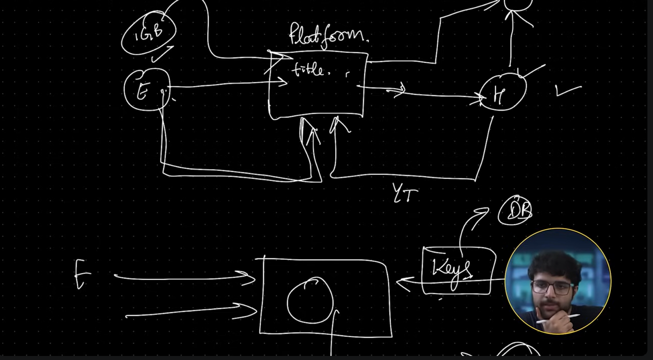

2nd Idea - Internationalization as a Service: The second one I'm calling Internationalization as a Service. So, most websites that you look at today might be written in English. A few websites let you change the language. This is a mildly hard technical problem to solve, and the reason is because for the developer of a company that has written everything in English, let's say, there is a very big uphill battle to find all the strings in your codebase that are in English and somehow templatize them so that they can be replaced with Chinese, Hindi, so on and so forth. So I've seen whenever a company wants to open to new markets and add other languages to their website, there's a very high uphill curve for a developer to build this whole internationalization system.

The second problem is as the website grows, new strings keep getting added, and when new strings get added, you need to convert them to Chinese, Japanese, Hindi, so on and so forth. So you need something called translators who help you translate your strings. I think both of these can be staggered together to build a business in itself, which is:

1. If you are an open-source codebase, our developers (or for you, it will just be one person) will come to your codebase.
2. I will add internationalization throughout your codebase and maintain a list of translators, which you can do either via AI or you can hire people from all around the world who will translate strings and take that pain away for a big codebase.
3. You go to a company, you go to an open-source codebase, and you tell them, "Your website doesn't have internationalization. I, as the developer, will come, add internationalization throughout your codebase, create a single English templates file which contains all the English strings, and all translations into Chinese, Japanese, Hindi I will handle by either translators or via AI."
4. That way you take away that pain point for that company, and for the initial uplift of adding internationalization to your code, pay me like a thousand to three thousand dollars, because it's an initial effort of 20 to 50 hours that you have to put in to go through their codebase and replace all the strings with templates.

3rd Idea - Adding OpenAPI to Backend: So you will still be a service provider like the last service, and you'll go to an open-source codebase or a company and you'll tell them, "Hey, you have a decent backend, why not OpenAPI-fy it?" That way other people can interact with your backend.

But more importantly, the reason I want to bring this up is because to create a ChatGPT Plugin or make ChatGPT talk to your own backend, you have to expose OpenAPI specs. That's what ChatGPT supports right now. Unless your backend has very well-documented routes—what every route does in the OpenAPI spec—you cannot create a ChatGPT plugin right now.

So I feel eventually all businesses, the mode will be just the backend and users might not go to websites. They'll just ask ChatGPT to do something. For example, they'll go to ChatGPT and write, "Hey, buy me stocks for Google at a certain price," and this will automatically open a trade on Zerodha or whatever exchange they're using. Hence, if this is the exchange, they need to expose their backend APIs in the OpenAPI spec so that ChatGPT can talk to it.

Right now this is the only way for ChatGPT to talk to your backend and understand what every route does. And I feel as more and more people cluster to ChatGPT and general language models, these backends are what will remain the mode of businesses, and no one will go to websites to access these backends—they'll simply ask ChatGPT to do something and ChatGPT will, based on the language model and whatever is written here as to what backend the routes do, finally call your backend products and execute the trade or do whatever service your website is doing.

For that, you need to add OpenAPI to your backend and that is again another uphill task to do. It's very hard and varied in every language. So you can charge a one-time fee and your pitch can be, "Okay, you can get ahead of your competitors by creating a ChatGPT plugin. That way your users can simply talk to ChatGPT and do things on your backend versus your competitors—people still have to go to the website and click buttons." That will be your pitch. I think you can easily charge 5 to 10K to do this for a certain company because depending on how big their codebase is, this will be an uphill task to figure out all the inputs and outputs and what a specific backend route does. These are all the things that you sort of put in this very big spec file that is what ChatGPT reads and understands what each route of yours does.

4th Idea - Adding Test to a codebase: So when you're a startup, when you're an open source project, a lot of times you have to move really fast. So if you look at a bunch of open-source projects, you'll see they always say tests are welcome, much appreciated, because the developers don't have the time to write tests. And even though they have long-term benefits, in the short term, writing tests just takes up a lot of time. So you could do one of two things: if there is an open-source project that does not have tests, create the complete testing suite for it and when you do this, I think you can charge them upfront like a decent amount.

Your software developers don't have to worry about tests. We will create an independent module that is testing between a test or integration tests, and give us an upfront fee, and then we'll be out of your business. Or you could be like, okay, we will handle your tests from here until eternity, which means it will be a recurring business. We will charge you based on the number of lines we cover, the number of lines of code we write, so on and so forth—just a flat fee of a thousand dollars a month. Anytime a developer of your team adds some code, we will write some tests. And this could also be automated via AI, I think, or at least you can use AI for a lot of help to write these tests.

So, either one of these two. And like, the third one is even if you want to just get hired at a company, open-source project, so you see there are no tests written and the developers of the specific project don't even know or have the time to write tests. If you come into the project and write the whole boilerplate to set up tests and add like 50% coverage, or more specifically like there was a bug in their company recently and you add a test that tests that specific bug, and you tell them, okay, if this test was there already, this bug would have failed before it got deployed.

These things can sort of be impressive factors, even if you're applying for a job. But this video is specifically for projects that you can charge for, so I feel testing as a recurring business is great, or adding a one-time test to a big project where developers don't have the time to do it is also good. The one-time fee that you can charge will vary from project to project, but for a good project, I think 2K to 5K or whatever—like hourly into like an hourly rate of 20-50 an hour into the number of hours you're putting into writing tests—is a very nice thing for a company to just outsource to someone.

5th Idea - Moving to NextJS 13: A very niche and a very new use case. So [**Next.js**](https://next.js/?form=MG0AV3)recently—not recently, like six months ago—came out with [**Next.js**](https://next.js/?form=MG0AV3)13. It's significantly better than the previous version and there are a lot of projects out there that haven't yet migrated to it. This causes a bunch of issues. So this [**Next.js**](https://next.js/?form=MG0AV3)13 specifically has this thing called server-side components and client-side components. I wouldn't call it a breaking change, but they have made a very big change of defining upfront when you are creating your front-end components whether it should be rendered on the server or on the client. Not every library has moved to it.

So you can go to an open-source, famous library, components framework, a UI library and tell them, "Okay, I will help you migrate to [**Next.js**](https://next.js/?form=MG0AV3)13," which basically means it'll help label their components as client or server side. Or you could go to a project that hasn't yet moved to the latest app router and still uses the existing one.

Vercel.com, for example, still uses the pages router, which is totally fine, good and works very well, has worked well for years, but eventually at some point, companies will migrate to the new app router that [**Next.js**](https://next.js/?form=MG0AV3)has introduced. And that you can pick up as a one-time task and, you know, charge them for this. I will do, and then I'll leave, and then your developers will do their thing as they used to.

This also seems like a very necessary use case that a company would very happily outsource for a one-time fee. So if I was in your shoes—and you may or may not do it—but I would just do the migration and then ping them, "Here, I made this migration. If you like it, you can pay me something. If not, that's fine." Best case, like, they pay you something. Worst case, you learn something new.

But this also is a very good learning experience for you to, one, understand how [**Next.js**](https://next.js/?form=MG0AV3)13 applications are written, how they're different from previous versions, and what the migration procedure is to bring it to the latest version. What are server-side components, what are client-side components, the new way to fetch things on the backend, how they have changed, how you can now create asynchronous server-side components versus, you know, sending fetch requests like you used to.

So a bunch of small things that have changed and these will have long-lasting impacts—like, these will become the norm eventually in a few years. So why not help companies migrate to it and get paid for it in the process?

Cool, so this was the first project. Again, the goal of this video was companies are either not hiring. Yeah, why not, rather than begging to get hired or, like, waiting to get hired, why not do something that helps the company actually, and then whatever you get paid for it is fine. I feel some of these can become really good, like real businesses, especially the YouTube one, but if you're not yet ready to, you know, build a business of your own, why not start giving services to people and then maybe get paid for it?

Types of projects

Some are related to algorithms, some to Front-end, some back-end,

some are related to machine learning, some are examples of chrome extensions

some are related to DBMS & the remaining are related to block-chains.

Now, we've made multiple roadmaps.

If you want to learn block-chain development then you'll get a roadmap for it.

If you want to learn web, you'll get a roadmap for it.

If you want to learn app development, iOS or Android, then you'll get a roadmap for it

on the channel.

Right!!

You'll get all the links in the description.

If you think that you have properly done your DSA preparation & you've time

I would definitely recommend you guys to learn one of these,

be it web or block-chain or android or iOS.

Web is the easiest.

You'll learn it very quickly, you would be able to add all the projects in your resume.

And you will be able to impress the interviewer in the interview.

Alright!

So, firstly let's go towards the project Ideas. The first project idea

which is algorithm based project Ideas.

Algorithm-based projects

Now, you can make them through JavaScript. They are language independent.

You won't face problem regarding language.

You can make it in C++, Java or JavaScript as well.

You can also make it in python as well.

You can make it in anything.

There isn't any problematic matter.

Firstly, Sorting Visualizer.

What does Sorting Visualizer mean? You've to show how

things are being sorted.

If you'll make only web app then it'll look very beautiful.

Alright! If you'll print it on terminal then it'll be fine, you'll be able to Visualize it.

How is sort working?

But it won't look so beautiful.

So, if you're able to make it after learning web then its a very good Idea.

Otherwise, you can also make it on C++ & Java.

Secondly, is the Graph or Tree Visualizer.

When you get any problem, then sometimes there are huge trees

very huge graphs & its very difficult to make them in paper.

So, for that you can make a solution that you just inserted the graph

and you visualized & printed a very beautiful graph.

So, this is a very good project idea.

Right!! Its used in several places so, you can make this.

Coming to the rd one, its the File compression.

File compression means......as you might've learned Huffman Coding when you were doing DSA

if you haven't then, do study it.

Alright!! Its a very good concept.

You can make basic algorithm like file compression, you'll get a lot of online examples.

And this can be a very good project Idea of yours.

It was the rd one.

Now coming to the th project, which is end-to-end encryption.

Alright!

In this, you can learn encryption algorithms a little.

You can use it to create an encryption tool where you can encrypt your passwords

you can encrypt your messages, which might sound very cool.

And you can add this on your resume.

Next project Idea is - we've played the game according to me. I've played

you might've played by-chance.

What happened in it?

It used to start with we used to keep adding it on- +=

+=and we could only add same types.

You had multiple options, so you can make that type of game.

Alright!!

You juts need to design an algorithm, which can be added to which one or can not be added.

And you can make a small cute game using it.

Alright!!

You'll get its examples online.

You'll also get tutorials.

But you can try it yourself.

Let's move on to the next one.

Next is the SUDOKU.

We all might have solved Sudoku solver.

Back-tracking, its a very renowned problem.

By using that algorithm you can make a game for yourself like Sudoku solver.

And you'll be filling your numbers in sudoku,

you have to tell that these numbers are inserted correctly or not.

And they'll check and tell you if the sudoku is correct or not.

Its very easy so you can do comfortably.

So, next you can make your own Bash commands, one of my senior had made it.

He made it with Harry Potter theme.

So, I've given its github link.

You can be inspired from it or make something different from it &

his project was very famous & many folks visited him.

And people liked it a lot. You can definitely check that out for reference &

you can use it and make a similar thing for you.

So, these are the ones where you don't need much UI & front-end

you can make it through basic-codes as well.

And if you'll make it using UI then, it'll be magnificent.

Now, these were our project ideas and let's move on to the next.

let's go!

Like, the front-end project Ideas, you should know a little bit of basic web development.

Front-end projects

You should know HTML, JavaScript, CSS for sure.

Apart from that, among these project Ideas there are React ones as well.

So, if you know React then perfect, you can use other ones apart from it.

You need one extremely perfect project in your resume

& you need supporting projects along with it.

Because generally when interviewers take the interview then

they ask me to take one project and explain it properly that

Where did this Idea arose from? Why did you do it? What challenges did you face?

And how you solved those challenges?

So, anytime the ones that I'm giving to you, don't just copy paste their code online

they'll ask question from you & of they come to know that you've just copied-pasted

then you'll straight-away get rejected.

So, try building it yourself, you can take it as a reference & learn from it

how things will work?!

But, you should write on your own.

So, next is the Travel companion using the API of Google maps.

In it, you can tell that here are the restaurants

Right!! I've given a video link to one of it.

You can watch it on the link in detail that

What exactly is the project & how can you make it!

And we'll be using APIs in it.

And the API you'll be using would be from RapidAPI.com

Alright!

You can explore lot of APIs from there, this is a project idea.

You can make similar to it

by using the APIs.

Similarly, if you're bale to find another same API in which you get the recipes

and you can make a beautiful front-end to display them.

Then your project for Recipe-Book has been created.

So, you can make it.

Apart from that, you can make a Translation tool by using google translate API.

This is also a very good project Idea of yours.

Next, you can make a game of Tic-tac-toe.

Alright!!

We all have played it during our school times, when we were bored in the class

then we used to play tic-tac-toe.

You can make the same thing by using the code.

So, it has been officially been given in the website of React.

So, I've also inserted its link here.

You can check it out.

All the links that I'm talking about, when you'll watch the entire video

right now, only names might be appearing

You'll get a vimsickle link for all of it in the description below.

And if you check out then all the sources have been given for everyone

all the the resources that I got, some have project Ideas,

some have resources as well.

You can follow those resources & make a decent project.

Next, you can make the snake game, alright!!

This is also very amazing.

The one that we played on phone - Nokia, you can make the same game.

There's nothing much difficult in it, its very easy.

You can make it in Python, JavaScript

So, the next Idea is of a MATHS training game, alright!!

You can get further projects on Code-damn.

And you get lot of guided projects on Code-damn, alright!

The projects that I've told, most of them are on Code-damn, so

they'll teach you and guide you to create a project.

And its very amazing.

You'll get read-me files & along with that you'll also get community solution.

If you get stuck anywhere then someone in the community might've build same app earlier.

So, you can take reference from their code & build your own.

So, you can definitely check out the website of Code-damn.

As you can see here, if we click on MATHS training game then guided project will open there

on Code-damn.

Alright!!

Now, in Code-damn the best thing I liked is that the normal videos & courses

you cannot attend it together.

A little while later you forget the things that you're learning

Here, you'll have to practice that alongside

the courses and assignments that you'll be getting.

You need to complete the tasks.

And your learning gets better with it.

Right!!

Now, similarly the guided projects are here.

In guided projects, as we'll click on start guided projects here

then the benefit here is that you don't need to setup anything locally. Right!!

Whatever you'll do on the coding site, everything will be mimiced and replicated

on your web app.

Alright!

And you get steps in it. As we need to complete multiple tasks at every step

then there'll be on the 'basic layout' step from 'getting started' step.

So, in the 'Getting started' step, when we'll click on it

then they'll give checkpoints there that

here - Make sure that the boilerplate code for the HTML file is syntactically correct.

So, you need to check its syntax.

Right!!

Now, we've code brush over here.

The pro members of Code-damn get the code brush where you get a lot of options.

You can increase the readability of your code, for example

we wrote a cdoe of JavaScript. I've written a code for this function.

Now, I want to increase the readabiltiy for this code so I'll select the entire code

I'll increase the readability and click on 'Readable'.

And readable makes your code more readable through AI, so that when you post it on community solution

and if anyone else wants you see your code then they're able to understand what you've written.

Instead of XYZ, they give good readable names.

Similarly, there are other tools in it, like, if we want to list the steps

that what all things do we need, then we'll select this.

And we'll click on 'List steps', then it'll add comments to all the lines.

All of your steps have been added, right!!

Now we've written this code & now we'll check all of it.

We'll check on submits, then we'll move on to the next step.

So, we've completed our 'Basic layout'.

So, we'll move on to the next step & our code is still like that.

So whatever you do in the last step, doesn't change anything in the new step &

you can complete your entire project.

And if you get stuck anywhere & you can't understand how to complete the next step then

you can go to community solutions.

And you can open any of the projects & you can directly click on 'See the solution code'.

Whoever might've submitted it, you can see all their files.

And you can see the difference that where have you made the mistake

how can you make things correct.

So, as you can see.

The entire code is written here.

So, this is the final app that you've to make.

And all set.

So, similarly I've added more guided projects.

You can check out on this sheet.

Many of them have this link.

If you visit this link then you'll get the guided projects.

And you can add this to your resume.

Now let's move on to the next project.

And apart from that, a new year sale is on-going on Code-damn in which you

will be getting % on their subscription.

So, just in Rs. you'll be getting the subscription of an entire year.

Now, in this subscription you get a lot of interactive courses

bite-sized content, apart from that powerful playgrounds where

you can make changes and run your code along with it & you get a completion certificate

after every course.

Apart from this you get AI power doubt support, interactive labs in which you

need to learn anything & practice it. And you've to complete all of your tasks

And apart from that, you get challenging quizzes as well.

By which you can assess your progress on the go.

Rest you get carefully curated learning paths for full-stack, front-end, back-end,

Web& Blockchain and Data structures and Algorithms.

So you can definitely check it out. You'll get its link in the description.

Now lets' move on to the next project.

Pomodoro App

If we'll click on Pomodoro app then what actually is Pomodoro technique

we rest for minute and work for minute.

So, you get several apps for this & you can even make one for yourself.

So, this is a very good project Idea.

You can check it out.

Next is the Password generator.

So, whenever we do anything, like I'm working on a similar app so password generation is a very useful option.

you can make a basic app related to password generation.

You can check the rest of the details that you can see here.

I've inserted all of your project ideas.

You can definitely check this out, you'll get so many project Ideas.

Alright!

Similarly, you can check out all the project ideas on Code-damn.

You'll get all of the links, you can try them.

how to make them and which one to make

So, it can help you a lot.

Next we'll move on to Flappy Bird.

Similarly, you can make Flappy Bird, right!

You can make the Flappy Bird game and if you visit 'Start guided project'

they'll keep on guiding you.

Along with guiding, you'll see that there are check points

Like there are points, checkpoint will keep checking along if you've done it correctly or not.

Right!! You'll simultaneously get help. You can complete your guided projects.

Similarly, next is the Spotify Clone.

Spotify has an API through which you can add the songs on Spotify anywhere.

So, when I made the portfolio website for myself in nd year

then I had played with this API. Similarly, youtube also has an API

through which you can access its videos by searching.

That's why you can also make the clone of Youtube.

So, there are some of Ideas of Clone that you can definitely check out.

Next is the front-end projects, where you can also make an app out of it

that is of Quiz. You can make a quiz app or website, where you can put quiz questions

like KBC type.

So, you can make a very nice quiz out of it. You can also make coding related quiz.

You can also make normal as well.

Full Stack projects

After that, you have some some full-stack project ideas.

You can make an e-commerce websites.

In e-commerce websites, you have both back-end and front-end.

You can store any data, you can fetch data from your database so

very amazing app can be created.

You can make a full-stack to-do app which consists of multiple users.

Alright!

That multiple users can collaborate, you can insert authentication in it.

You can put authorization that who has which type of accesses.

Your authorization is that who all can access this to-do list.

Authentication means you can put login and logout here.

So, its a very amazing app Idea.

Next, you can make student time table planner.

Alright!

Now, students always face the problem that which is the next class

often they miss their classes.

Or if you want to study stem and I'm not able to study it

then you can make a time-table or planner type.

You'll also get this on Code-damn. Its a guided project.

You can definitely try out.

Another is the chat application that you can make, I've given its link, you can check it out.

Chat application is a very good example.

Next is your Content Management System.

These days content creators have been increasing in India, right!!

So, content management is very difficult often that this video has been sent to the editor.

If the thumbnail for this video has been created or not.

Have they put the subtitles or not?

These are the things or content ideas, so you can make such an app in which

all these things are there that this has to be done Live in this moment

At this time we've to post in the Instagram.

The content creators can put their Ideas, their posts, they can add their timings

and they can collaborate with people as well.

This is an Idea you can add more things.

And this can also become a startup as well.

Next is the video conferencing website. Right!!

You can also try it out.

Its going to be very interesting, you need to learn a lot of things for it.

So, this is another Idea for you.

System Management projects

Next are some System Management project ideas, right!!

When you learn DBMS then you've to make a project related to DBMS for sure.

So, in my time I made library management myself.

And I also included in my resume during my internship.

So, this is a very interesting project, you can also make UIs in it.

So, you can make a UI for Web but we had made on NetBeans.

We made it using Java & integrated RDBMS with it.

This was Libraray Management. Another can be Hotel Management.

Then there is airlines Management & you can also make a website for Placement cell.

That which companies are coming, which of your students have been placed.

Which of the students haven't been placed, what is the CGP

So, you can make the students & companies register on that website,

and also the application through this website as well, so

Many people in our college programmed a website for T&P -Training & Placement cell

and they even added the project in their resume as well.

It has huge impact from it.

So, you these are another project Ideas.

Machine Learning projects

Next, let's move on to Machine learning project ideas.

If you have done Machine learning then well & good otherwise you can skip it but

there are some project ideas for Machine learning

there is a Spam detector or emails, in which you can recognize words

you can look into it if its a spam or not, for example when you

use gmail, you get the message -Is this spam? This looks like a spam!

So, it comes because it extracts the text through machine learning and

it looks as if someone has already spammed it, for example

we trained the machine learning modulator

from older spam emails.

So, it extracts and keeps the words which look similar then this is a spam &

this one is not so,

you can try making in it.

You can make a Crop Yield Optimizer. Right!!

Now, you'll get a lot of data that which places experience rainfall

and which seeds are good

And you can search this type of data online & train your module through it.

That in this region, on which time which crop is best grown

and with that your yield will optimize.

This is another Idea.

Next you can make Recommendation system, right!!

You can make recommendation system for your content.

Now, as there is Youtube, Instagram, so, how is the content recommended to you

that is through machine learning and AI.

What is this user engaging more on, we need to show him more

so that he is sitting on this platform.

So, you can make something related to this.

Next, you can make something for Object detection, for example

if you follow Linkedln then many people post there that

camera is co-detecting the ball and red square is visible around it

Its detecting the face.

So, these are some project ideas.

Apart from that, you can make for fake news prediction.

You'll get tweets and commenst for trainig your module for fake news.

You can train your module and make fake news detector.

And apart from this you can make a House price predictor

that in this area, what will be the price of this house after some time

you can train in your old data.

And you can make that.

Block Chain Projects

Next, let's move on to Block chain related projects.

Now, you'll get a lot of block chain related projects on Code-damn as well.

You can definitely check out there.

Apart from that there are some project ideas that you can make.

You have the Crowd Funding Platform that you can make on Block chain.

Now, the benefit from this would be that as there are a lot of frauds

we can stop them to a limit.

For example, people put their money in crowd funding that we'll make this app

but they never make it.

Because they use all the money that they get for themselves.

But what you can do here is, you can add voting rights and all the transactions taking place

would take place on Block-chain so, anyone can access it because

its a public network.

Now, these are the things wherever you need transparency, security

Alright!! And whenever you want the things to be immutable

there you can use the block chains

You can use block-chain for voting, this is another project idea for you.

Apart from this you can make an app for Car-pooling

in which you removed the middle man.

Alright!

You're directly connecting two people who are going to the same destination.

Right!!

Like Uber works like a middle man, so before covid services of car-pooling were taking place.

On Uber and Ola if you remember,

then Uber and Ola used to work like a middle man for car-pooling but

you can make this on your own.

On block chain.

Next you can make one for Document storage in block chain for example

your Aadhar Card or any of your document that you want to be secured

Its shouldn't be hampered or tampered

so you can store it on block chain & make a storage system on block chain.

Apart from this, next you can make Stock Market Application for Crypto currencies

like, all the apps on smaller scale, you can mimic them.

And this can be a very good Idea on Block chain.

We've discussed a total of project ideas, we've more related to Google chrome extension.

Google Chrome Extension Projects

One is the Colour picker in which you can make

if you'll point anywhere in your website then it'll give you its hexcode.

And that hexcode will be your color on that particular point.

So, you can make an extension.

Apart from that you can make an extension for Notes Keeping.

For example, if you're watching a Youtube video or there's a student

who is working along with that he needs to make some notes.

So, he put his notes on Google chrome alongside.

So, these are Project ideas which you can add yo to your resume.

-among them which you found interesting

or the technology that you've learned until now & aligning with, you can make them.

Final Tip

And if you're learning a new technology whose roadmap I've created then

you can check out their link in the description.

And definitely check out Code-damn! Sale is on-going for new year.

If you need any subscription then you can definitely take it.

Along with it you'll get all the details in the description.

And the projects that you can deploy

if you've made a chrome extension then you can put it in the webstore of chrome.

If you make any app or website, you can host it, means

when you do this then the value of your project increases by x, x, x or even x

That bro, he has inserted the project.

If you made any game then you can host the game.

For hosting you can also use Firebase as well, right!

When I made my game related to colour balls

then I had hosted it. If I get it then I'll put it in the description as well.

You can play with it.

So, thank you so much for watching this video. I hop

India's job market became very competitive in the last few years.

And to tackle this thing, you need good resume.

And to make a good resume, you need good projects.

Everyone can make tattered projects in college

after doing so many podcasts, after talking with so many guests - after asking them the same question that

what is a good project - how can we make a good project

we've come up with a video in which I'll tell you about bad projects that you shouldn't make at all.

And I'll be talking about amazing projects, that if you add to your resume

don't directly copy paste, otherwise same thing will be repeated.

You can similar ones. Then there'll be more chances that you get shortlisted for your next coding interview.

Hi, guys! I'm Nishant Chahar. I'm an ex Microsoft Software Engineer currently building Algoprep & Tayyari

and today we're going to talk about such project ideas which will give you a competitive edge during your interviews

as well as in your resume.

So, let's get started.

Now, before talking about good project ideas, let's discuss bad project ideas.

That you shouldn't add at all. And if you've added it in your resume, then tear it today itself.

Firstly, the amazing project that everyone talks about is - e-commerce website.

That everyone makes & adds it in their resume.

And many people don't even deploy them as well. So, recently, I hired a web developer & app developer for Tayyari

around people applied in it & there were many resume mistakes, there were lot of projects

that maximum people had made. I told them about it in this video.

Definitely check it out.

Firstly, listen this one properly.

Second project is, Chat application.

Many people make Chat applications. But is it that impressive now?

Third one is a Blogging platform, fourth one is the Crypto currency converter

making projects on blockchain doesn't mean that you can make crypto currency converter. Making projects

on blockchain means that you can make project using blockchain.

So, this is not the right blockchain project. And this is being taught in an online course of Udemy.

Students copy and paste from there & they just add it to the resume.

You'll not believe, many of the resumes which I checked - around % of the resumes

consisted of the same project. It was directly a disappointment on my face.

Fifth comes, To-do list app. People make basic to-do list because whenever you learn any programming language,

web development framework or anything, its being taught.

They make a to-do list & you add it to your resume. And finally comes, Social Media clone.

"I made a clone of Instagram, twitter, snapchat" - and people're just making clones.

So, you shouldn't add all the projects in your resume at all.

Fine! You can make it, practice it - there're good projects to learn from, but they're not good for your resume.

Firstly, a good project is - Real time ticket booking app.

It can be anything. It can be app like make my trip where you book flights. It can be book my show where you book movie tickets.

Or it can be an app for any event - you can also create like - Make my trip - anything.

So, with all these apps you learn lot of things. Now what problem are you solving here.

Whenever you make a ticket booking app, the it has concurrency issues

multiple people try to book the same ticket on high demand, so who will get the ticket first.

How will you handle the concurrency? You learn all these things when you make this project.

The most important among the features you can make is - Dynamic seat selection and Real time update.

If you've selected a real time seat then, it should get blocked. Now, you also need to think about scalability

that if there's high traffic - then you can't push a bad code. You should know a bit of low level design as well.

So, you can also learn that.

Finally, what many people don't do is - Integrating it with a payment gateway.

If you integrate it with payment gateway then, you'll be learning many other things.

Now, along with this, if you don't understand many things then we've already launched - Dev prep.

Dev Prep is going on. Its already been around weeks when Dev Prep had started.

Not much classes have been conducted. We learnt basic HTML only, until now. We're going to start JavaScript

So, go and enroll in that now. Last chance coupon code is valid for only a few days.

And along with it, if you want to learn DSA as well then a combo is available as well.

Do check it out.

Quickly enroll. Because it is going to be really helpful for you.

And lot of amazing projects are also being made there. You'll be taught how to make VLC media player,

Whatsapp clone - where you'll learn how to use Firebase and Next.js - Finally you'll learn to make the clone of Jio cinema

In Jio cinema, you'll learn how streaming works in real world, real time.

And it is going to be a really good course. And the entire course will be project based learning.

You'll learn new technologies and things through project. You can check out the curriculum on website.

And let's move on to our next project. Next amazing project can be - Distributed File Storage System.

In this, you'll be able to learn that if there're files in different servers, then how can you retrieve it.

During childhood, we might've learnt lot of torrent, you might've seen torrents, right!

We used to download gamed from torrent, videos, movies.

That is also based on this concept. That if you've different nodes, which consists of few files & we're downloading all at once.

Then how does network speed, download speed increases - when you have that, then how can you help it to upload.

So, you'll be able to learn lot of things.

And it is a very good project for your resume.

In this, you can you'll be learning fault tolerance, data retendency. You'll learn how data can be safely retrieved

and along with it, what load balancing is.

And along with it, scalability to handle large data sets and high traffic.

That data sets might be large - how will you be able to handle it?

And it would be a really amazing project. Even if you're -years experienced then this should be in your resume.

You'll be able to showcase it. If you want to transition from service to product based, it can be a very good project.

If you want to go from SDE to SDE even then it can be a very good project in your resume.

And I'm telling you, make it - its going to be very beneficial.

Robust payment retry mechanism.

Right! Lot of problems that you encounter are real engineering problems, real engineering projects.

You won't be looking at fancy things, that UI is made extremely perfect and it has a fancy name.

These are real world problems. The problems you face, the problems which engineers actually solve.

So, these are called as very good projects. Now, due to internet issues, payment failure occurs very often

often when you pay from Google pay, then payment doesn't occurs & if you do it with Paytm, then

payment remains successful most of the times, so the engineers of paytm might have done something different

that google engineers aren't.

Or often we can pay through PhonePe, but sometimes not. So, you need to learn how these things are implemented.

You can read different articles, watch tutorials & you can build your own fault tolerance retry mechanism

if the payment fails, how to retry it.

It has an extension that is your th project, that if you need to do offline payments, then how will you be doing it.

When you don't have internet but you need to pay through your mobile phone, so this can be a very good project

for your resume and it can be an extension of the previous one.

In this, what you exactly need to do is - you need to store all the transactions in the local storage, whenever

you're connected with the internet, you need to send it to the server.

You need to try these things & you'll be learning many things.

Partial payment options, if the payment has been done partially, if your balance isn't available, then

you'll be learning many things. Basically, you'll have your offline wallet.

So, read about it & this can be a really good project for your resume.

In this, you'll be learning - how to mange transaction securely. The most important, crucial data is transaction or money data

how can you process the security to it & actually save it on your device

in your system or anywhere else. Last and final project that you can add in your resume

there can be many more projects & these are some of the projects that I researched myself, asked from people

and added for you, which if you add in your resume then definitely, if anyone looks at your resume

they will be impressed.

Fifth one will be a - Smart Utility Management System.

For example, you live in a society & you need lumbers, electricians, then how can you book them

if you need to make an entire system of booking for a society

how will you make it - so this can be really good project.

In this, you need to add ratings - you need to add how to raise service request

booking timing, schedule - you need to match everything. When did booking start, when did booking end

when will the next booking start from, if one of the booking took lot of time

then how do you need to reschedule the next booking and all other things.

And along with it, you can also make a mobile app for user interaction.

How will the users be interacting with this app & this will help you learn a user centric

approach, that if you need to solve a problem of the user. Then how do you approach it.

And these are the projects that I've researched a lot.

I talked to many people, we'e come up with these projects that you can add your resume, definitely!

And do check out Algoprep.in

Here you can learn thinsg, be it DSA, SYSTEM design, low level design,

high level design or development of DevOps, anything!

And many amazing thing are on their way. So, we'll meet soon, with other video.

1 : [1:14](https://www.youtube.com/watch?v=Bg7SG7yIp4A&t=74s) RCE System { Remote Code Execution} 2 : Expense Tracking System 3 : Ed Tech Platform 4 : Community Based Project 5 : Refren

Hello ji how are you all this I love Babbar and in this video we are going to talk about five such project ideas which if you include in your resume then your interview is going to be very impressed the weightage of your resume is going to increase a lot and your chances of short listing are going to increase from ground to sky so let's start without wasting any time if you were thinking that brother let's create a project I am in second year or third year or now I have not got placement maybe you are weak in the resume maybe the projects are not that good or the person in front has made very good projects then by including any one or two of these five ideas in your resume you can create a very powerful resume let's start with our first project idea first of all with the bomb whose name is RC system if described then Remote code execution system, you must have used many platforms till now, whether I talk about Lead Code or Hacker Rank Hacker Earth GFG, where you go, in the left panel you see a problem statement that give me the largest sum, give me the maximum number, on the right side you see a coding editor where you are coding, running, submitting, evaluating test cases, when you go to a contest, there are many questions there, you attempt a question, in the question contest you see a leader board, the whole thing is here, we are going to work on the same type of system, by this we are saying that the code of the remote code execution system, you have written it on your system which is being executed remotely, you are going to create something like this. Now it may sound very easy. Bhaiya, it is nothing. I will just make an HTTP request where I will send my code along with it. I will go to my server and compile that code and whatever output comes, I will compare that code with whatever test cases I have written down. I will verify whether the correct answer is coming or not. I will tell you how many test cases have passed and how many have not. I said, it is going perfectly friend, but there are many entry cases in it which we have not even thought of yet. Like the code you have written is trying to access your system resources. It is depleting your resources completely. I think, brother, I will take all its CPU, I will fill all its memory, I will make its server crash. Who will take care of those things? Okay, your system is being used on a lot of scales. Of late, you have worked on the lead code. When a contest is organized, thousands and lakhs of people are participating in the contest, so it does not crash. The system scalability has been taken care of there. So the system you are developing here, scalability should also be taken care of in the RC. Okay, again, you can find many articles on Google. I am forgetting his name. There is SD F in Masho. He wrote an article on RC and explained in a very nice way what should be the HLD, what should be its LLD and what all security harms can happen in it which we can avoid. So when you start creating it, you will find that you are going to use containers here, you are going to use Docker, you are going to use Kube Tus and you will have to pay a lot of attention to the security aspect here. Okay, so it is a very nice system. I would like you to try your hand at developing this system once because one Let me give you a simple example. Recently, around six months back, we launched a thing called Quick Compare for Covid Help in beta. We did not take care that someone could come and access our system. So if you do a cd dot dot ls, you will see what things are lying in which directory. If you want to delete them by doing R myrf, that was also happening. Later, we fixed it. There is no issue with that. But yes, you are going to learn these things with time. I am already telling you that if you are going to develop RC, you are going to learn a lot of web development concepts. You are going to read a lot of security concerns. You are going to learn about Docker. You are going to learn about Komut. And you are going to learn how you can limit a code so that I can only run it with this much amount of CPU. I am going to give this much amount of space, I am going to give this much amount of resources and in how much time has it performed execution on how many test cases, so we have given you a very nice option, you can develop RC and you can show in your interview that I have developed something that many people can use in the real world, today the lead code is executing this code within so many seconds and our code which we have developed RC is also doing like this or we have improved it further, it may be no big deal, so I think this is a very good problem you can solve, the second one is expense tracking system, so let's say five friends have gone on a trip, you have gone

And there someone has paid, someone has paid, someone has paid and later you sit and decide how much money you have to take from whom, so the splitting of expenses, you must have heard a term called split wise, is your term able to perform that or you want to track the transactions you have been doing in the last few days, how much of my expenses have been in food, how much has been in shopping, how much has been in beverages, how much has been in fuel, etc., so that you get a complete breakup that some of your expenses are going in food but some are going in fuel, in this way you have to create a system like split wise, while creating which you are going to see that you have used a lot of graph, a lot of graph algorithm, you have used heap, you have used mathematics and While creating this, you are going to learn many things. It may sound easy to you that it is easy to create Split Wise, but when you go to create it, it is going to be very difficult and it will be fun when it is created. How do I know, when I was in my college days, I myself thought that let's create a diet tracker system. At that time, I used to do education development, so when I was creating it, I thought that I may not be able to track the diet or manage the diet. This leads to expenses. Money is not going to be spent in life and money is definitely going to come. So it tracks all the things. So I created an expense management system by myself, kind of like Split Wise. So you can also create it by yourself. It will take a little more effort, a little more hard work will have to be done, but at the end, when you put it in your resume, then Your interviewer will feel very powerful that he created something which is being used in real life. His friends went on a trip and used this application. Some feedback came and there was some scope of improvement. Later, by making more changes, he made this application stronger. Today, the real users of this application are the other candidates who have come. The projects in their resume did not have real users. You have created a difference in yourself. If you are able to show yourself differently among those candidates, then this is going to be a very good idea for you. Now let's talk about our third idea. The third idea is like we have a venture, we have named it Code Help. So if you search on google.cin, you will see that a complete tech platform has been created where any person or child can come and buy a course, courses in live format or recorded format. Within the courses, you can watch videos, take live sessions, see articles, mock tests are available there, you can run coding contests or coding questions there, you can try it once, articles are also available on the platform and many more features are coming, so you can create such things yourself where you have created an online website where many courses are listed, a person comes, clicks on the course, reaches the specific page of the course, clicks on buy now, reaches the payment gateway page and makes payment there, then the course gets added on the dashboard of that child on the dashboard UI, the course is added, as soon as the course is added, a mail comes on the email ID of the child that you have added all the things of Discordance there, how to link your course addition to the payment gateway, how to make payment for the course On joining, you have set up a webbook which sends your Discord email. How can you create a course on an admin site? How can you watch a course on a viewer site? How to handle live sessions? How to handle video recordings? How to handle encryption? How to handle piracy? There are many interfaces in this tech website. You will have to pay attention to many such packs. From the point of view of security or utility or curriculum, you will get a lot of learning here. Generally, you must have seen that there are many web development courses where their main project is that they are getting an e-commerce website made by you. Its basis is just this. If you feel that everyone is getting e-commerce made, then it is old. Its basis is just this that while making that e-commerce website, you You can learn many concepts of web development, you get to learn many things, same with this, you will be making this tech platform where many courses are listed, articles are listed, a person can come and buy the course, live format, recorded format, mock test, MCQ, articles, coding test, so a lot of learning is going to be available here, again, you will learn more while making this tech platform than what you are going to learn in e-commerce, okay, again personal experience, when we created it ourselves, it took us two to three months to create it and we used a lot of concepts and this project is going to be very beneficial for you, again it will take hard work, you will have to learn many things, but at the end you are going to feel very satisfied that friend .

The last one is reference. Now about the creator circle, when I talk about I am a creator or my friends are creators, so in that case we use a software for invoicing or billing, that is reference again it is freely available, you can also go yourself on reference not spin video, so if we want to collaborate with a brand, we have to tell them that we will charge you ₹ lakhs, I am taking an example, so it is not like that I told you to give me lakhs, they gave me lakhs like this, so we have to create a resume, otherwise we have to create an invoice where we tell which person is going to get the money, which person will pay, what are the account details and I send the invoice to our brand, the brand cleared that invoice and sent me the money, so an invoicing based system of reference is very large scale in India. It is used for invoicing, for GST billing, for generating quotations, for e-way bill handling, so all these things are handled by an application called Reference, which you can also adopt somewhere. Again, when I say adopt, it is not like you have completed the reference in two to three months, it will take time. They have also created it, it has taken time for them too. But yes, you will be able to create a minimalistic application, an MVP, which you can show to your interviewer that brother, I have created this, these people are using it and there are all these scopes of improvement in it, which I am gradually adding. It is going to be very beneficial. Now again, when you go to create an application like Reference, which handles online billing or online e-voicing, then there are many things in that case. If you need knowledge of accounting and a lot of CRM, then you can sit with an accounts person or friend and ask them to tell you what all things are needed for this invoicing or you can use this tool once and then after knowing the requirement, you can implement it in your application and then you can deploy this application again in the real world, you can get feedback and you can improve it further and when the interviewer asks you some important questions like why was this made, you answered which tech and which framework did you use, you answered that you specifically used this tech and this framework, what alternatives were available and why you did not use them, you also answered that did you get any feedback or opinion from other people in the real world? Yes, you did. Implemented it, took feedback and made changes in the code base. Yes, what was the most difficult part of implementing it? This was how to fix it. What kind of design is it? You have shown it. Here is HLD, here is LD. So all these things are going to help you a lot. When I talk about good projects, these five projects bring you within the definition of those good projects. More videos will come on the project in which we will discuss how you can combine two different technologies. I have taken up WebP and I have taken up AI and combined them together. Now I have created a hybrid project which is going to impress the introverts a lot. It is going to make my resume more powerful. I hope you understood the video a lot. I hope you have benefited from it and enjoyed it. We will wait for your opinion and feedback in the comment section so that If we implement our scope of improvement quickly, then thank you. We will meet you in your next video. That's all for this video. Till then, thank you. Love you all. Bye.

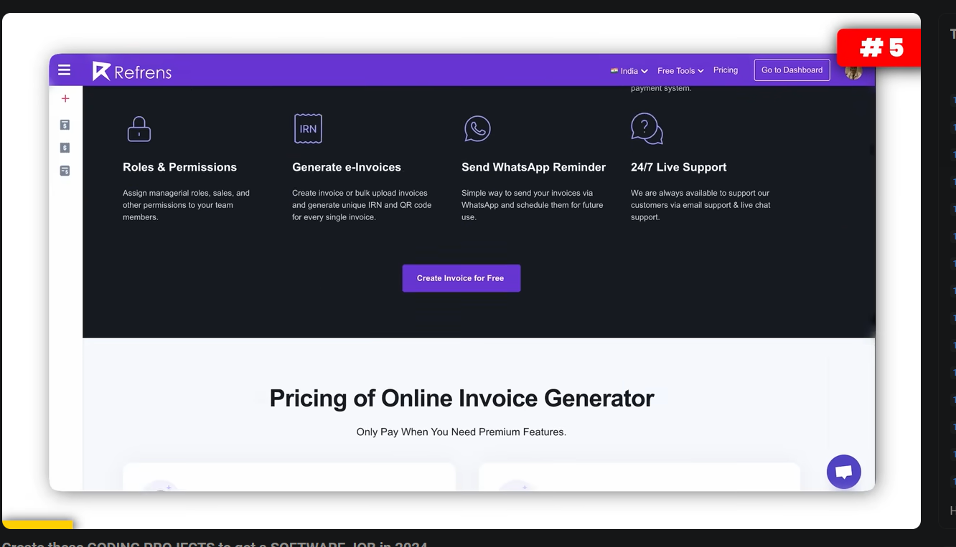

1 image compressor 2 invoice generator 3 coding platform 4 diet tracker 5 online teaching app

**Top 22 AI Project Ideas:**

* [01:07](https://www.youtube.com/watch?v=aMJYwRw6nck&t=67s) - 1. Predict Housing Prices: Use a dataset from the UCI Machine Learning Repository to create a model that predicts Boston house prices. Learn regression models and data analysis.
* [01:27](https://www.youtube.com/watch?v=aMJYwRw6nck&t=87s) - 2. **\*Enron Investigation:\*** Analyze the Enron email dataset for social network analysis or anomaly detection. Practice handling large datasets and uncover hidden patterns.
* [01:47](https://www.youtube.com/watch?v=aMJYwRw6nck&t=107s) - 3. **\*Stock Price Prediction:\*** Use historical stock data to predict future prices. Perfect for understanding time series analysis and improving data handling skills.
* [02:07](https://www.youtube.com/watch?v=aMJYwRw6nck&t=127s) - 4. **\*Customer Recommendation System:\*** Build a system to suggest products using customer browsing data. Learn about collaborative filtering and content-based recommendations.
* [02:27](https://www.youtube.com/watch?v=aMJYwRw6nck&t=147s) - 5. **\*Chatbots:\*** Create a chatbot to dive into natural language processing (NLP). Start with a simple customer service bot and add features gradually.
* [02:47](https://www.youtube.com/watch?v=aMJYwRw6nck&t=167s) - 6. **\*Voice-Based Virtual Assistant for Windows:\*** Create a virtual assistant that can open applications, write messages, and search the web based on voice commands. Integrate speech recognition and NLP.
* [03:06](https://www.youtube.com/watch?v=aMJYwRw6nck&t=186s) - 7. **\*Facial Emotion Recognition and Detection:\*** Build a system using deep learning to detect and interpret human emotions in real-time. Combine computer vision and neural networks.
* [03:22](https://www.youtube.com/watch?v=aMJYwRw6nck&t=202s) - 8. **\*Online Assignment Plagiarism Checker:\*** Develop a tool to check for copied content in assignments. Learn about text mining and similarity detection.
* [03:37](https://www.youtube.com/watch?v=aMJYwRw6nck&t=217s) - 9. **\*Personality Prediction System via CV Analysis:\*** Create software that interprets the personality of a candidate by analyzing their CV. Perfect for those interested in HR tech and NLP.
* [04:24](https://www.youtube.com/watch?v=aMJYwRw6nck&t=264s) - 10. **\*Heart Disease Prediction Project:\*** Use AI for online medical consultation and guidance. Predict heart conditions by analyzing patient data and connect them with specialists.
* [05:01](https://www.youtube.com/watch?v=aMJYwRw6nck&t=301s) - 11. **\*Banking Bot:\*** Build a banking bot for customer queries and transactions. Learn about chatbots and AI in finance. The bot can answer questions and escalate issues to human executives if needed.
* [05:39](https://www.youtube.com/watch?v=aMJYwRw6nck&t=339s) - **Additional Project Ideas:**

12. Differentiate music genres from an audio file. 13. Image reconstruction using an occluded scene. 14. Identify human emotions through pictures. 15. Summarize articles written in technical text. 16. Filter content and identify spam.

* [06:07](https://www.youtube.com/watch?v=aMJYwRw6nck&t=367s) - 17. **\*Fake News Detector:\*** Create a fake news detector using the Real and Fake News dataset from Kaggle. Combat misinformation effectively.
* [06:23](https://www.youtube.com/watch?v=aMJYwRw6nck&t=383s) - 18. **\*Translator App:\*** Build a translator app using transformer models. Perfect for those interested in NLP.
* [06:37](https://www.youtube.com/watch?v=aMJYwRw6nck&t=397s) - 19. **\*Instagram Spam Detection:\*** Develop a spam detection model for Instagram comments using web scraping and algorithms like cosine similarity.
* [06:52](https://www.youtube.com/watch?v=aMJYwRw6nck&t=412s) - 20. **\*Object Detection System:\*** Use computer vision techniques to build a system that identifies and labels objects in an image.
* [07:07](https://www.youtube.com/watch?v=aMJYwRw6nck&t=427s) - 21. **\*Animal Species Prediction:\*** Use the Animals-10 dataset from Kaggle to identify animal species from pictures using multi-class classification techniques.
* [08:02](https://www.youtube.com/watch?v=aMJYwRw6nck&t=482s) - 22. **\*Image to Pencil Sketch App:\*** Create a web application that converts images into pencil sketches using Python and OpenCV.

1. independent thinking {do your own experiment and figure it out] 2. managerial experiments [ you are also a sales guy, get result for company]

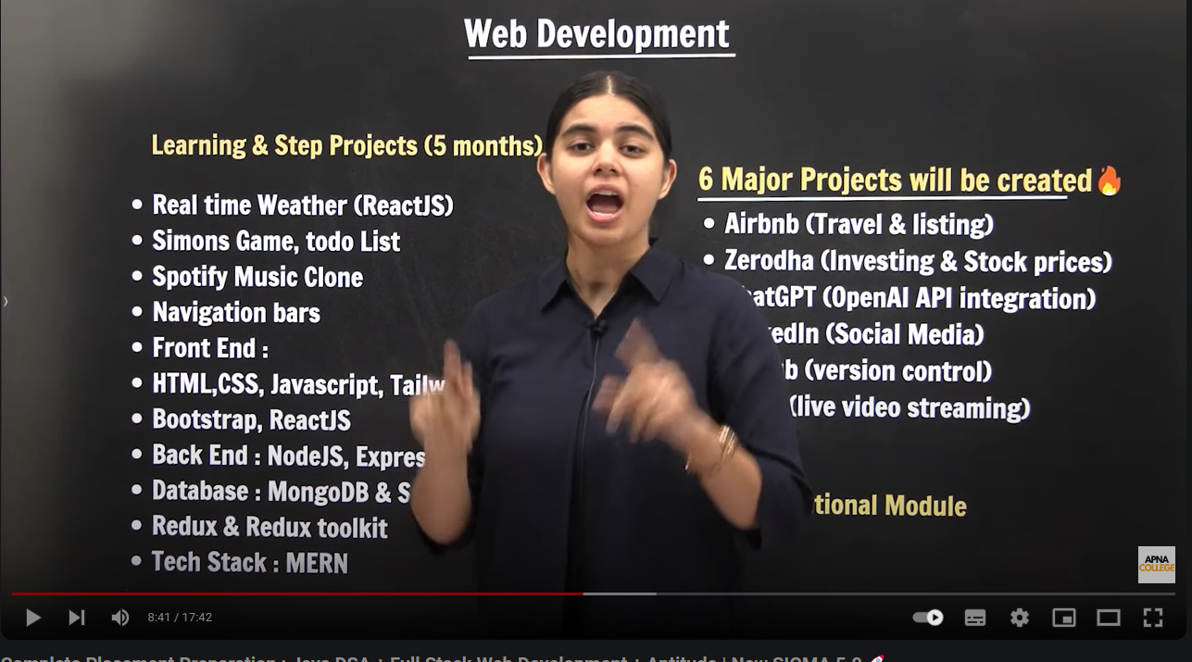

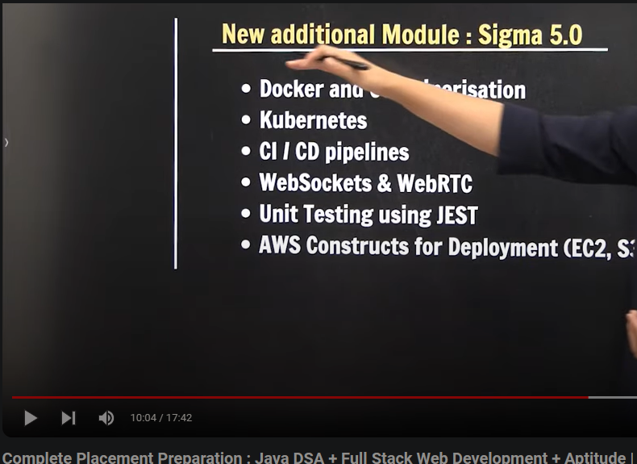

<https://dotnettutorials.net/lesson/modules-in-hotel-booking-application/>

<https://dotnettutorials.net/lesson/e-commerce-real-time-application-using-asp-net-core-web-api/>

<https://youtu.be/4RKuyp_bOhY?si=ydpbmrb2sj6s54uY>

<https://www.youtube.com/watch?v=95ZTxNJIHnY&list=PLp_RsiLZjwQQfPeCuTaozJAgc87MfwH9G>