Game Design Document

Fill up the Following document

1. Write the title of your project.

Ramayana – The Game

1. What is the goal of the game?

To rescue Sita from Ravana and find the virtual Rama of present times.

1. Write a brief story of your game?

The player has to rescue Sita from Ravana, on his way he has to fight monsters/Rakshasas. They will be of different kinds having variety of powers and will die in various ways. Also, the player will get points and power by identifying jadibooti in the jungle. He also has to avoid poisonous fruits.

1. Which are the playing characters of this game?

* Playing characters are the ones which respond to the user based on the input from the user
* Cars, monkeys, dinos, wizards etc, are the playing characters in the game.

|  |  |  |
| --- | --- | --- |
| Number | Character Name | What can this character do? |
| 1 | Rama | Run and fight |
| 2 |  |  |
| 3 |  |  |
| 4 |  |  |
| 5 |  |  |
| 6 |  |  |
| 7 |  |  |
| 8 |  |  |

1. Which are the Non Playing Characters of this game?

* Non Playing characters are the ones which don't have an action or a behaviour when the user interacts with the game.
* Hurdles, stones, bananas, coins, etc are non playing characters in the game.

|  |  |  |
| --- | --- | --- |
| Number | Character Name | What can this character do? |
| 1 | jadibooti | Give points |
| 2 | Poisonous fruits | Reduce power |
| 3 | weapons | Give power |
| 4 |  |  |
| 5 |  |  |
| 6 |  |  |
| 7 |  |  |
| 8 |  |  |

Draw your imagination of this game. What does this game look like?

* Draw the game either on your computer or on paper,
* Add images of scenes of the game to show each of the playing and non-playing characters at least once.

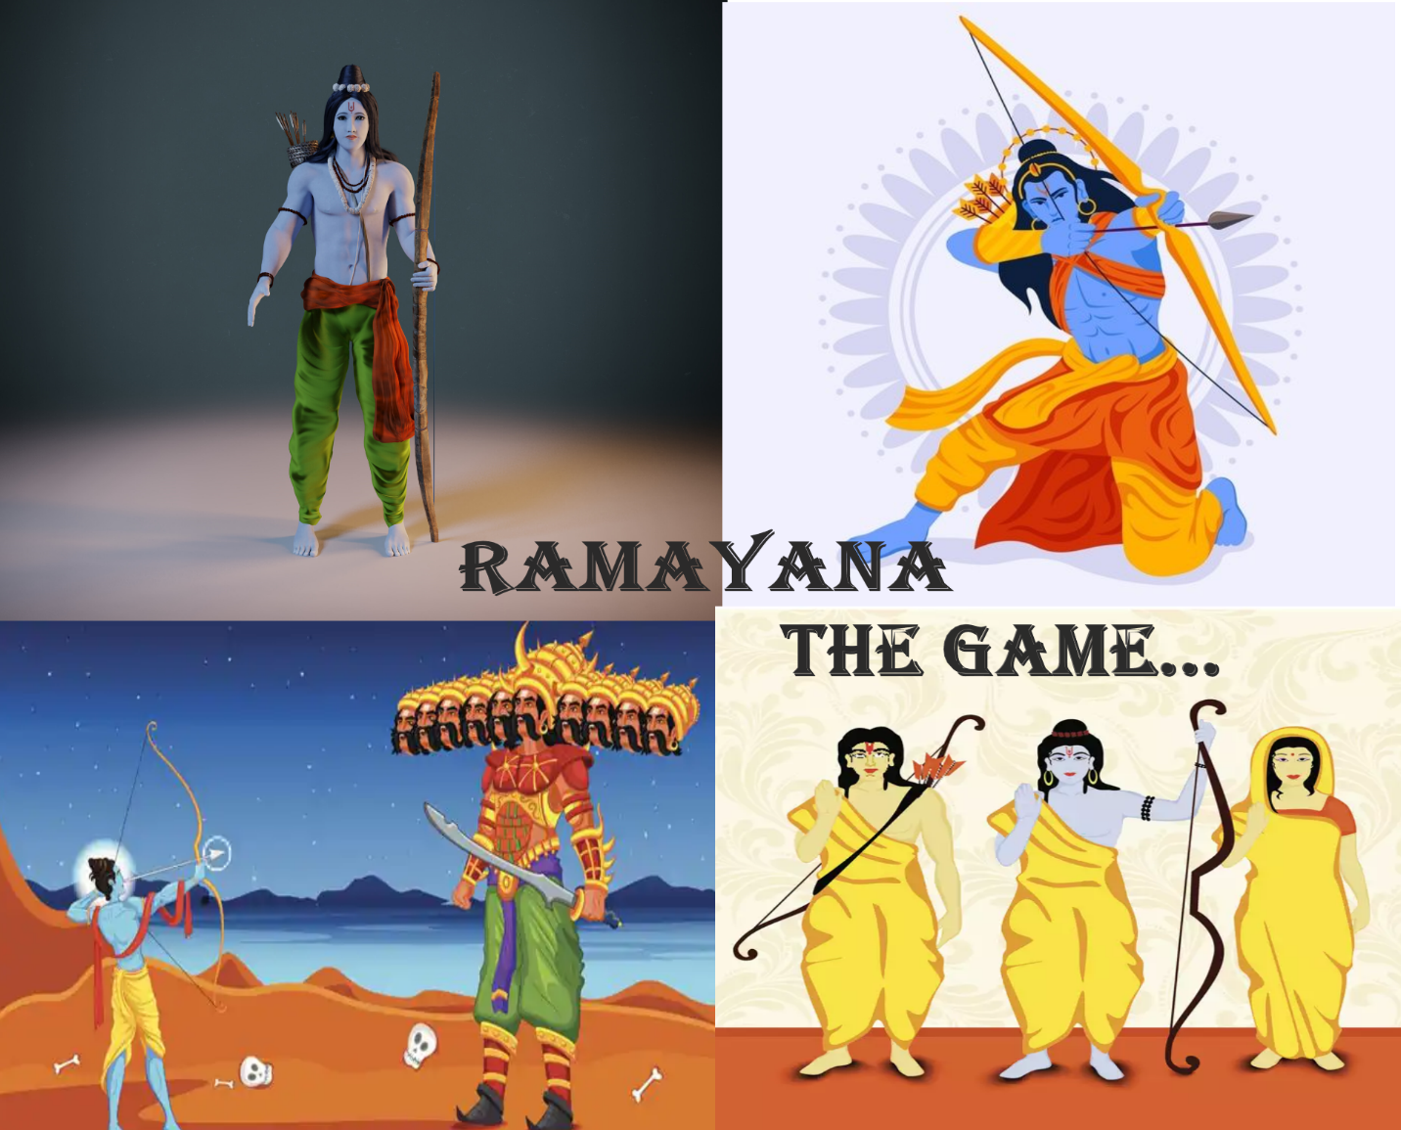

How do you plan to make your game engaging?

I want to devise the game in a way that if different player or the same player takes a different route in jungle, he gets to fight different kind of monsters so that the player is never tired of the game and even if he wins, wants to try other options/route.