**Spring –Jms integration**

**Please go through below steps to work with Spring JMS ActiveMQ .**

Environment Setup:

1. JDK 7/8 2.Spring 4x

3. Maven 4.Apache Active MQ

5. Tomcat 6.JSP /JSTL

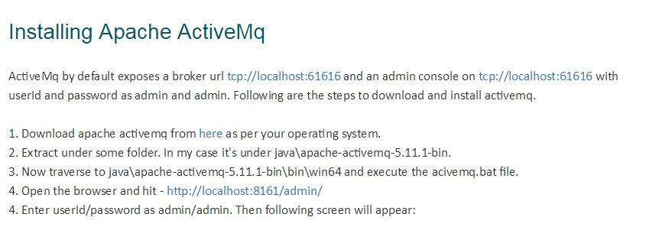

Download Link: <http://activemq.apache.org/activemq-5111-release.html>

After open it looks like below

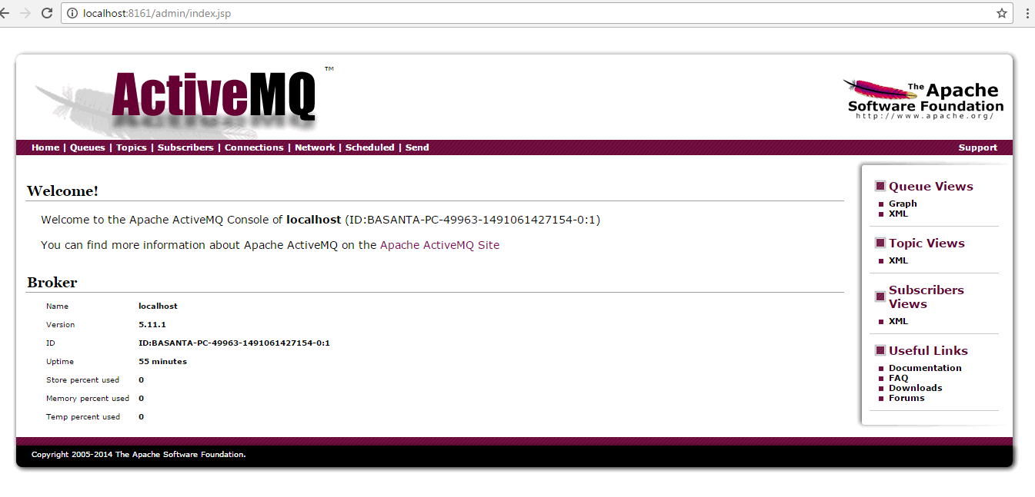

Then click on queue field top left one

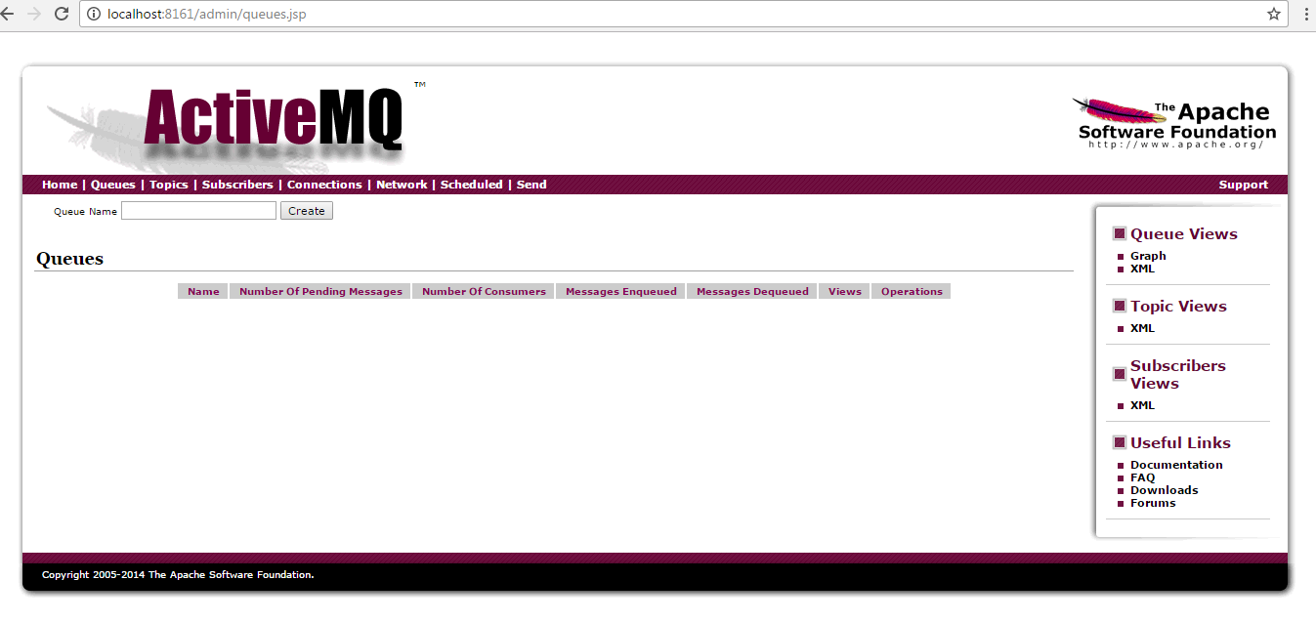

Now there is no queue generated still. So now run your provider/sender service and then again refresh this <http://localhost:8161/admin/queues.jsp> page.

After run my application

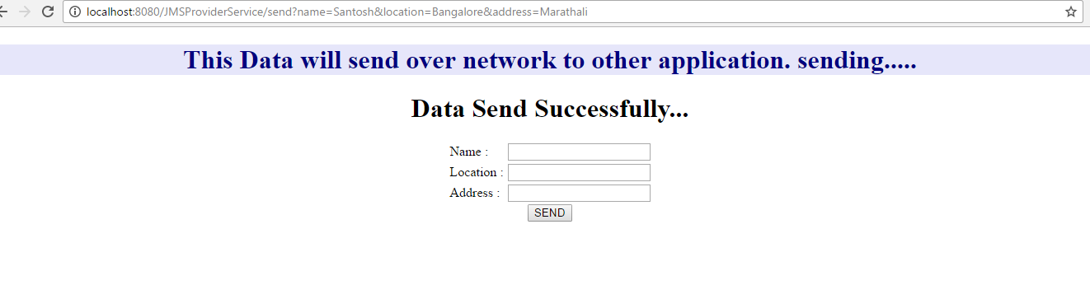

Now let’s check whether queue generated or not

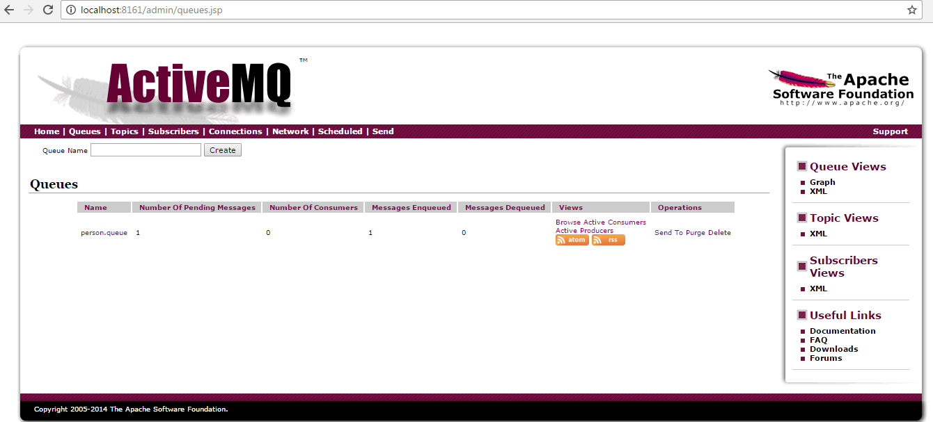

Check queue is generated now go to receiver service and check data is send or not..

Thanks..Please gone through code u will know..