班级 NZ231 姓名 苏鹏睿 学号 237007

实验一 The Harpe Gaming Store Website

- 实验目的
Samantha Goro is the owner of Harpe Gaming, a small board game store in Palmerston North, Manawatu. You have been asked to work on the store’s new website, Samantha wants you to write the HTML5 code for the store’s home page. Samantha also publishes reviews of new games as a service to her loyal customers. She would also like you to write the HTML5 code for two new reviews that she has written for the Towers and Temple game and the Alliance game. Samantha has already written all the content for the three pages and only requires your help to turn them into HTML5 documents.
- 实验内容
The Final Web Pages ：
index.html
hg_towers.html
hg_alliance.html
三、实验结果
index.html
<!DOCTYPE html>
<html>
<head>
<!--
Name: Pengrui Su
Date: 2025-09-21
Purpose: this web page is for store's home page
-->
<meta charset="utf_8">
<title>HARPE GAMING HOME PAGE</title>
<meta name="keywords" content="Home,Towers and Temples,Aliance">
</head>
<body>
<header>
<h1>&copy;HARPE GAMING HOME PAGE</h1>
<hr>
</header>
<img src="hg_logo.png"alt="there should be a logo">
<br>
<ul>
<li><a href="index.html">Home</a></li>
<li><a href="hg_towers.html">Towers and Temples</a></li>
<li><a href="hg_alliance.html">Alliance</a></li>
</ul>
<p>Welcome to <strong>Harpe Gaming</strong>. We have a simple philosophy. It has three main points:</p>
<ul>
<li>Unplug</li>
<li>Interact</li>
<li>Reconnect</li>
</ul>
<article>
<p>And that's it. We believe that the best games are the ones
that bring people together through shared experiences. With
all due respect to our video gamer friends, you can't always get
that from a computer screen. Sometimes you need the
intimate approach of sitting face-to-face around
a common table with the soda and chips at your elbow.
</p>
<br>
<p>We are a local board and card game store located in the
heart of Morgantown near the campus. We carry
hundreds of games and puzzles, including educational games, family games, card games, historical
simulations, role-playing games, and so much more.
If you remember a great game from your youth, we
probably have it in our antiques collection. If we don't, we know where we can get it.
</p>
<br>
<p>We're more than just a place to buy games. We celebrate
gaming and the company of good friends.
Our game room is free for all to us. Sit down, pick out
a game from our demo library and start playing.
We sponsor tournaments, challenges, and special
social events. You'll always find a game to play.
</p>
<br>
<p>We're always on the lookout for the best new games. We
publish periodic reviews of new titles. Just out
our reviews of <a href="hg_towers.html">Towers and Temples</a> and <a href="hg_alliance.html">Alliance</a>; both
new this month at Harpe Gaming.</p>
</article>
<br>
<aside>
<p>Questions? Contact us at:</p>
<a href="mailto:3191375717@qq.com">3191375717@qq.com</a>
<br>
<p>or call us at:</p>
<a href="tel:15530301652">15530301652</a>
<P>Our web:</P>
<a href="file:///D:/three%20on/Wang/01-harpe-gaming/index.html">file:///D:/three%20on/Wang/01-harpe-gaming/index.html</a>
</aside>
<hr>
<footer>
<p>&copy;Harpe Gaming * 785 Chester Avenue * Morgantown, WV 26502</p>
</footer>
</body>
</html>
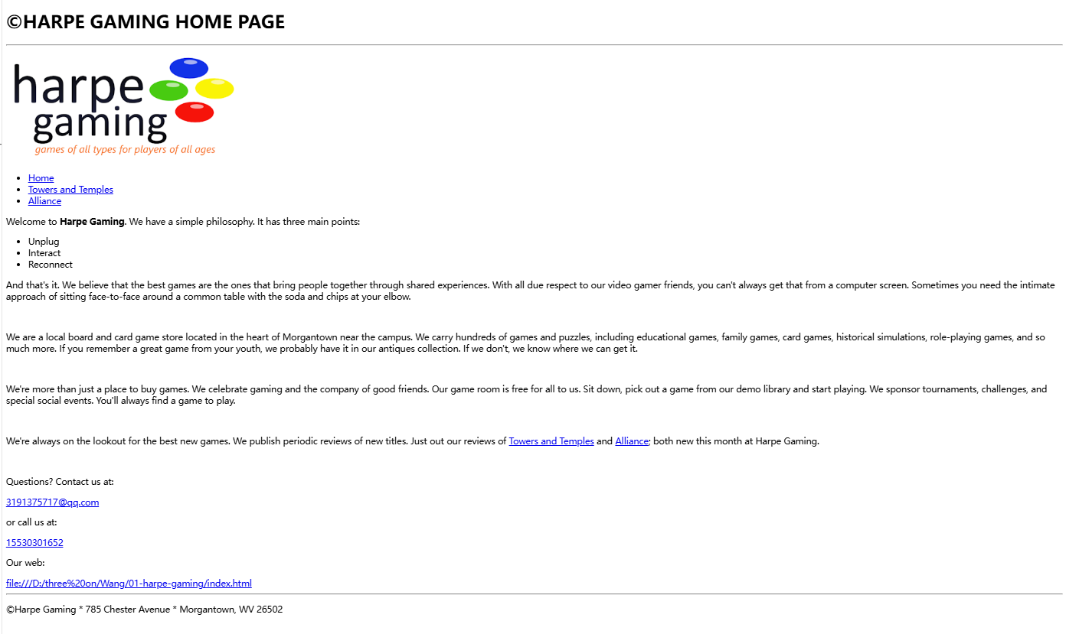hg_towers.html
<!DOCTYPE html>
<html>
<head>
<!--
Name: Pengrui Su
Date: 2025-09-21
Purpose: this web page is for towers and temples page
-->
<meta charset="utf_8">
<title>TOWERS AND TEMPLES PAGE</title>
<meta name="keywords" content="Home,Towers and Temples,Aliance">
</head>
<body>
<header>
<h1>&copy;TOWERS AND TEMPLES PAGE</h1>
<hr>
</header>
<img src="hg_logo.png"alt="there should be a logo">
<br>
<ul>
<li><a href="index.html">Home</a></li>
<li><a href="hg_towers.html">Towers and Temples</a></li>
<li><a href="hg_alliance.html">Alliance</a></li>
</ul>
<img src="hg_towers.png"alt="there should be a picture about towers and temples">
<br>
<section>
<h1>Review of Towers and Temples</h1>
<p>Game ID:<br>&nbsp;&nbsp;&nbsp;&nbsp;&nbsp;&nbsp;&nbsp;&nbsp;&nbsp;&nbsp;bg210</p>
<p>List Price:<br>&nbsp;&nbsp;&nbsp;&nbsp;&nbsp;&nbsp;&nbsp;&nbsp;&nbsp;&nbsp;$17.73</p>
<p>Media<br>&nbsp;&nbsp;&nbsp;&nbsp;&nbsp;&nbsp;&nbsp;&nbsp;&nbsp;&nbsp;Board Game</p>
<p>Release Date:<br>&nbsp;&nbsp;&nbsp;&nbsp;&nbsp;&nbsp;&nbsp;&nbsp;&nbsp;&nbsp;October 21, 2017</p>
<p>Age:<br>&nbsp;&nbsp;&nbsp;&nbsp;&nbsp;&nbsp;&nbsp;&nbsp;&nbsp;&nbsp;10+</p>
<p>Players:<br>&nbsp;&nbsp;&nbsp;&nbsp;&nbsp;&nbsp;&nbsp;&nbsp;&nbsp;&nbsp;2 - 8</p>
<p>Time:<br>&nbsp;&nbsp;&nbsp;&nbsp;&nbsp;&nbsp;&nbsp;&nbsp;&nbsp;&nbsp;30 - 60 minutes</p>
</section>
<section>
<h1>Rule an Ancient City</h1>
<br>
<p><strong>Towers and Temples</strong> is the winner of the 2017 Palmer
Medal for Best New Simulation Board Game.
Players adopt role cards of characters from ancient
Greece and Rome in an attempt to manage
the administration of a city. Each role provides
a different ability and strategy. However,
one role card belongs to a deadly assassin and players
must be constantly aware of betrayal
and double-cross. This card game provides a ton
of enjoyment and can handle up to eight players
and expansion packs available for larger parties.
</p>
<br>
<p>This is a nicely balanced game, where each player must
carefully choose his or her roles and
the strategies can quickly change with the turn
of a card. However the level of randomness is
just right and cunning and resourcefulness can
overcome bad luck (if given time.) I do not
recommend this game unless there are at least 4
players; less than that reduces the intrigue
and some of the game appeal.
</p>
<ul>
<li>Entertainment (8/10)</li>
<li>Strategy (9/10)</li>
<li>Innovation (7/10)</li>
<li>Art Work (6/10)</li>
<li>Community Enjoyment (10/10)</li>
<li>Ease of Set Up (9/10)</li>
<li>Play Again (10/10)</li>
<li>OVERALL (8.43/10)</li>
</section>
<blockquote>
<section>
<h1>Highly Recommended</h1>
<br>
<p>Towers and Temples is a great game. The balance is
just about perfect and each player must
carefully choose roles each turn. Even though the
strategic possibilities are nearly endless,
the game is simple to learn. The replay value is
high and gets even better when you replace
some of the cards with new cards available in the
expansion packs.
</p>
<p>Rating: 4.5 / 5</p>
<a href="http://www.example.com/bgreview"><em>Board Game Review</em> </a>
</section>
<br>
<section>
<h1>Great Strategic Board Game</h1>
<br>
<p>We tested Towers and Temples with everything from 2
to 6 players and we can strongly
recommend the game. The different phases of the
game are interesting and intriguing, from
bluffing and stealing to site construction and planning.
With the variety of cards and
scenarios, no two games are ever quite the same. It's
a great introduction to the world of
strategic board games and role playing.
</p>
<p>Rating: 5 / 5</p>
<a href="http://www.example.com/gamersshop"><em>Gamers Shop</em></a>
<br>
</section>
<section>
<h1>An Incredible Game</h1>
<br>
<p>The artwork on the cards and the board is excellent
and one of the best around. As
for play, this game offers lots of strategy, and there
are tough decisions to make every
turn. It's not only important to select the character
that increases your chances for scoring,
but also to anticipate the characters the opponents
are likely to select, and then hedge against
their availability. This causes a lot of unpredictability
and deep strategic thinking. However,
it can still be played at a more basic level for
younger users.
</p>
<p>We had a lot of fun with this game and rate it as
<em>Best in its Class.</em> Highly recommended.</p>
<p>Rating: 10 / 10</p>
<a href="http://www.example.com/tacticstrials"><em>Tactics and Trials</em></a>
<br>
</ul>
</section>
</blockquote>
<hr>
<footer>
<p>&copy;Harpe Gaming * 785 Chester Avenue * Morgantown, WV 26502</p>
</footer>
</body>
</html>
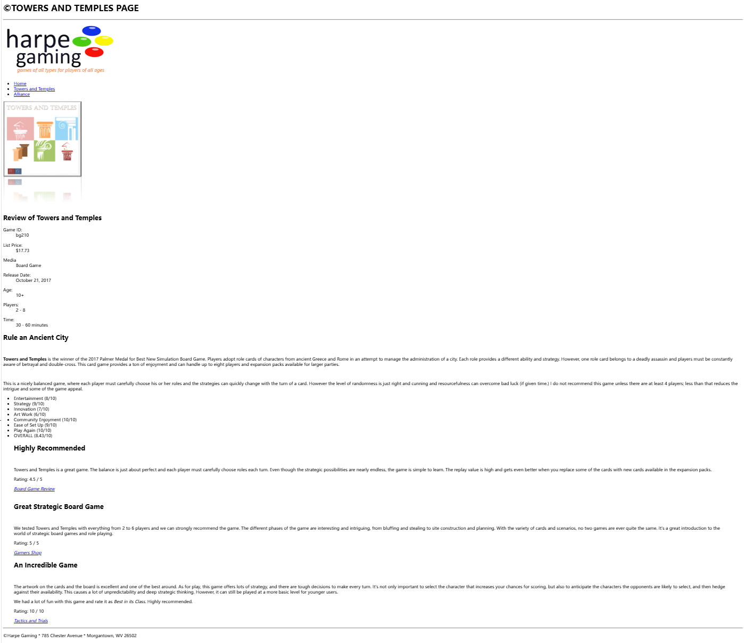
hg_alliance.html

<!DOCTYPE html>
<html>
<head>
<!--
Name: Pengrui Su
Date: 2025-09-21
Purpose: this web page is for alliance page
-->
<meta charset="utf_8">
<title>ALLIANCE PAGE</title>
<meta name="keywords" content="Home,Towers and Temples,Aliance">
</head>
<body>
<header>
<h1>&copy;ALLIANCE PAGE</h1>
<hr>
</header>
<img src="hg_logo.png"alt="there should be a logo">
<br>
<ul>
<li><a href="index.html">Home</a></li>
<li><a href="hg_towers.html">Towers and Temples</a></li>
<li><a href="hg_alliance.html">Alliance</a></li>
<meta name="keywords" content="Review of Alliance,Decide the Fate of the World,Tedious and Confusing,Decent Game but Many are Better,Fun and Challenging">
</ul>
<img src="hg_alliance.png"alt="there should be a picture about Alliance">
<section>
<h1>Review of Alliance</h1>
<p>Game ID:<br>&nbsp;&nbsp;&nbsp;&nbsp;&nbsp;&nbsp;&nbsp;&nbsp;&nbsp;&nbsp;bg210</p>
<p>List Price:<br>&nbsp;&nbsp;&nbsp;&nbsp;&nbsp;&nbsp;&nbsp;&nbsp;&nbsp;&nbsp;$22.15</p>
<p>Media<br>&nbsp;&nbsp;&nbsp;&nbsp;&nbsp;&nbsp;&nbsp;&nbsp;&nbsp;&nbsp;Board Game</p>
<p>Release Date:<br>&nbsp;&nbsp;&nbsp;&nbsp;&nbsp;&nbsp;&nbsp;&nbsp;&nbsp;&nbsp;September 14, 2017</p>
<p>Age:<br>&nbsp;&nbsp;&nbsp;&nbsp;&nbsp;&nbsp;&nbsp;&nbsp;&nbsp;&nbsp;12+</p>
<p>Players:<br>&nbsp;&nbsp;&nbsp;&nbsp;&nbsp;&nbsp;&nbsp;&nbsp;&nbsp;&nbsp;2 - 6</p>
<p>Time:<br>&nbsp;&nbsp;&nbsp;&nbsp;&nbsp;&nbsp;&nbsp;&nbsp;&nbsp;&nbsp;60 - 120 minutes</p>
</section>
<section>
<h1>Decide the Fate of the World</h1>
<p>The world is at war.<strong>Alliance </strong>challenges you and your opponents to decide
the outcome. As one of the world powers
battling for supremacy you must lead your country's
military drive; but you can't do it alone.
You have to form alliances and then betray your
allies before they betray you!</p>
<p>Decide where to strike, when to strike, and the intensity
of the strike. Will it be a bombing
raid, an offshore missile barrage, or an invasion
with land forces and tanks? Plan your attack,
move into enemy territory with your forces and win
the conflict.</p>
<p>The economic destiny of your nation is also at stake.
Buy armaments and develop secret
weapons from your country's economic funds and
natural reserves, but be sure to save
something for the future.</p>
<ul>
<li>Entertainment (7/10)</li>
<li>Strategy (10/10)</li>
<li>Innovation (6/10)</li>
<li>Art Work (5/10)</li>
<li>Community Enjoyment (8/10)</li>
<li>Ease of Set Up (7/10)</li>
<li>Play Again (5/10)</li>
<li>OVERALL (6.86/10)</li>
</section>
<blockquote>
<section>
<h1>Tedious and Confusing</h1>
<p>The list of war simulation games is long. All of them
share similar features including the
formation of temporary Alliance and battles simulated
through random draws of a deck or the
roll of the die. <em>Alliance</em> offers very little that
is new or innovative in that regard.</p>
<p>We found the game to be too drawn-out and confusing.
In fact, I dare say we spent more time
reading and rereading the rule book than actually
playing the game. If you want to read a
book on war, we suggest Sun Tzu.</p>
<p>Rating: 1 / 5</p>
<a href="http://www.example.com/bgreview"><em>Board Game Review</em></a>
</section>
<section>
<h1>Decent Game but Many are Better</h1>
<p><em>Alliance</em> is a good war simulation game. We found the
game play to be robust and engaging. The
rules are long and drawn out but, for anyone with
experience in this class of board games, there
is little there that's unexpected or difficult. We
think the battle simulation cards are some of
the best we have encountered.</p>
<p>All of that being said, the competition for this type
of game is fierce. There are a lot of
established titles with loyal clients. We're not
exactly sure where <em>Alliance</em> fits in with
that group. It's a good game, but not good enough
to draw our attention away from games like
<em>Battle Tested </em>and <em>Global Conflict</em>.</p>
<p>Rating: 7 / 10</p>
<a href="http://www.example.com/tacticstrials"><em>Tactics and Trials</em></a>
</section>
<section>
<h1>Fun and Challenging</h1>
<p><em>Alliance</em> is fun game and is sure to appeal to
war game enthusiasts. We think it offers several new
ideas that we're surprised have not been utilized in other simulation games. The card system and the
investment options give the game a "real world" feel.</p>
<p>Things We Liked</p>
<ul>
<li>Variety of Battle Scenarios</li>
<li>Flexible Rules and Setup</li>
<li>Detail and Historical Accuracy</li>
<li>Wealth of Expansion Packs</li>
</ul>
<p>Things We Hated</p>
<ul>
<li>Long and Complicated Rule Book</li>
<li>Setup takes too Long</li>
</ul>
<p>This is a great game for anyone 16 years or older. Younger players may have trouble with the rules and may be bored</p>
<p>Rating: 4 / 5</p>
<a href="http://www.example.com/leisureroom"><em>Leisure Room Gamers</em></a>
</ul>
</section>
</blockquote>
<hr>
<footer>
<p>&copy;Harpe Gaming * 785 Chester Avenue * Morgantown, WV 26502</p>
</footer>
</body>
</html>
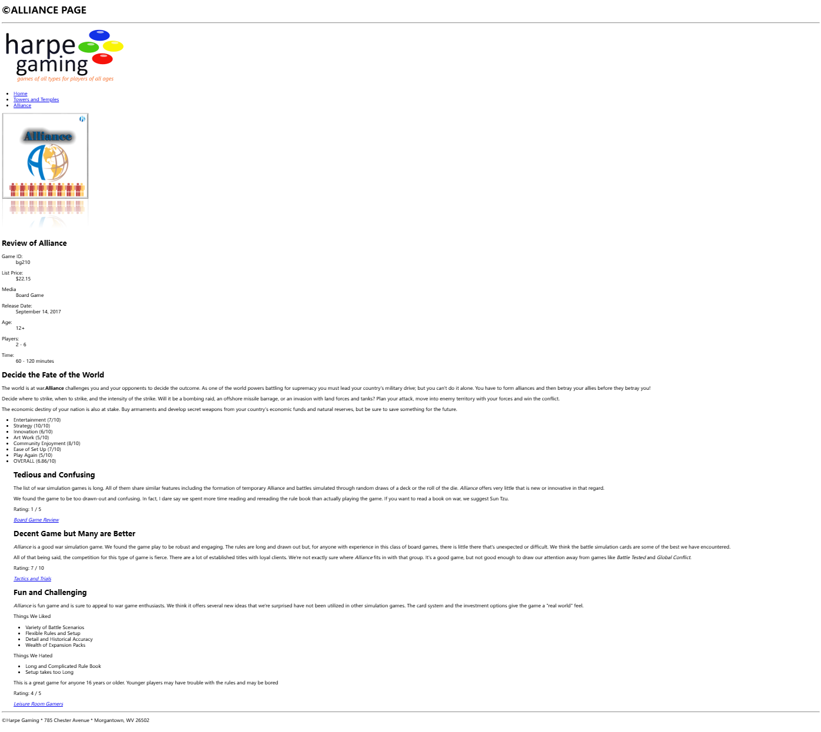
GithubURL:https://github.com/Spring24009388/weblab1.git

