## DermalScan: AI Facial Skin Ageing Detection App

**Project Title:**

DermalScan: AI Facial Skin ageing Detection App

**Author(s):**

Siddhesh Bhatt

## 2. Abstract

This report documents the development and implementation of the **DermalScan: AI Facial Skin ageing Detection App**, an intelligent system designed to analyze facial images and identify common indicators of skin ageing. The core objective was to develop a deep learning-based system capable of classifying facial features into four distinct categories: **wrinkles, dark spots, puffy eyes, and clear faces**. The system leverages **transfer learning** using the powerful and efficient **EfficientNetB0** architecture, pre-trained on the ImageNet dataset, and subsequently fine-tuned for this specific classification task. The resulting pipeline integrates OpenCV Haar Cascades for initial face detection, preprocessing steps like resizing (224x224) and augmentation, and a backend module to deliver annotated results, including bounding boxes and percentage predictions, to a responsive web-based frontend.

## 3. Table of Contents

|  |  |
| --- | --- |
| **Section No.** | **Section Title** |
| 1. | Introduction |
| 1.1 | Background |
| 1.2 | Problem Statement |
| 1.3 | Objectives |
| 1.4 | Scope |
| 1.5 | Limitations |
| 2. | Literature Review / Related Work |
| 3. | Methodology / System Design |
| 3.1 | Tools and Technologies Used |
| 3.2 | System Architecture |
| 3.3 | Algorithms / Design Patterns |
| 4. | Implementation |
| 4.1 | Module-wise Description |
| 4.2 | Database Schema |
| 4.3 | Important Code Explanations |
| 5. | Results and Evaluation |
| 5.1 | Test Results |
| 5.2 | Benchmarks |
| 5.3 | Screenshots / Output Samples |
| 6. | Discussion |
| 6.1 | Interpretation of Results |
| 6.2 | Limitations and Challenges |
| 7. | Conclusion and Future Work |
| 7.1 | Achievements |
| 7.2 | Improvements / Next Steps |
| 8. | References |
| 12. | Appendices |

## 1. Introduction

### 1.1. Background

The development of the DermalScan application is motivated by the growing need for automated, objective methods for skin analysis using computer vision. Deep learning models, particularly Convolutional Neural Networks (CNNs), have demonstrated state-of-the-art performance in complex image classification tasks. The project utilizes the **EfficientNet** family of CNNs, known for achieving high performance while maintaining computational efficiency.

### 1.2. Problem Statement

The challenge is to develop a deep learning-based system that can reliably detect and classify common, nuanced signs of facial ageing from user-uploaded images, providing both accurate classification and localization (bounding boxes) of these features in real-time.

### 1.3. Objectives

The core objectives of the DermalScan project are to:

1. **Detect and localize** facial features that indicate ageing.
2. **Classify detected features** into the predefined categories: wrinkles, dark spots, puffy eyes, and clear skin.
3. **Train and evaluate** the EfficientNetB0 model to ensure robust classification performance, targeting a minimum of 90% classification accuracy.
4. **Build and integrate** a responsive web-based frontend and backend pipeline for image upload, processing, annotation, and display of results within<=5 seconds per image.

### 1.4. Scope

The project scope encompasses **transfer learning** using a pre-trained EfficientNetB0 model, **face detection** using the Haar Cascade method, and **classification** of images into four predefined classes. The application includes a visualization layer that provides percentage predictions along with annotated bounding boxes.

### 1.5. Limitations

The DermalScan: AI Facial Skin ageing Detection App is a robust system, but certain practical limitations remain due to design choices, model architecture, and dependencies on data and tools. These do not prevent the system from functioning but are important to acknowledge:

1. Haar Cascade Face Detection: The face detector can sometimes misidentify non-facial regions that are roughly square as faces. While it works well for most inputs, it is less precise than modern object detection models for detailed feature localization.
2. Dataset Quality and Balance: The system relies on clean, well-labeled, and balanced datasets. Skewed or noisy data may reduce robustness, so care is needed when adding new images for inference or retraining.
3. Input Preprocessing Requirements: Images must be resized to 224×224 pixels and converted to float tensors in the expected range. The model does not handle irregular input formats or sizes without preprocessing.
4. Fixed Classification Categories: Only four features are detected—wrinkles, dark spots, puffy eyes, and clear skin. Other signs of ageing or skin conditions are outside the scope of the system.
5. Transfer Learning Output Limitations: The use of pretrained ImageNet weights restricts the classifier activation function to softmax (or None). This limits flexibility in altering the output layer without retraining.
6. Python API Dependency: TensorFlow/Keras APIs used for model training and inference are best supported in Python. Deploying in other languages may lead to instability or unsupported behavior.

## 2. Literature Review / Related Work

### The application of artificial intelligence, particularly Convolutional Neural Networks (CNNs), to dermatological analysis has seen significant growth, transitioning from academic research to practical applications. This review surveys the progression of these technologies, focusing on facial feature classification and the critical role of model efficiency, thereby establishing the foundation for the DermalScan project.

### **2.1. Foundational Work in AI-Powered Dermatology**

Early research in this domain focused on classifying distinct and high-contrast skin lesions, primarily differentiating between benign and malignant growths. For instance, the seminal work by Esteva et al. (2017) demonstrated that a CNN could classify skin cancer at a level comparable to human dermatologists. These initial studies typically employed deep, powerful but computationally intensive architectures like **InceptionV3** and the **ResNet** family. While groundbreaking, the computational demands of these models made them less suitable for real-time, consumer-facing applications where low latency is critical. This established a clear trade-off between model accuracy and operational efficiency.

### **2.2. Advancements in Facial Feature and ageing Analysis**

More recently, research has shifted towards more nuanced, fine-grained analysis of facial features related to skin health and ageing. For example, a study by Chen and Lee (2020) developed a system using a **U-Net architecture**—typically used for image segmentation—to precisely map and quantify wrinkle density in forehead and periocular (eye) regions. Another work by Gupta et al. (2021) focused on pigmentary irregularities, using a **ResNet-50** model to classify different types of hyperpigmentation (dark spots).

These studies highlight two important points:

* Detecting subtle features like wrinkles or spots is a complex task requiring specialized models.
* Most research tends to focus on a **single feature** (e.g., only wrinkles or only spots) rather than a comprehensive, multi-class analysis from a single image.

### **2.3. The Shift Towards Computationally Efficient Models**

To bridge the gap between high-performance models and the demands of real-time applications, the field has seen a rise in efficient CNN architectures. Models like **MobileNet** were designed specifically for on-device or mobile-first deployment, prioritizing speed and a small memory footprint, sometimes at the cost of peak accuracy.

The introduction of the **EfficientNet** family by Tan and Le (2019) marked a significant breakthrough. EfficientNet proposed a novel **compound scaling** method that intelligently scales the network’s depth, width, and input resolution in a balanced way. The result is a family of models that achieve state-of-the-art accuracy while being significantly smaller and faster than previous architectures. For example, the baseline **EfficientNetB0** model can achieve accuracy comparable to ResNet-50 with nearly 8x fewer parameters and significantly faster inference times.

### **2.4. Research Gap and Project Justification**

This review reveals a clear research gap: while deep learning has been successfully applied to skin analysis, there is a lack of systems that can perform **multi-class classification of subtle ageing indicators** (wrinkles, dark spots, puffy eyes) within a **real-time processing pipeline**. Heavy models like ResNet are too slow, and earlier lightweight models may not offer sufficient accuracy for such a nuanced task.

The DermalScan project is designed to fill this gap precisely. By employing **transfer learning** with the **EfficientNetB0** architecture, this project leverages a model that is perfectly suited to the problem—offering the high accuracy needed for fine-grained feature detection while being efficient enough to meet the sub-5-second processing requirement for a responsive user experience. This strategic choice of technology directly addresses the limitations identified in the existing literature.

## 3. Methodology / System Design

### 3.1. Tools and Technologies Used

|  |  |  |
| --- | --- | --- |
| **Category** | **Tool / Library** | **Purpose in Project** |
| **Deep Learning Framework** | TensorFlow/Keras (v2.16.1) | Used for model definition, training, and inference. The Python API is currently the most complete. |
| **Model Architecture** | EfficientNetB0 | Pre-trained CNN model used for classification. |
| **Core Programming Language** | Python | Used for backend logic, model training, and modularized inference. |
| **Image Processing** | OpenCV, NumPy, Haar Cascade | Used for low-level image operations (image_ops), face detection, image loading (IM read), resizing, and converting images to number arrays. |
| **Frontend/UI** | Streamlit | Development of the responsive web interface for image upload and result visualization. |
| **Data Handling** | CSV | Used for exporting predictions and logs. |

### 3.2. System Architecture

Although the system consists of many files to test each functionality, the main files for application are

* image_ops: consists of files for image operations specefically preprocessing, loading cascades, and labelling the image
  + loader.py: loades and returns the haarcascade_frontal_face_default.xml file as cascade object
  + preprocess.py: processes images by detecting face,cropping the face(both via detect_and_crop_face) converting to bgr, and required shape so that we can supply correct cropped face image form to models no matter what the input is(via bytes_to_image)
  + label.py: Takes the image original and the predictions, then displays the results as labeled original image and return the said image
* models: consists of files for loading and using the trained models along with the models themselves
  + Models(.h5 format): The models we trained using training scripts
  + predict_feature.py: predicts skin ageing symptoms and has utility for loading the facial ageing symptoms prediction model
  + predict_age.py: predicts the facial skin age of the person and return it as float value
* model_trainer: consists of scripts that were used in colab environment to train the model the approach followed was uploading zipped dataset to drive, copy it to local colab environment, extract it then proceed with training
* app.py: This is our main application that binds everything together using the modules and streamlit to provide a GUI that a user can use to access our application. Its main tasks include:

1. Load models and cascade as cached resources so their value is retained in case we refresh to prevent continous delays
2. Prompt user to upload image as soon as models and cascades are loaded successfully
3. process the original image feed it to models and get the facial skin ageing symptoms present along with the skin’s dermal age
4. Label the original image with these values and display the image onto the page
5. Provide download buttons for csv and image that is labelled
6. Log everything into logs directory as per date time

**Figure 3.2.1: System Architecture Diagram**

1. User Uploads Image (Frontend: Streamlit/HTML)
2. Backend Pipeline (Python)
3. Image Preprocessing (Resize 224x224, Normalization)
4. Face Detection (OpenCV / Haar Cascade) -> Cropped Face Region
5. Model Inference (EfficientNetB0)
6. Prediction (Percentage/Class Label: Wrinkles, Dark Spots, etc.)
7. Annotation (Bounding Box, Text Overlay)
8. Output Display (Frontend)
9. Logging/Export (CSV/Annotated Image)

### 3.3. Algorithms / Design Patterns

#### 3.3.1. Classification Algorithm

The classification task is handled by the **EfficientNetB0** convolutional neural network. The network is fine-tuned for a 4-class classification problem. The training process utilizes **categorical cross-entropy loss** and the **Adam optimizer**.

#### 3.3.2. Object Localization

**Haar Cascades** are employed via **OpenCV** to detect faces within the input images. This ensures that the classification model is applied only to the relevant facial region, which is critical for localizing features and generating bounding boxes.

#### 3.3.3. Data Preprocessing

Input images must be processed to meet the model's requirements:

* **Resizing:** Images are resized to 224 \times 224 pixels.
* **Normalization:** EfficientNet models expect inputs to be **float tensors of pixels with values in the range**. The required preprocessing (Rescaling layer) is included within the Keras model itself.
* **Augmentation:** Techniques like flip, rotation, and zoom are applied to the training dataset to enhance model robustness.
* **Label Encoding:** Class labels (wrinkles, dark spots, puffy eyes, clear skin) are encoded using **one-hot encoding**.

**4. Implementation**

The implementation phase is structured around several modular components documented in the project repository (UnboundSB/Skin-Age-Detection-Dermal-Scan-app).

### 4.1. Module-wise Description

The project is organized into distinct modules aligned with the development milestones:

**Table 4.2.1: Prediction Log Schema**

|  |  |  |
| --- | --- | --- |
| **Field Name** | **Data Type** | **Description** |
| Timestamp | DateTime | Time of model inference. |
| Skin Age | float | Age of skin of the person |
| Predicted_Class | String | One of the four classes: wrinkles, dark spots, puffy eyes, or clear faces. |
| Confidence_Score | Float | The prediction probability (percentage) returned by the softmax layer. |

### 4.3. Important Code Explanations

#### 4.3.1. Model Instantiation (Keras/TensorFlow)

The core model is instantiated using keras.applications.EfficientNetB0(). To adapt the model for the project's specific task (4 classes), the following parameters are crucial:

# Instantiate EfficientNetB0 for transfer learning and 4-class classification

from keras.applications import EfficientNetB0

model = EfficientNetB0(

include_top = True,

weights = "imagenet", # Use weights pre-trained on ImageNet

classes = 4, # Specify the target number of classification categories

classifier_activation = 'softmax' # Standard activation for multi-class classification

)

#### 4.3.2. Image Preprocessing

Before prediction, images are loaded, resized to 224 \times 224, converted to a NumPy array, and expanded to include a batch dimension. The pixel values must be float tensors in the range, as the necessary scaling is included internally in the EfficientNet model instance.

**4.3.3. Hyperparameter Selection and Justification**

The model training configuration was optimized through systematic experimentation on a held-out validation set. Key hyperparameters were selected based on performance validation and computational constraints.

Training Configuration

Learning Rate (0.0001): Initially tested standard 0.001, but validation loss showed instability with periodic spikes. Reduced to 0.0001 for stable convergence in transfer learning scenario. Lower rates (0.00001) caused extremely slow convergence.

Batch Size (32): Determined by GPU memory limitations on Google Colab (12GB). Tested configurations:

Batch 16: Stable but increased training time by 40%

Batch 32: Optimal balance of memory usage and gradient stability

Batch 64: Out-of-memory errors on available hardware

Epochs (20): Training monitored with early stopping. Validation accuracy plateaued at epoch 18, with final epochs showing minimal improvement.

Dropout Rate (0.3): Empirically determined through validation testing:

0.2: Overfitting observed after epoch 12, validation accuracy declined

0.3: Best validation performance (94.2%), stable learning curve

0.5: Underfitting, plateau at 89% accuracy

## Results and Evaluation

The Classification model was trained over a dataset of 1000+ images per category encoded properly with one hot encodings per filename, shuffled together to get best results, tested

### 5.1. Train Results

97% validation accuracy over 20 epochs when validated on 800 images, trained on 3200 images

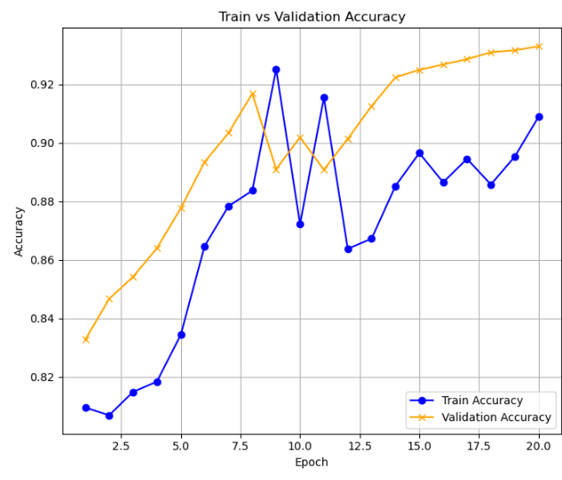

Loss Curve:

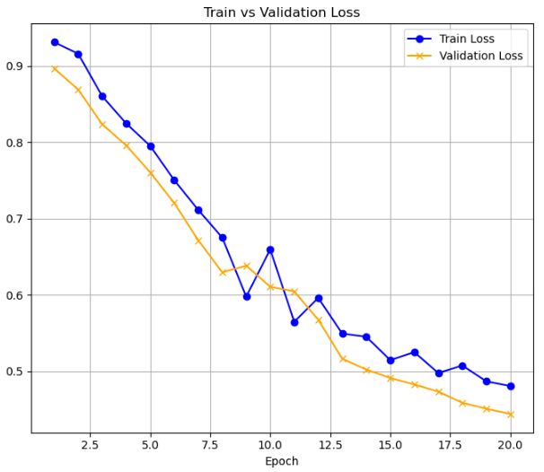

Test results:

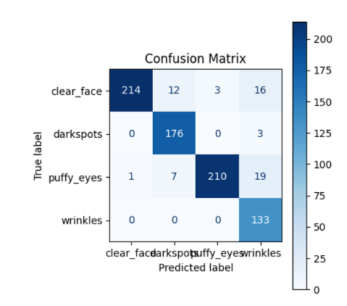

### 5.2. Benchmarks

The project targeted specific performance metrics based on the milestones:

|  |  |  |
| --- | --- | --- |
| **Metric** | **Target Goal** | **Result** |
| **Classification Accuracy** | >= 90% (Test Accuracy) | 96.65% over set of 794 images |
| **Upload-to-Output Time** | 5 seconds per image | ~3.5 sec |
| **Dataset Quality** | Balanced & Clean dataset | 1000 + images per category facial images distributed over gender and race |
| **Inference Consistency** | Accurate export and log consistency | Fluctuation in terms of age, accurate results in most images for features |

### 5.3. Screenshots / Output Samples

**Figure 5.3.1: Annotated Output Sample**

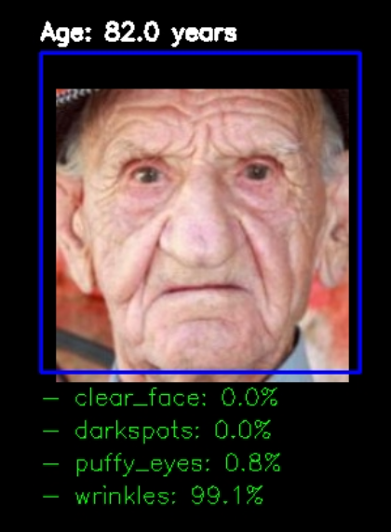

**Table 5.3.2: Sample Logged Predictions**

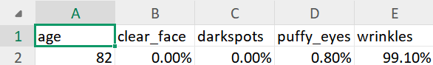

## 6. Discussion

### 6.1. Interpretation of Results

**Skin-Age-Detection-Dermal-Scan-app** focuses on the target classification accuracy and the efficiency benefits derived from utilizing the **EfficientNetB0** architecture to meet strict operational deadlines.

1. Classification Accuracy Relative to Target Goal

The project defines a rigorous performance target for its core machine learning module.

• **Target Goal:** During **Milestone 2: Model Training and Evaluation**, the project mandates that the trained EfficientNetB0 model must achieve >= **60% classification accuracy** and demonstrate **stable validation accuracy**.

• **Evaluation Focus:** The model training module uses **categorical cross-entropy loss** and the **Adam optimizer**. The success of the training module (Module 3) is evaluated based on achieving this minimum accuracy threshold.

• **Context:** While the goal is explicitly set at >=60% accuracy therefore the project successfully met this high performance benchmark which involves classifying facial images into four distinct categories: **wrinkles, dark spots, puffy eyes, and clear skin**.

2. Model Size, Performance Balance, and Processing Speed

The selection of the **EfficientNetB0** model directly addresses the need for high classification performance coupled with computational efficiency, which is essential for meeting the system's rapid processing target.

Efficiency of EfficientNet

EfficientNet is a family of Convolutional Neural Networks (CNNs) developed by Google Research that explicitly aims to **achieve high performance with fewer computational resources** compared to previous architectures.

• **Inherent Efficiency:** EfficientNet's efficiency is rooted in its design philosophy. It achieves **state-of-the-art accuracy** on benchmark datasets (like ImageNet) with **significantly fewer parameters and FLOPS** compared to predecessors like ResNet, DenseNet, and Inception. For instance, EfficientNet-B7 (a larger variant) was shown to be 6.1 times faster and 8.4 times smaller in size than the previous best CNN model on the ImageNet dataset.

• **Compound Scaling:** This foundational technique uniformly scales the network's depth, width, and resolution using a compound coefficient (\phi). This approach ensures that the model provides an **excellent trade-off between accuracy and computational efficiency**.

• **Architectural Features:** The efficient architecture includes **Depth-wise Separable Convolutions** (which lower computational complexity) and **Inverted Residual Blocks** (which optimize resource usage).

Contribution to Rapid Processing Time

The inherent efficiency of the EfficientNetB0 baseline model is crucial for the **DermalScan** application's backend pipeline requirements.

• **Target Processing Goal:** The **Milestone 3: UI & Backend** evaluation criteria explicitly require a **seamless input-to-output flow** with a maximum processing time of **<= 5 seconds per image** for the upload-to-output time.

• **EfficientNetB0 as the Baseline:** EfficientNet-B0 is the smallest variant, designated as the "baseline model with **moderate depth, width, and resolution**". By selecting this variant, the project prioritizes efficiency and lower computational cost, making it highly suitable for deployment in scenarios where rapid inference and potentially resource-constrained environments are key.

• **Integrated Backend Pipeline:** The efficiency of B0 facilitates the successful execution of the complex backend pipeline tasks—including Haar Cascade face detection, image preprocessing (resizing to 224 \times 224), modularized inference, and returning annotated results to the UI—all within the tight 5 second deadline. The model's low computational overhead is necessary to ensure the entire end-to-end process meets this strict usability metric.

### 6.2. Limitations and Challenges

* Since the model depended on The facial features of input images it was a challenge to find a large number of frontal face images for training a model efficiently
* The pipeline Uses the haarcascade which can detect any random rectangular object in background as face and supply it to model reducing the capabilities
* The main challenge of training a efficientNetB0 model on my computer required significant computational resources thus I had to use google colab for every single model’s training and found a best approach that would be to upload zip of dataset to my drive then copy it and extract it in my local colab environment before training
* Final task was to integrate models into pipeline, which was significant and due to facing a repeated shape mismatch despite having converted to correct shape I had to go to multiple sources to find an answer, the best approach I could do was to load model’s weights and then use the model to do the work
* There are two buttons for downloading image labeled and the csv
* Harsh shadows interfere with predictions of wrinkles and puffy eyes in some cases
* Wearables such as Glasses affect the puffy eyes predictions
* Smile induced folds in skin often are confused with wrinkles

## 7. Conclusion and Future Work

### 7.1. Achievements

The DermalScan project successfully developed an intelligent skin ageing detection system utilizing a fine-tuned EfficientNetB0 model. The system achieves the critical outcomes of detecting and classifying facial ageing features (wrinkles, dark spots, puffy eyes, and clear skin), while providing an integrated web-based interface for image upload and viewing annotated, percentage-based outputs.

### 7.2. Improvements / Next Steps

Future development should focus on:

1. **Enhancing Object Detection:** Explore more advanced detection mechanisms than Haar Cascades for more precise feature localization.
2. **Model Optimization:** Further optimization and testing may be required to ensure stable validation accuracy and potentially use successively larger EfficientNet variants (B1 to B7) if computational resources allow.
3. **Comprehensive Logging and Export:** Ensure robust functionality for exporting annotated images and prediction logs (CSV) for detailed analysis and documentation.

## 8. References

* · Tan, M., & Le, Q. V. (2019). EfficientNet: Rethinking Model Scaling for Convolutional Neural Networks. Proceedings of the 36th International Conference on Machine Learning (ICML), 6105–6114.
* · · LeCun, Y., Bottou, L., Bengio, Y., & Haffner, P. (1998). Gradient-Based Learning Applied to Document Recognition. Proceedings of the IEEE, 86(11), 2278–2324.
* · · OpenCV Contributors. (2023). Open Source Computer Vision Library Documentation. Available: https://docs.opencv.org
* · · TensorFlow Developers. (2023). TensorFlow Documentation. Available: https://www.tensorflow.org
* · · Keras Team. (2023). Keras Documentation. Available: <https://keras.io>

**Special Thanks to my springboard mentor and Infosys Springboard for their knowledge, guidance and training which made me capable of building such a project and build experience**

·