*Spring Security
- Spring Security Components:

- Authentication Filter:
    - It’s a Filter in the Filter/Chain which detects an authentication attempt and forwards it to the AuthenticationManager.

- Authentication:
    - This component specifies the type of authentication to be conducted. It’s an interface. Its implementation specifies the type of Authentication.
    - UsernamePasswordAuthenticationToken is an implementation of the Authentication interface which specifies that the user wants to authenticate using a username and password.
    - Examples: OpenIDAuthenticationToken,
RememberMeAuthenticationToken.

- Authentication Manager:
    - The main job of this component is to propagate the authenticate() method call to the correct AuthenticationProvider.
    - An application can have multiple AuthenticationProviders, few of which are DaoAuthenticationProvider, LdapAuthenticationProvider, OpenIDAuthenticationProvider, etc).
    - The AuthenticationManager decides which Authentication Provider to delegate the call to by calling the supports() method on every available AuthenticationProvider.
    - If the supports() method returns true, then that AuthenticationProvider supports the Authentication type and is used to perform authentication.

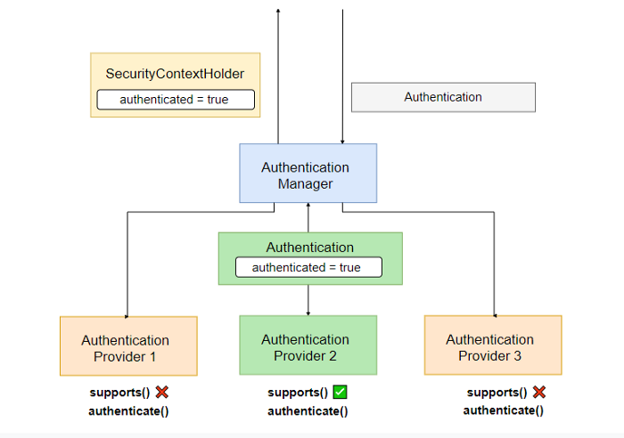

In this diagram, we can see there are three Authentication Providers. Out of the three, Authentication Provider 2 supports the type of incoming Authentication as its supports() method returns true. It then performs authentication and on success, returns an Authentication object of the same type with the authenticated property set to true along with some other relevant properties.
- Authentication Provider:
    - It is an interface whose implementation processes a certain type of authentication.
    - An AuthenticationProvider has an authenticate method which takes in the Authentication type and performs authentication on it.
    - On successful authentication, the AuthenticationProvider returns back an Authentication object of the same type that was taken as input with the authenticated property set to true.
    - If authentication fails, then it throws an Authentication Exception.

Following figure shows a generalized AuthenticationProvider:

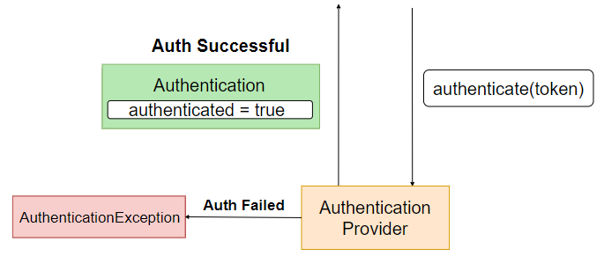
In most apps, we perform username and password authentication and therefore, before performing authentication we have to fetch the UserDetails (username / email, password, roles, etc..) from a “datasource” such as a database with the help of an UserDetailsService, and then authenticate the provided data against the actual data. The following figure demonstrates the process of a DaoAuthenticationProvider (this is an implementation of the AuthenticationProvider interface which mainly deals with username password authentication)
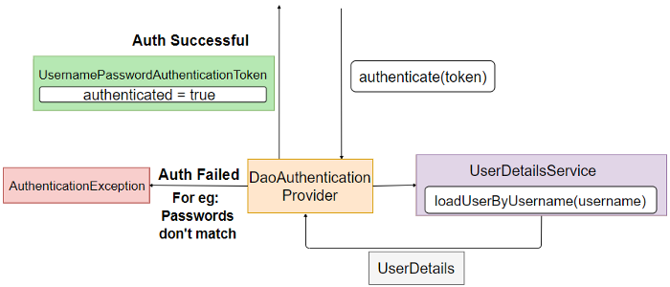
- UserDetailsService:
- This is a service which is responsible for fetching the details of the user from a “datasource”, most likely a database using the loadUserByUsername(String username) methods which takes in the username as a parameter.
- loadUserByUsername() then returns a UserDetails object populated with the user data fetched from the datasource ( database ). The three main fields of an UserDetails object are username, password and the roles/authorities.

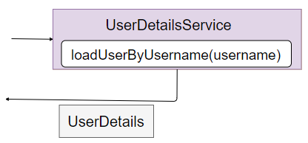

- Complete Security Flow

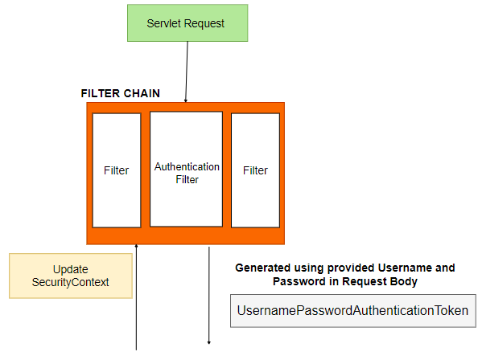

Step 1:
When the server receives a request for authentication, such as a login request, it is first intercepted by the Authentication Filter in the Filter Chain.
Step 2:
A UsernamePasswordAuthenticationToken is created using the username and password provided by the user. The UsernamePasswordAuthenticationToken is an implementation of the Authentication interface and used when a user wants to authenticate using a username and password.
Step 3:
The UsernamePasswordAuthenticationToken is passed to the AuthenticationManager so that the token can be authenticated.

Step 4:
The AuthenticationManager propagates the authentication to the appropriate AuthenticationProvider. The AuthenticationManager selects the appropriate AuthenticationProvider based on supports() method.
Step 5:
The AuthenticationProvider calls the loadUserByUsername(username) method of the UserDetailsService and gets back the UserDetails object containing all the data of the user. The most important data is the password because it will be used to check whether the provided password is correct. If no user is found with the given user name, a UsernameNotFoundException is thrown.
Step 6:
The AuthenticationProvider after receiving the UserDetails checks the passwords and authenticates the user. If the passwords do not match it throws a AuthenticationException. However, if the authentication is successful, a UsernamePasswordAuthenticationToken is created, and the fields principal, credentials, and authenticated are set to appropriate values. Here principal refers to your username or the UserDetails, credentials refers to password and the authenticated field is set to true. This token is returned back to the AuthenticationManager.
Step 7:
On successful authentication, the SecurityContext is updated with the details of the current authenticated user. SecurityContext can be used in several parts of the app to check whether any user is currently authenticated and if so, what are the user’s details.