Literature Review:
Previous Issues on Decision Support Systems
By
LIN Shanshan, Alice
1030300027
A Final Year Project Literature Review (COMP4221; 3 credits)
Submitted in partial fulfillment of the requirements
For the degree of
Bachelor of Science (Honor)
In
Computer Science and Technology
At

BNU-HKBU
UNITED INTERNATIONAL COLLEGE

OUTLINE
- Introduction------------------------------------------------ 3
- Historical Perspective------------------------------------ 3
- Taxonomies------------------------------------------------- 4

3.1 Model-driven DSS---------------------------------------------- 4

3.2 Data-driven DSS------------------------------------------------ 5

3.3 Communication-driven DSS--------------------------------- 5

3.4 Document-driven DSS----------------------------------------- 6

3.5 Knowledge-driven DSS---------------------------------------- 6
- Components------------------------------------------------- 6
- Architecture------------------------------------------------- 7
- Application-------------------------------------------------- 9
- Current Trends--------------------------------------------- 10

References----------------------------------------------------- 11

Appendix------------------------------------------------------- 12

- Introduction
Business model has experienced dramatic revolution since E-business technology involved. The benefit of computer-aided software applications reflects improvement in working efficiency and information transmission. An increasing number of transactions in business corporations results in the growing demand for superior information system. In the aspect of details of job, analysts observe the variation of data flows more often. For managers, they require a reliable information system which illustrates data changes in certain period visually and possible future trends before making decisions. Information system researchers and software developers have dedicated to deploying better decision support system for nearly five decades. (Power D.J., 2007) The field of decision support system has expanded from model-driven DSS to the creation of Web-based DSS. This paper begins with explorations on decision support systems, including the origin, development and applications. Most present study mentioned in this paper draws primarily on the work of Power (2007). In addition, several secondary resources are also consulted.
- Historical perspective
The research of Decision Support System dates back to the late 1960s when computerized quantitative models were found to have contribution to decision making. (Power D.J., 2007) categorized the results before 1970 into two streams: the conceptual studies and practical work. Theoretical and technical exploration for decision support system was considered an independent issue during the 1970s. (Power D.J., 2007) As personal computers gained growing popularity in the market, researchers were boosting expanding the functions of DSS as well as improving system efficiency in the 1980s. (Haettenschwiler P., 1999) The 1980s was a period of alternative types of DSS’s emergence such as Executive Information System (EIS), Group Decision Support System (GDSS) and Organizational Decision Support Systems (ODSS). Ten years later, the use of networking evolved “a shift from mainframe-based DSS to client/server DSS”. (Power D.J., 2007) This great leap might not be achieved without the accomplishment of the first enterprise data warehouses and the introduction of online analytical processing (OLAP) tools. (Figure 1)
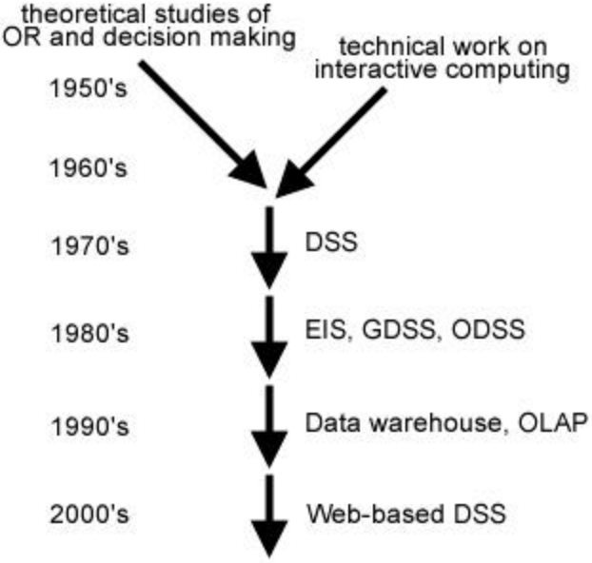
Figure 1 A brief History of DSS
Since 2000, DSS have been largely influenced by the speedy development of the web. Web-based DSS becomes the most widespread of e-business system in this era. The new trend of DSS is a Web-based system with multiple functions concerning database research, artificial intelligence, human-computer interaction, simulation methods, software engineering and telecommunications. (Power, 2007)
- Taxonomies
In the aspect of theoretical progress, Power proposed the differentiation of DSS in 2002. He claimed that there are five forms of DSS in total: Model-Driven DSS, Data-Driven DSS, Communication-Driven DSS, Document-Driven DSS and Knowledge-Driven DSS.

  - Model-driven DSS
A Model-Driven DSS emphasizes access to and manipulation of a statistical, financial, optimization, or simulation model.(Power, 2007) Model-Driven DSS help managers analyze a situation where information (data and parameters) provided by DSS users are used. Interactive financial planning system (IFPS), developed by Gerald R. Wagner and his students at the University of Texas, was the first tool which utilized financial and quantitative models for constructing model-driven DSS. (Power, 2007) Sharda, Barr and McDonnell summarized in their 1988 paper that the first 15 years’ research on model-driven DSS was encouraging but not progressive. According to researchers’ conclusion, the concept of model-driven spatial decision support system (SDSS) was presented in the late 1980s but established in paper in 1995. (Power, 2007)

3.2 Data-driven DSS
A data-driven DSS emphasizes access to and manipulation of a time-series of internal company data and sometimes external and real-time data. (Power, 2007) File systems and data warehouse systems were combined with each other so that the level of functionality can reach the highest. Examples of data-driven DSS are Executive Information Systems. (Power, 2002) In fact, the first generation of DSS was data-oriented DSS, Analysis Information Systems (Power, 2007) and retrieval-only DSS, Bonczek, Holsapple and Whinston claimed in 1981.

3.3 Communication-driven DSS
Communications-driven DSS use network and communications technologies to facilitate decision-relevant collaboration and communication. (Power, 2007) Communications-driven DSS is also a predominant element among all the DSS systems. The first Computer Mediated Communications System, EMISARI , was developed by Murray Turoff for promoting group communications (Power, 2007). In 1980s, researchers gave a new definition, Group decision support systems, which referred to group decision-making software. Communications-driven DSS development was marked up by various software, such as Co-op, NEGO and Notes. The scientific results became commercialized ultimately. In general, Communications-driven DSS requires technologies like groupware, bulletin boards, audio and videoconferencing. Yet, scientists attempted to implement synchronization of voice and video transmission via the internet.

3.4 Document-driven DSS
A document-driven DSS uses computer storage and processing technologies to provide document retrieval and analysis. (Power, 2007) Documents of different types (scanned documents, hypertext documents, images, sounds, video, etc) are essentials contained in the database. Power (2002) added that “A search engine is a primary decision-aiding tool associated with a document-driven DSS”. Before the mid-1990s, little assistance was done to managers in decision making. As the internet technologies enhanced, the availability of document-driven DSS has expanded.

3.5 Knowledge-driven DSS
Knowledge-driven DSS can suggest or recommend actions to managers. (Power, 2007) Knowledge-driven DSS is like an expertise that possesses algorithms to solve problems of a specific field. It used to be called suggestion DSS (Alter, 1980) and knowledge-based DSS (Power, 2007). Later, Goul, Henderson, and Tonge verified in 1992 that the functionality of Knowledge-driven DSS was attributed to Artificial Intelligence (AI). Knowledge-driven DSS is now a part in modern DSS patterns (with the aid of Web-based DSS)

- Components
Researchers preserved different views on the components of DSS.
Power (2002) identified four main sections: (a) the user interface, (b) the database, (c) the model and analytical tools, (d) the DSS architecture and network.
Hättenschwiler (2002) discussed DSS in terms of five elements: (a) users with different roles or functions in the decision making process (decision maker, advisors, domain experts, system experts, data collectors), (b) a specific and definable decision context, (c) a target system describing the majority of the preferences, (d) a knowledge base made of external data sources, knowledge databases, working databases, data warehouses and meta-databases, mathematical models and methods, procedures, inference and search engines, administrative programs, and reporting systems, (e) a working environment for the preparation, analysis and documentation of decision alternatives.

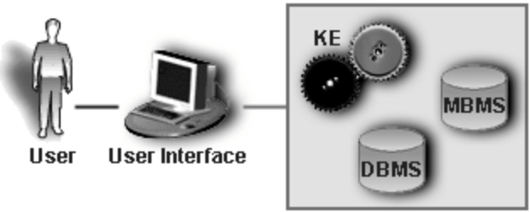
Figure 2 The five distinct components of a DSS (Marakas, 1999)

As noted in Figure 2, Haettenschwiler (2002) considered five unique parts: (a) the data management system, (b) the model management system, (c) the knowledge engine, (d) the user interface, and (e) the user(s)

- Architecture
Data Warehouse
There are three levels which constitute the complete data warehouse: data sources, data storage and management, Online Analytical Processing (OLAP) and data mining tools. (Figure 3)
The data stored in the Data warehouse is categorized into four groups: Early details, the details, light degree integrated, highly integrated level. Data warehouse preserves data-matadata, consisting of two sets of data storage environment which control data conversion and transforming environment. The process of “data mining with ETL, OLAP of DW” can be built on modes such as Related analysis, Time order
mode, Cluster, Classification, Deviation testing and Forecasting models. (Bao Y. & Zhang L.J., 2010)
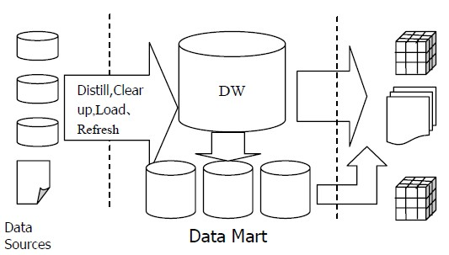
Figure 3 Architecture of Data Warehouse (Bao Y. & Zhang L.J., 2010)

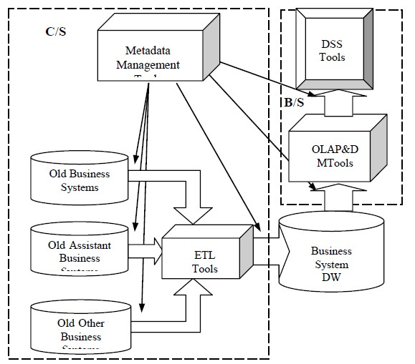
Figure 4 Architecture of Decision Support System (Bao Y. & Zhang L.J., 2010)
Figure 4 shows the architectural design of the DSS, Data warehouse, OLAP tools and DSS tools included. The graph also mentions how to collect data in old storage systems and transmit it to new data warehouse.
- Application
Decision Support Systems (DSS) with data mining technologies (DMT) have been deployed into software applied in various fields.
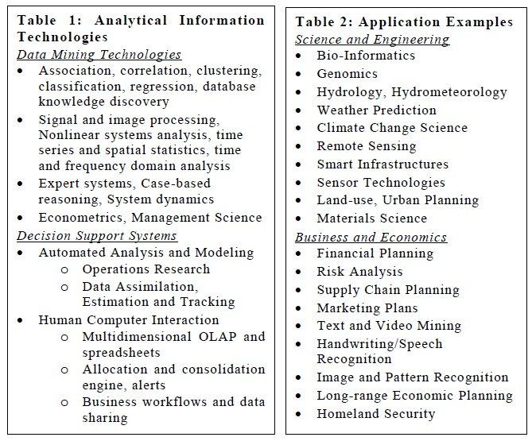
Table 1 lists the Technologies of DSS with DMT and Table 2 underlines some examples of application in science and engineering, business and economics. (Ganguly A.R. & Gupta A., 2004)
Scientists and engineers have been engaging in finding optimized methodologies to enhance the decision support analysis. The scalability of tools has been extended to not only conventional data processing, but also signal processing, artificial intelligence and data mining. More dedication are focused on improving the speed of real-time analysis. (Ganguly A.R. & Gupta A., 2004)
Business and IT vendors collaborate to develop DSS which monitor the business workflow, analyze the current situation and predict future possibilities. Business Intelligence (BI) technologies provide historical, current and predictive views of business operations. E-business vendors such as SAP, PeopleSoft, Oracle provide specialized Business DSS which covers the most percentage of Business Company System.
- Current Trends
Web-based DSS are considered as the fundamental types of DSS of the twenty-first century. Since 1995, the evolution of internet technologies enlarges the scale of DSS functions. Power (2001) identified the Web-based DSS as computerized systems which provide decision making reports via web browser like internet explorer. The systems eliminate the problems of physical data storage. Once a server is setup, users with permission can get access to DSS via computers located in any area. In the meantime, DSS can also acquire the latest information flows retrieved from the World Wide Web.
Communication-driven DSS, Knowledge-driven DSS, Document-driven DSS gains popularity as web-based DSS emerges. (Power, D.J., 2001) Bhargava and Krishnan noted some web enabling technologies which control the access to DSS including CGI, Java applications, server-side scripting languages, active server pages and Java server pages. Common technologies which connect backstage with the front-end are client-side scripting languages, Java applets, ActiveX controls and browser plugins, together with elements for deploying DSS components including CORBA, DCOM, Java RMI and Java Beans. (Power, D.J., 2001)

References
Bao Y. & Zhang L.J. (2010) “Decision Support System Based on Data Warehouse” World Academy of Science, Engineering and Technology 71, 2010

Ganguly A.R. & Gupta A. (2004) “Data Mining Technologies and Decision Support Systems for Business and Scientific Applications”, 2004

Haettenschwiler, P. (2002). “Decision Support Systems”, 2002

Power, D.J. (2001) “Decision Support Systems and Web Technologies: A Status Report”, 2001

Power, D. J. (2002). Decision support systems: concepts and resources for managers. Westport, Conn., Quorum Books.

Power, D.J. “A Brief History of Decision Support Systems.” DSSResources.COM, World Wide Web, http://DSSResources.COM/history/dsshistory.html, version 4.0, March 10, 2007.

Appendix I

Table 1 DSS Timeline (Power,2007)
Year | Major Milestones
1945 | Bush proposed Memex
1947 | Simon book titled Administrative Behavior
1952 | Dantzig joined RAND and continued research on linear programming
1955 | Semiautomatic Ground Environment (SAGE) project at M.I.T. Lincoln Lab uses first light pen; SAGE completed 1962, first data-driven DSS
1956 | Forrester started System Dynamics Group at the M.I.T. SloanSchool
1960 | Simon book The New Science of Management Decision;Licklider article on “Man-Computer Symbiosis”
1962 | Licklider architect of Project MAC program at M.I.T.; Iverson’s book A Programming Language (APL); Engelbart'spaper "Augmenting Human Intellect: A Conceptual Framework"
1963 | Englebart established Augmentation Research Center at SRI
1965 | Stanford team led by Feigenbaum created DENDRAL expert system; Problem Statement Language/Problem Statement Analyzer (PSL/PSA) developed at Case Institute of Technology
1966 | UNIVAC 494 introduced; Tymshare founded and Raymond article on computer time-sharing for business planning and budgeting
1967 | Scott Morton’s dissertation completed on impact of computer-driven visual display devices on management decision-making process; Turban reports national survey on use of mathematical models in plant maintenance decision making
1968 | Scott Morton and McCosh article; Scott Morton and Stephens article; Englebart demonstrated hypermedia—groupware system NLS (oNLine System) at Fall Joint Computer Conference in San Francisco
1969 | Ferguson and Jones article on lab study of a production scheduling computer-aided decision system running on an IBM 7094; Little and Lodish MEDIAC, media planning model; Urban new product model-based system called SPRINTER
1970 | Little article on decision calculus support system; Joyner and Tunstall article on Conference Coordinator computer software; IRI Express, a multidimensional analytic tool for time-sharing systems, becomes available; Turoffconferencing system
1971 | Gorry and Scott Morton SMR article first published use of term Decision Support System; Scott Morton book Management Decision Systems; Gerrity article Man-Machine decision systems; Klein and Tixier article on SCARABEE
1973 | PLATO Notes, written at the Computer-based Education Research Laboratory (CERL) at the University of Illinois by David R. Woolley
1974 | Davis’s book Management Information Systems; Meador andNess article DSS application to corporate planning
1975 | Alter completed M.I.T. Ph.D. dissertation "A Study of Computer Aided Decision Making in Organizations"; Keen SMR article on evaluating computer-based decision aids; Bouldenbook on computer-assisted planning systems
1976 | Sprague and Watson article "A Decision Support System for Banks"; Grace paper on Geodata Analysis and Display System
1977 | Alter article "A Taxonomy of Decision Support Systems", Klein article on Finsim; Carlson and Scott Morton chair ACM SIGBDP Conference DSS Conference
1978 | Development began on Management Information and Decision Support (MIDS) at Lockheed-Georgia; Keen and Scott Morton book; McCosh and Scott Morton book; Holsapple dissertation completed; Wagner founded Execucom to market IFPS; Bricklinand Frankston created Visicalc (Visible Calculator) microcomputer spreadsheet; Carlson from IBM, San Jose plenary speaker at HICSS-11; Swanson and Culnan article document-based systems for management planning
1979 | Rockart HBR article on CEO data needs
1980 | Sprague MISQ article on a DSS Framework; Alter book;Hackathorn founded MicroDecisionware
1981 | First International Conference on DSS, Atlanta, Georgia;Bonczek, Holsapple, and Whinston book; Gray paper on SMU decision rooms and GDSS
1982 | Computer named the “Man” of the Year by Time Magazine;Rockart and Treacy article “The CEO Goes On-Line” HBR; Sprague and Carlson book; Metaphor Computer Systems founded by Kimball and others from Xerox PARC; ESRI launched its first commercial GIS software called ARC/INFO; IFIP Working Group 8.3 on Decision Support Systems established
1983 | Inmon Computerworld article on relational DBMS; IBM DB2 Decision Support database released; Student Guide to IFPS by Gray; Huntington established Exsys; Expert Choice software released
1984 | PLEXSYS, Mindsight and SAMM GDSS; first Teradata computer with relational database management system shipped to customers Wells Fargo and AT&T; MYCIN expert system shell explained
1985 | Procter & Gamble use first data mart from Metaphor to analyze data from checkout-counter scanners; Whinstonfounded Decision Support Systems journal; Kersten developed NEGO
1987 | Houdeshel and Watson article on MIDS; DeSanctis and Gallupearticle on GDSS; Frontline Systems founded by Fylstra, marketed solver add-in for Excel
1988 | Turban DSS textbook; Pilot Software EIS for Balanced Scorecard deployed at Analog Devices
1989 | Gartner analyst Dresner coins term business intelligence; release of Lotus Notes; International Society for Decision Support Systems (ISDSS) founded by Holsapple and Whinston
1990 | Inmon book Using Oracle to Build Decision Support Systems;Eom and Lee co-citation analysis of DSS research 1971–1988
1991 | Inmon books Building the Data Warehouse and Database Machines and Decision Support Systems; Berners-Lee’s World Wide Web server and browser, become publicly available
1993 | Codd et al. paper defines online analytical processing (OLAP)
1994 | HTML 2.0 with form tags and tables; Pendse’s OLAP Report project began
1995 | The Data Warehousing Institute (TDWI) established; DSS journal issue on Next Generation of Decision Support;Crossland, Wynne, and Perkins article on Spatial DSS;ISWorld DSS Research pages and DSS Research Resources
1996 | InterNeg negotiation software renamed Inspire; OLAPReport.com established;
1997 | Wal-Mart and Teradata created then world’s largest production data warehouse at 24 Terabytes (TB)
1998 | ACM First International Workshop on Data Warehousing and OLAP
1999 | DSSResources.com domain name registered
2000 | First AIS Americas Conference mini-track on Decision Support Systems
2001 | Association for Information Systems (AIS) Special Interest Group on Decision Support, Knowledge and Data Management Systems (SIG DSS) founded
2003 | International Society for Decision Support Systems (ISDSS) merged with AIS SIG DSS

