S2021

Essay: Here is a template for the Essay

The title font (above) of the essay is 16, bold, written in Times New Roman.

N. N., 39548L

Remember to write down your name and student number.

Maximum length of the essay is 3 pages including all the pages. Return in pdf format.

Sub headers (e.g. **Introduction, Theory, Example Exercise, References**), font size is 14, bold, written in Times New Roman.

Main text, use font size 12 and Times New Roman. Line spacing 1.0. Do not change the marginal which are now set as 2.54cm to all directions.

You can write equations within the text or in separate lines. In the latter case, it is good to number the equations as

$p=p_{0}+∆p=p_{0}+ρgh$ (1)

If you use figures, please write the caption and number the image.

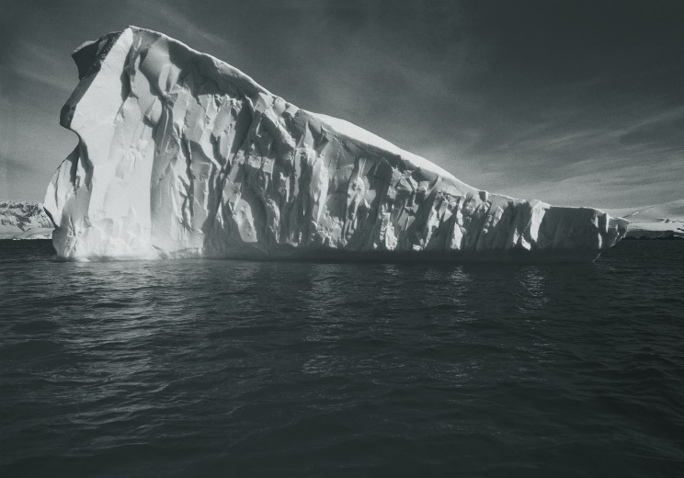

Figure 1. An ice berg.

In case you use tables, remember to number them.

Table 1. The properties of water.

|  |  |  |  |
| --- | --- | --- | --- |
| Substance | Density [kg/m3] | Viscosity [Ns/m2] | Surface tension [N/m] |
| Water | 999 | 2.34E-5 | 7.34E-2 |