**Name: Nguyen Xuan Binh**

**Student ID: 887799**

**Fracture Mechanics Assignment 1**

We are given these data:



Using the given values, we can calculate the fracture toughness from the finite width plate formula from the datasheet (slide 5, second formula) as follows:



We have: 



The formula for fracture stress for infinite width plate from the datasheet (slide 3, 4th formula) is:

(answer)

The stress intensity factor for the edge crack according to the formula in the datasheet is:

 given the distance  from the crack tip. Integrate over distance b by the applied stress, we have:



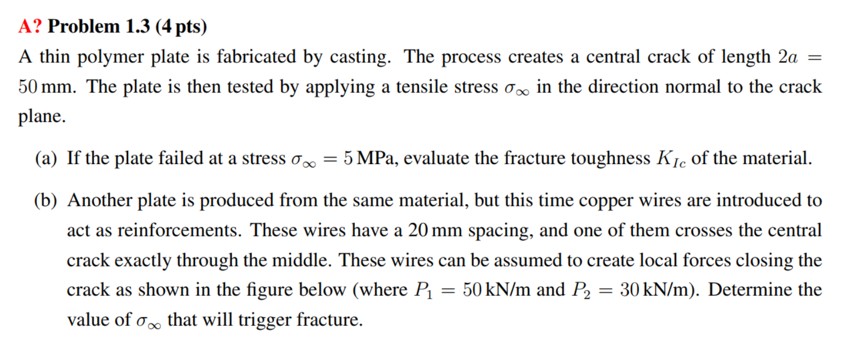

The fracture toughness of the material is

 (answer)

The stress intensity factor induced by P1 on the middle of the plate (at tip A formula in datasheet, slide 4). Note: the sign of P is negative because the wire is trying to close the gap



The stress intensity factor induced by P2 on the right side (at tip A formula in datasheet)



The stress intensity factor induced by P2 on the left side (at tip B formula in datasheet)



By principal of superposition, the fracture toughness with copper wires reinforcement becomes

The tensile stress that can triggers the fracture of the reinforced plate becomes

 (answer)

Adding the wires increases the fracture stress to 6.9 MPa

**Name: Nguyen Xuan Binh**

**Student ID: 887799**

**Fracture Mechanics Assignment 2**

From the figure, each arm is displace by from the horizontal middle plane. On the cross section, we can see that the height of upper arm is 1h and lower arm is 2h. The width of the chopstick is B = h. There is no applied force in this case, but instead with a wedge, so this is a displacement control setting. Assume the wedge applies the reaction force P on the chopsticks, from the beam theory of cantilever maximum displacement, we have:



For the upper arm of the chopstick, we have:

* Inertia: 
* Compliance:  (answer)

For the lower arm of the chopstick, we have:

* Inertia: 
* Compliance:  (answer)

The compliance of the whole system is



Then we derive the force P as the function of displacement



The energy release rate in the load control setting is

 (answer)

Under displacement control, the energy release rate is:



Assuming that the material has a flat R-curve, crack growth is stable under displacement control.

The plate is thin and large => The plane stress condition is assumed

* 

The moment at which fracture will become unstable is when:

 and 

The first condition gives us:

 (I)

Whereas the second condition returns:

 =>  (II)

Combining two equations, we have the following equality:



We have only one unknown variable here, which is a. According to the exercise, a maximum stable crack growth is 6.3mm at both tips, which means . Replace all identities to the equation, we have:



* 
* 

Both sides are equal => a maximum stable crack growth is 6.3mm at both tips

We can substitute the stable crack growth into the second equation to obtain the critical stress



*  (answer)

Unit of energy release rate is  or . If the compliance C is a linear function of the crack length a, then, dC/da will be a constant and the energy release rate G will be independent of the crack length a.

We can calculate the critical energy release rate  at each stage

1st record: 

2nd record: 

3rd record: 

4th record 

5th record 

On average, the critical energy release rate is = . The difference between each record may be due to erroneous measurements. This conclusion can be wrong, as true answer of is . The answer uses second order polynomial fitting to derive the value of 

**Name: Nguyen Xuan Binh**

**Student ID: 887799**

The stress field in the global reference frame is:



The first and second points on the Mohr circle are:  and 

* The two points are  and 

The Mohr’s circle for this stress field is:

where the centre c and radius r of the circle are:  and 

The stresses  and  in the local reference frame are given by:

(answer)  
 (answer)

Finally, the stress intensity factors are given by:



The energy release rate G is the sum of each mode:



A fracture criterion is obtained by setting *G* equal to the material’s toughness:

(1). The plate is also conditioned as thin

* plane stress condition is assumed so

Additionally, we have: . In this exercise, 

* 

Plug in equation (1), we have: 

*  (answer)

To find the angle of crack propagation, we set , and this gives:



* 

We are also given the information that 

* 

We can apply these two identities to simplify the equation

* 

Let . Replace this into the equation: 

We can further factorize the equation as:

. # Numerical solution applies here

* 
* 
* 
* 
* 
* 
* 
* 

We can either have  => 

or

Numerical solution in MATLAB

From the numerical solutions

 radian

 radian

The correct angle  is the one corresponding to the maximum . Plotting



We are also given the information that , so we need to maximize this quantity



Plugging the solutions above:

=> 

=> 

=> 

Therefore, it shows that  corresponds to a maximum in , whereas  corresponds to a minimum in . Therefore, the crack will propagate along (answer)

**Name: Nguyen Xuan Binh**

**Student ID: 887799**

**Fracture Mechanics Assignment 4**

According to the formula in the datasheet:

 (answer)

The polymer plate is thin => The plane stress condition is assumed

Therefore, the plastic zone size:



If the plastic zone size  is roughly an order of magnitude smaller than the crack length (), we conclude that LEFM applies, and fracture will occur when . Since , LEFM can be applied here.

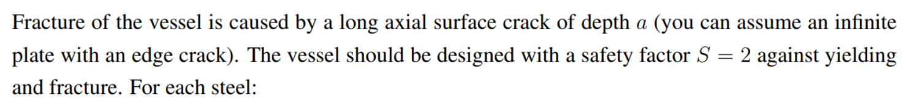

The formulas belong to the thin-wall version, which means we assume plane stress state.

Because we assume an infinite plate with an edge crack, the formula from datasheet is

, where safety factor is taken into account

* The maximum permissible pressure p as a function of crack depth a is
*  The maximum permissible pressure a is 

Because we assume a plane stress condition, the longitudinal stress is along the vessel surface. Thus, the von Mises criterion yielding stress becomes

, where

(hoop stress), (longitudinal stress) and 

* 
* 
* . Yielding occurs when 

The Matlab code:

% radius and thickness (m)

R = 1;

t = 0.04;

% Safety factor

S = 2;

% Steel A 4340

A_sigmaY = 860;

A_Kic = 100;

% Steel B 4335

B_sigmaY = 1300;

B_Kic = 70;

% Steel C 350

C_sigmaY3 = 1550;

C_Kic = 55;

% Define the range of crack depths

a = 0:0.1:30; % Assume crack depth values from 0 to 10 with a step of 0.1

% Calculate the maximum permissible pressure

pA = A_Kic * (t./(1.12 * S * R * sqrt(pi * a)));

pB = B_Kic * (t./(1.12 * S * R * sqrt(pi * a)));

pC = C_Kic * (t./(1.12 * S * R * sqrt(pi * a)));

% Plot the maximum permissible pressure as a function of crack depth

plot(a, pA, 'r-', 'LineWidth', 2);

hold on;

grid on;

plot(a, pB, 'b-', 'LineWidth', 2);

plot(a, pC, 'g-', 'LineWidth', 2);

legend('Steel A 4340', 'Steel B 4335', 'Steel C 350');

xlabel('Crack Depth (a) [mm]');

ylabel('Maximum Permissible Pressure (p) [MPa]');

title('Maximum Permissible Pressure vs. Crack Depth');

First, we need to check if the operating pressure will cause yielding stress larger than the material yielding stress



This yield stress is smaller than the material yielding stress for all three materials, so any steel can be used for this design. Now we can plug in the formula for maximum permissible crack depth a:

% Maximum permissible crack depth when p = 12MPa

p_op = 12;

aA = ((A_Kic * t)./(p_op * 1.12 * S * R * sqrt(pi)))^2 * 10 ^ 3;

disp(aA)

aB = ((B_Kic * t)./(p_op * 1.12 * S * R * sqrt(pi)))^2 * 10 ^ 3;

disp(aB)

aC = ((C_Kic * t)./(p_op * 1.12 * S * R * sqrt(pi)))^2 * 10 ^ 3;

disp(aC)

Steel A 4340: 7.04mm (answer)

Steel B 4335: 3.45mm (answer)

Steel C 350: 2.13mm (answer)

First, we need to calculate the maximum pressure according to critical stress intensity factor:

%%%%%% pressure at a = 1mm according to KIc

a = 0.001;

pA = A_Kic * (t/(1.12 * S * R * sqrt(pi * a)));

pB = B_Kic * (t/(1.12 * S * R * sqrt(pi * a)));

pC = C_Kic * (t/(1.12 * S * R * sqrt(pi * a)));

disp(pA)

disp(pB)

disp(pC)

Steel A 4340: 31.9 MPa

Steel B 4335: 22.3 MPa

Steel C 350: 17.5 MPa

Next, we need to calculate the maximum pressure according to yield stress

%%%%%% maximum pressure according to yield stress

pA = (2 * t * A_sigmaY)/(S * R * sqrt(3));

pB = (2 * t * B_sigmaY)/(S * R * sqrt(3));

pC = (2 * t * C_sigmaY)/(S * R * sqrt(3));

disp(pA)

disp(pB)

disp(pC)

Steel A 4340: 19.9 MPa

Steel B 4335: 30.0 MPa

Steel C 350: 35.8 MPa

Therefore, the failure pressure p for the 1mm crack depth is the minimum of the two pressures derived from the two criteria

Steel A 4340: 19.9 MPa (answer)

Steel B 4335: 22.3 MPa (answer)

Steel C 350: 17.5 MPa (answer)

First, the top and bottom faces are rigidly clamped, so there won’t be deformation normal to the deformation plane => Plane strain condition is assumed. Additionally, the material is linear elastic, so it means J = G (energy release rate).

The definition of the J integral is:

 and the contour can be divided in five segments as:



Let’s define x and y in the horizontal and vertical directions, respectively. Along segments AB and CD, we have no variations in y and the displacement field will be constant with x so:

 and  => 

Along segments AA’ and DD’, we have no stress, and the contour is vertical, therefore:

 and  => 

Consequently, 

 since there is only shear stress

*  where G is the shear modulus
* , the shear strain is 
* , since  for isotropic materials