Functionality Requirements:

1. Overview & Architecture:

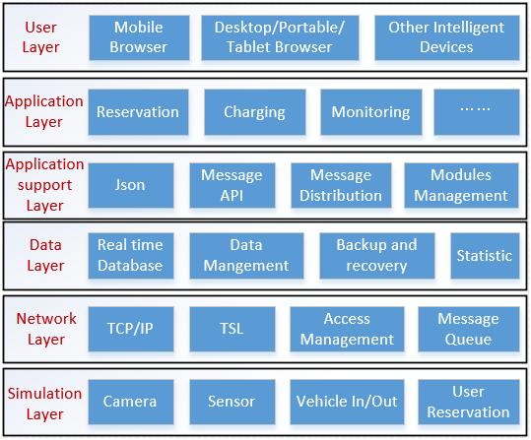

1. Functionality modules

