**GUIDED CAPSTONE PROJECT REPORT**

**Introduction**

Big Mountain Resort is a ski resort located in Montana. It has been charging its 350,000 yearly customers a premium above the average ticket price of resorts in its market segment. The leadership is suspicious that Big Mountain is not capitalizing on its facilities, and the current pricing model based on the average of market prices is hampering investment strategies. In this project, we were tasked to develop a new predictive model that would select a better value for a ticket price while cutting operating costs.

**Data Analysis**

We were supplied with data of 330 ski resorts from 35 states in the US. The data had 27 unique features which included the adult ticket price during the weekday and the weekend, it also included other 25 features such as the name of the resort and the

state where it is located, the vertical drop of the resort, the number of chairlifts, etc.

**Figure 1** **Figure 2**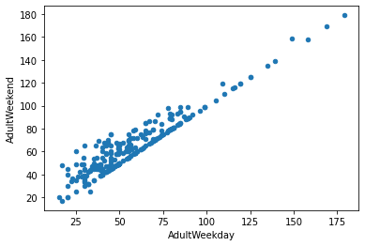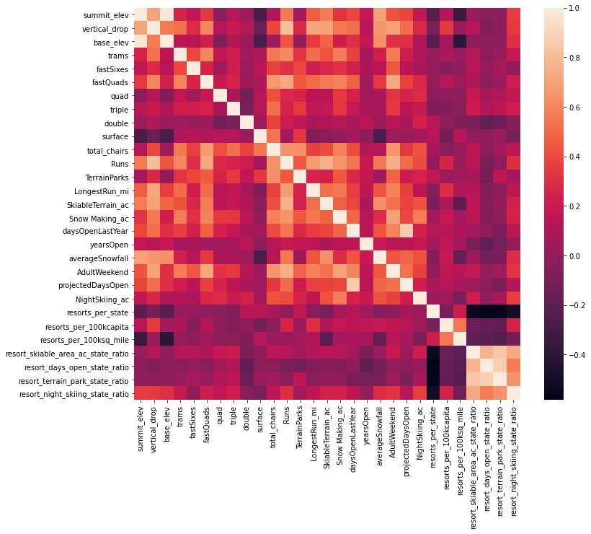

After collecting more data, about states that house these resorts such as their population and surface area, so that we can have more comparative features, we were able to clean our data using packages in *Python* and found that the most features in our data that have a strong relationship with the ticket price, and hence can be use to optimize the ticket price, were: the number of runs (*runs*), the number of fast four person chairs (*fastQuads*), the vertical change in elevation (*vertical_drop*), the total area covered by snow (*snow_making_ac*) and the number of chairlifts (*total_chairs*) as shown in Figure 1. We decided to only consider the adult ticket price for the weekend since it had more data but also was largely equal to the ticket price for the weekday as shown in Figure 2.

We developed two machine learning models and decided to use the *random forest model* (against the linear regression model) since it had a higher predictability. The random forest model confirmed that the four best features that can be used to predict the ideal ticket price were indeed: *fastQuads*, *runs*, *snow_Making_ac*, and *vertical_drop* 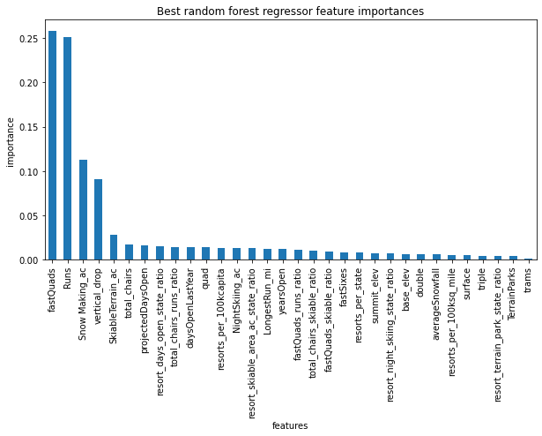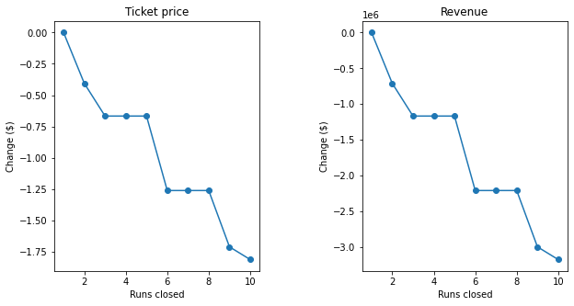

**Figure 3 Figure 4**

as mentioned above and shown in Figure 3. Our model predicted that the ideal ticket price for Big Mountain Resort is  **$95.87** or an **18.4%** increase from the current ticket price of **$81**.

**Recommandations**

Here are some recommendations from our findings:

* Our model found that the expected value of an ideal ticket price is **$95.87,** but the leadership could choose any value between **$85.48** and **$106.26.**
* The leadership could choose to close one run. That would cut the operating costs and would not affect the ticket price and the overall revenue as our model predicts (see Figure 4).
* If the leadership chooses to close a second run, the expected ticket price would decrease by **$0.40** and the overall revenue would decrease by **$700,000.** If they choose to close a third run, the initial expected ticket price would decrease by **$0.67** and the overall seasonal revenue would decrease by **$1.2 millions.**
* Closing 3 runs would have the same effects as closing a 4th run and a 5th run (as shown in Figure 4), but operational costs may be cut considerably, but closing a 6th run would dramatically decrease the ticket price and the overall revenue.
* Our model also predicts that if the Big Mountain adds **one run**, increases the **vertical drop** by **150 feet** and installs an **additional chairlift**, the expected ticket price would increase by **$1.99**, and the seasonal revenue would increase by **$3,474, 638.** In this scenario though, the operating costs would increase as well.