**Project Title: DermalScan:AI_Facial Skin Aging Detection App**

Mentor : Praveen

Submitted by : Pakhi Sharma

**Project Statement:**

The objective is to develop a deep learning-based system that can detect and classify facial aging signs—such as wrinkles, dark spots, puffy eyes, and clear skin—using a pretrained EfficientNetB0 model. The pipeline includes face detection using Haar Cascades, custom preprocessing and data augmentation, and classification with percentage predictions. A web-based frontend will enable users to upload images and visualize aging signs with annotated bounding boxes and labels.

**Modules to be implemented :**

* Dataset Setup and Image Labeling
* Image preprocessing, augmentation, and one-hot encoding
* EfficientNetB0-based image classification using TensorFlow/Keras
* Frontend interface for image upload and result display
* Backend pipeline for processing and model inference
* Testing, Evaluation & Optimization
* Final Presentation & Documentation

**Milestone 1 : Dataset Preparation and Preprocessing**

**Module 1 : Dataset Setup and Image Labeling**

**Tasks needs to be done:**

* Set up and inspect dataset of facial images or create own dataset which you can categorize or use the dataset
* Label classes: wrinkles, dark spots, puffy eyes, clear skin.
* Ensure balanced distribution and clean samples.

**What I have done:**

* I have loaded the dataset from the provided google drive and created a csv file which contains the image path and the class of each image like wrinkles , dark spots , puffy eyes and clear skin.
* I have counted the total images per class and plotted the distribution using matplotlib library.

**Results:**

* Darkspots images are 102
* Clear_face images are 97
* Wrinkles images are 100
* Puffy_eyes images are 101

Plot distribution of classes is given below:

**Module 2 : Image Preprocessing and Augmentation**

**Tasks need to be done:**

* Resize and normalize images (224x224).
* Apply image augmentation (flip, rotation, zoom).
* Encode class labels using one-hot encoding.

**What I have done :**

* For image augmentation and resizing , I used Tensorflow’s ImageDataGenerator for real-time augmentation.
* Applied resizing, rescaling , horizontal_flip , height and width shift , vertical flip , and validation split of 0.2 etc.
* Instead of applying One hot encoding separately , I used the class_mode argument and set it as categorical.
* Also visualized augmented image for checking.

**Results:**

* Preprocessed the whole dataset for training
* Augmented image is displayed below:

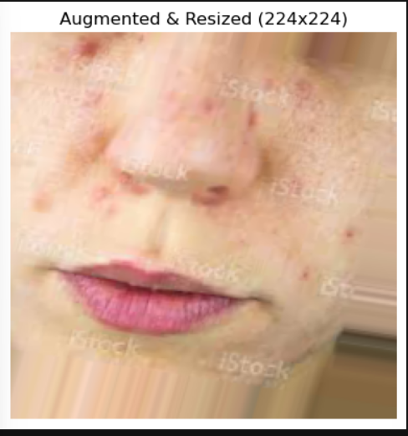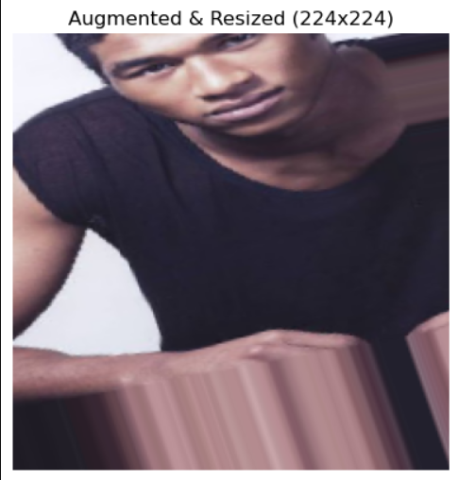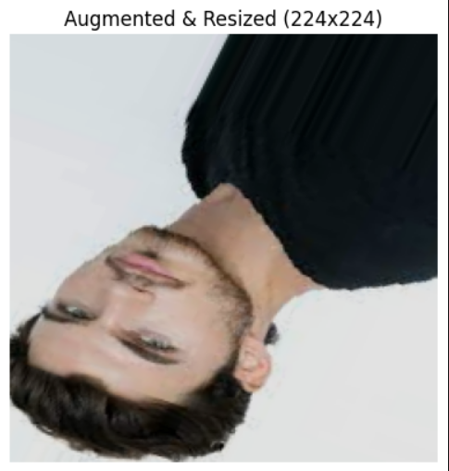

**Milestone 2: Model Training and Evaluation**

**Module 3: Model Training**

**Tasks needs to be done:**

* Use pretrained EfficientNetB0 for transfer learning.
* Train with categorical cross-entropy loss and Adam optimizer.
* Validate model and plot training metrics.

**What I have done:**

* Initially trained EfficientNetB0 model but it is giving very low accuracy due to the shortage of images. So I tried few more pretrained models like EfficientNetB0 like ResNet50,DenseNet121,InceptionV3,VGG16, MobileNetV2, EfficientnetV2.
* After training and comparing all the six training models , For my dataset , MobileNetV2 performed the best .
* Visualized the accuracy and loss curve

**MobileNetV2:**

* MobileNetV2 is a CNN architecture optimized for mobile and embedded vision applications.
* MobileNetV2 is a lightweight architecture allows for efficient deployment on mobile and embedded vision applications with limited computational reseources . and It’s architecture achieves competitive accuracy compared toto larger and more computationally expensive models
* The architecture of MobileNet-v2 consists of a series of convolutional layers, followed by depthwise separable convolutions, inverted residuals, bottleneck design, linear bottlenecks, and squeeze-and-excitation (SE) blocks.

**Why MobileNetV2 works good here?**

1. **Lightweight and fast**, ideal for real-time skin and face analysis.
2. **Efficient feature extraction** using inverted residuals for clear detail capture.
3. **Low memory use**, perfect for limited-resource environments.
4. **High accuracy-to-size ratio**, performs well even with small datasets.
5. **Great for transfer learning**, easily adapts to skin condition prediction.

**Results:**

* The model achieved a training accuracy of 78.56% and a validation accuracy of 82.28%.
* The model stopped training at 8th epoch.
* The graph regarding accuracy and loss is given below:

**The confusion matrix is given below:**

**Module 4: Face Detection and Prediction Pipeline :**

**Tasks need to be done:**

* Use OpenCV and Haar Cascade for face detection.
* Apply model to cropped face regions.
* Display predictions as percentages along with age.

**What I have done:**

* Implemented **face detection** using OpenCV’s Haar Cascade Classifier to locate faces in input images.
* Used the **trained DenseNet121 model** to predict dermal conditions like clear face, dark spots, puffy eyes, and wrinkles.
* Added an **age estimation feature** using randint() to assign approximate age ranges based on the predicted class.
* Displayed **bounding boxes, confidence percentages, and age** on the detected faces for clear visualization.
* Created a **complete automated pipeline** combining detection, classification, and visual output using Matplotlib.

**Results:**

