
DermalScan :AI_Facial Skin Aging Detection App

Infosys Springboard Virtual Internship Program

Submitted by
Parth Agrawal

Under the Guidance of
Mr. Praveen
Mentor, Infosys Springboard

1. Introduction
The goal of Milestone 1 is to complete all dataset-related tasks required for the AI Facial Skin Aging Detection App.
The Milestone 1 includes two modules:
- Module 1: Dataset Setup and Image Labelling.
- Module 2: Image Preprocessing and Augmentation.
This documentation describes the dataset preparation, cleaning, class distribution visualization, augmentation pipeline, and one-hot encoding implemented in your notebook.
2. Module 1: Dataset Setup and Image Labelling
2.1 Dataset Folder Structure
The dataset was organized in a directory structure where each folder represents a class label:
dataset/
├── wrinkles/
├── dark spots/
├── puffy eyes/
├── clear skin/

2.2 Dataset Scanning & Image Counting
A custom script was written to scan the dataset and count the number of images in each class:
def scan_dataset(dataset_dir=DATASET_DIR):
class_counts = {}
for cls in CLASSES:
folder = os.path.join(dataset_dir, cls)
count = len(os.listdir(folder))
class_counts[cls] = count
return class_counts

2.3 Duplicate Image Detection & Removal
To produce a clean dataset, a hash-based duplicate detection algorithm was implemented:
with open( f:
h = hashlib.md5(f.read()).hexdigest()
- If the hash already exists → image is a duplicate
- All duplicates were logged and removed automatically
- Dataset was re-scanned after cleanup
2.4 Class Distribution Visualization
def plot_class_distribution(counts):
plt.figure(figsize=(8,5))
colors = ["#FF5733", "#33C1FF", "#44196D", "#FF33F8"]
plt.bar(counts.keys(), counts.values(),color=colors)
plt.title("Class Distribution")
plt.xlabel("Classes")
plt.ylabel("Number of Images")
plt.show()

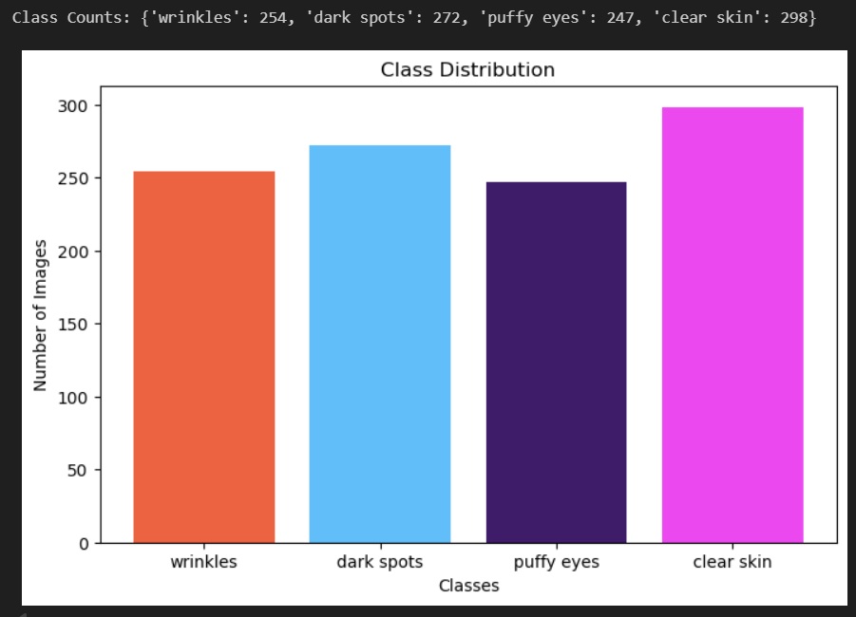

3. Module 2: Image Preprocessing & Augmentation
As required in the project specification, Module 2 includes:
- resizing to 224×224
- normalization
- augmentation
- one-hot encoding
All four requirements were fully implemented.

3.1 Image Preprocessing with ImageDataGenerator
IMG_SIZE = (224, 224)
augmentation = ImageDataGenerator(
rescale=1/255,
rotation_range=10,
zoom_range=0.1,
horizontal_flip=True,
width_shift_range=0.05,
height_shift_range=0.05,
validation_split=0.2
)

Preprocessing Achieved:
Requirement | Status
Resize to 224x224 | Implemented
Normalize images | Using rescale=1/255
Augmentation (flip, zoom, rotation) | Implemented
Train/Validation split | 80/20
3.2 Loading Data with One-Hot Encoding
train_gen = augmentation.flow_from_directory(
"dataset",
target_size=IMG_SIZE,
batch_size=32,
class_mode="categorical",
subset="training"
)

This automatically converts each label into a one-hot encoded vector.
3.3 Augmentation Visualization
A 4×4 grid of augmented images was displayed:
for i in range(16):
plt.subplot(4,4,i+1)
plt.imshow(images[i])
plt.axis("off")

This confirms the applied augmentations visually.
Conclusion:
Milestone 1 was successfully completed by preparing a clean and well-structured dataset, implementing preprocessing techniques, applying image augmentation, and enabling one-hot encoding for class labels. The dataset is now fully ready for model development in Milestone 2, where EfficientNetB0 will be trained using the processed inputs.

Milestone-2
In Milestone 2 we integrates OpenCV for face detection and TensorFlow/ Keras for deep learning–based skin condition classification. This approach allows the system to focus only on the facial area, reducing noise from background regions and improving prediction accuracy.
1.Objectives
The main objectives of the Dermal AI project are:
- To automatically detect human faces from static images using computer vision techniques
- To draw bounding boxes around detected facial regions for visual clarity
- To classify facial skin conditions using a trained deep learning model
- To display the predicted class along with confidence percentage, providing interpretability of results
- To visualize model performance using training accuracy and loss curves
These objectives collectively ensure that the system is accurate, interpretable, and suitable for further real-world enhancement.
2. Technology Stack
Programming Language
- Python, chosen for its extensive support for machine learning and computer vision libraries.
Libraries and Frameworks
- TensorFlow / Keras: Used for building, training, and saving the deep learning classification model.
- OpenCV (cv2): Used for face detection, image preprocessing, and drawing bounding boxes.
- NumPy: Used for numerical operations and array manipulation.
- Matplotlib: Used for visualizing training accuracy and loss curves.
import tensorflow as tf
from tensorflow.keras.preprocessing.image import ImageDataGenerator
from tensorflow.keras.applications import MobileNetV2
from tensorflow.keras.layers import Dense, GlobalAveragePooling2D, Dropout

from tensorflow.keras.models import Model
from tensorflow.keras.optimizers import Adam
from tensorflow.keras.callbacks import EarlyStopping, ReduceLROnPlateau, ModelCheckpoint
import os

Development Environment
- (Anaconda): Used for model training, experimentation, and visualization.
- VS Code: Used for editing, debugging, and running scripts efficiently.
3.Dataset Description
The dataset consists of facial images categorized into the following four skin-condition classes:
- Wrinkles
- Dark Spots
- Puffy Eyes
- Clear Skin
Key characteristics of the dataset:
- Images are resized to 224 × 224 pixels to match the model’s input requirements.
- Pixel values are normalized to improve training stability.
- The dataset is split into training and validation sets to evaluate the model’s performance on unseen data.
- Each class is stored in a separate folder, enabling automated label generation during training.
DATASET_DIR = "dataset"
IMG_SIZE = (224, 224)
BATCH_SIZE = 16
EPOCHS = 50
NUM_CLASSES = 4

4. Model Architecture
The skin-condition classification model is based on a Convolutional Neural Network (CNN) using transfer learning principles.
- Input Shape: (224, 224, 3)
- Base Model: Pretrained CNN (such as MobileNetV2 / EfficientNet) trained on ImageNet
- Custom Layers:
  - Global Average Pooling
  - Fully Connected Dense Layers
  - Dropout (to reduce overfitting)
- Output Layer: Softmax activation with 4 neurons (one per class)
Training Configuration
- Loss Function: Categorical Crossentropy
- Optimizer: Adam
- Evaluation Metric: Accuracy
This architecture allows the model to reuse pretrained visual features while learning task-specific skin-condition patterns.
base_model = MobileNetV2(
input_shape=(224, 224, 3),
include_top=False,
weights="imagenet"
)
base_model.trainable = False

5. Training Process
The model training process follows a structured and optimized approach:
- Training is performed for multiple epochs to allow the model to converge.
- Validation data is used to monitor performance and detect overfitting.
- ModelCheckpoint is used to automatically save the best-performing model based on validation accuracy.
- Learning curves (accuracy and loss) are tracked across epochs to analyze training behavior.
This process ensures efficient learning and stable convergence of the model.
6.Face Detection
Face detection is performed using OpenCV’s Haar Cascade classifier:
- File used: haarcascade_frontalface_default.xml
- The classifier detects frontal faces in grayscale images.
- Detected faces are represented as bounding boxes defined by (x, y, width, height).
Face detection is a crucial step as it isolates the region of interest (face) before passing it to the classification model.
7. Prediction Pipeline
The prediction pipeline follows these sequential steps:
- Load the input image from disk
- Convert the image to grayscale for face detection
- Detect facial regions using Haar Cascade
- Crop the detected face region
- Resize and normalize the cropped face image
- Pass the processed image to the trained CNN model
- Predict the skin condition
- Display bounding box, predicted label, and confidence score
This pipeline ensures end-to-end automation from image input to final visual output.
8.Output Example
The output generated by the system includes:
- A green bounding box drawn around the detected face
- A text label indicating the predicted skin condition
- A confidence percentage showing the model’s prediction certainty
This visual output improves interpretability and user understanding of model predictions.
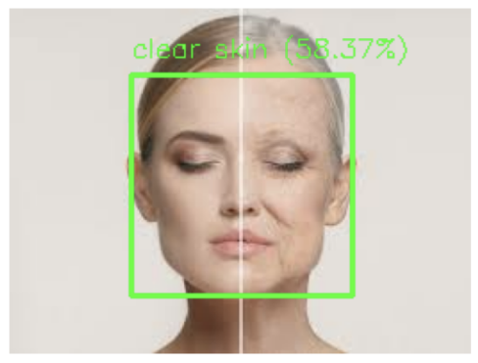

9. Performance Visualization
To evaluate training quality, the following graphs are generated:
- Accuracy vs Epoch Curve: Shows how classification accuracy improves over time.
- Loss vs Epoch Curve: Indicates how prediction error decreases during training.
These plots help in identifying issues such as overfitting or underfitting and guide further model improvements.

10. Performance Visualization
To evaluate training quality, the following graphs are generated:
- Accuracy vs Epoch Curve: Shows how classification accuracy improves over time.
- Loss vs Epoch Curve: Indicates how prediction error decreases during training.
These plots help in identifying issues such as overfitting or underfitting and guide further model improvements.
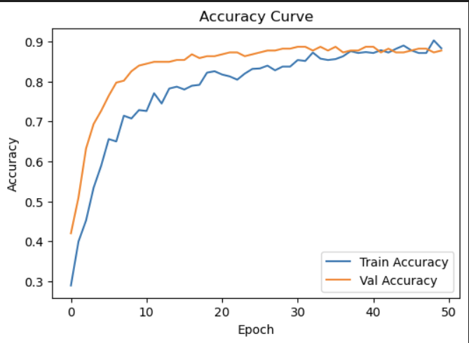
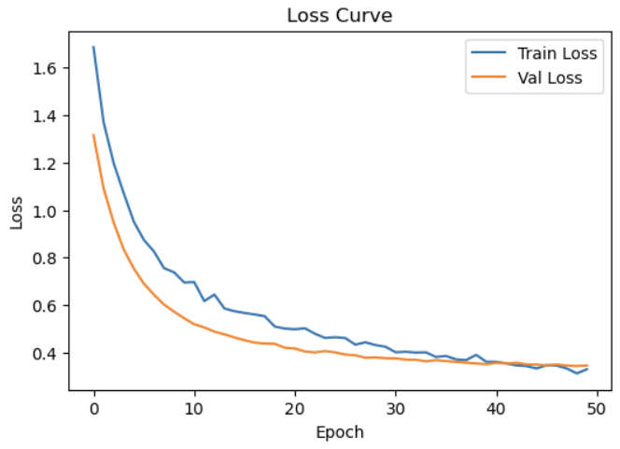
11. Challenges Faced
During development, several challenges were encountered:
- File path mismatches between C drive and D drive
- Missing or incorrectly named image files
- Oversized bounding boxes due to Haar Cascade default parameters
- Lower confidence scores caused by limited dataset size
These challenges were resolved through path validation, preprocessing improvements, and parameter tuning. I also run drive check with the help of Command Prompt and remove the corrupt file that causes the problem in running the script.

Milestone-3
Module-5: Web UI for Image Upload and Visualization
1.Objective
The objective of this module is to design and implement an interactive web-based user interface that allows users to upload facial images and visualize the results of AI-based skin analysis in a clear and user-friendly manner. This module focuses on presenting the output of the trained deep learning model through visual elements such as images, tables, charts, and annotations.
2.Description
In this module, a web interface is developed using Streamlit, which acts as the frontend of the Dermal AI system. The interface enables users to upload an image, processes the image through the backend inference pipeline, and displays the analysis results in real time.
The UI is designed to be clean, responsive, and intuitive so that users can easily understand the predictions made by the AI model. The interface separates the original image and the annotated image for better comparison and provides additional visual insights such as confidence scores and prediction tables.
3.Key Features Implemented
- Image Upload Interface
  - Users can upload facial images in common formats such as JPG and PNG.
  - The uploaded image is displayed immediately on the interface for verification.
- Original and Annotated Image Display
  - The original uploaded image is shown on one side.
  - The annotated image, containing a bounding box around the detected face along with prediction labels, is displayed alongside it.
- Bounding Box Visualization
  - A rectangular bounding box is drawn around the detected face.
  - The bounding box includes the predicted skin condition, confidence percentage, and estimated age.
- Prediction Summary
  - The primary predicted skin condition is displayed clearly.
  - Confidence score and estimated age are shown for easy interpretation.
  - Processing time is calculated and displayed to indicate system efficiency.
- Detailed Confidence Analysis
  - A detailed table shows confidence percentages for all skin condition classes.
  - An interactive bar chart visualizes the confidence distribution across all classes.
- Download Functionality
  - Users can download the annotated image for future reference or reporting.
- Prediction Table
  - A structured table displays technical details such as:
    - Bounding box coordinates
    - Predicted class
    - Confidence score
    - Estimated age
    - Detection confidence
4.Technology Stack:-
Component | Technology
Frontend | Streamlit
Deep Learning | TensorFlow / Keras
Face Detection | OpenCV (Haar Cascade)
Image Processing | OpenCV, Pillow
Data Handling | NumPy, Pandas
Visualization | Streamlit Charts

Module-6: Backend Pipeline for Model Inference
5.Inference Logic (inference.py)
Inference.py contains all core AI logic:
- Model loading
- Face detection
- Image preprocessing
- Skin prediction
- Age estimation logic (heuristic)
This file can be reused for:
- REST APIs
- Batch processing
- Mobile or desktop apps
6.User Interface (app.py)
app.py handles:
- Image upload
- Display of original & annotated images
- Visualization of confidence scores
- Prediction tables
- Download functionality
It does not contain ML logic, making it easy to maintain.
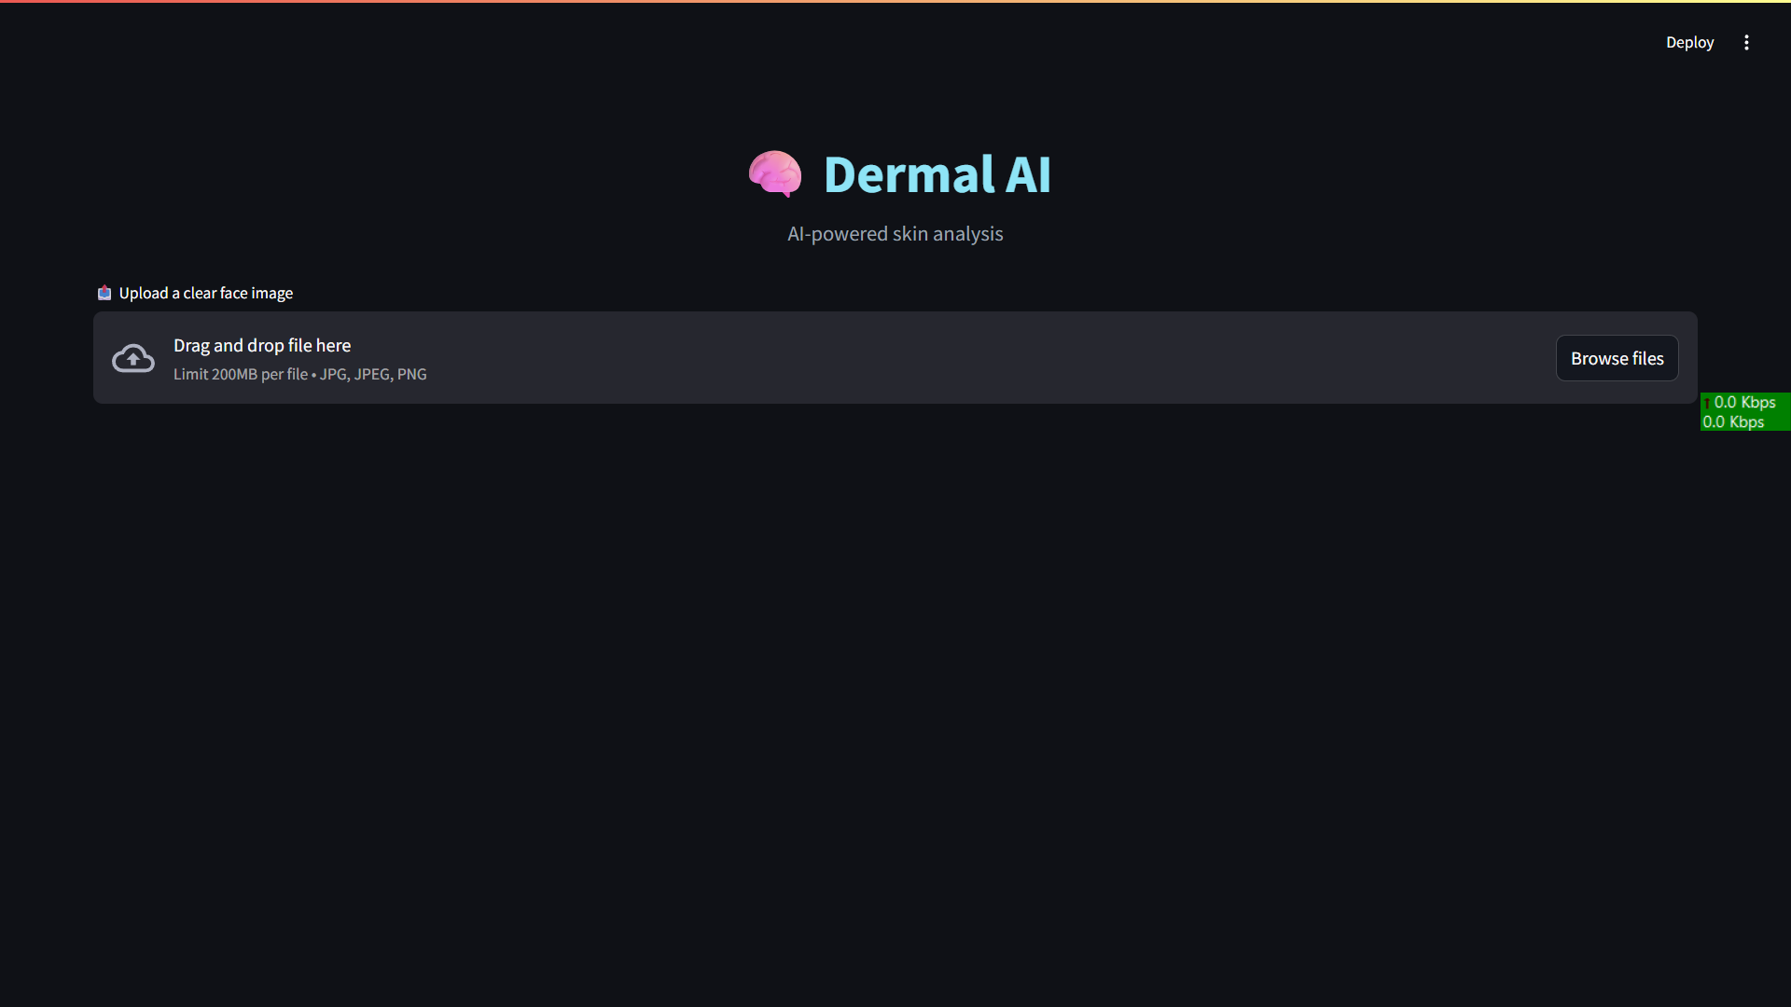

7.How the System Works:
User Uploads Image
↓
Face Detection (OpenCV Haar Cascade)
↓
Face Cropping & Preprocessing
↓
Skin Classification Model
↓
Confidence Calculation
↓
Bounding Box Annotation
↓
UI Visualization + Download
8.Outcome
This module successfully bridges the gap between the AI backend and the end user by providing a visually rich and interactive interface. It enhances user experience by transforming raw model predictions into meaningful visual insights, making the system accessible even to non-technical users.

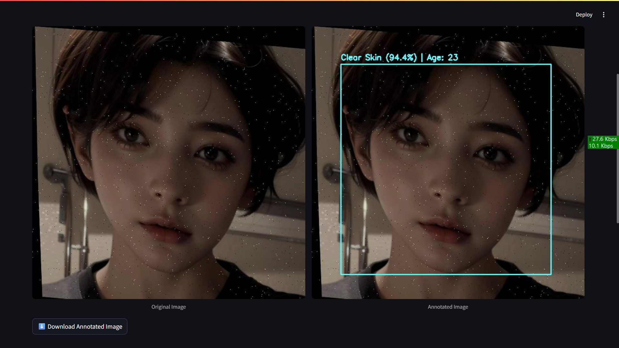

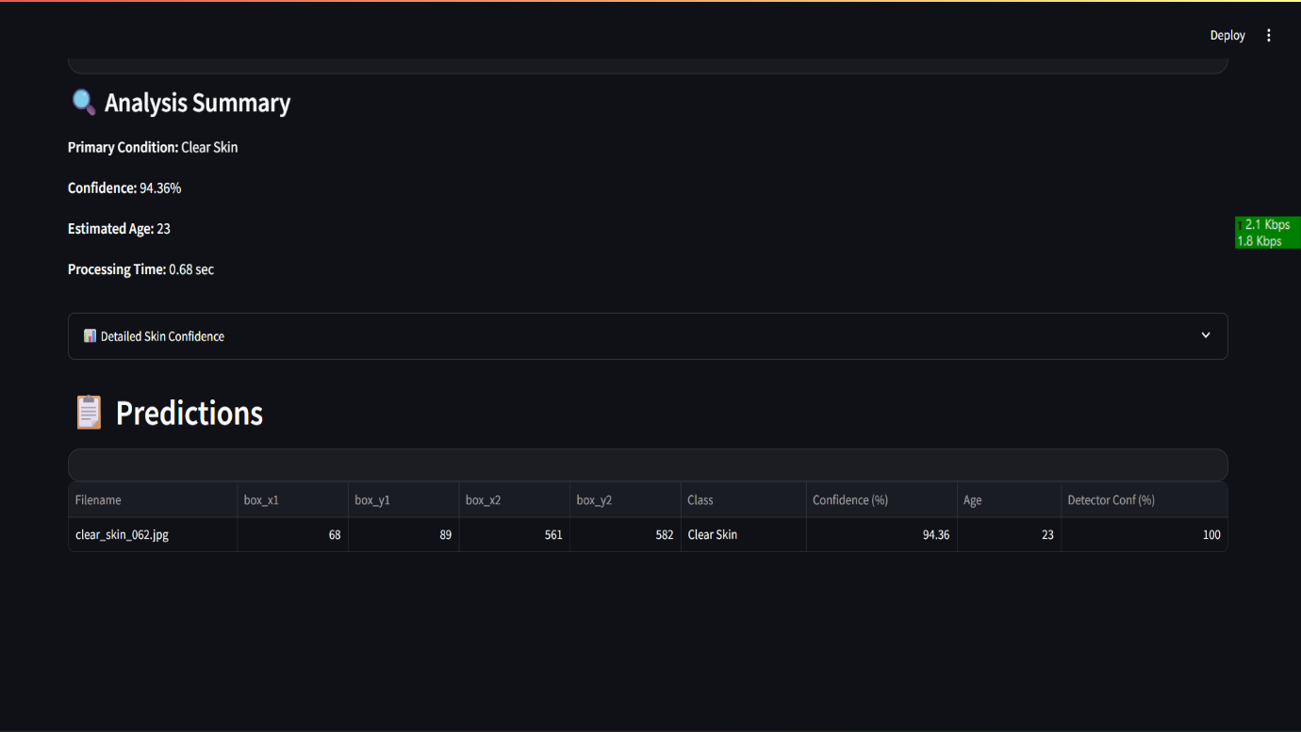
9.Conclusion
Module-5 and Module-6 plays a crucial role in the Dermal AI project by enabling real-time interaction with the AI system. It demonstrates how machine learning outputs can be effectively visualized through a web interface, making the solution practical, user-centric, and suitable for real-world applications.

