🎙
Meeting Summarizer Pro
Capture · Transcribe · Diarize · Summarize · Export
An End-to-End AI-Powered Meeting Intelligence Platform
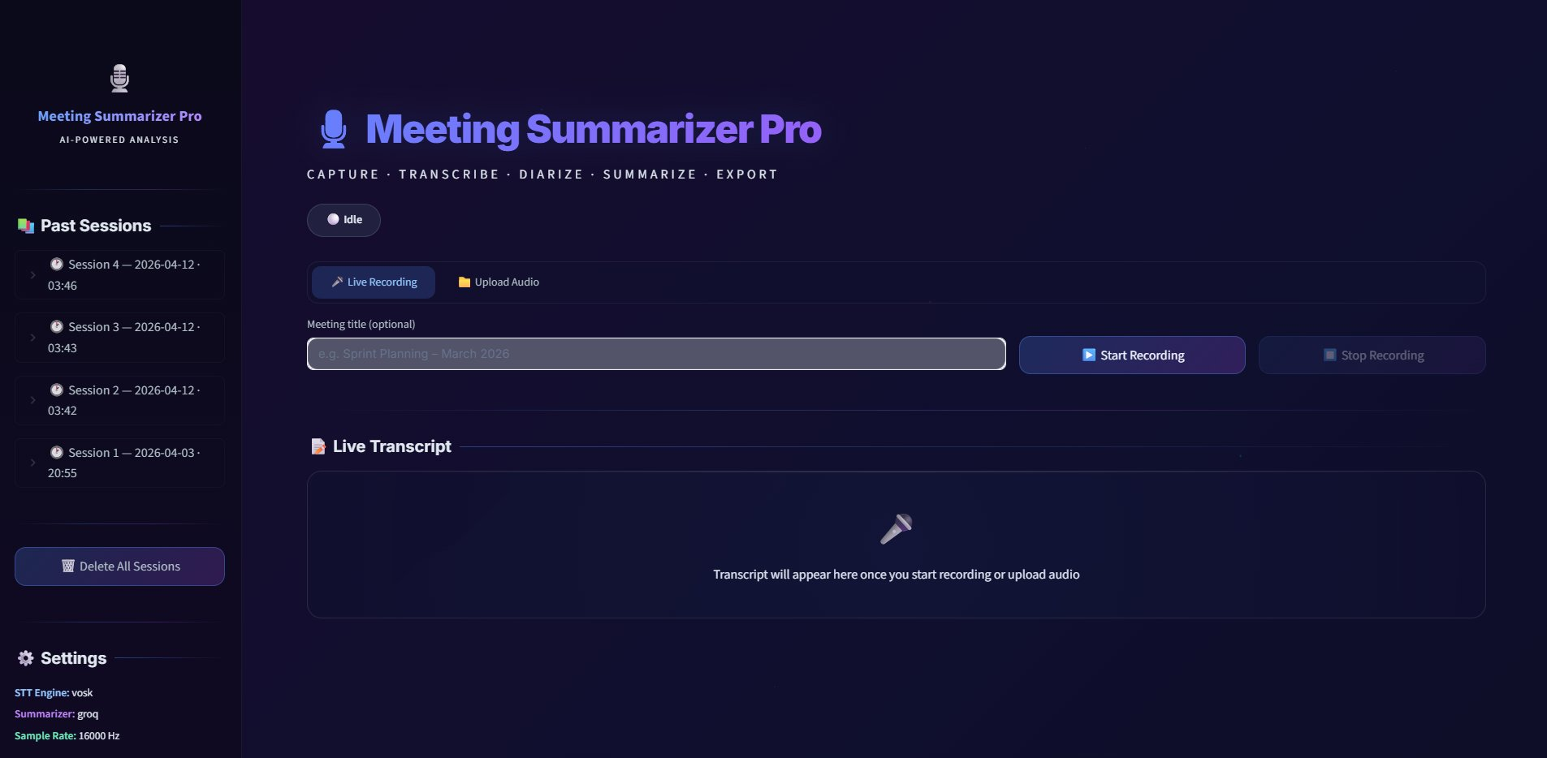
Fig. 1 — Meeting Summarizer Pro: Hero Interface with Live Transcript Panel, Session History & Settings

Python 3.10+ · Streamlit · Whisper / Vosk · pyannote.audio · Groq LLaMA 3.1 · Hugging Face
Real-Time Speech Intelligence · Multi-Speaker Diarization · LLM Summaries · Rich Analytics · One-Click Export

1. Project Overview
Meeting Summarizer Pro is a production-grade, full-stack AI application that converts live spoken conversations — or pre-recorded audio files — into structured, actionable meeting summaries with zero manual effort. It combines four state-of-the-art AI models into a single, beautifully crafted Streamlit interface, eliminating the traditional pain point of meeting documentation.
Design philosophy: Remove every friction point between a spoken meeting and a written record. Press Start. Speak. Press Stop. Fully automated.

1.1 Core Capabilities
- 🎤 Audio Capture — Live microphone audio via PyAudio/SoundDevice in real-time PCM chunks; partial transcription streams to UI with sub-second latency.
- 📝 Speech-to-Text — Vosk (offline, <30 ms/chunk) or OpenAI Whisper (transformer, <8% WER), selectable without code changes.
- 👥 Speaker Diarization — Up to 6 distinct speakers via pyannote.audio, with colour-coded, time-aligned transcript output.
- 🤖 LLM Summarization — Groq LLaMA 3.1 (<3 seconds) or BART/T5 via Hugging Face (fully offline) for structured summaries.
- 📊 Analytics Dashboard — Duration, word count, speaker distribution bars, words-per-minute, and top-25 keyword frequency cloud.
- 📤 Export & Archive — Markdown or PDF export, Gmail SMTP email dispatch, and auto-archive to JSON/Parquet per session.

1.2 Dual Input Modes
🔴 Live Recording Mode  Press Start Recording to open the system microphone. Audio is captured in real time and the live transcript streams word-by-word. Pressing Stop triggers the full post-processing pipeline: diarization → LLM → summary.  Ideal for: stand-ups, interviews, live team meetings | 📁 Upload Audio Mode  Drop any audio file — WAV, MP3, M4A, OGG, FLAC, or WebM — into the upload zone. pydub automatically converts non-WAV formats before routing through the same full pipeline.  Ideal for: recorded calls, podcasts, archived sessions

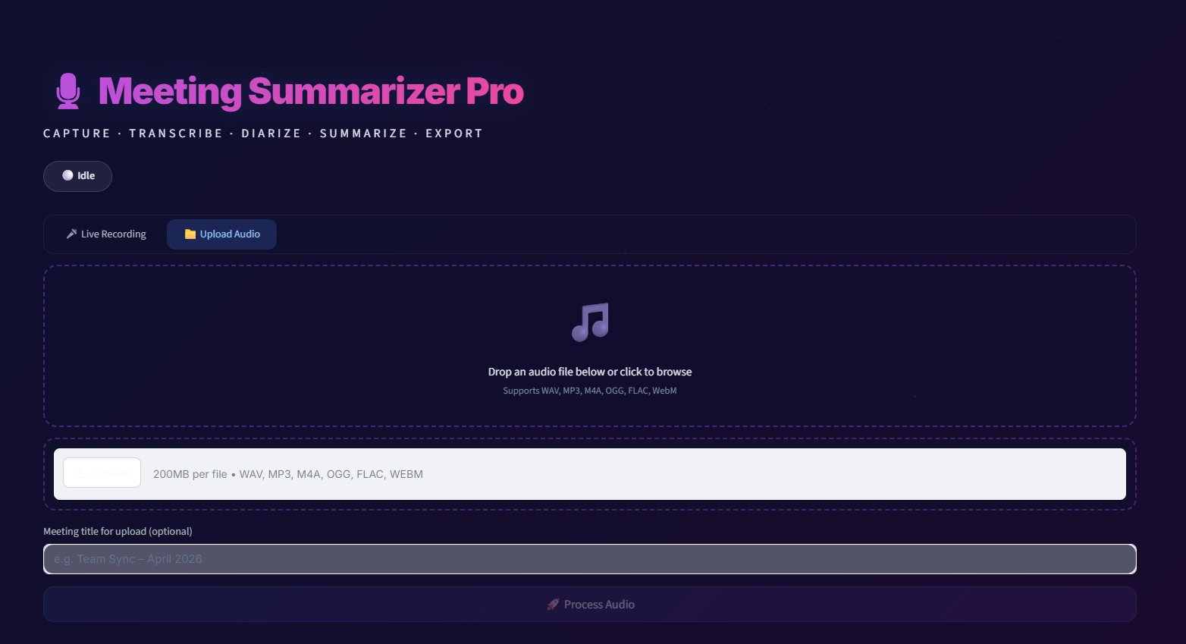
Fig. 2 — Upload Audio Mode: Drag-and-drop zone with format support (WAV, MP3, M4A, OGG, FLAC, WebM)
2. System Architecture
The application is built around a central MeetingPipeline class (src/pipeline.py) that orchestrates all processing threads and owns the authoritative application state. The Streamlit frontend (app.py) reads from this state object on every UI refresh cycle. All business logic lives entirely in the backend — the UI is deliberately stateless.
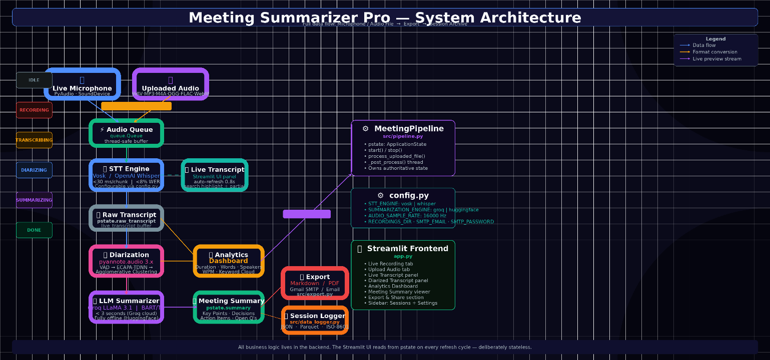
Fig. 3 — Full System Architecture: Microphone / Audio File through to Export and Session Archive

2.1 Pipeline State Machine
The application progresses through six gated states. Each state controls which UI elements are visible and which backend operations are permitted — eliminating race conditions and guaranteeing correct output ordering.
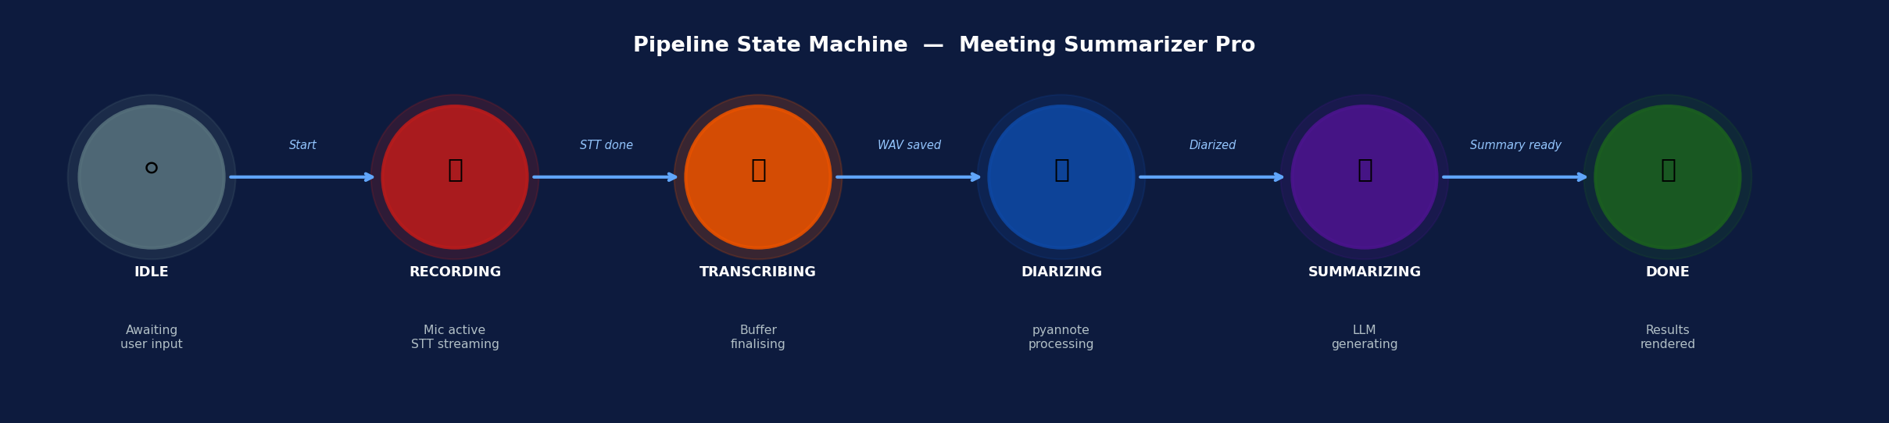
Fig. 4 — Six-State Pipeline: IDLE → RECORDING → TRANSCRIBING → DIARIZING → SUMMARIZING → DONE
IDLE | Start & Upload enabled. All result panels hidden.
RECORDING | Live transcript updating every 0.8s. Mic active.
TRANSCRIBING | STT buffer finalising. UI auto-refreshing.
DIARIZING | pyannote.audio processing saved WAV file.
SUMMARIZING | Diarized transcript sent to LLM for summary.
DONE | All panels visible. Export & email enabled. Session saved.

2.2 Three-Thread Concurrency Model
Three concurrent Python threads underpin live recording without blocking the Streamlit UI refresh loop. They communicate through a single thread-safe queue.Queue, ensuring no audio frame is lost regardless of downstream processing speed.
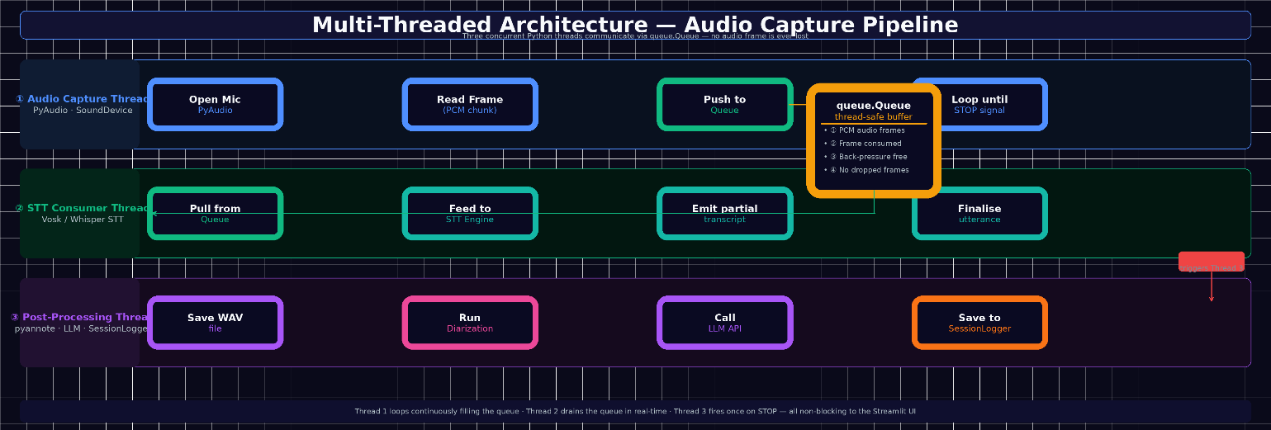
Fig. 5 — Multi-Threaded Architecture: Audio Capture, STT Consumer, and Post-Processing threads
- ① Thread 1 — Audio Capture: Opens system microphone via PyAudio. Reads fixed-size PCM frames into queue.Queue at 16,000 Hz. Loops until STOP signal.
- ② Thread 2 — STT Consumer: Pulls frames from queue; emits partial transcripts (italic) and appends finalised sentences to the live_transcript buffer.
- ③ Thread 3 — Post-Processing: Triggered by STOP event. Saves WAV → runs diarization → calls LLM API → writes session to SessionLogger. Non-blocking.

3. Speech-to-Text Engine
The STT layer converts raw PCM audio into human-readable text in near real time. Two interchangeable back-ends are supported, selectable via config.STT_ENGINE without any code changes.
Vosk — Offline, Ultra-Low-Latency  Kaldi-based acoustic model. Processes each chunk in under 30 ms on modern hardware. Fully on-device — ideal for privacy-sensitive environments.  WER: 10–15% on clean English · Custom vocabulary support · No network calls | Whisper — Transformer, High Accuracy  Trained on 680K hours of multilingual audio. Sub-8% WER on clean English; robust on accented speech. Models: tiny (39M) to large (1.5B params).  Latency: 150–400 ms/segment · Punctuated, capitalized output · Configurable model size

3.1 Live Transcript Panel
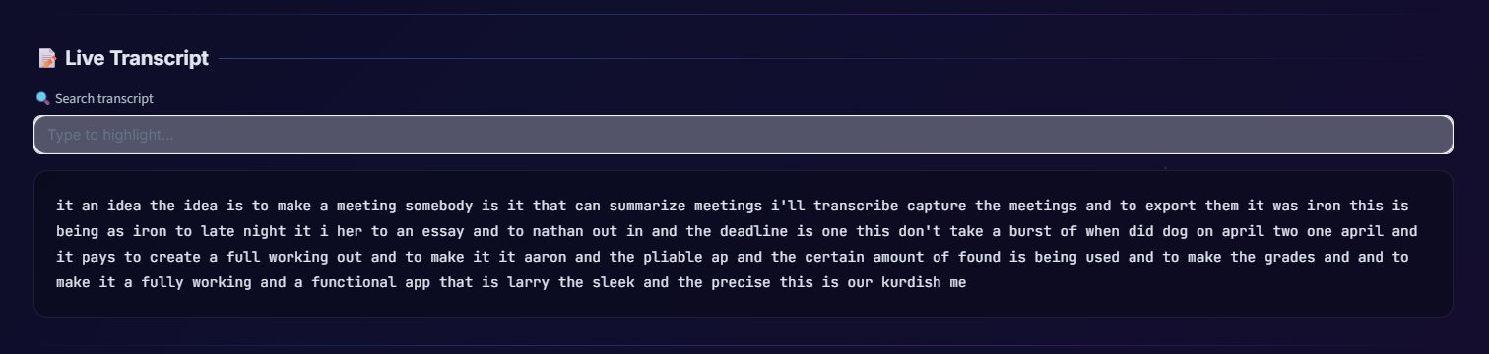
Fig. 6 — Live Transcript Panel with full-text search highlighting
The transcript panel auto-updates every 0.8 seconds via Streamlit's st.rerun() loop. Partial STT results appear in italic. A full-text search field uses Python's re module to highlight all matching terms with a blue overlay in real time.

4. Speaker Diarization
Speaker diarization partitions the audio stream by speaker identity — determining not just what was said, but who said it and when. The saved WAV file is processed by pyannote.audio 3.x through three sequential sub-tasks:
- ① Voice Activity Detection — classifies each 80 ms audio frame as speech or non-speech using a pretrained binary classifier.
- ② Speaker Embedding — each segment is passed through an ECAPA-TDNN network mapping acoustic characteristics to a high-dimensional vector space.
- ③ Clustering — embeddings grouped via agglomerative hierarchical clustering. Each cluster = one speaker, labelled in order of first appearance.

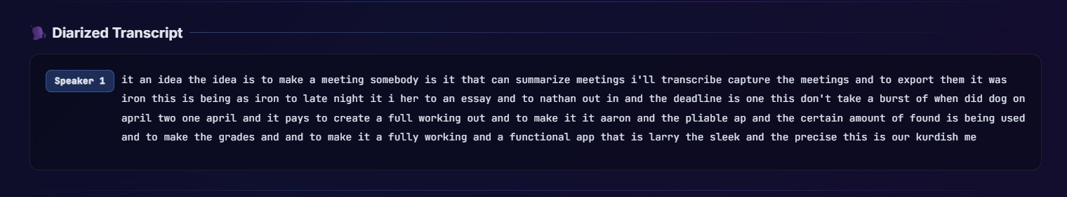
Fig. 7 — Diarized Transcript Panel: colour-coded speaker attribution with timestamped segments

4.1 Colour-Coded Speaker System
The diarized output uses unique colour badges for up to 6 speakers, consistent across the transcript, analytics bars, and summary output.
Speaker 1 — Blue | Speaker 2 — Pink | Speaker 3 — Teal | Speaker 4 — Amber | Speaker 5 — Purple | Speaker 6 — Cyan

5. Meeting Analytics Dashboard
After the pipeline completes, a rich analytics dashboard is automatically rendered, giving participants instant data-driven insight into the meeting's characteristics.
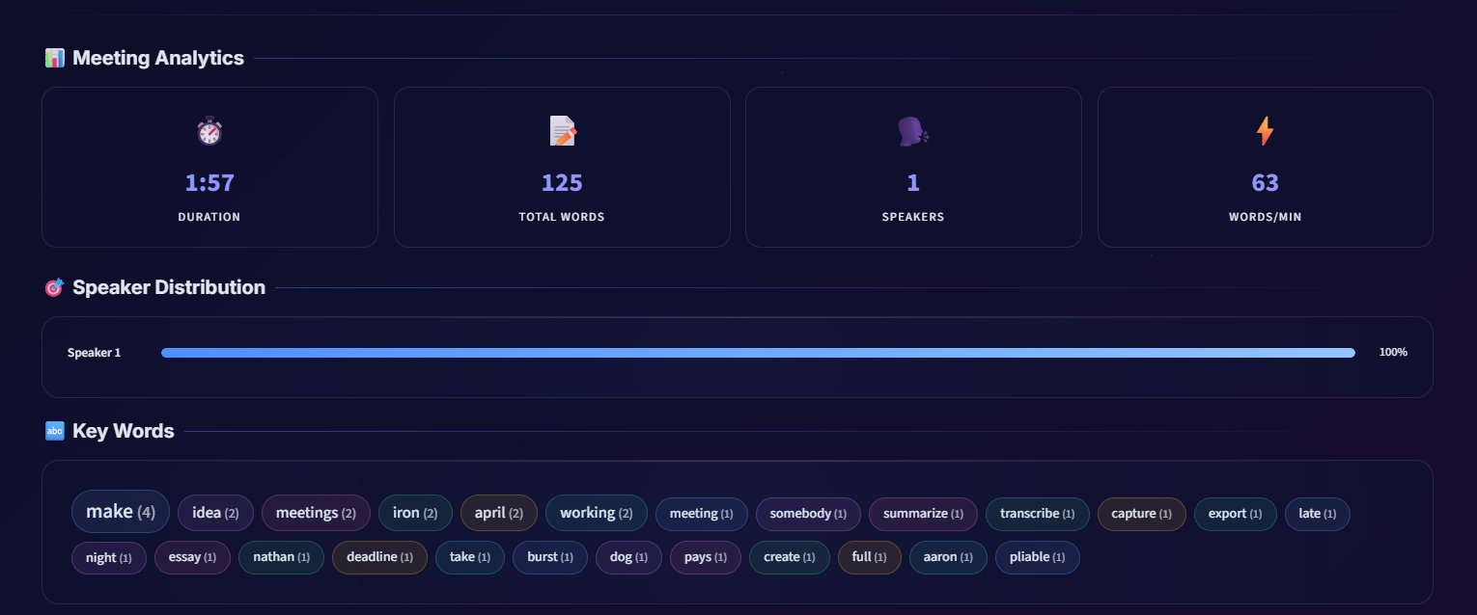
Fig. 8 — Meeting Analytics: Duration, Word Count, Speaker Distribution, and Keyword Cloud

5.1 Four Core Metric Cards
⏱ Duration & 📝 Total Words  Duration computed from WAV frame count ÷ sample rate (Python wave module), displayed as MM:SS. Total words = len(raw_transcript.split()), formatted with thousands separator. | 👥 Speakers & ⚡ Words/Min  Speaker count = unique [Speaker N] labels in diarized transcript. Words/min = total_words ÷ (duration_seconds ÷ 60) — indicates meeting pace and information density.

5.2 Speaker Distribution & Keyword Cloud
Per-speaker word counts are computed by parsing every [Speaker N]: line. Contribution expressed as % of total words, rendered as animated CSS progress bars ranked in descending order using the same gradient colours as the diarized transcript badges.
Keyword cloud: Python collections.Counter applied to raw transcript after stripping 80+ common stop words. Top 25 content words rendered as interactive chips with font-size proportional to frequency: size_factor = 0.75 + (freq / max_freq) × 0.55.

6. AI Meeting Summarization
The summarization module transforms the raw diarized transcript into a structured, decision-ready document. It is model-agnostic — routing to different backends via config.SUMMARIZATION_ENGINE without touching application code.
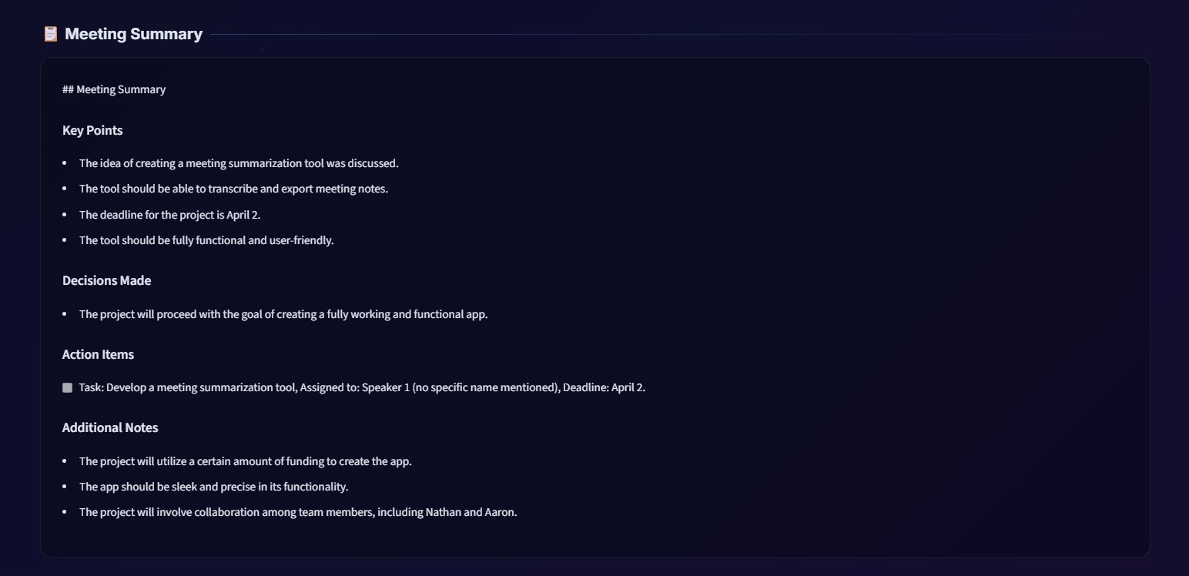
Fig. 9 — AI-Generated Meeting Summary: Key Points, Decisions, Action Items, and Additional Notes

6.1 Groq API — LLaMA 3.1 (Cloud, < 3 Seconds)
Groq provides hardware-accelerated inference via custom LPU chips, delivering LLaMA 3.1 at 500–800 tokens/second. A typical 60-minute meeting transcript is fully summarized in under 3 seconds. The structured prompt produces:
- Executive Summary — 3–5 sentence overview of meeting purpose and outcome.
- Key Decisions — bulleted list of all decisions formally made during the meeting.
- Action Items — per-speaker task assignments with implied deadlines where inferable.
- Open Questions — unresolved issues requiring follow-up before the next meeting.
Speaker attribution is preserved in Action Items — making it immediately clear who owns each task. This eliminates the most common pain point of traditional meeting minutes.

6.2 Summarization Model Comparison
Model | Parameters | Strength | Trade-off
Groq LLaMA 3.1 | Cloud API | Fastest (<3s), best quality, speaker-aware | Requires internet; API key needed
BART-large-CNN | 406M params | Fully offline, strong abstractive summarization | Slower on CPU; no speaker attribution
T5-base | 220M params | Fastest local inference, resource-efficient | Lower quality on long transcripts

7. Export, Email & Session Management
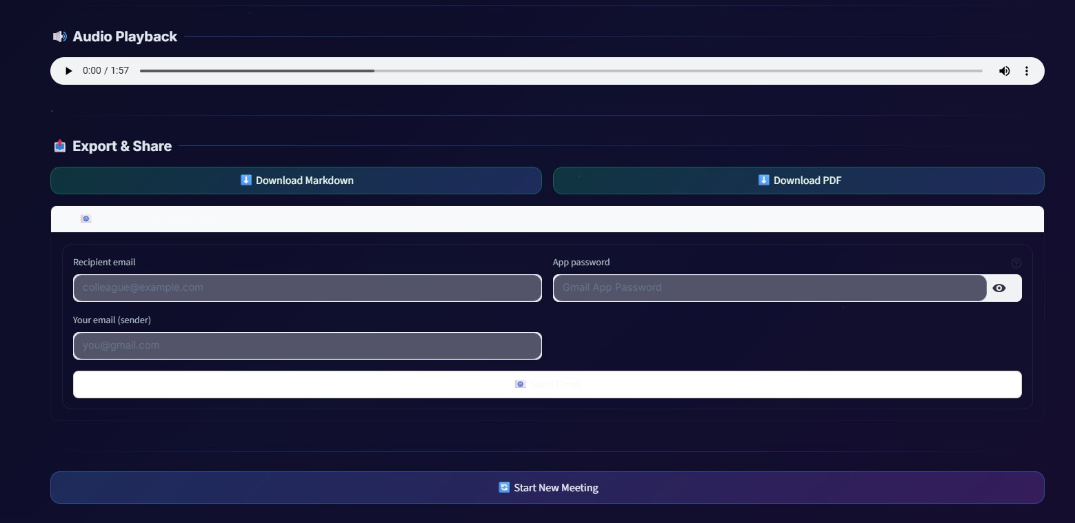
Fig. 10 — Export & Share Panel: Download Markdown, PDF, and Gmail email dispatch

7.1 One-Click Export
📄 Markdown Export (.md)  Full structured summary + diarized transcript encoded as UTF-8. Served via st.download_button. Preserves all headings, speaker labels, and bullet formatting. Paste directly into Notion, Confluence, or GitHub. | 📑 PDF Export (.pdf)  export_pdf() in src/export.py generates a polished PDF with section headings, speaker attribution, and professional typography. Served as binary download — suitable for archival or email attachment.

7.2 Email Dispatch via Gmail SMTP
An expandable email panel uses smtplib with SSL/TLS authentication via a Gmail App Password. The send_email() function composes a MIME multipart message with meeting title, date, summary, and diarized transcript. Input validation confirms addresses before delivery.
- Subject: auto-formatted as 'Meeting Summary — [Meeting Title]'
- Gmail App Password (myaccount.google.com/apppasswords) used for secure auth — main Google password never entered or stored.
- Inline success/error feedback via st.success() / st.error() renders immediately after the send attempt.

7.3 Session Logger & History Archive
Every completed meeting is auto-saved by the SessionLogger class (src/data_logger.py). Each record contains: full raw transcript, diarization output, LLM summary, unique speaker list, and an ISO-8601 timestamp — stored as JSON or Parquet.
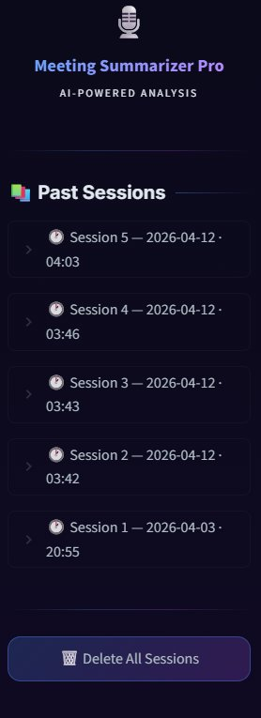 | Session Sidebar Features  - Sessions listed in reverse chronological order  - Expanding a session previews first 500 characters of its summary  - Per-session delete button with confirmation dialog  - Bulk 'Delete All' button for archive management  - Sessions identified by filename for reliable targeting

8. UI / UX Design System
Meeting Summarizer Pro features a premium glassmorphism design system that sets it well apart from standard Streamlit prototypes.

8.1 Glassmorphism Visual Design
- ◆ Glass Cards — Semi-transparent panels with backdrop-filter: blur(24px), rgba backgrounds, and 1px glass borders create depth without heavy shadows.
- ◆ Animated Background — 4-keyframe CSS animation cycles the deep-navy/purple gradient on a 15-second infinite loop.
- ◆ Floating Particles — CSS pseudo-element radial gradients create subtle twinkling particles with sinusoidal opacity animation.
- ◆ Gradient Typography — Hero title uses a 4-colour animated gradient (blue → purple → pink → amber) via -webkit-background-clip: text.

8.2 JavaScript Interaction Layer
A custom JS component (streamlit.components.v1.html) adds two premium 60 fps interaction effects running entirely in the browser:
- Mouse-Follow Glow — A 420 px radial gradient blob follows the cursor with smooth lerp animation (gx += (mx - gx) × 0.08).
- 3D Card Tilt — Glass cards respond to mouse hover with a 3D perspective tilt (rotateY(dx*2deg) rotateX(-dy*2deg)) computed from mouse position relative to each card's bounding rect.

8.3 Status Badge System
IDLE | Start & Upload enabled. All result panels hidden.
RECORDING | Live transcript updating every 0.8s. Mic active.
TRANSCRIBING | STT buffer finalising. UI auto-refreshing.
DIARIZING | pyannote.audio processing saved WAV file.
SUMMARIZING | Diarized transcript sent to LLM for summary.
DONE | All panels visible. Export & email enabled. Session saved.

9. Complete Technology Stack
Every library and tool in the application — including backend modules not directly visible in app.py — is catalogued below.
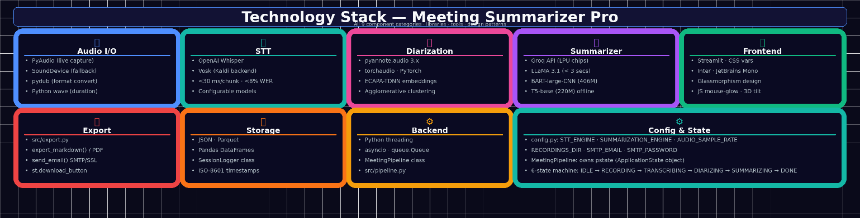
Fig. 11 — Full Technology Stack: all 9 component categories with specific libraries and tools
Component | Libraries & Details
Frontend | Streamlit · streamlit.components.v1 · Custom CSS (Inter font) · JetBrains Mono · glassmorphism · CSS keyframe animations · JS mouse-glow & 3D tilt
Audio I/O | PyAudio · SoundDevice (live capture) · pydub (MP3/M4A/OGG/FLAC/WebM → WAV) · Python wave module
STT | Vosk (offline Kaldi-based, <30 ms/chunk) · OpenAI Whisper (transformer, tiny → large models)
Diarization | pyannote.audio 3.x · torchaudio · PyTorch · ECAPA-TDNN speaker embeddings · Agglomerative clustering
Summarization | Groq API → LLaMA 3.1 (<3s, 500–800 tok/s) · Hugging Face → BART-large-CNN (406M) · T5-base (220M)
Analytics | Python collections.Counter (word frequency) · Custom stop-word filter (80+ words) · CSS animated bars · HTML word-chip cloud
Export | src/export.py: export_markdown(), export_pdf(), send_email() · smtplib (Gmail SMTP/SSL) · st.download_button
Session Store | src/data_logger.SessionLogger · JSON · Parquet · Pandas · ISO-8601 timestamps · Per-session and bulk delete
Backend | Python threading · asyncio · queue.Queue · MeetingPipeline state machine (src/pipeline.py) · tempfile
Config | config.py: STT_ENGINE · SUMMARIZATION_ENGINE · AUDIO_SAMPLE_RATE · SMTP_EMAIL · RECORDINGS_DIR

10. Impact & Future Scope
A 60-minute meeting generates 8,000–12,000 words of speech. Meeting Summarizer Pro processes it into a structured summary in under 10 seconds — a task that would take a human 30–45 minutes. That is a 180–270× efficiency gain.

10.1 Key Differentiators
- 🔒 Privacy-first — Vosk STT + Hugging Face summarization paths are fully offline. No audio or transcript leaves the local machine.
- ⚙️ Model-agnostic — Swapping STT engines or summarization models requires only a config.py change. Zero code modifications.
- 🎨 Production-quality UI — Glassmorphism design, animated gradients, JS tilt effects, and colour-coded speaker system set this apart from standard Streamlit prototypes.
- 🗄️ Persistent intelligence — Every session auto-archived with full transcript, diarization, and summary, building a searchable organisational knowledge base.
- 🎙️ Dual input modes — Live recording and file upload share the same pipeline, with automatic format conversion via pydub.

10.2 Future Scope
- Real-time streaming summaries — Generate partial summaries as the meeting progresses, not just after Stop.
- Calendar API integration — Automatically attach summaries to Google Calendar or Outlook meeting events.
- Multi-language support — Switch to a multilingual Whisper model with a single config change.
- Cloud deployment — Containerise with Docker and deploy as a shared team service accessible from any browser.
- Domain fine-tuning — Train custom STT and summarization models on company-specific meeting corpora.

Meeting Summarizer Pro demonstrates a complete AI engineering lifecycle: low-level audio capture, multi-threaded pipeline design, state-of-the-art ML models, production-quality UI, analytics, and one-click output delivery — all in a single, cohesive application.

