1. Project Title
OpenDeepResearcher: Agentic LLM-Based AI Research Assistant

2. Project Objective
The objective of the OpenDeepResearcher project is to develop an AI-powered research assistant capable of autonomously conducting in-depth explorations of complex topics by leveraging large language models (LLMs), agentic workflows, and web search APIs. The system aims to streamline the research process by automatically planning, retrieving, analysing, and summarising information from credible sources. By simulating the behaviour of a skilled human researcher, the tool enables users to generate high-quality, multi-perspective reports efficiently and cost-effectively.

3. Project Description in Detail

Approach
OpenDeepResearcher uses a structured, agent-based pipeline to automate the research lifecycle. The system follows a sequential workflow where different components perform specific roles.
A Planner-like step refines the user’s input query (if implemented) or directly forwards it for processing. A Searcher module then queries the web via the Tavily API to retrieve relevant, up-to-date information. The retrieved results are filtered and structured before being passed to the next stage. A Writer module, powered by a locally hosted or API-based LLM (Qwen2.5-3B-Instruct via LM Studio), synthesises the collected data into a coherent and structured response. Finally, the system generates a well-organised research output from the processed information.

Technology Used
- Python — Core language for all agent logic and orchestration.
- LangChain — Handles LLM integration, memory, and tool coordination.
- LM Studio — Provides local or hosted LLM inference (e.g., Qwen2.5-3B-Instruct).
- Tavily API — Enables real-time web search and content retrieval.
- MemorySaver — Tracks research threads for continuity across sessions.

Real-World Impact
OpenDeepResearcher dramatically reduces the time and effort required to conduct thorough research on complex topics. It is particularly valuable in academia, business intelligence, legal research, and journalism, where comprehensive, multi-source analysis is critical. Automating the planning, searching, and synthesis pipeline, it enables professionals to focus on decision-making rather than information gathering while maintaining source citations for credibility and traceability.

4. Timeline Overview
Week | Activities Planned | Activities Completed
Week 1 | Set up Python environment, virtualenv, and install dependencies | Development environment configured
Week 2 | Design project architecture, define agent responsibilities and data flow | Architecture drafted; stubbed research flow returns basic output
Week 3 | Build Planner Agent (sub-question decomposition) and Searcher Agent (Tavily integration) | Planner and Searcher agents functional
Week 4 | Build Writer Agent, implement LangGraph execution pipeline, validate end-to-end flow | Full research loop executes; coherent summaries generated
Week 5 | Build ChatGPT-like UI; connect UI to backend agent pipeline | UI is integrated and interactive
Week 6 | Implement session memory (MemorySaver), midpoint testing | Session memory functional; midpoint review completed
Week 7 | Improve agent coordination, prompt tuning, and structure the final report output with citations | Structured report generation with cited sources
Week 8 | Optimise performance, finalise documentation, and prepare demo | Full system demo and documentation completed

5. Project Execution Details
The project was executed in four structured milestones, each spanning two weeks, with evaluations at the close of each milestone to ensure alignment with objectives.

Milestone 1 — Foundation Setup (Weeks 1–2):
- Configured the Python development environment with virtualenv and all required dependencies.
- Defined the overall system architecture, agent responsibilities, and data flow.
- Integrated a local LLM via LM Studio and configured the Tavily API for web search.
- Produced a stubbed research flow that returned basic output by the end of Week 2.

Milestone 2 — Core Agent Development (Weeks 3–4):
- Built the Planner Agent to decompose the main research query into targeted sub-questions.
- Built the Searcher Agent to fetch relevant content using the Tavily API.
- Built the Writer Agent to synthesise retrieved data into structured summaries using the LLM.
- Implemented the LangGraph execution pipeline and validated the end-to-end research loop.

Milestone 3 — UI and Memory Integration (Weeks 5–6):
- Designed and built a clean, ChatGPT-like user interface for prompt input and result display.
- Connected the UI to the backend multi-agent pipeline.
- Implemented session memory using MemorySaver to support thread tracking and research continuity.
- Conducted midpoint testing and addressed identified issues.

Milestone 4 — Refinement and Final Output (Weeks 7–8):
- Improved agent coordination and refined prompts for higher-quality outputs.
- Structured final reports with organised sections, cited sources, and timestamps.
- Optimised overall system performance and response quality.
- Finalised all documentation and prepared the project demo.

6. Snapshots / Screenshots

Figure 1: User Input and Generated Output

Description:
This figure shows the user query provided to the system and the final structured research output generated by the LLM.
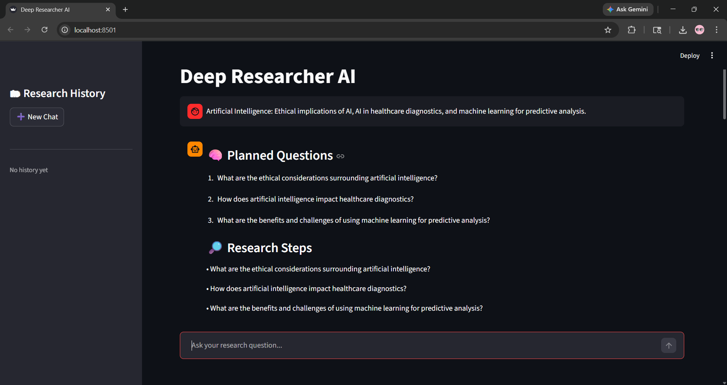

Figure 2: Tavily Search Results (Console Output)
Description:
This figure displays the raw search results retrieved from the Tavily API, including title and URL.
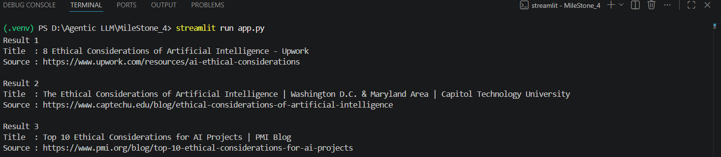

3. Code Snippet : Web Search Function
Description:
This figure shows the implementation of the search_web() function, which integrates the Tavily API and filters results.

TAVILY_API_KEY = os.getenv("TAVILY_API_KEY")
if not TAVILY_API_KEY:
raise ValueError("TAVILY_API_KEY not found in .env file")
tavily = TavilyClient(api_key=TAVILY_API_KEY)

def search_web(query: str):
try:
response = tavily.search(
query=query,
search_depth="advanced",
max_results=3
)

results = response.get("results", [])
if not results:
print("No results found.")
return [
output = []
for i, result in enumerate(results, 1):
title = result.get("title", "No Title")
content = result.get("content", "")[:500]
url = result.get("url", "No URL")

print(f"\nResult {i}")
print(f"Title : {title}")
print(f"Source : {url}")

output.append({
"title": title,
"url": url,
"content": content
})

return output

except Exception as e:
print("Search Error:", str(e))
return []

Figure 4: LM Studio – Local LLM Execution

Description:
This figure shows the Qwen2.5-3B-Instruct model running locally using LM Studio.

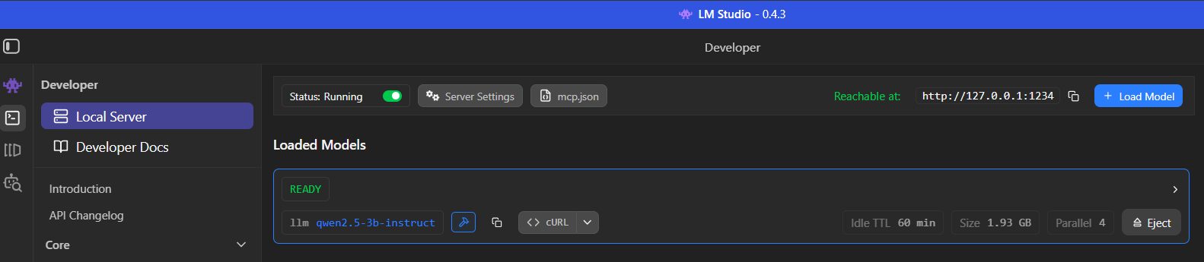

7. Challenges Faced
- LLM Hallucination & Quality Control:
Ensuring that the LLM (Qwen2.5-3B-Instruct) generated accurate and relevant summaries was challenging. Prompt engineering and iterative tuning were required to reduce incorrect or misleading outputs.
- Web Search Relevance:
Retrieving highly relevant results from the Tavily API required careful configuration. This was addressed by using advanced search depth, limiting results to top entries, and applying content filtering techniques such as truncation and structured extraction.
- Pipeline Design & Data Flow Management:
Designing a smooth and efficient sequential pipeline was challenging, as data needed to be correctly passed between different stages (web search and LLM processing). Ensuring that the retrieved search results were properly structured before being given to the LLM was important to avoid incomplete or inconsistent outputs.
- Handling API Responses:
Processing raw Tavily API responses and converting them into a clean, structured format suitable for LLM input required additional parsing and filtering logic.
- Local LLM Performance:
Running the Qwen2.5-3B-Instruct model locally via LM Studio introduced latency. Optimisations such as limiting input size and filtering content were necessary to maintain acceptable response times

8. Learnings & Skills Acquired
- Agentic AI Architecture: Gained deep understanding of multi-agent systems, agent orchestration, and agentic workflow design using LangGraph and LangChain.
- LLM Integration: Acquired hands-on experience integrating local LLMs (via LM Studio) and cloud APIs into production-grade pipelines.
- Prompt Engineering: Developed skills in crafting and iterating system prompts for Planner, Searcher, and Writer agents to maximise output quality.
- Web Search API Usage: Learned to effectively use the Tavily API for real-time research content retrieval and result filtering.
- Python & Tooling: Strengthened Python proficiency, environment management (venv), and version control (Git) practices.
- Streamlit: Built an end-to-end AI-powered application integrating backend agents, LLM inference, and a user-facing UI.

9. Conclusion
The OpenDeepResearcher project delivered a fully functional, agentic AI research assistant capable of autonomously planning, retrieving, synthesising, and reporting on complex topics. Over eight weeks, the project progressed from environment setup to a polished, demo-ready system with a working UI and session memory. The experience provided invaluable exposure to cutting-edge agentic AI frameworks, real-world LLM integration challenges, and end-to-end product development — all of which strongly align with both academic growth and professional career goals in AI and software engineering.

10. Acknowledgements
Sincere thanks to the mentors, team members, and the organisation for providing the opportunity, guidance, and resources needed to complete this internship project. Your support and feedback were instrumental in shaping both the project outcomes and personal growth throughout this journey.

