Bouseathlon Illustrated Quick Guide
BouseInTheNose • Season 26/27. A short event-day reference; use the handbook for complete rules. Officials review faults and disputes. Impartial alternates replace conflicted officials.

1 Field Goal
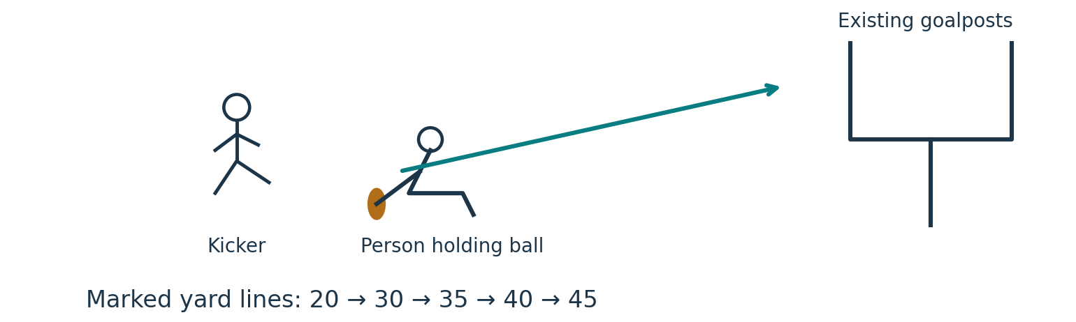
≤5 remain OR reach 45: use 1-yard steps. Example: 4 left after 30 → next is 31. Kick above the crossbar, between the uprights. One kick per distance; one miss eliminates, subject to winner-only sudden death.
Shared lower places stand. To decide the winner: equal attempts; all miss = repeat; all hit = move back 1 yard; otherwise only hitters continue. A sole successful contender wins.

2 QB Throw
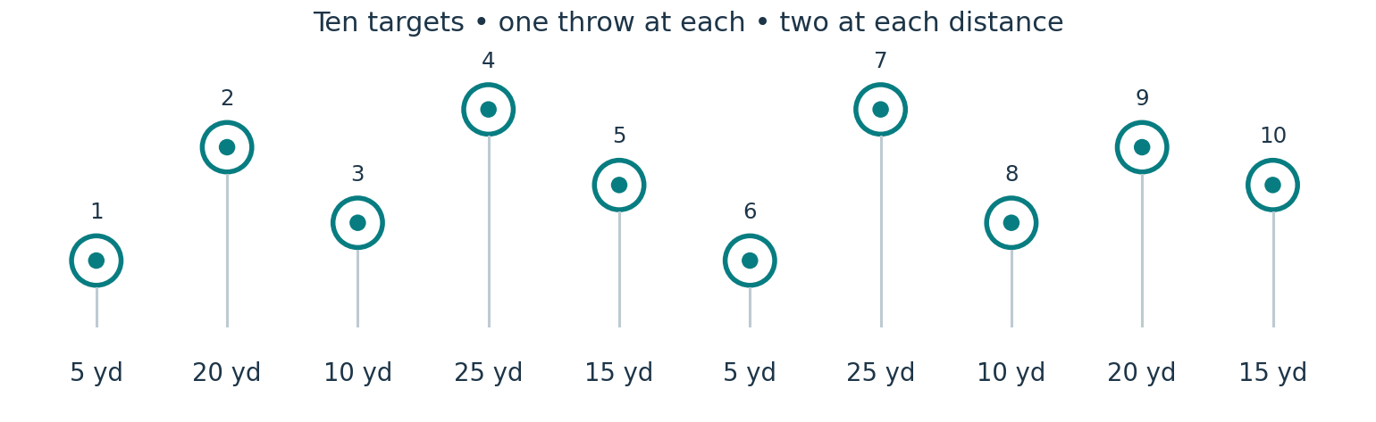
Example sequence only — use the same selected sequence for everyone. One throw per target, then move on. Any contact counts; most hits wins.
Separate first and second by equal-attempt throwing sudden death to select QB1 and QB2. Keep resolving any group still eligible for either place; other ties may stand.

3 Routes
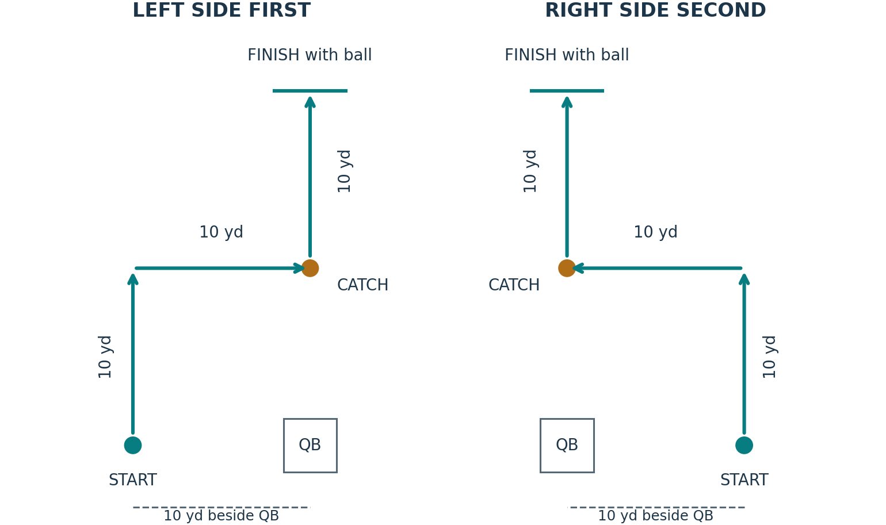
View from behind the QB. Start on the left side first; mirror on the right second. Run forward, cut 90° towards the centre, catch, turn upfield and cross the finish with the ball in hand.
Random runner order. QBs alternate per runner: the same QB handles both routes and all retries. When a QB runs, the other throws. The QB stays in the pocket.
START on “Hut” as the QB receives the ball. STOP at the finish with ball. Two timekeepers; average their readings.
Missed catch or fumble: stop when the ball touches the ground. Wrong route or missed marker: stop when noticed, subject to review. Retry the route and retain failed-attempt time; reset time does not count.
A genuinely bad throw is disregarded after impartial review: retry without that attempt’s time. The QB involved cannot judge the disputed throw. Replace all conflicted officials; a three-person panel decides by majority.
Add left and right accumulated times; lowest total wins. Tiebreak: faster accumulated individual route, including failed attempts. If still tied, share placement and pooled points.

4 Beer Dash
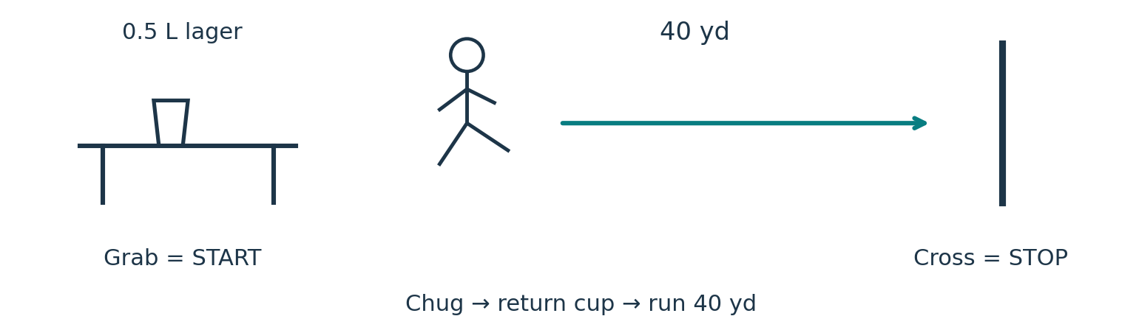
One scored attempt. Contestant decides when the cup is empty; commissioners check afterwards. Spill penalties per incident: minor +3 sec; major +5 sec. Sufficient beer left +5 sec. Tiny droplets generally receive no penalty.
Result = (Timekeeper 1 + Timekeeper 2) ÷ 2 + applicable penalties. Lowest result wins; equal results share placement and pooled points.

5 Gauntlet
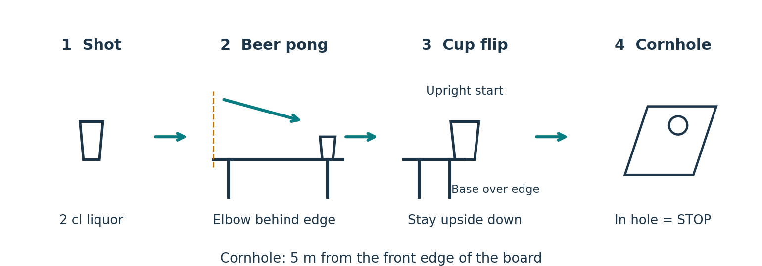
One scored attempt. Grab the shot glass = START. Complete each station before advancing. Use one beer-pong cup at the opposite end of the table. Illegal throw = miss; keep trying while time runs.
Flip cup starts upright with part of its base over the table edge. It must land and remain upside down. Retry misses. Cornhole: 5 m from the front edge of the board; throw until a bag goes in the hole = STOP.
Two officials time; the third watches the beer-pong elbow line. Other contestants retrieve balls and bags. Average both times; lowest wins. Ties share points. Impartial alternates replace conflicted officials.

6 Cornhole
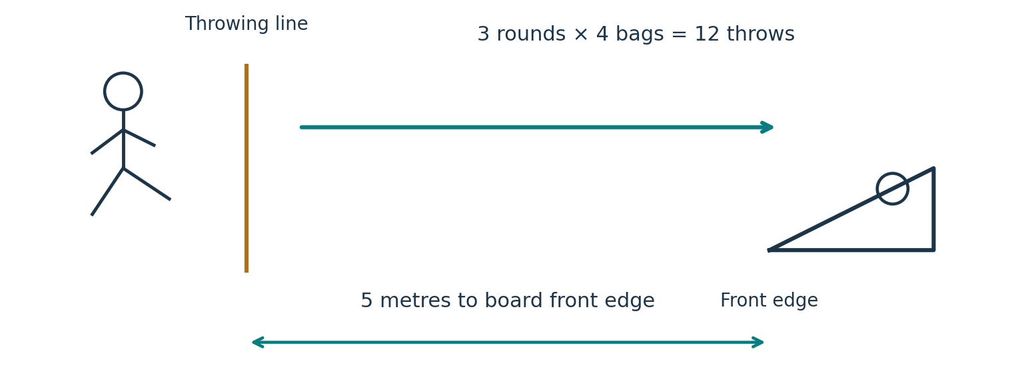
Only bags in the hole count. Individual event; most scored bags wins. A later legal throw knocking a bag into the hole also counts. Clear the board between rounds.
Foot fault: throw used, no score. Undo scoring caused by that throw and reset affected bags. Commissioners review faults and disputes.

7 Darts
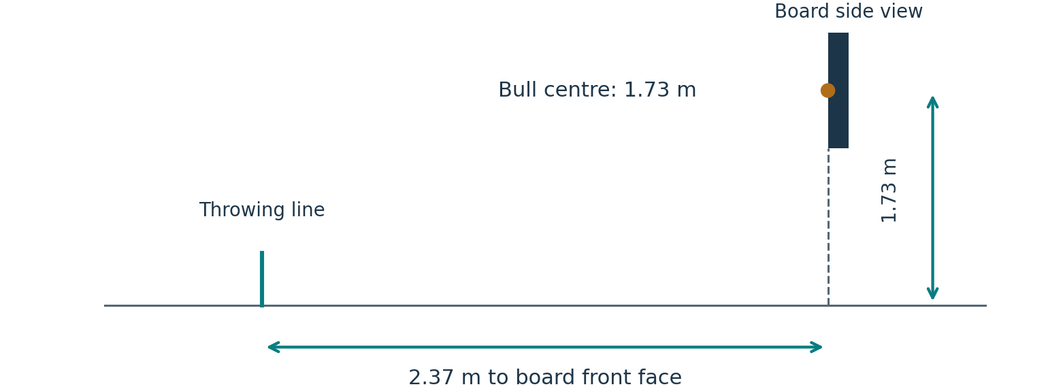
Kenny’s regular dartboard. 3 sets × 3 darts = 9 throws. Add all nine scores; highest total wins. Singles, doubles and triples; outer bull 25, inner bull 50.
Bounce-outs: zero, no rethrow. Foot fault: zero and dart used. Commissioners review faults. Cornhole and Darts ties share placement and pooled points.

8 Kubb
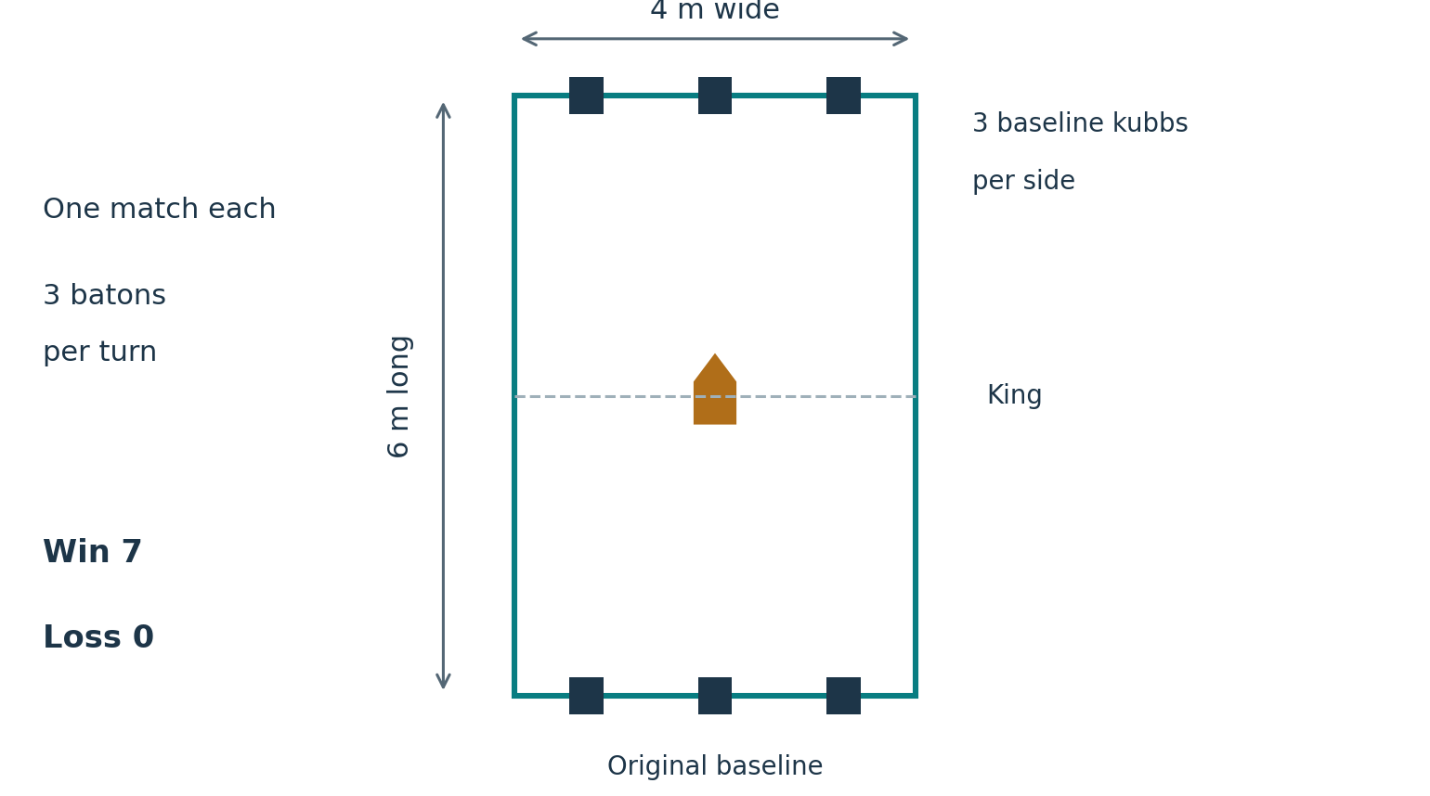
After Event 7, seed 1 vs 14, 2 vs 13, 3 vs 12, 4 vs 11, 5 vs 10, 6 vs 9, 7 vs 8. Rock-paper-scissors resolves tied seeds. The lower-ranked contestant starts.
Throw underarm and vertically in the direction of travel, holding one end. No helicopter throws. Illegal throw: baton used, warning, reset all pieces it knocks down, including the king.
Between turns, throw knocked-down kubbs underarm onto the opponent’s half and stand them where they land. Three placement attempts total per kubb; after three failures, the opponent places it on their own half.
Clear all field kubbs before baseline kubbs; reset a baseline kubb knocked down too early. If field kubbs remain, the opponent may advance to the foremost field kubb on their own half for regular throws.
All king throws from the original baseline. Clear all opposing field and baseline kubbs first; use remaining batons. A legal early king knockdown loses; a legal king knockdown after clearing wins. If the king stays up, play passes to the opponent.
One match each. Win 7 / Loss 0. No further tournament rounds.

9 Mystery
The details and rules will be revealed when the event begins.

10 Quiz
Submit one NFL, NFL fantasy or BouseInTheNose question by arrival at Bouseathlon. Everyone answers all questions, including their own. Duplicate questions are replaced with random ChatGPT-generated questions.
One minute per question. Commissioners host; contestants swap answers and mark. Commissioners check marking and question validity. An impartial alternate rules on an official’s own answer when needed.
Correct answer = 1 point. Partial credit at commissioner discretion. Highest score wins; ties share placement and pooled points.

Points and draft-slot choice
With 14 contestants: 14 points for first down to 1 for last. Apply event tiebreakers, then average points for occupied places. Three tied for second: (13 + 12 + 11) ÷ 3 = 12 each; next is fifth, earning 10.
Kubb: win 7 / loss 0. Add all ten events; highest total ranks first. Resolve overall ties with beer pong below. Winner chooses any available draft slot; second chooses from those remaining, and so on.

Overall beer-pong tiebreaker
Same table as Gauntlet; one cup at the opposite end. Keep elbow behind the throwing edge; illegal throw = miss. Impartial officials apply throughout.
Equal attempts and redemption: everyone gets one shot before the round is decided. Two contestants: both hit or both miss = repeat; one hits and one misses = hitter wins.
Three or more: all hit or all miss = repeat. Otherwise hitters rank ahead of missers. Each still-tied subgroup continues until all required placements are resolved. Then choose draft slots in that order.

