Entanglement-Dynamic Topology for Robust Quantum Sensing in Defence Applications
Hang Hu¹, Hsu Kiang Ooi¹, and Anguang Hu²
1 Digital Technologies Research Centre, Digital Technologies, National Research Council of Canada
2 Suffield Research Centre, Defence Research and Development Canada, PO Box 4000 Stn Main, Medicine Hat, Alberta T1A 8K6
CANADA
Anguang.Hu@drdc-rddc.gc.ca
ABSTRACT
Quantum sensors could support defence tasks such as weak-field magnetometry, magnetic anomaly detection, and narrowband radio-frequency sensing. Their practical value depends on more than peak sensitivity: useful settings must also tolerate noise, control errors, and the time needed to prepare and read the sensor. We use Entanglement-Dynamic Topology (EDT) as a framework for identifying optimal finite operating regime. We apply this framework to NV-center sensing with XY8 protocols using a resource-resolved model informed by published NV sensing data. At 200 kHz, we identify an optimal pulse spacing of 1.25 µs and the best depth is 20 eight-pulse blocks. Nearly equivalent performance extends from 10 to 34 blocks. A 16-block option uses 20% fewer pulses for a predicted performance penalty below 1%. Beyond this range, additional pulses become counterproductive: 40 groups falls outside the near-optimal window, while 64 groups (512 pulses) is predicted to perform about 72% worse than the optimum.
The analysis converts measured hardware quality into a control recommendation.
1.0 INTRODUCTION
NATO’s quantum strategy identifies sensing, imaging, and positioning, navigation and timing as defence-relevant application areas [1]. Nitrogen-vacancy (NV) center in diamond are promising quantum sensors because their electron spins can be prepared and measured using light, enabling weak magnetic fields to be detected under ambient conditions [2–4]. Potential applications include magnetic anomaly detection, narrowband radio-frequency sensing, and local characterization of electromagnetic signatures. For these applications, field performance depends as much on stable control and rapid calibration as on the best value obtained in a laboratory sweep.
XY8 is a widely used control sequence that applies eight precisely timed microwave pulses in alternating directions. In this study, XY8 is used to make the NV-centre sensor selectively responsive to an oscillating magnetic field while suppressing background noise. The spacing between pulses selects the sensing frequency, whereas the number of eight-pulse blocks controls the duration and selectivity of the measurement.
Pulse timing selects an alternating field, while adding eight-pulse blocks extend phase accumulation, strengthen signal accumulation and reject unwanted spectral components [5–7]. Yet every added block consumes time and applies eight additional π rotations. Decoherence, imperfect rotations, and fixed initialization/readout time can therefore erase the nominal gain. The design question is not simply how deeply the sensor can be driven, but which finite depth remains useful for the measured hardware.

Rather than report only one best setting, we define an EDT operating window as every tested setting predicted to perform within 10% of the most optimal. A credible window must have clear edges: performance should worsen on both sides, and the result should remain understandable when plausible hardware assumptions change. This distinguishes a useful operating range from a single low point that may be caused by the chosen search grid.
A finite window is more useful than a single optimum for defence-oriented engineering. It reveals tolerance to calibration drift, supports a lower-complexity fallback, and gives test teams boundary cases that should fail for known reasons. In deployed systems, particularly those constrained by size, weight, and power, using fewer pulses may reduce microwave operation, simplify calibration, and limit exposure to unmodelled errors. Operators can balance pulse count against predicted sensitivity, a shorter sequence may reduce microwave use, simplify calibration, and lower the risk of errors.
2.0 Methodology
2.1 Model design
The model is a ranking tool. For every tested pulse spacing τ (half the interval between consecutive pulses) and XY8 depth N (the number of complete XY8 blocks), it calculates the sequence duration, its response to the target frequency, the expected loss of spin coherence, and the cumulative effect of errors across the 8N control pulses. It also accounts for photon collection, optical contrast, and the time required to initialize and read the sensor. These factors are combined into a common performance score: settings receive a better score when they accumulate signal efficiently, remain coherent, preserve contrast, and complete each measurement cycle quickly. The setting with the lowest score is identified as the nominal optimum, while settings whose scores are within 10% of this minimum define the near-optimal operating window. At a 200 kHz target frequency, the primary resonant timing is therefore 1.25 µs. Twenty blocks contain 160 pulses and take 400 µs before initialization and readout are added.
For each candidate setting, the score rewards signal accumulation and frequency selectivity, then accounts for loss of coherence, accumulated pulse errors, optical readout quality, and fixed preparation and readout time. The model parameter is tabulated in Table 1 is built using published NV sensing and dynamical-decoupling work [2,3,5–8].
Table 1: Representative model assumptions and their practical meaning.
Model input | Assumption and practical meaning
Target and timing | 200 kHz target; the primary resonant setting is 1.25 µs
Control depth | One XY8 block contains eight pulses; depths are tested from 1 to 128 blocks
Optical readout | 3% contrast and 1.5 × 10¹⁰ detected photons per second; representative values
Pulse quality | 99.7% fidelity per pulse; small errors accumulate as the sequence grows
Coherence | 300 µs reference coherence time; control can extend coherence, but longer exposure still incurs loss
Fixed cycle time | 7.3 µs for sensor initialization, readout, and dead time
Operating window | All tested choices with a predicted score no more than 10% above the best score

2.2 Predication evaluation
The analysis systematically tests pulse timing and sequence depth, including the exact resonant timings rather than relying on a coarse numerical grid. It records the best setting and every setting within 10% of it. Extra depth values are tested near the upper edge so that the operating window has a measured boundary. Three hardware scenarios then ask whether lower, nominal, and higher overall quality lead to different recommended depths.
Additional ablation study is used to identify the underlying cause, the model is rerun while removing pulse error, coherence loss, and fixed cycle time one at a time. Portability is checked at 19 target frequencies from 50 to 500 kHz. Uncertainty is assessed with 400 repeat calculations in which plausible hardware values are varied.
A separate decision map varies pulse fidelity and coherence time while keeping readout quality, photon rate, fixed timing costs, and the remaining assumptions at their nominal values. It groups the recommendation into shallow, moderate, deep, very deep, or unresolved regions. The resulting rule takes a target frequency and measured hardware quality and returns a resonant timing, recommended depth, 10% operating window, lower-pulse alternative, and warnings when the answer reaches the limits of the tested range.
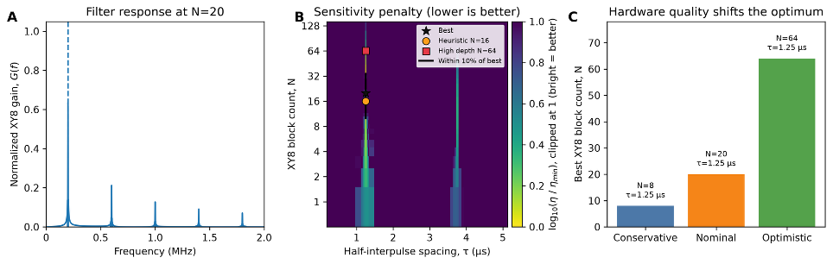
Figure 1: Canonical XY8 sweep. (A) The pulse sequence responds most strongly at the 200 kHz target and its harmonics. (B) Yellow indicates settings closest to the best predicted performance; purple indicates a larger penalty. The black contour encloses the 10% operating window, and markers identify the best, lower-pulse, and high-depth choices. (C) Conservative, nominal, and optimistic hardware scenarios select 8, 20, and 64 blocks, respectively.

3.0 RESULTS AND DISCUSSIONs
3.1 Optimal Control Depth
At 200 kHz, the best nominal setting is a 1.25 µs timing and 20 blocks, or 160 pulses. The pulse sequence lasts 400 µs and the full measurement cycle lasts 407.3 µs. The sensor retains 95.2% of the signal after coherence loss, but the accumulated pulse-error factor has fallen to 61.8%. Shallow sequences collect too little signal; very deep sequences lose too much through repeated imperfect control. Their balance creates the middle optimum. The 10% operating window spans 10 to 34 blocks. The tested values immediately outside it perform worse, so both edges are resolved rather than imposed by the search boundary.
The window has a useful engineering interpretation. N = 8 is predicted to be 17.1% worse than the optimum because it accumulates too little signal. N = 64 is 72.4% worse because 512 imperfect rotations outweigh the extra accumulation. N = 16 is considered the most optimal: it uses 128 pulses 20% fewer than N = 20, for only a 0.97% penalty. Thus a platform with tighter microwave-duty or reliability constraints can choose N = 16 without surrendering meaningful nominal performance.
3.2 Ablation and hardware uncertainty
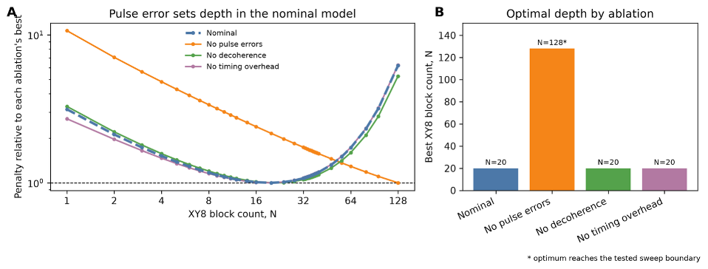
Figure 2: Resource ablation at 200 kHz. Removing pulse error moves the best tested depth to the N = 128 boundary; removing decoherence or timing overhead leaves N = 20. The boundary result is unresolved rather than a claimed physical optimum.
The ablation identifies the dominant cause within the model. As expected, removing pulse errors improves the best predicted score by 71.3% and sends the optimum to the largest tested depth. Removing coherence loss improves the score by 4.77%, and removing fixed timing costs improves it by 0.90%; both leave the optimum at 20 blocks. Pulse quality is therefore the main upper-depth limit. Hardware with different readout, environmental noise, or coherent control errors may behave differently. Timing remains predictive across the 50–500 kHz frequency sweep: every modeled optimum follows τ = 1/(4f). The best depth rises from N = 8 at 50 kHz to N = 20 from 150 kHz onward. A 2% timing offset at 200 kHz (1.225 rather than 1.250 µs) produces a 5.39-fold predicted penalty, making resonance selectivity a particularly important factor.

We also examined hardware uncertainty by simulating 400 possible hardware conditions. Each condition varied pulse fidelity, coherence time and its dependence on control depth, optical contrast, detected photon rate, and preparation and readout overhead within assumed ranges around their nominal values. Hardware uncertainty broadens the finite window without changing the best fixed choice. Although the best depth changed between cases, 89.8% of the case-specific optima remained within the nominal 10-to-34-block operating window. N=16 was selected most common as the optimal depth for an individual case, occurring in 90 of the 400 samples (22.5%). For case where N=16 was not optimal, the performance loss could be high. When one control depth must be chosen before the exact hardware properties are known, N=20 performed the best. For 380 out of the 400 cases, N=20 performance is within 16% of the case specific optimal. It minimizes both the average relative performance loss and the loss covering 95% of the simulated conditions.
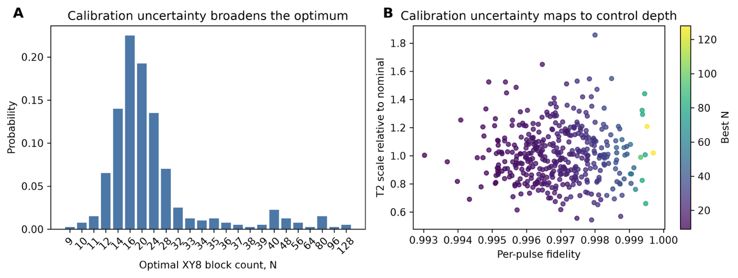
Figure 3. Effect of modeled hardware uncertainty on the recommended XY8 depth. Four hundred possible hardware conditions were simulated by varying pulse fidelity, coherence time and its scaling with control depth, optical contrast, detected photon rate, and preparation and readout overhead around their nominal values. (A) Distribution of the optimal XY8 block count. N=16 is the most frequently selected depth, while 89.8% of the case-specific optima remain within the nominal N=10–34 operating window. (B) Relationship between per-pulse fidelity, coherence time relative to the nominal 300 µs value, and the optimal depth, indicated by colour. Higher pulse fidelity generally supports deeper sequences, although the spread shows that coherence, readout, and timing properties also affect the recommendation.

5.0 CONCLUSIONS
In conclusion, this study shows that useful quantum control occupies a finite operating range that depends on both the target signal and the quality of the available hardware. Increasing the length of an XY8 sequence is beneficial only while the additional signal accumulation and frequency selectivity outweigh coherence loss, pulse errors, and measurement time. In the representative 200 kHz NV-centre model, this balance produces a resonant timing of 1.25 µs and a nominal optimum of N=20, corresponding to 160 pulses. However, the optimum is not a single indispensable setting. Depths from N=10 to 34 remain within 10% of the best predicted performance, and N=16 retains almost all of that performance while using 20% fewer pulses. Beyond this range, additional control becomes counterproductive; for example, N=64 uses 512 pulses but performs substantially worse under the nominal assumptions. Ablation studies shows that accumulated pulse error as the principal limit on control depth.

For practical defence and security applications such as magnetic anomaly detection and narrowband radio-frequency sensing. Instead of performing a large control sweep whenever a sensor is deployed or recalibrated, an operator could measure a small set of hardware properties, identify a bounded range of useful settings, and retain a lower-complexity option when microwave use, calibration time, or available power is constrained. The next step is prospective experimental validation and testing on a calibrated NV-centre platform. These tests will show how well the predicted operating window transfers to real hardware and provide the calibration data needed to improve the model. Later refinements can incorporate finite pulse widths, rotation-axis and detuning errors, and measured environmental noise spectra.

6.0 REFERENCES
- North Atlantic Treaty Organization, “Summary of NATO’s Quantum Technologies Strategy,” Brussels, Belgium, 16 January 2024. Available: https://www.nato.int/cps/en/natohq/official_texts_221777.htm
- C. L. Degen, F. Reinhard, and P. Cappellaro, “Quantum sensing,” Reviews of Modern Physics, vol. 89, 035002, 2017, doi: 10.1103/RevModPhys.89.035002.
- J. F. Barry, J. M. Schloss, E. Bauch, M. J. Turner, C. A. Hart, L. M. Pham, and R. L. Walsworth, “Sensitivity optimization for NV-diamond magnetometry,” Reviews of Modern Physics, vol. 92, 015004, 2020, doi: 10.1103/RevModPhys.92.015004.
- J. M. Taylor, P. Cappellaro, L. Childress, L. Jiang, D. Budker, P. R. Hemmer, A. Yacoby, R. Walsworth, and M. D. Lukin, “High-sensitivity diamond magnetometer with nanoscale resolution,” Nature Physics, vol. 4, pp. 810–816, 2008, doi: 10.1038/nphys1075.
- G. de Lange, Z. H. Wang, D. Ristè, V. V. Dobrovitski, and R. Hanson, “Universal dynamical decoupling of a single solid-state spin from a spin bath,” Science, vol. 330, pp. 60–63, 2010, doi: 10.1126/science.1192739.
- F. Casola, T. van der Sar, and A. Yacoby, “Probing condensed matter physics with magnetometry based on nitrogen-vacancy centres in diamond,” Nature Reviews Materials, vol. 3, 17088, 2018, doi: 10.1038/natrevmats.2017.88.
- Ł. Cywiński, R. M. Lutchyn, C. P. Nave, and S. Das Sarma, “How to enhance dephasing time in superconducting qubits,” Physical Review B, vol. 77, 174509, 2008, doi: 10.1103/PhysRevB.77.174509.
- S. Ernst, P. J. Scheidegger, S. Diesch, and C. L. Degen, “Modeling temperature-dependent population dynamics in the excited state of the nitrogen-vacancy center in diamond,” Physical Review B, vol. 108, 085203, 2023, doi: 10.1103/PhysRevB.108.085203.

