SPRINGFIELD CHALLENGE APP

USER GUIDE

The following is the main page of the Springfield App.

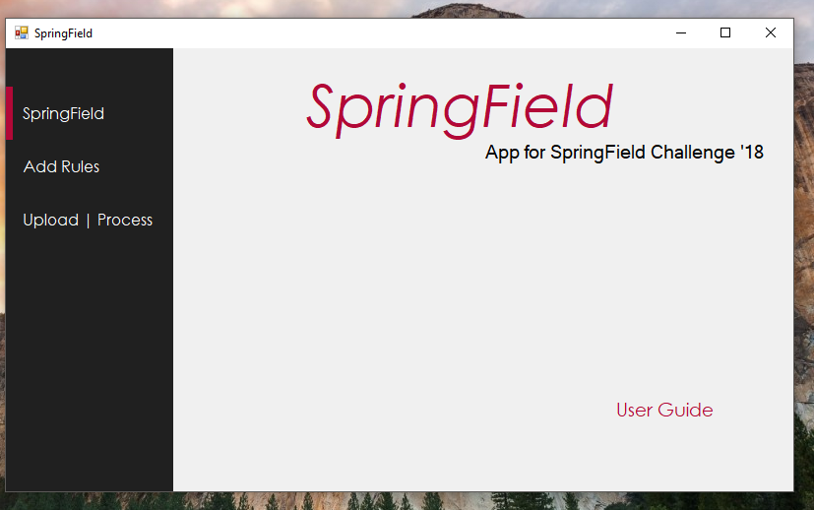

The following page contains 3 main tabs i.e

1. **Springfield**: On clicking this tab , the user can redirect himself to the main page of the App.

The main page of the app includes the User Guide button, which upon clicking, opens this document.

1. **Add Rules**: On clicking this tab, the user will be directed to the rules page where he can enter the various rules for processing documents.
2. **Upload | Process**: On clicking this tab, the user will be directed to the upload and process page where he can select multiple files and upload it and get the required data.

The following is the Add Rules Page.

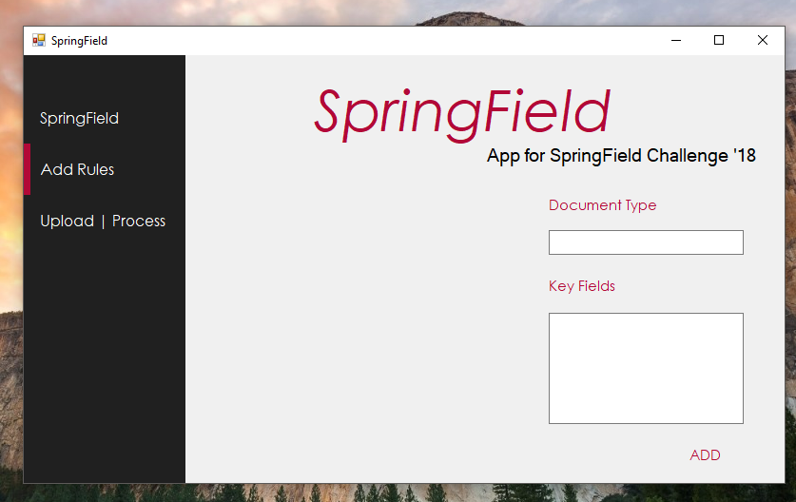

This page has 2 Textboxes viz. Document Type and Key fields and an ADD button to add the rules for the given document.

1. First, the Document Type Textbox reads the document type.
2. After this, the Key Fields Textbox reads different fields which the user wants for the particular document.

The user should enter the fields, each on new line.

1. Then, on clicking the Add Button the entered fields are set to the corresponding document.

The following image shows the state of the app after setting rules for three documents.

The list of rule names are displayed dynamically.

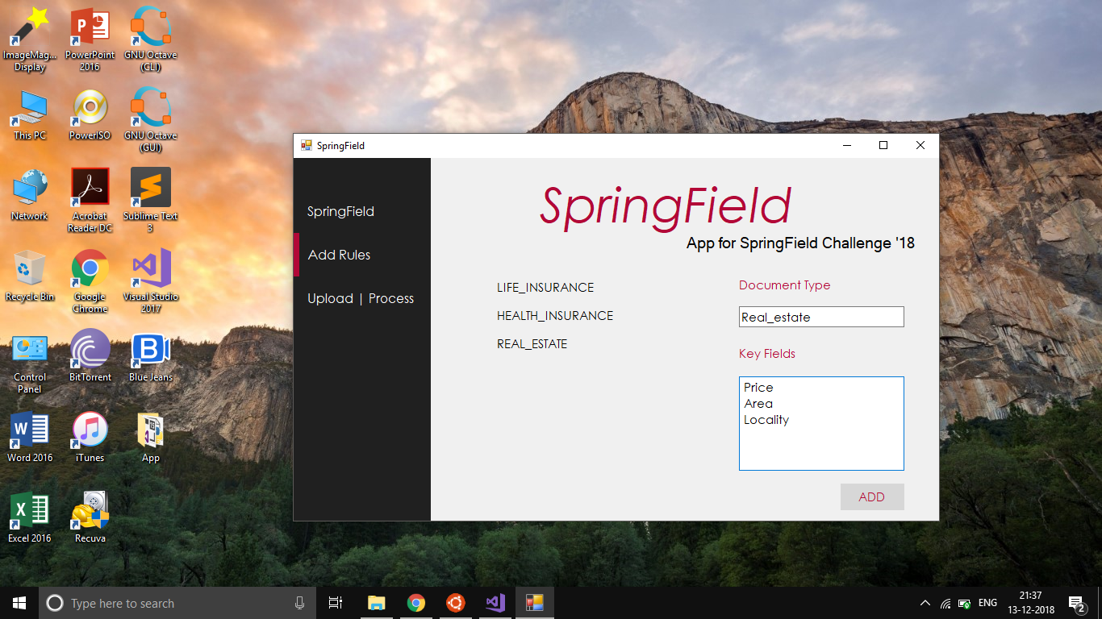

The following is the Upload | Process page.

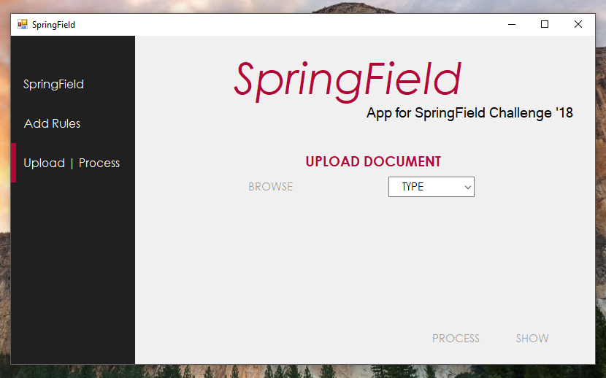

This page has a Dropdown List and Browse, Process and Show buttons which help the user to upload multiple documents, process them and get the desired result.

1. The Dropdown List contains names of document types, mentioned in the rules section by the user.
2. The BROWSE button helps the user to upload files.
3. The PROCESS button processes the files based upon the rules provided and files uploaded.
4. The SHOW button displays the data required by the user, in .csv format.

Here, first the user has to choose the type of document to upload. After choosing the type of document, the browse button becomes enabled and user can choose the file. After this, user can process the file and by pressing show, can get the required Data.

The following page shows the state of the app after uploading 3 files.

The uploaded documents’ names and types are shown.

