題目

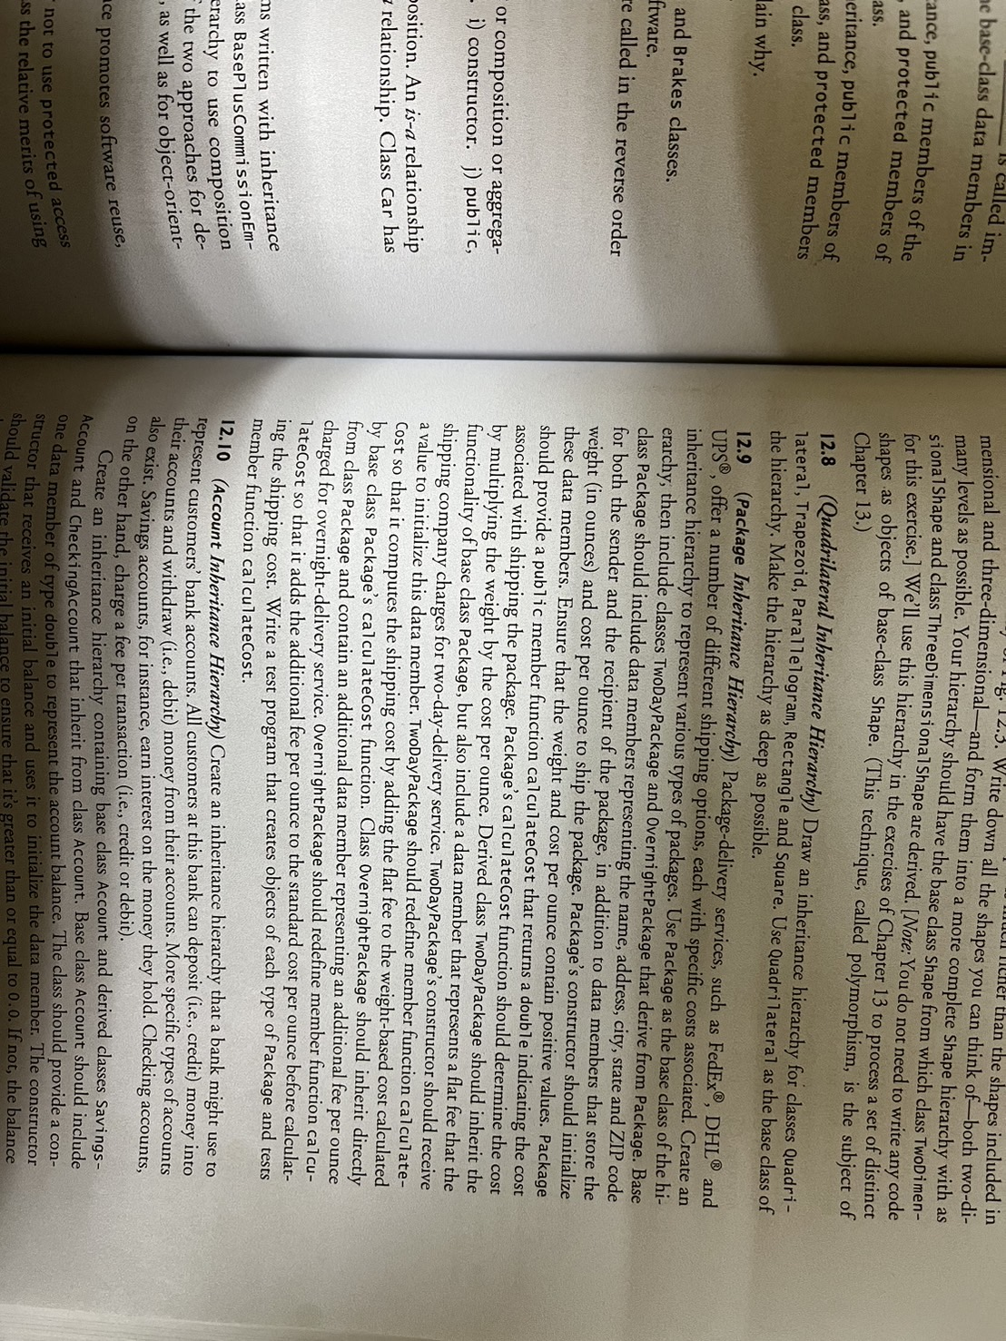

測資

int main() {

// Test program

// Create a Package object

Package package("John Doe", "123 Main St", "Anytown", "CA", "12345",

"Jane Smith", "456 Elm St", "Othertown", "NY", "54321",

10, 0.5);

std::cout << "Package shipping cost: $" << package.calculateCost() << std::endl;

// Create a TwoDayPackage object

TwoDayPackage twoDayPackage("John Doe", "123 Main St", "Anytown", "CA", "12345", "Jane Smith", "456 Elm St", "Othertown", "NY", "54321", 10, 0.5, 5);

std::cout << "Two-day package shipping cost: $" << twoDayPackage.calculateCost() << std::endl;

// Create an OvernightPackage object

OvernightPackage overnightPackage("John Doe", "123 Main St", "Anytown", "CA", "12345", "Jane Smith", "456 Elm St", "Othertown", "NY", "54321", 10, 0.5, 2);

std::cout << "Overnight package shipping cost: $" << overnightPackage.calculateCost() << std::endl;

return 0;

}

Output:

Package shipping cost: $5

Two-day package shipping cost: $10

Overnight package shipping cost: $25