HW11題目&測資

題目:

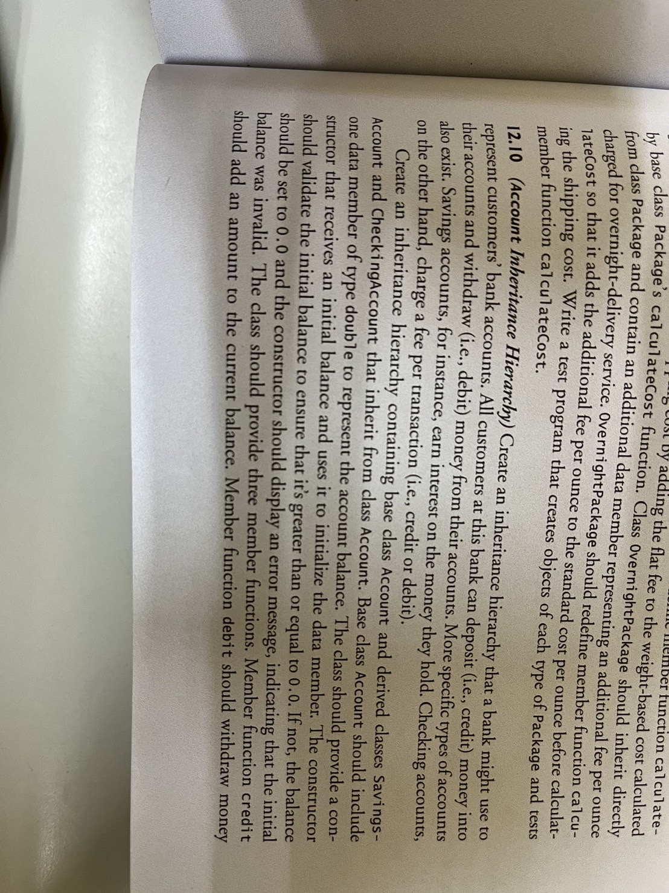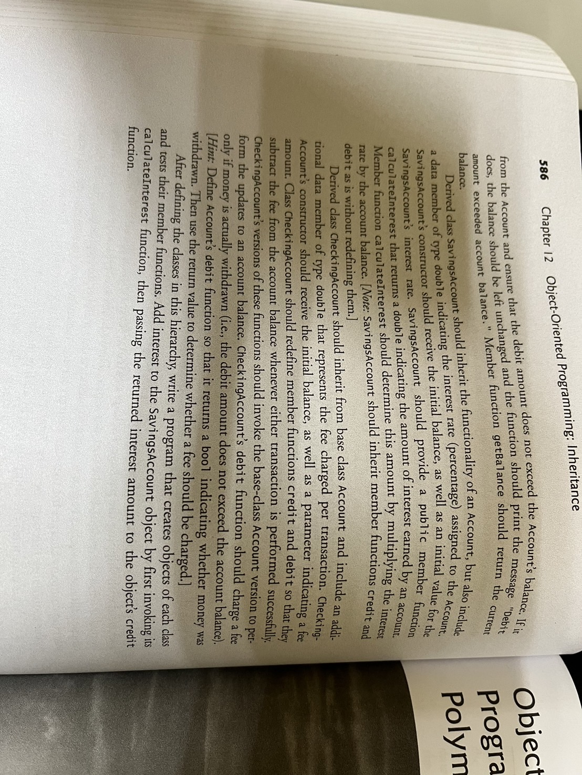

測資:

int main() {

// Testing Account class

Account acc(100.0);

std::cout << "Account balance: " << acc.getBalance() << std::endl;

acc.credit(50.0);

std::cout << "Account balance after credit: " << acc.getBalance() << std::endl;

acc.debit(30.0);

std::cout << "Account balance after debit: " << acc.getBalance() << std::endl;

// Testing SavingsAccount class

SavingsAccount savings(500.0, 0.05); // Initial balance $500, interest rate 5%

std::cout << "Savings account balance: " << savings.getBalance() << std::endl;

double interest = savings.calculateInterest();

savings.credit(interest);

std::cout << "Savings account balance after interest: " << savings.getBalance() << std::endl;

// Testing CheckingAccount class

CheckingAccount checking(200.0, 1.0); // Initial balance $200, transaction fee $1

std::cout << "Checking account balance: " << checking.getBalance() << std::endl;

checking.credit(100.0);

std::cout << "Checking account balance after credit: " << checking.getBalance() << std::endl;

checking.debit(50.0);

std::cout << "Checking account balance after debit: " << checking.getBalance() << std::endl;

return 0;

}

Output:

Account balance: 100

Account balance after credit: 150

Account balance after debit: 120

Savings account balance: 500

Savings account balance after interest: 525

Checking account balance: 200

Checking account balance after credit: 299

Checking account balance after debit: 248