HW13題目&測資

題目: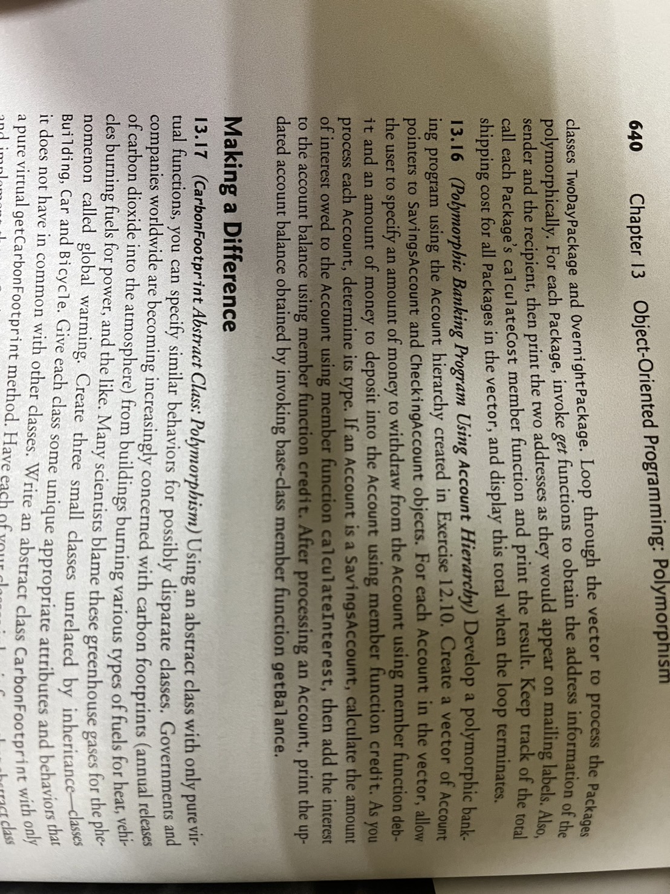

測資:

int main() {

std::vector<Account*> accounts;

// Create SavingsAccount and CheckingAccount objects

accounts.push_back(new SavingsAccount(500.0, 0.05)); // Savings account with $500 initial balance and 5% interest rate

accounts.push_back(new CheckingAccount(200.0, 1.0)); // Checking account with $200 initial balance and $1 fee per transaction

// Process each account

……

// Clean up dynamically allocated memory

……

return 0;

}

Output:

Processing 14SavingsAccount account.

Enter amount to deposit: 100

Enter amount to withdraw: 50

Interest added: 27.5

Updated balance: 577.5

Processing 15CheckingAccount account.

Enter amount to deposit: 100

Enter amount to withdraw: 50

Updated balance: 248

Enter amount to deposit和Enter amount to withdraw為使用者輸入