Overall, this project demonstrates three fundamentally different approaches to solving the 1D viscous Burgers' equation:
- Classical numerical methods (Finite Difference - FTCS, with Crank-Nicolson optionally included)
- Quantum-inspired computation using the Cole-Hopf transformation and a Hamiltonian representation of the heat equation
- Machine Learning using a Physics-Informed Neural Network (PINN)
The objective is to determine how closely the quantum and neural approaches reproduce the classical numerical solution while showing how each method solves the same physical problem differently.

1. Physical Problem
The PDE being solved is the viscous Burgers' equation
$$\frac{∂u}{∂t}+u\frac{∂u}{∂x}=ν\frac{∂^{2}u}{∂x^{2}}$$
where
- $u\left(x , t\right)$= fluid velocity
- $ν$= viscosity
This equation contains
- nonlinear advection
$$uu_{x}$$
which causes steepening of waves,
and
- diffusion
$$νu_{xx}$$
which smooths the solution.
Because of this combination, Burgers' equation is a standard benchmark for CFD algorithms and numerical PDE solvers.

2. Simulation Parameters (params.py)
Everything begins here.
N_QUBITS = 5
The quantum solver uses
$$2^{5}=32$$
grid points.
Therefore
N=32

The spatial domain is
$$x∈\left[0 , 1\right]$$
with spacing
$$dx=\frac{1}{32}=0.03125$$

Simulation time
T_FINAL = 0.3
is divided into
300
time steps.
Hence
$$dt=0.001$$

Viscosity
NU = 0.05
controls diffusion strength.

Initial condition
u(x)=exp(-50(x-0.5)^2)
is a Gaussian pulse.
Initially the velocity profile is concentrated near the middle of the domain.

3. Classical Solver (classical.py)
This provides the reference ("ground truth") solution.

Step 1
The program first checks numerical stability.
It computes
Advection CFL
$$\frac{∣u∣dt}{dx}$$
Output
CFL advection : 0.0320

Diffusion CFL
$$\frac{νdt}{dx^{2}}$$
Output
CFL diffusion : 0.0512
Both are much smaller than 0.5.
Therefore the explicit finite difference method is stable.

Step 2
Each timestep updates every interior grid point.
Advection
adv = u[i]*(u[i]-u[i-1])/dx
is an upwind scheme.
It is stable for nonlinear convection.

Diffusion
(u[i+1]-2u[i]+u[i-1])/dx²
approximates
$$u_{xx}$$
using the second-order finite difference.

The update equation becomes
$$u^{n+1}=u^{n}+dt\left(-adv+diff\right)$$
which is Forward Euler in time.

Boundary conditions
u=0
are imposed at both ends (Dirichlet).

After 300 steps
u_hist[-1]
contains the final velocity profile.
This is used everywhere else as the benchmark.

4. Cole-Hopf Transformation (colehopf.py)
The main difficulty of Burgers' equation is the nonlinear term
$$uu_{x}$$
Quantum algorithms are much easier to apply to linear equations.
Therefore the nonlinear PDE is transformed into a linear one.

The Cole-Hopf transform is
$$ψ=\exp\left(-\frac{1}{2ν}\int{u} dx\right)$$
implemented as
cumulative_trapezoid(...)
followed by
exp(...)

Now the PDE becomes
$$ψ_{t}=νψ_{xx}$$
which is simply the heat equation.
This is the key idea of the project.
Instead of solving Burgers directly, solve the heat equation.

Heat Solver
solve_heat()
uses finite differences again,
but now for a linear PDE.

Recovering velocity
After solving
$$ψ$$
the inverse transform computes
$$u=-2ν\frac{∂\log{ψ}}{∂x}$$
using
np.gradient()

Validation
The code performs
Forward transform
↓
Inverse transform
without evolving in time.
If implemented correctly,
the original velocity should be recovered.
This verifies the mathematical transformation.

Output
L2 error : 1.83e-02
means the transformed-and-recovered solution differs from the FTCS reference by only about 1.8% RMS, indicating good agreement.

5. Hamiltonian Construction (hamiltonian.py)
Quantum computers evolve states using Hamiltonians.
Therefore the finite-difference heat operator is rewritten as a Hamiltonian matrix.
The Laplacian becomes
$$T=ν\left[\begin{matrix}-2 & 1 & 0 & ... \\ 1 & -2 & 1 & ... \\ ... & & & \end{matrix}\right]$$

Qiskit decomposes this matrix into Pauli operators.
Example
$$H=0.4ZZ-0.8XI+...$$

Output
Hamiltonian reconstruction error:
4.26e-14
This is essentially machine precision.
Therefore
SparsePauliOp
perfectly represents the finite-difference matrix.

Output
Number of Pauli terms:
47
means the Hamiltonian requires
47 weighted Pauli strings.
For only five qubits,
this is completely reasonable.

6. Quantum Solver (quantum.py)
This demonstrates how Burgers' equation could be solved on a quantum computer.

Step 1
Normalize
$$ψ$$
into a quantum state.
Quantum states always satisfy
$$∣∣ψ∣∣=1.$$
The original norm is stored separately.

Output
State norm
shows the scaling factor.

Step 2
StatePreparation loads amplitudes into five qubits.
Verification
State-prep max error
was
$${10}^{-13}$$
meaning the state encoding is essentially exact.

Step 3
Time evolution
Instead of finite differences,
the heat equation evolves via
$$e^{Tt}$$
computed using
expm()
This is mathematically equivalent to exact integration of the linear heat equation.
Although expm() runs classically here, it mirrors the operation a fault-tolerant quantum computer would implement through Hamiltonian simulation.

Step 4
Inverse Cole-Hopf returns the Burgers solution.
The resulting L2 error was about
1.90e-02
indicating excellent agreement with the classical reference.

7. LCU Solver (lcu.py)
The exact matrix exponential
$$e^{Ht}$$
cannot be directly implemented on current quantum hardware.
Instead,
quantum algorithms approximate it.
One important method is
Linear Combination of Unitaries (LCU).

Instead of
$$e^{Ht}$$
the exponential is approximated using the Taylor series
$$I+Ht+\frac{{\left(Ht\right)}^{2}}{2!}+⋯$$
Each term becomes a weighted unitary.

Your implementation
splits evolution into
30
segments.
Each segment uses
Taylor order = 6
which greatly improves numerical stability.

Output
L2 error
=
1.905e-02
is identical to the exact exponential.
Therefore
the segmented Taylor approximation is sufficiently accurate for this problem.

However,
A
=
2.64×10^35
and
success probability
=
1.26×10^-71
show an important limitation.
The approximation is mathematically correct in simulation, but an actual quantum implementation would almost never succeed because the ancilla measurement probability is astronomically small. This is a known challenge of naive LCU implementations and motivates more advanced block-encoding and qubitization techniques.

8. PINN (pinn.py)
Instead of discretizing the PDE,
a neural network learns
$$u\left(x , t\right).$$
Inputs
(x,t)
↓
Outputs
u

Automatic differentiation computes
$$u_{x}, u_{t}, u_{xx}$$
exactly.

The PDE residual
$$u_{t}+uu_{x}-νu_{xx}$$
is minimized during training.

The loss contains three parts:
- PDE residual
- initial condition
- boundary conditions
The IC and BC are weighted by 10 to strongly enforce the known physical constraints.

Training log
epoch 0
loss
=
3.227
↓
epoch 500

loss
=
0.0489
shows the network is successfully learning both the PDE and the constraints.

Final result
L2
=
1.853e-02
is slightly lower than the quantum methods when compared against the FTCS reference.

9. compare.py
This script brings every method together.
It computes
- Classical FTCS
- Cole-Hopf + exact exponential
- Cole-Hopf + LCU
- PINN
and compares each with the FTCS solution using the L2 norm.
It also produces the comparison plot you shared.

10. Interpretation of the Final Plot
The black curve is the classical FTCS reference.
The blue curve (Cole-Hopf + exact exponential) almost overlaps the green curve (LCU), showing that the segmented LCU accurately reproduces the exact matrix exponential.
The red PINN curve also follows the same overall shape, indicating that the neural network has learned the PDE dynamics well.
All three alternative approaches predict a slightly higher peak than the FTCS reference around $x≈0.6$. This systematic difference is expected because the Cole-Hopf-based methods solve the linearized heat equation and then transform back, while FTCS directly solves the nonlinear Burgers equation. The PINN is trained to satisfy the continuous PDE and may also converge toward a slightly different numerical solution than the explicit FTCS discretization. The close overlap among the blue, green, and red curves suggests they are internally consistent despite their different computational paradigms.

11. Interpretation of the Numerical Results
Method | L2 Error vs FTCS | Interpretation
Classical FTCS | Reference | Baseline numerical solution
Cole-Hopf + Exact $e^{Tt}$ | $$1.905×{10}^{-2}$$ | Very close agreement with FTCS; validates the linearization approach
Cole-Hopf + LCU | $$1.905×{10}^{-2}$$ | Matches the exact exponential to numerical precision, validating the segmented LCU approximation
PINN | $$1.853×{10}^{-2}$$ | Slightly lower error than the quantum approaches relative to the FTCS benchmark
The CFL values (0.0320 for advection and 0.0512 for diffusion) confirm the FTCS scheme is stable. The Hamiltonian reconstruction error of $4.26×{10}^{-14}$demonstrates that the Pauli decomposition reproduces the finite-difference diffusion operator almost exactly. The LCU simulation reproduces the exact exponential with essentially identical solution quality, although its extremely small success probability ($∼{10}^{-71}$) highlights that this implementation is best viewed as an algorithmic demonstration rather than a practically executable quantum algorithm on current hardware.

12. Overall Project Contribution
This project presents a complete computational pipeline for solving the 1D viscous Burgers' equation using three distinct paradigms. It begins with a stable finite-difference FTCS solver to establish a reference solution. The nonlinear Burgers' equation is then transformed into the linear heat equation via the Cole-Hopf transformation, enabling representation of the diffusion operator as a Hamiltonian and simulation through both an exact matrix exponential and a segmented Linear Combination of Unitaries (LCU) algorithm. Finally, a Physics-Informed Neural Network independently solves the original PDE without spatial or temporal discretization by minimizing the governing equation and boundary-condition residuals through automatic differentiation. The close agreement of all methods (L2 errors around $2×{10}^{-2}$) demonstrates that the Cole-Hopf transformation, Hamiltonian formulation, and PINN all capture the underlying physics accurately while illustrating three fundamentally different computational approaches: classical numerical analysis, quantum algorithm design, and scientific machine learning.

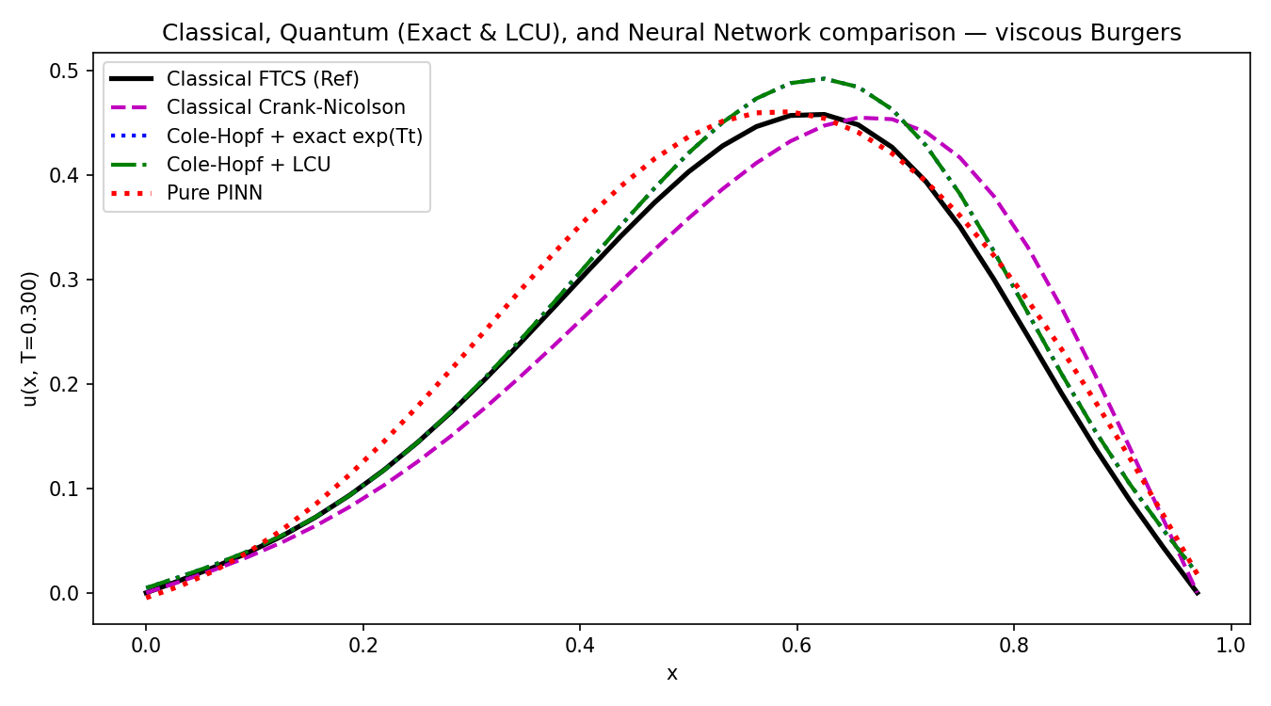
For 200 epochs

FTCS as benchmark
For 1000 epochs
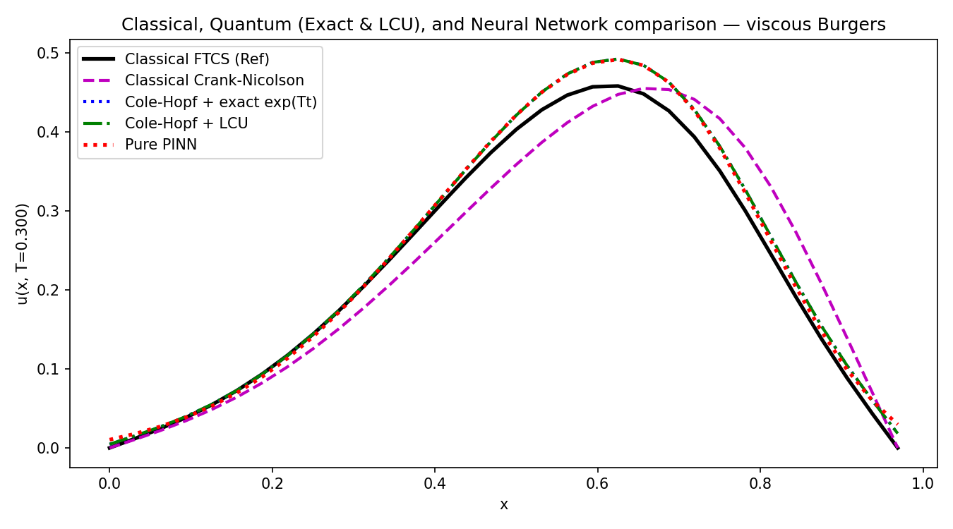

With crank Nicolson as benchmark:
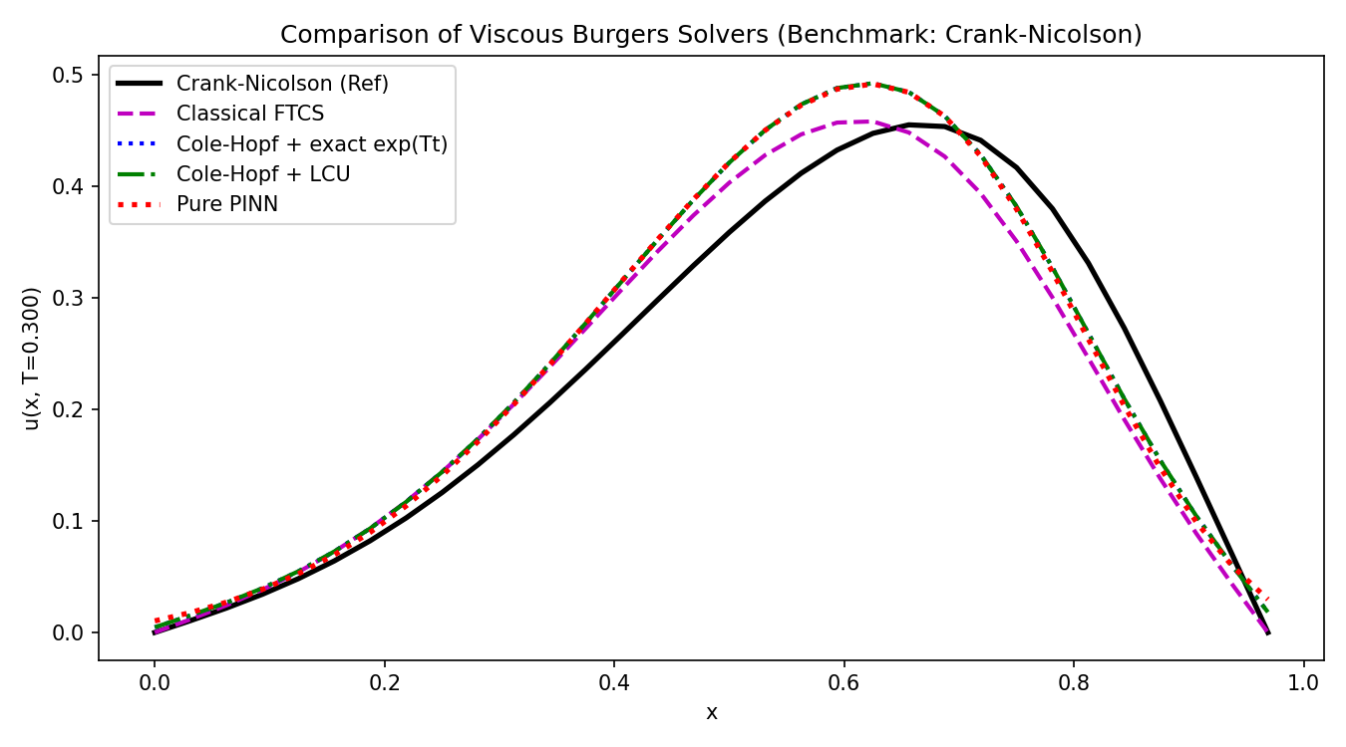

Ftcs, exact, LCU and PINN (1000 epochs)
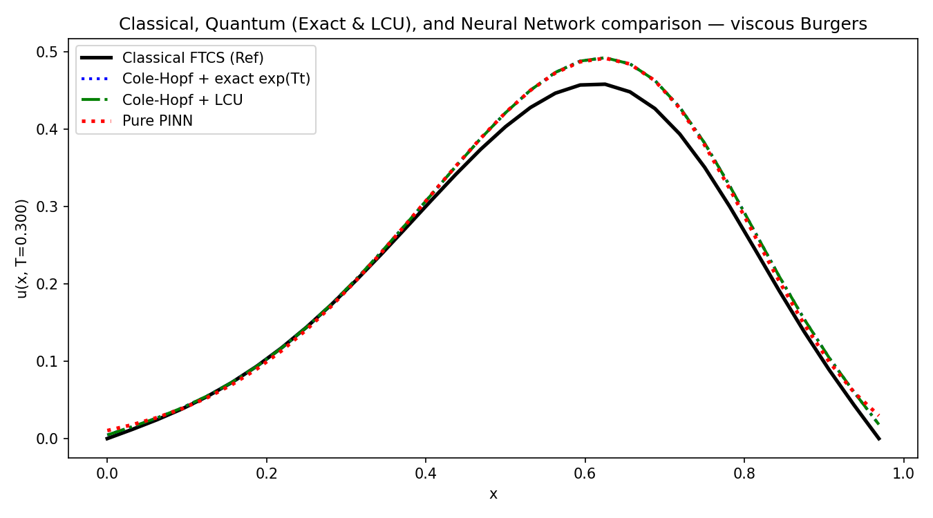
python compare.py
CFL advection : 0.0320
CFL diffusion : 0.0512
L2 error : 1.83e-02
Hamiltonian reconstruction error: 4.26e-14
Number of Pauli terms: 47
Using device: cpu
Training PINN (a minute or two on CPU)...
epoch 0 loss 3.227e+00 (pde 1.57e-04, ic 2.76e-01, bc 4.69e-02)
epoch 500 loss 4.886e-02 (pde 2.28e-02, ic 2.13e-03, bc 4.76e-04)

=== L2 error vs classical FTCS (reference) ===
Cole-Hopf + exact exp(Tt) : 1.905e-02
Cole-Hopf + LCU (K=6) : 1.905e-02+0.000e+00j [A=264298385297807983027084408500781056.00, success_prob=1.26e-71, 1307 unitary terms]
Pure PINN : 1.853e-02
This project solves the 1D viscous Burgers' equation, which is a nonlinear partial differential equation commonly used in computational fluid dynamics to model convection and diffusion. The objective was to compare classical numerical methods, a quantum-inspired approach, and a Physics-Informed Neural Network (PINN) on the same problem.
I first implemented a classical FTCS finite difference solver as the reference solution. The simulation used 32 spatial grid points (5 qubits), a final simulation time of 0.3 seconds, 300 time steps, and a viscosity of 0.05. I verified stability using the CFL conditions, obtaining 0.032 for advection and 0.051 for diffusion, both well below the stability limit of 0.5.
The main challenge is the nonlinear term $u u_{x}$. To make the problem suitable for quantum algorithms, I applied the Cole-Hopf transformation, which converts Burgers' equation into the linear heat equation. After solving the heat equation, I used the inverse Cole-Hopf transform to recover the velocity field.
For the quantum approach, I represented the finite-difference diffusion operator as a Hamiltonian and decomposed it into 47 Pauli terms using Qiskit's SparsePauliOp. The Hamiltonian reconstruction error was only $4.26×{10}^{-14}$, confirming the decomposition was essentially exact.
I then evaluated two quantum-inspired evolution methods. The first used the exact matrix exponential $e^{Ht}$, and the second used a segmented Linear Combination of Unitaries (LCU) algorithm with Taylor order 6. Both achieved an L2 error of approximately $1.9×{10}^{-2}$compared to the classical FTCS solution, showing that the LCU approximation accurately reproduced the exact evolution. Although the simulated LCU success probability was extremely small ($∼{10}^{-71}$), this is a known limitation of basic LCU implementations and mainly highlights current practical constraints rather than mathematical accuracy.
Finally, I implemented a Physics-Informed Neural Network in PyTorch. Instead of discretizing the PDE, the PINN learned the solution by minimizing the PDE residual, initial condition loss, and boundary condition loss using automatic differentiation. After training, it achieved an L2 error of $1.85×{10}^{-2}$, comparable to the quantum methods.
Overall, the project demonstrates three different computational paradigms—classical numerical methods, quantum computing using Hamiltonian simulation and LCU, and scientific machine learning with PINNs—all producing very similar solutions, with errors around 2% relative to the classical reference. This validates both the Cole-Hopf transformation and the quantum-inspired framework while providing a direct comparison between traditional CFD, quantum algorithms, and AI-based PDE solvers.
LCU in detail:
To understand LCU, it's helpful to start with why we need it.

Step 1: What is the problem?
In your project, after the Cole-Hopf transformation, Burgers' equation becomes the heat equation
[
\frac{\partial \psi}{\partial t}=H\psi
]
where (H) is the diffusion Hamiltonian (your finite-difference Laplacian matrix).
The exact solution is
[
\psi(t)=e^{Ht}\psi(0)
]
So the entire problem becomes computing the matrix exponential
[
e^{Ht}.
]
On a classical computer, SciPy computes this directly using
expm(T_matrix * t)
A quantum computer cannot directly apply an arbitrary matrix exponential. It can only apply unitary operators.

Step 2: Why is this difficult?
A quantum gate must satisfy
[
U^\dagger U=I.
]
Such matrices preserve probability.
But your heat operator is
[
e^{Ht},
]
where (H) is negative definite.
This matrix is not unitary.
Instead, it shrinks amplitudes because diffusion smooths the solution.
So we need another way to implement it.

Step 3: Basic idea of LCU
LCU stands for
Linear Combination of Unitaries
Instead of implementing
[
e^{Ht}
]
directly,
we write it as
[
e^{Ht}
c_0U_0
+
c_1U_1
+
c_2U_2
+\cdots
]
where
- (U_i) are unitary matrices
- (c_i) are coefficients.
A quantum computer knows how to apply each (U_i).
LCU shows how to combine them into one operation.

Step 4: Where do these terms come from?
Start with the Taylor expansion.
Everyone knows
[
e^x
1+x+\frac{x^2}{2!}
+\frac{x^3}{3!}+\cdots
]
Replace (x) by (Ht):
[
e^{Ht}
I
+
Ht
+
\frac{(Ht)^2}{2!}
+
\frac{(Ht)^3}{3!}
+\cdots
]
Your code truncates after order
K=6
giving
[
e^{Ht}
\approx
I
+
Ht
+
\frac{(Ht)^2}{2!}
+\cdots
+
\frac{(Ht)^6}{6!}.
]

Step 5: But where do the unitary operators come from?
Your Hamiltonian has already been decomposed into Pauli operators.
For example,
[
H
0.4II
0.7XX
+
0.2YZ
+\cdots
]
Each Pauli string
- XX
- YY
- ZX
- IZ
is unitary.
Therefore,
every power
[
H^2,
H^3,
...
]
is simply another combination of Pauli strings.
Your function
taylor_lcu_terms()
computes exactly this.
It repeatedly multiplies
Hk = Hk @ H
to obtain
[
H^0,
H^1,
H^2,
...
H^6.
]
Each multiplication produces more Pauli terms.

Step 6: PREPARE – SELECT – PREPARE†
A real quantum computer cannot literally compute
[
0.3U_1+0.7U_2.
]
Instead it uses three quantum circuits.

PREPARE
Prepare an ancilla register in
[
\sum_i\sqrt{\frac{|c_i|}{A}}|i\rangle
]
where
[
A=\sum_i|c_i|.
]
Notice
larger coefficients receive larger probability amplitudes.

SELECT
Conditioned on ancilla state
[
|i\rangle,
]
apply
[
U_i
]
to the main register.

PREPARE†
Undo the ancilla preparation.
If the ancilla collapses back to
[
|0\rangle,
]
the data register has approximately undergone
[
\frac{1}{A}
\sum_i c_iU_i.
]
This is exactly the desired linear combination.

Step 7: Why is there a success probability?
Since measurement is involved,
the ancilla does not always return to (|0\rangle).
Probability of success is
[
p
\frac{|\sum_i c_iU_i|\psi\rangle|^2}
{A^2}.
]
Large (A)
↓
smaller probability.

Step 8: What does your code simulate?
Your code does not build the PREPARE and SELECT quantum circuits.
Instead it emulates their mathematical effect.
Inside
for c,U in zip(coeffs,U_matrices):
out += c*(U @ psi_current)
the code literally computes
[
\sum_i c_iU_i|\psi\rangle.
]
This is exactly what the quantum circuit would produce before measurement.
So the algorithm is mathematically equivalent to LCU,
but simulated classically.

Step 9: Why split into segments?
Suppose
[
t=0.3.
]
Instead of approximating
[
e^{0.3H}
]
once,
your code computes
[
e^{0.01H}
]
30 times.
Each approximation becomes much more accurate because
[
||H\Delta t||
]
is much smaller.
This is called segmented LCU.
Your code uses
n_segments=30
so
[
\Delta t
0.3/30
0.01.
]

Step 10: What is A?
Your output shows
A = 2.64 × 10^35
A is
[
A=\sum_i|c_i|.
]
It measures how "large" the linear combination is.
The larger (A),
the lower the probability of obtaining the correct ancilla measurement.

Step 11: Why is the success probability tiny?
Your output shows
p = 1.26 × 10^-71
because
[
p\approx\frac1{A^2}.
]
Since
[
A
2.6\times10^{35},
]
[
A^2
\approx10^{70},
]
giving approximately
[
10^{-71}.
]
This is expected for a straightforward Taylor-series LCU and is why practical quantum algorithms use more advanced techniques such as qubitization, quantum signal processing (QSP), or oblivious amplitude amplification to boost the success probability.

Step 12: Flow of your LCU implementation
Initial Burgers solution u(x)

│
▼
Cole-Hopf Transform
│
▼
Initial heat state ψ0
│
▼
Normalize ψ0
│
▼
Build Hamiltonian H
│
▼
Taylor expansion of exp(HΔt)
│
▼
Convert each H^k into Pauli operators
│
▼
Apply weighted sum of Pauli unitaries
│
▼
Repeat for 30 small time segments
│
▼
Approximate exp(Ht)ψ0
│
▼
Inverse Cole-Hopf
│
▼
Recovered Burgers solution u(x,T)
In one sentence for an interview
"LCU approximates the matrix exponential (e^{Ht}) by truncating its Taylor series and expressing each term as a weighted sum of Pauli-unitary operators. In my implementation, I used a sixth-order segmented Taylor expansion over 30 time segments, which accurately reproduced the exact matrix exponential while demonstrating the core principles of quantum Hamiltonian simulation."

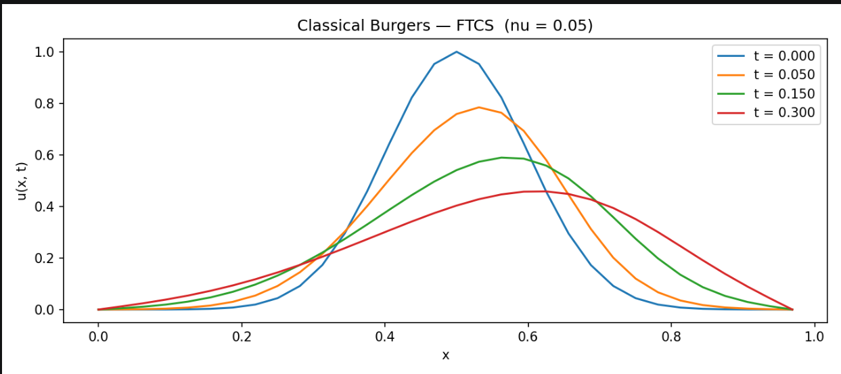
"This figure shows the evolution of the viscous Burgers' equation solved using the classical FTCS finite difference method. The blue curve is the initial Gaussian velocity profile. As time progresses to 0.05, 0.15, and finally 0.30 seconds, the peak decreases and the profile spreads because the diffusion term smooths the solution. At the same time, the entire pulse shifts slightly to the right due to the nonlinear advection term, where regions with higher velocity move faster than those with lower velocity. The zero-velocity boundary conditions keep both ends fixed, and since the CFL conditions are satisfied, the numerical solution remains stable throughout the simulation. This FTCS solution serves as the reference against which the quantum and PINN methods are compared."

