**Cairo University  
Faculty of Computers and Artificial Intelligent**

|  |  |  |  |
| --- | --- | --- | --- |
| # | **Name** | **ID** | **group** |
| **1.** | Mohamed Shawky Mohamed Galal | 20216086 | S4 |
| **2.** | Mohamed Elyousfy | 20216083 | S4 |
| **3.** | Ali Amr Mohamed Moussa | 20216065 | S4 |
| **4.** | Ahmed Ashraf El-Marakby | 20216002 | S4 |
| **5.** | **Sama Ahmed Abosaty** | 20216048 | S4 |

***Database project***

**TA:** Eng. Dina abbas

**Conceptual ERD**

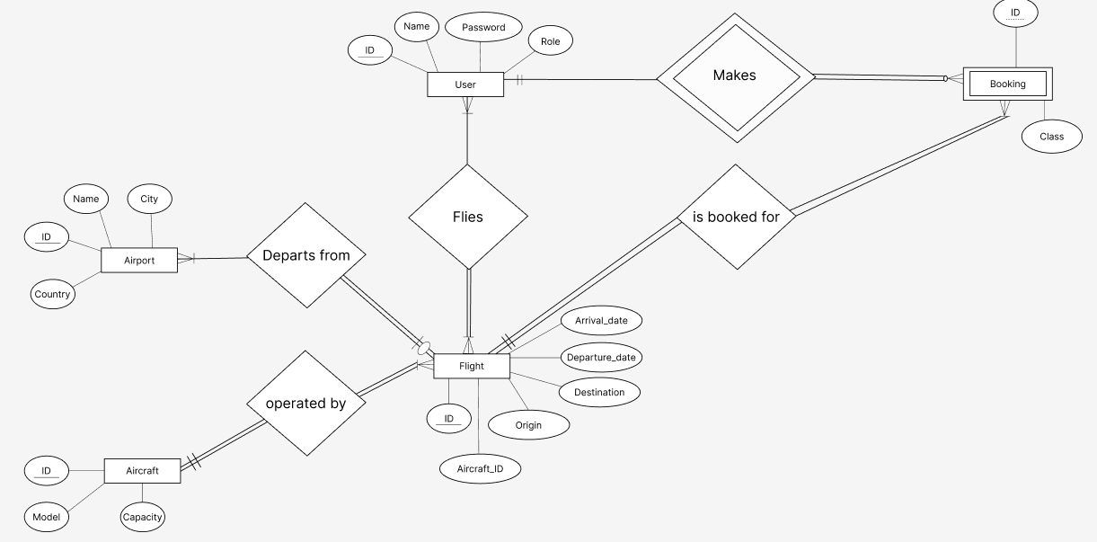

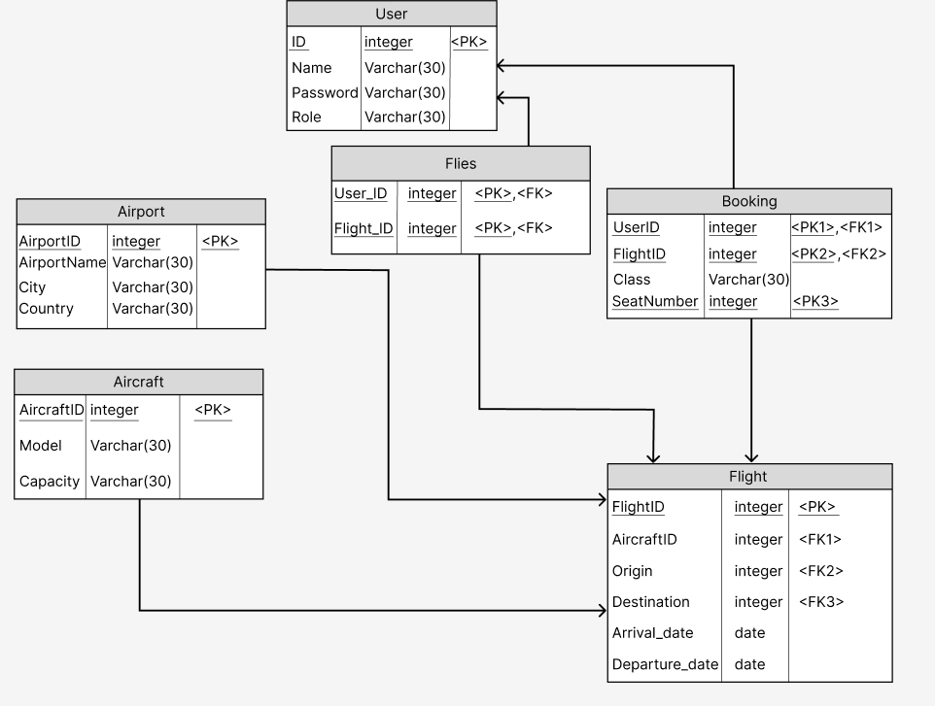

**Physical ERD**

**seatNumber integer <PK3>**

**CREATE DATABASE flight**

**CREATE TABLE [user] (**

**SQL code**

**id INT IDENTITY(1,1) PRIMARY KEY,**

**name VARCHAR(255) NOT NULL,**

**[password] VARCHAR(255) NOT NULL,**

**[role] VARCHAR(50) NOT NULL CHECK ([role] IN ('admin', 'customer'))**

**);**

**CREATE TABLE aircraft (**

**id INT IDENTITY(1,1) PRIMARY KEY,**

**model VARCHAR(255) NOT NULL,**

**capacity INT NOT NULL**

**);**

**CREATE TABLE flight (**

**id INT IDENTITY(1,1) PRIMARY KEY,**

**origin INT NOT NULL,**

**destination INT NOT NULL,**

**departure_date DATETIME NOT NULL,**

**arrival_date DATETIME NOT NULL,**

**aircraft_id INT NOT NULL,**

**FOREIGN KEY (aircraft_id) REFERENCES aircraft (id),**

**FOREIGN KEY (origin) REFERENCES airport (id),**

**FOREIGN KEY (destination) REFERENCES airport (id)**

**);**

**CREATE TABLE booking (**

**user_id INT NOT NULL,**

**flight_id INT NOT NULL,**

**seat_number INT NOT NULL,**

**[class] VARCHAR(50) NOT NULL CHECK ([class] IN ('economy', 'business','first')),**

**FOREIGN KEY (user_id) REFERENCES [user] (id),**

**FOREIGN KEY (flight_id) REFERENCES flight (id),**

**PRIMARY KEY (user_id, flight_id, seat_number)**

**);**

**CREATE TABLE airport (**

**id INT IDENTITY(1,1) PRIMARY KEY,**

**name VARCHAR(255) NOT NULL,**

**city VARCHAR(255) NOT NULL,**

**country VARCHAR(255) NOT NULL**

**);**

**Screenshots**

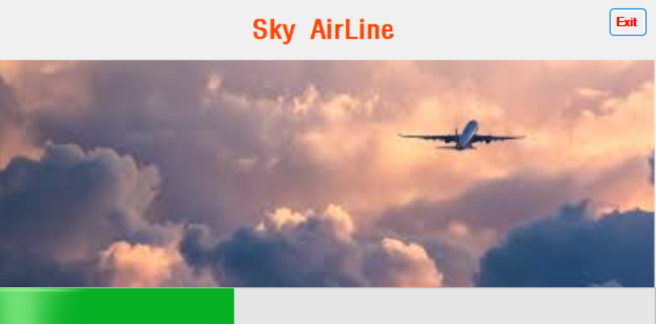

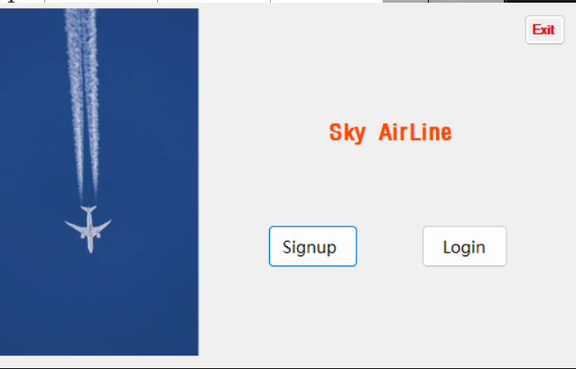

**Signing up a new user** 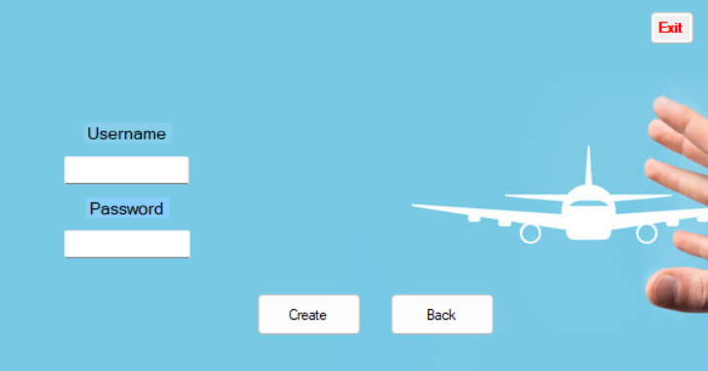

**Login**

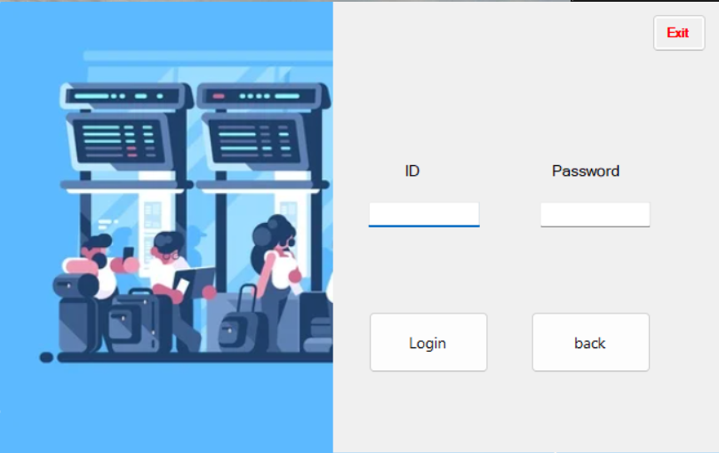

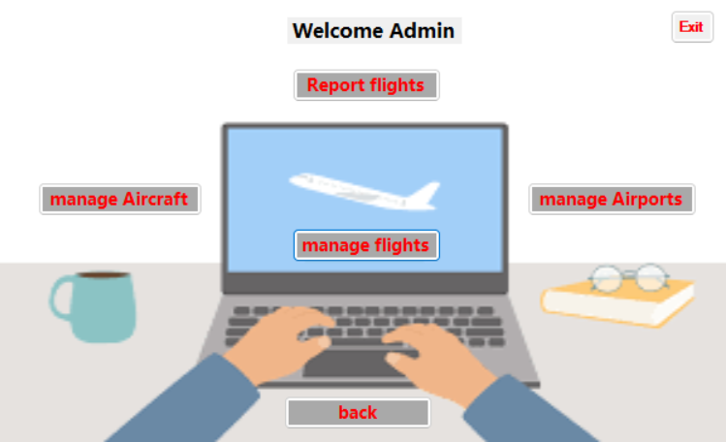**admin interface**

**Adding an aircraft Updating an aircraft details**

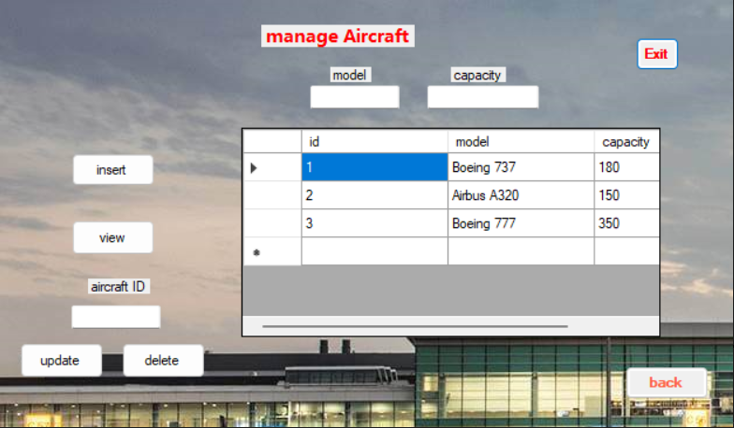

**Adding an airport Updating an airport details**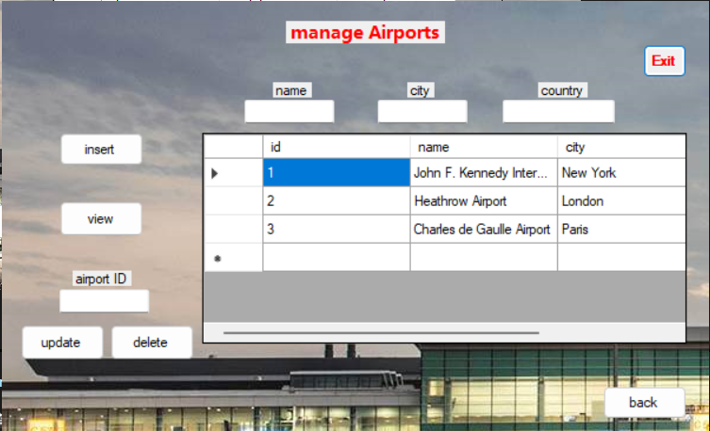

**Adding a flight Updating a flight details.**

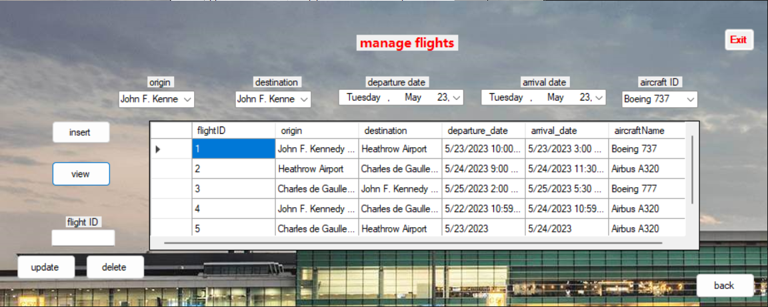

**User interface**

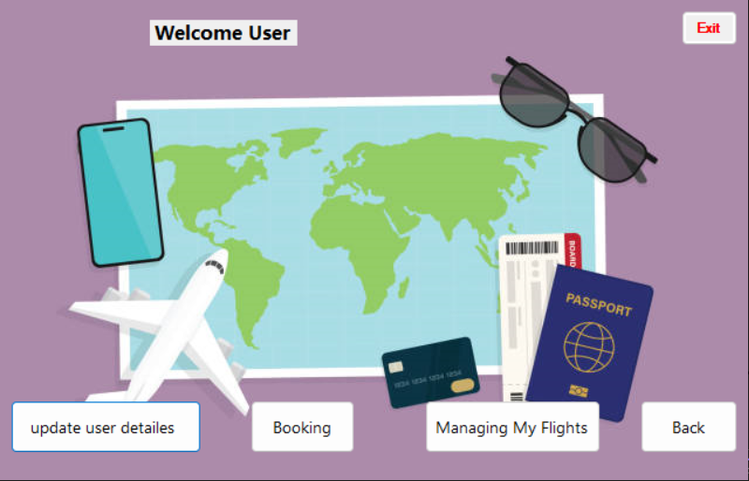

**Updating a user's details**

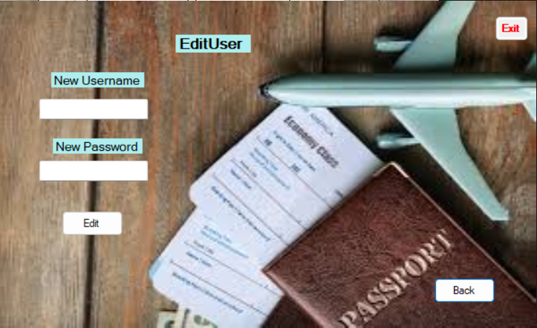

**Performing operations on flights: booking**

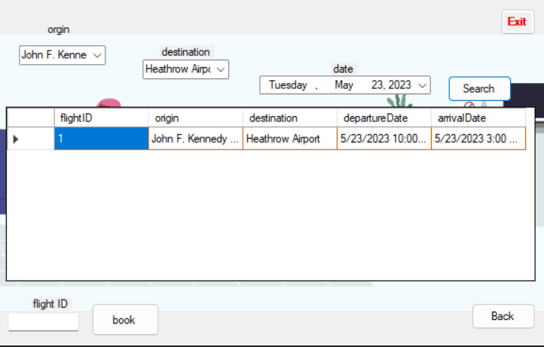

**Performing operations on flights cancelling**

