**Using SQL to Clean & Analyse Data**

In this project we use a Call Center dataset and Import it to MySQL Workbench, Clean it a bit then analyse it.

Step 1: Importing Data

The call-center dataset basically has over 32900 record of data that describers calls made to various call centers. It includes the ID of the call, duration of the call in minutes, the name of the person who called, their satisfaction score and many other attributes.

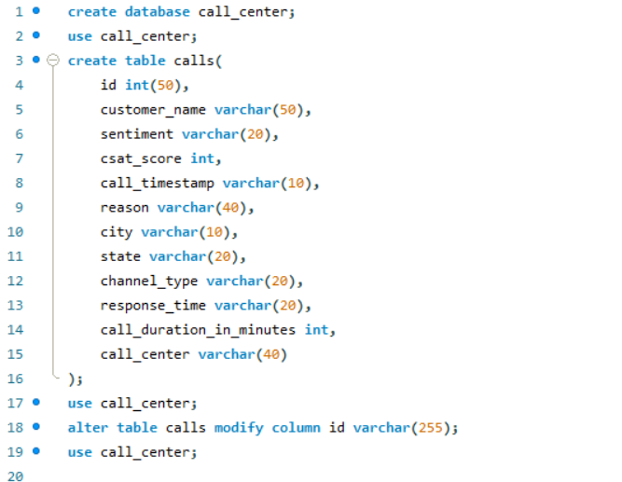

Step 2: Clean the data

