**Red Wine Quality Prediction Using Machine Learning**

**PROBLEM STATEMENT:**

According to experts, the wine is differentiated according to its smell, flavor, and color, but we are not a wine expert to say that wine is good or bad. What will we do then? Here’s the use of Machine Learning comes, here we are using machine learning to check wine quality.

**DATA:**

Several features has been used to classify the quality of wine, many of them are chemicals, let’s understand them:

* Volatile acidity: This is the gaseous acids present in wine
* Fixed acidity: Primary fixed acids found in wine are tartaric, succinic, citric, and malic
* Residual sugar: Amount of sugar left after fermentation
* Citric acid: It is weak organic acid, found in citrus fruits naturally
* Chlorides: Amount of salt present in wine
* Free sulphur dioxide: So2 is used for prevention of wine by oxidation and microbial spoilage
* Total sulphur dioxide: Amount of free and bound forms of So2
* pH: In wine pH is used for checking acidity
* density: The measurement of how tightly a material is packed together
* Sulphates: Added sulphites preserve freshness and protect wine from oxidation, and bacteria
* Alcohol: Percent of alcohol present in wine

Below are the steps that are followed to find which algorithm has the best fit:

1. Importing Libraries
2. Collecting Data
3. Data Information
4. Missing Values Handling
5. Target Categorizing
6. Normalization
7. Initialization
8. Logistic Regression
9. SVC
10. Result
11. 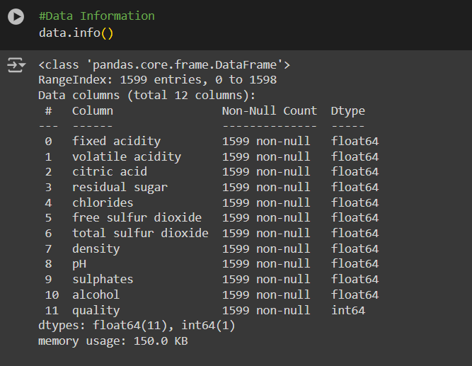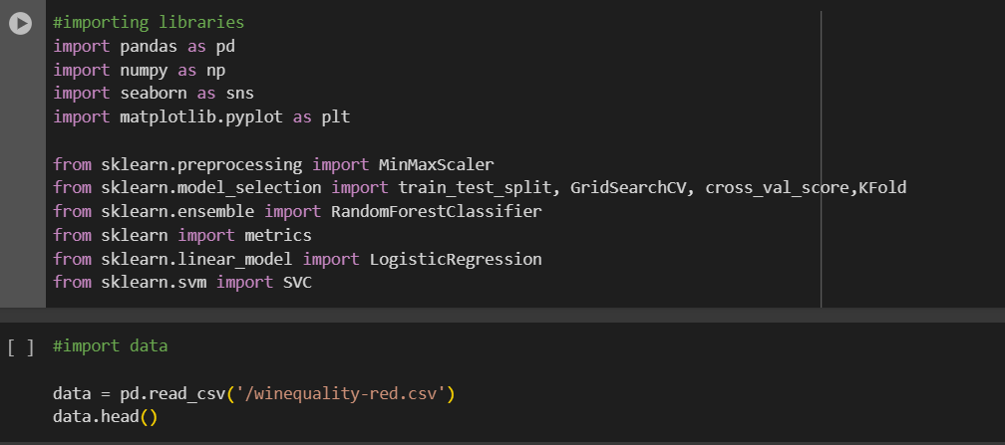Final Modeling

