**Stock Market Prediction using Machine Learning**

**PROBLEM STATEMENT:**

The Google training data has information from 3 Jan 2012 to 30 Dec 2016. There are five columns. The Open column tells the price at which a stock started trading when the market opened on a particular day. The Close column refers to the price of an individual stock when the stock exchange closed the market for the day. The High column depicts the highest price at which a stock traded during a period. The Low column tells the lowest price of the period. Volume is the total amount of trading activity during a period of time.

**DATA:**

This project is subdivided into following sections:

1. **Importing the libraries**
2. **Loading the training dataset**
3. **Use the Open Stock Price Model to Train your Model**
4. **Normalizing the model**
5. **Using X_train and y_train Data Structures**
6. **Reshape the Data**
7. **Building the Model by Importing the Crucial Libraries and Adding Different Layers to LSTM**
8. **Fitting the Model**
9. **Extracting the Actual Stock Prices of Jan-2017**
10. **Preparing the Input for the Model**
11. **Predicting the Values for Jan 2017 Stock Prices**
12. **Plotting the Actual and Predicted Prices for Google Stocks**

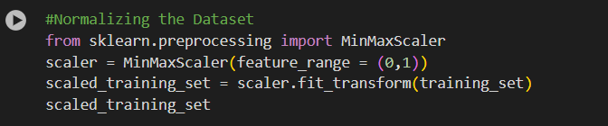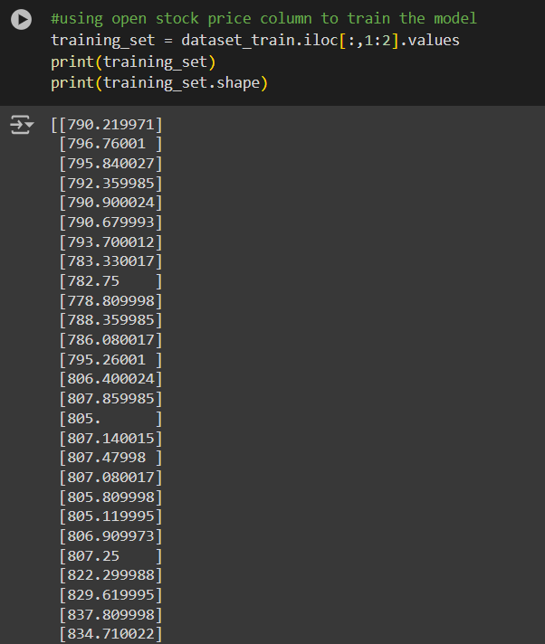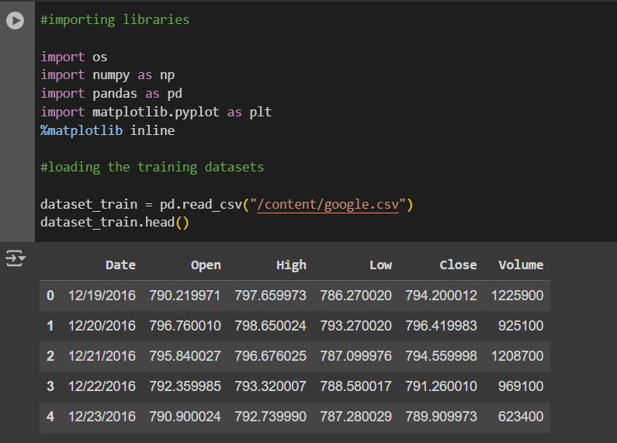

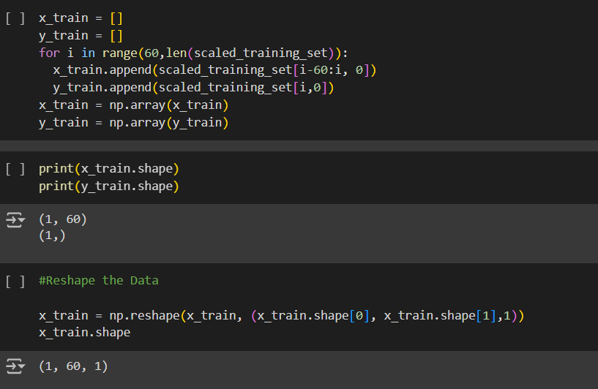

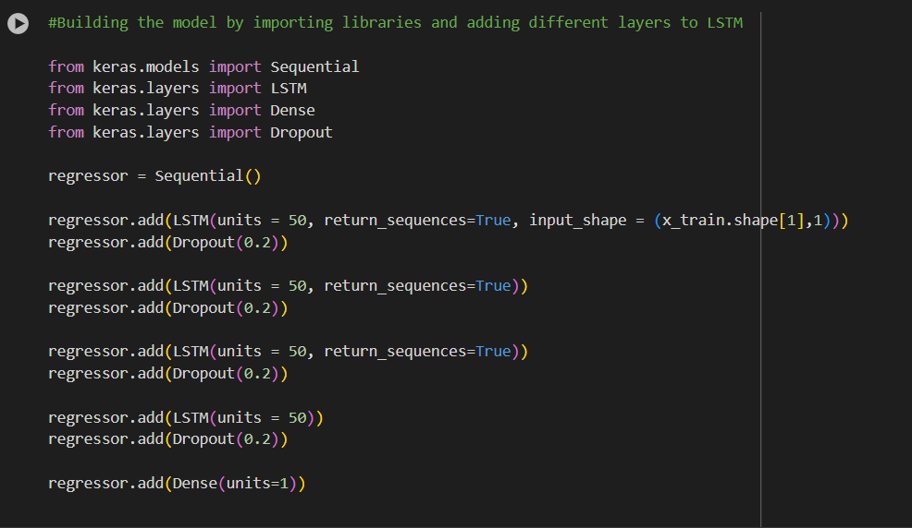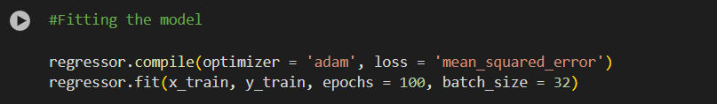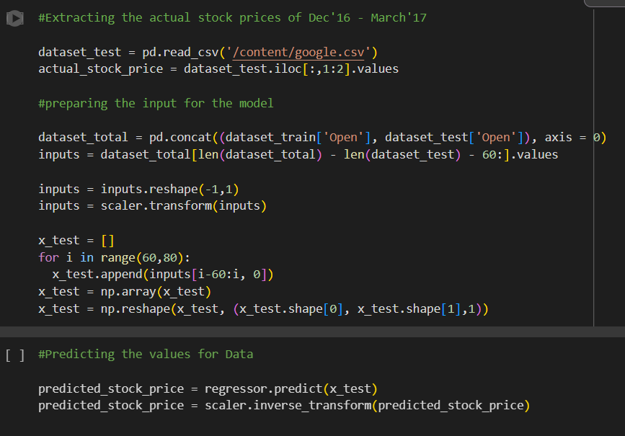

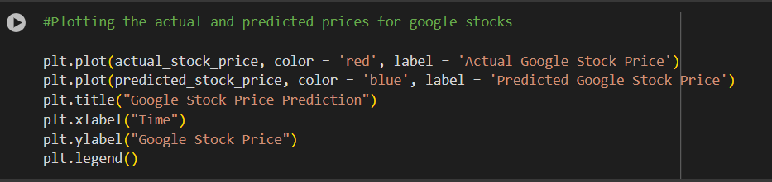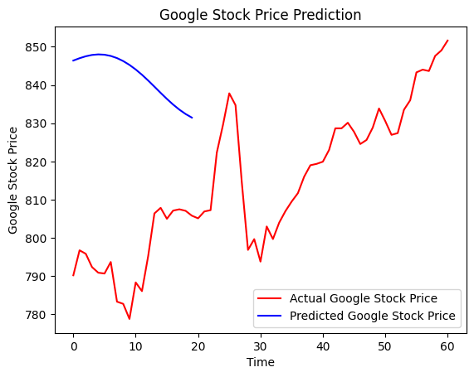

**CONCLUSION:**

The model can predict the trend of the actual stock prices very closely. The accuracy of the model can be enhanced by training with more data and increasing the LSTM layers.