Assignment -11.2
Name: M.SprusheethRao
Hallticket :2303A51206 Batch:04
Task Description -1 – (Stack Using AI Guidance)
- Task: With the help of AI, design and implement a Stack data structure supporting basic stack operations.
Expected Output:
- A Python Stack class supporting push, pop, peek, and empty-check operations with proper documentation.

Prompt:
Create a Python Stack class with push, pop, peek, and is_empty methods. Include proper documentation and example usage

Code:
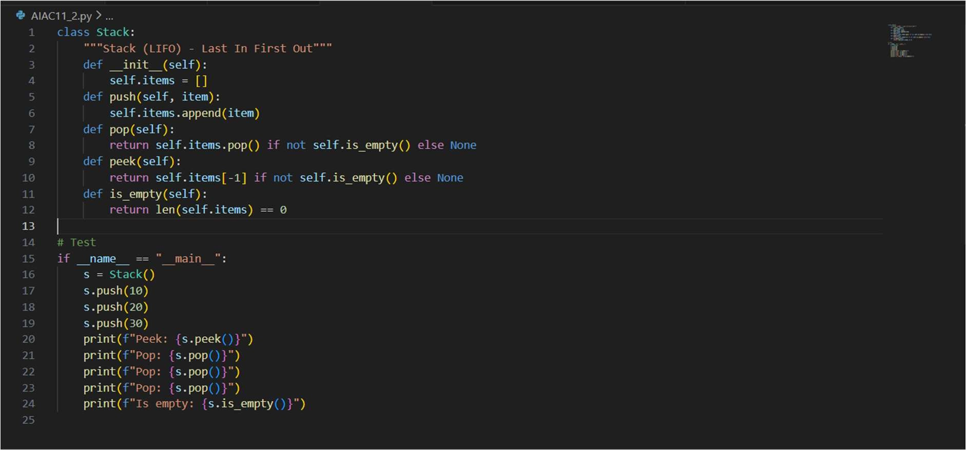

Output:
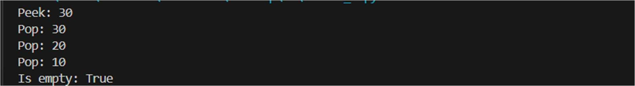

LIFO (Last In First Out) Python list is used because append() and pop() make push and pop easy and fast.
Methods like peek() and is_empty() are added to avoid errors and improve usability.

Task Description -2 – (Ǫueue Design)
- Task:Use AI assistance to create a Ǫueue data structure following FIFO principles Expected Output:
- A complete Ǫueue implementation including enqueue, dequeue, front element access, and size calculation

Prompt:
Create a Queue class in Python following FIFO principle with enqueue, dequeue, front, and size methods

Code:
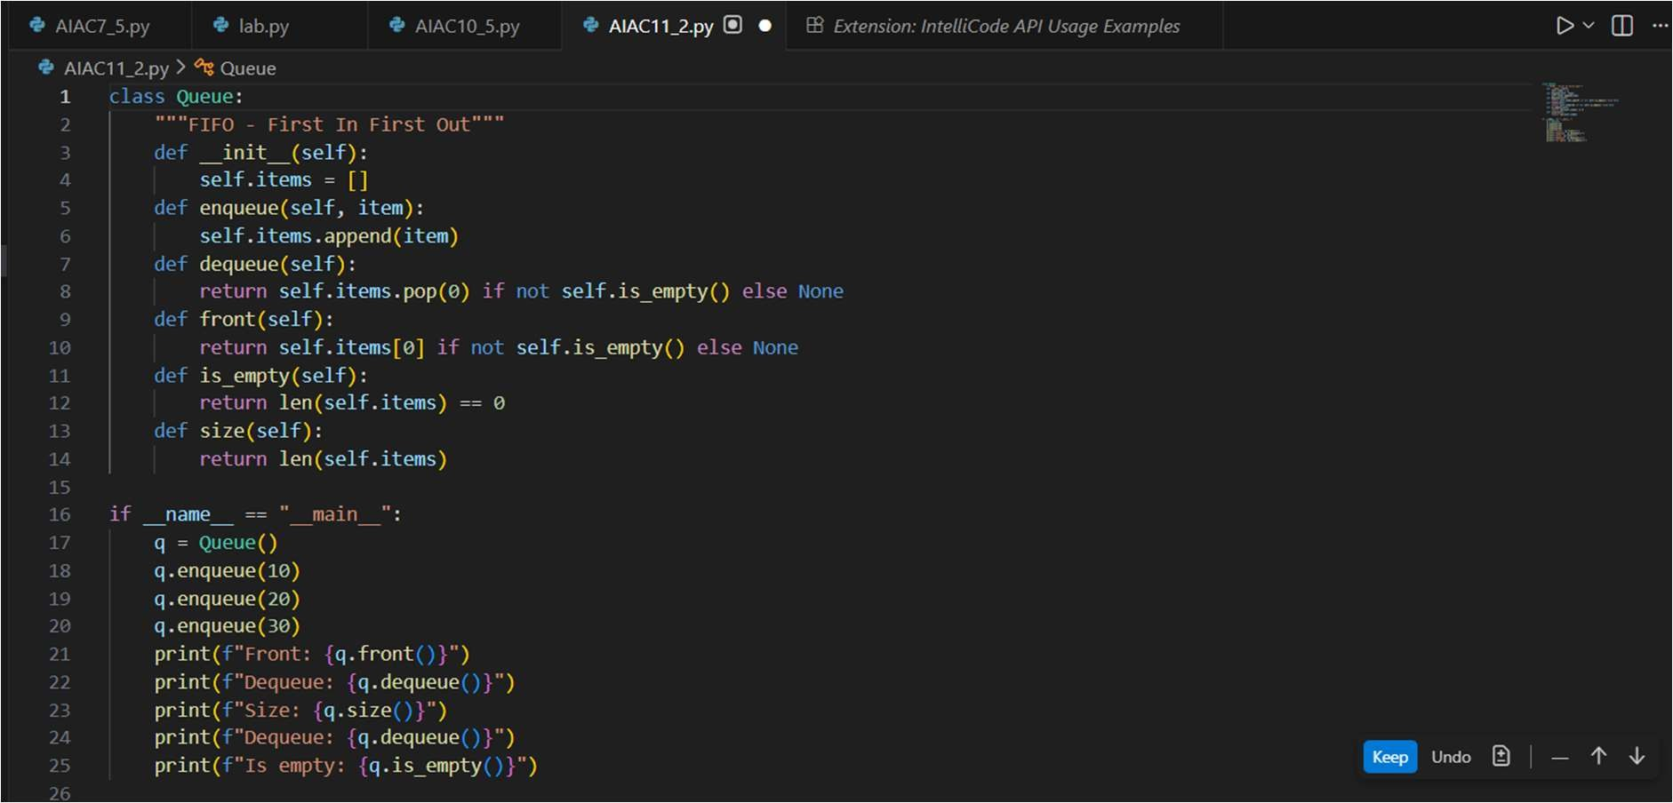

Output:

Ǫueue follows FIFO (First In First Out).
List is used to insert elements at rear and remove from front.
Functions like enqueue(), dequeue(), and front() maintain proper queue order

Task Description -3 –(Singly Linked List Construction)
- Task: Utilize AI to build a singly linked list supporting insertion and traversal. Expected Output:
- Correctly functioning linked list with node creation, insertion logic, and display functionality.

Prompt:
Build a singly linked list in Python with node creation, insertion at end, and traversal display

Code:
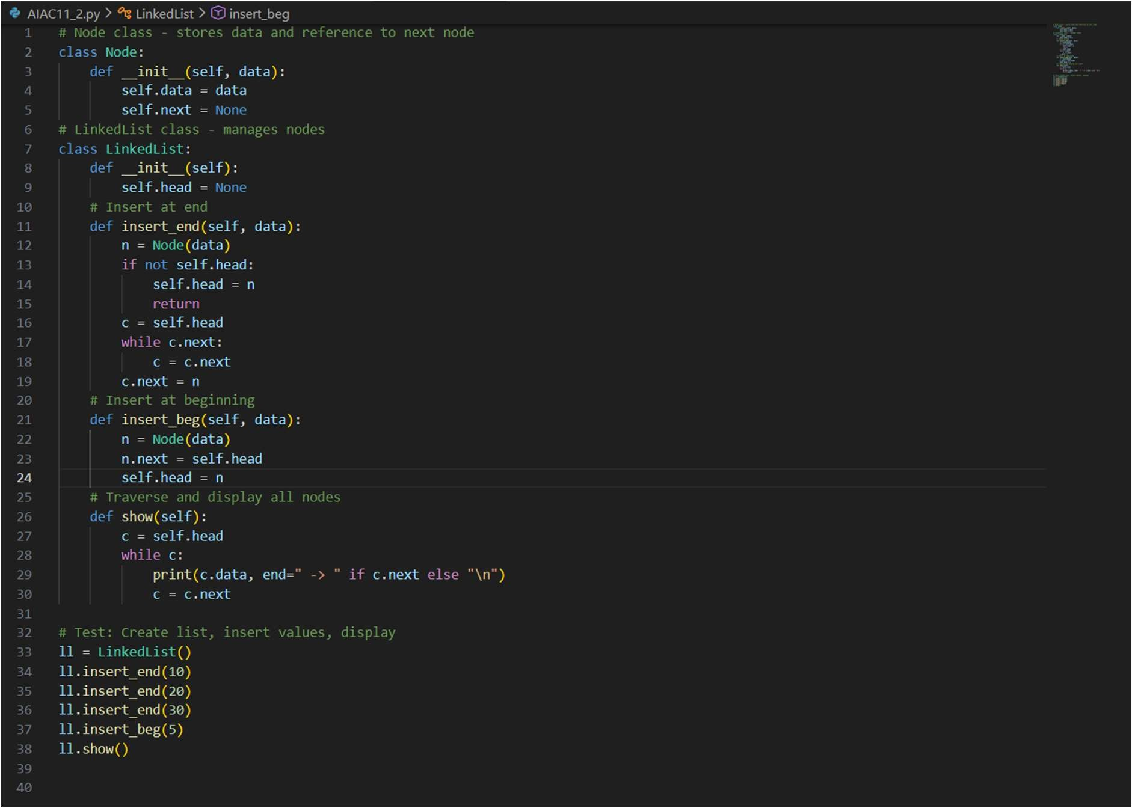

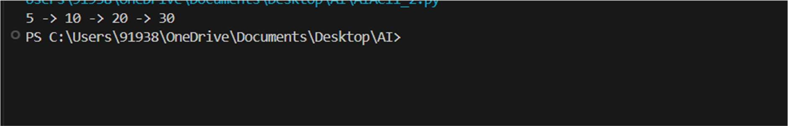

Justification:
Linked list uses nodes connected by pointers. Separate Node class stores data and next reference. Insertion and traversal show how elements are linked dynamically.

Task Description -4 – (Binary Search Tree Operations)
- Task: Implement a Binary Search Tree with AI support focusing on insertion and traversal.
Expected Output:
- BST program with correct node insertion and in-order traversal output. Prompt:Implement a Binary Search Tree with insertion and in-order traversal. Code:
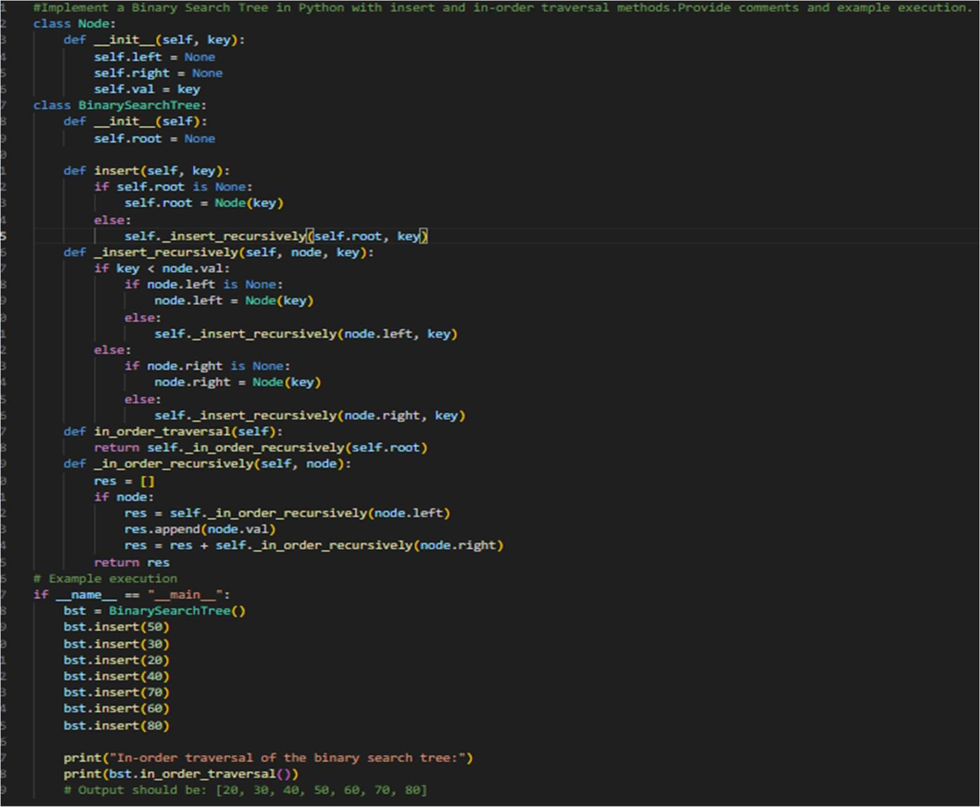

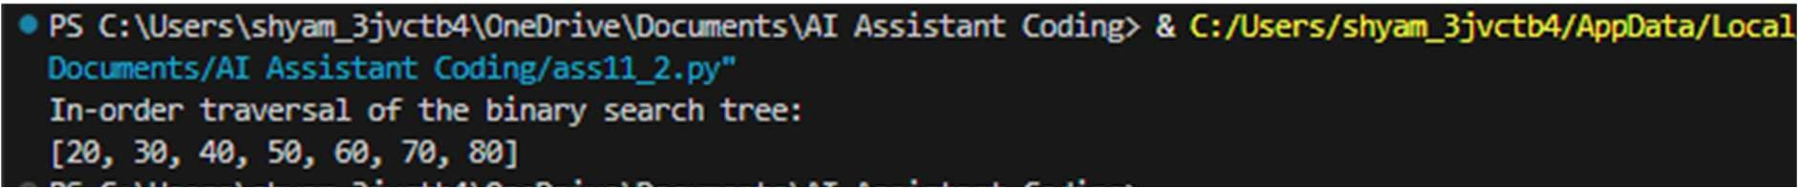

Justification:
This program implements a Binary Search Tree (BST) using a Node class and a BinarySearchTree class. The insert() method adds elements following the BST rule (left < root < right). The in_order_traversal() method prints elements in sorted order. The example shows values printed in ascending order, proving the BST works correctly.

Task Description -5 – (Hash Table Implementation)
- Task: Create a hash table using AI with collision handling Expected Output:
- Hash table supporting insert, search, and delete using chaining or open

Prompt:
create a Hash Table in Python with insert, search, delete operations using chaining collision handling

Code:
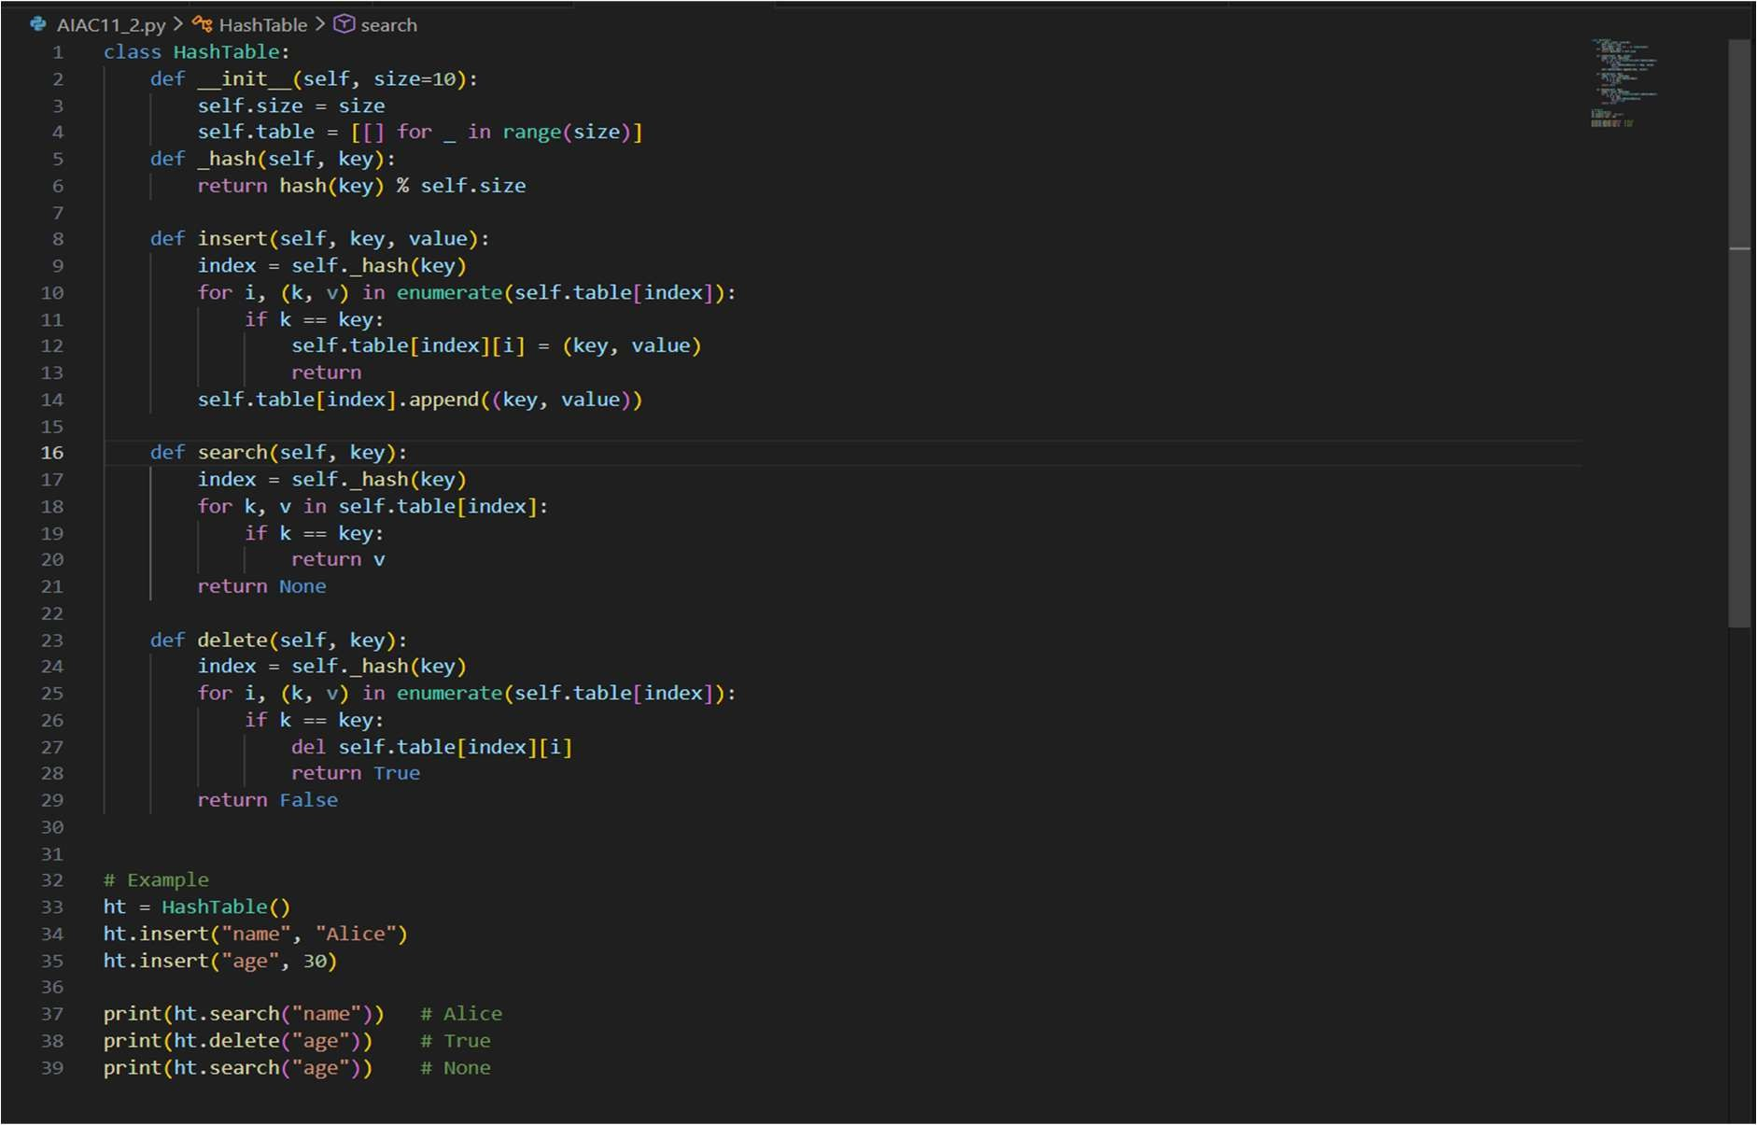

Justification:
Hash table allows fast data access. Modulo hash function is used to find index. Chaining method handles collisions by storing multiple elements in one bucket.

Task Description -6 :
prompt : "With the help of AI, implement the Inorder Traversal of a Binary Tree... give short and simpler code"

Code:
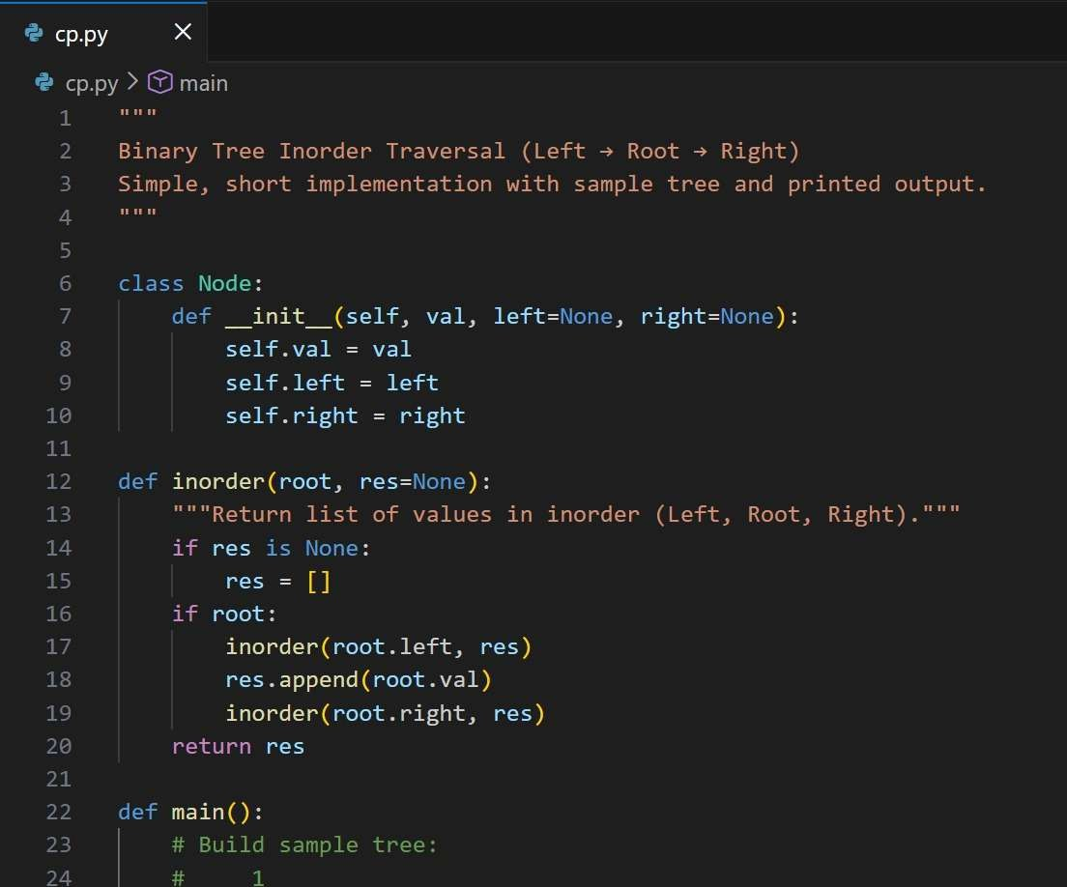

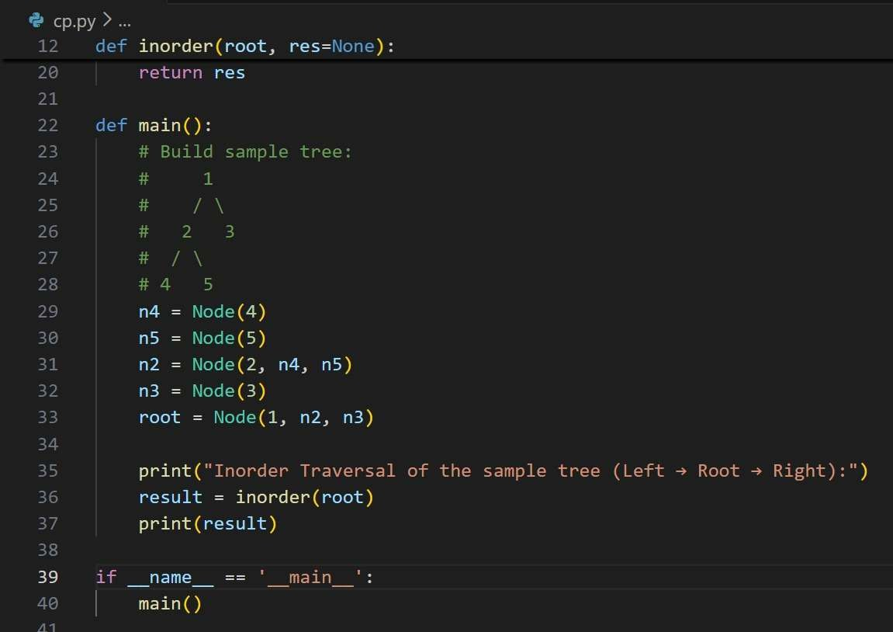

Output:

Justification:
Node: simple binary node with value, left and right children
Inorder(root) : recursive traversal visiting left, then root, then right; returns a list of values
Sample tree built in main:
root 1 with left child 2 and right child 3; node 2 has children 4 and 5 main: builds sample tree, calls inorder, prints result and short notes Task Description -7 :
Prompt:implement preorder traversal, show output for a sample tree.

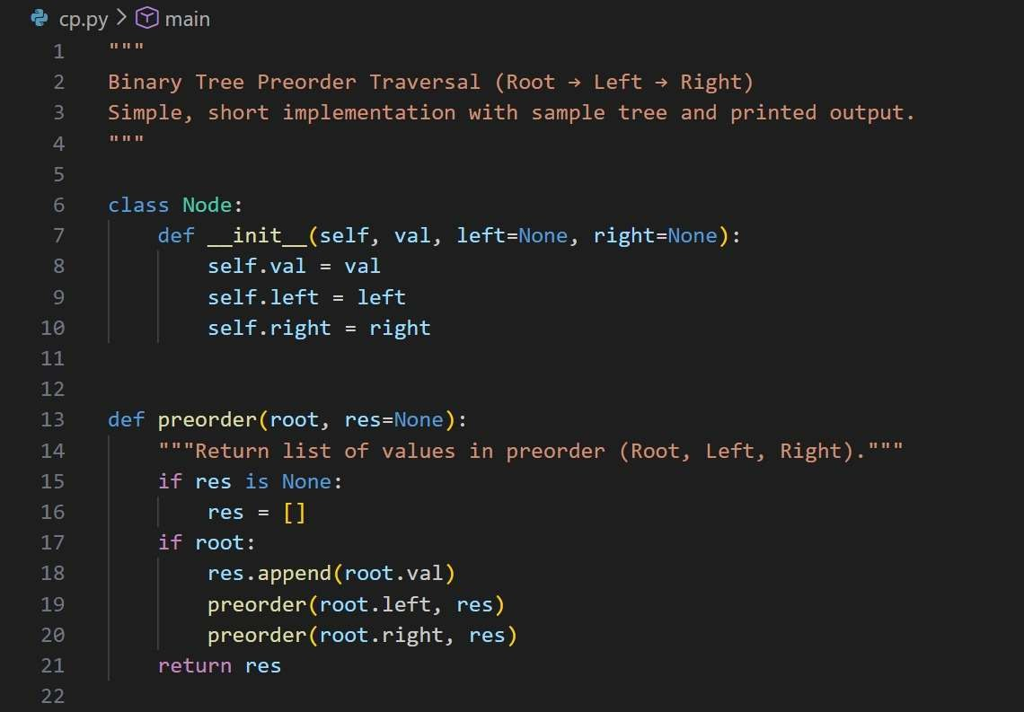
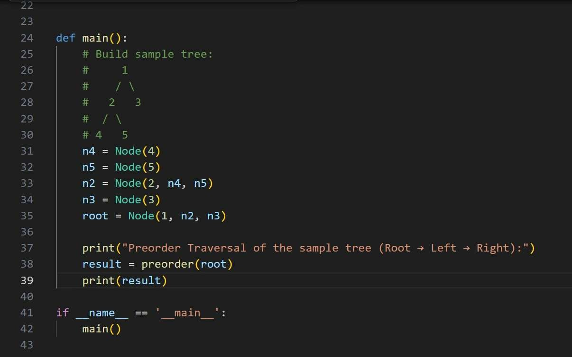

Justification:
Comments C Code Explanation
Node: simple binary tree node with fields val, left, right.
preorder(root): recursive function — append root.val, then recurse preorder(root.left), then preorder(root.right); returns a list of visited values.
main(): builds sample tree (1 root, left 2, right 3, and 2 has children 4 and 5), calls preorder(root), prints the result and brief notes.
Traversal order: Root → Left → Right. Sample output: [1, 2, 4, 5, 3]

