Assignment 6.2

Name: M. Sprusheeth rao

Hallticket: 2303A51206 Batch - 04

Task Description-1 (Classes – Data Validation)
- Prompt AI to generate a Student class with attributes: name, roll_no, and marks. Add a method is_pass() that returns whether the student has passed (marks ≥ 40).
Prompt:Write a Python program using a class Student with attributes name, roll_no, and marks. Include a method is_pass() that returns True if marks are 40 or above, otherwise False. Create an object and print the result.

Code:

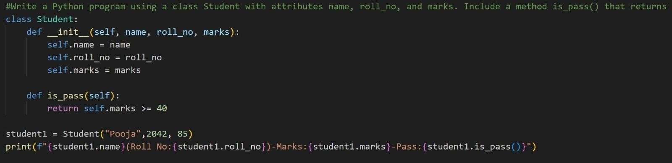

Output:

This program defines a Student class to store student details like name, roll number, and marks. The init method initializes these values when a student object is created. The is_pass method checks whether the student has passed by verifying if the marks are 40 or more and returns True or False. An object is created using the class, and the result of the pass check is printed.

Task Description-2 (Loops – Pattern Generation)
- Ask AI to generate a function that prints a right-angled triangle star pattern using a for loop. Then regenerate the same pattern using a while loop.
Prompt:Write a Python function using a while loop to print a right-angled triangle pattern of stars for a given number.

Code:
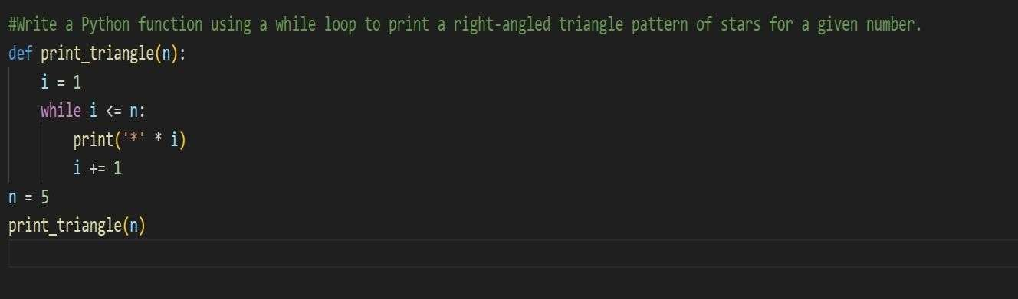

Output:
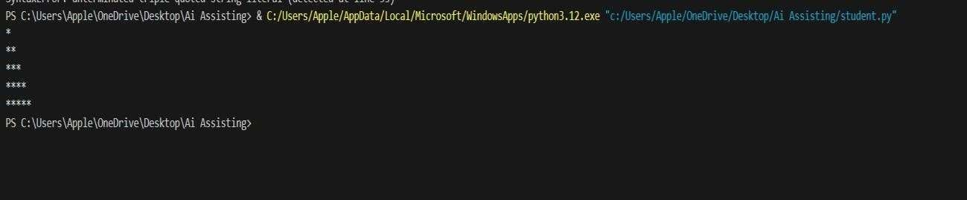

This program defines a function triangle_while that takes a number n as input. Inside the function, a variable i starts from 1 and a while loop runs until i is less than or equal to n. In each loop iteration, it prints i number of * characters to form a triangle pattern. After printing each line, i is increased by 1. Finally, the function is called with the value 5, which prints a triangle of 5 rows.

Task Description-3 (Conditional Statements – Number Analysis)
- Ask AI to write a function that checks whether a given number is positive, negative, or zero using if-elif-else. Test the function with multiple inputs.
Prompt:Write a Python function that checks whether a number is positive, negative, or zero and prints the result.

Code:
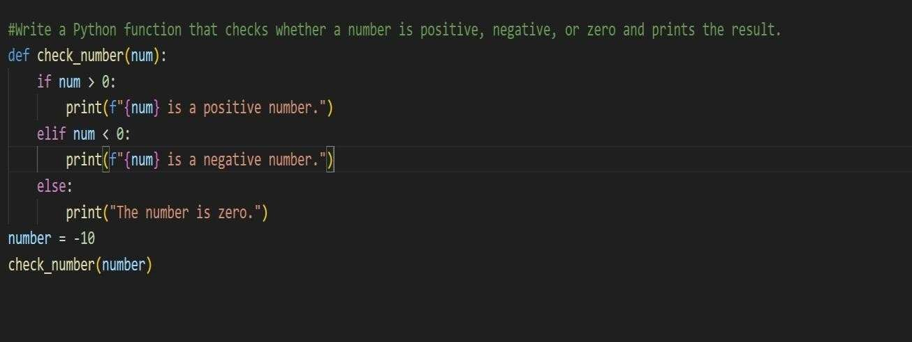

Output:
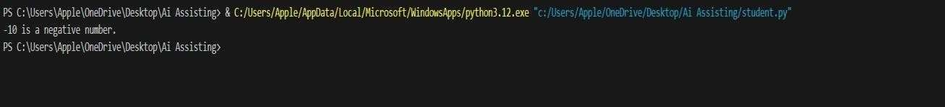

This program defines a function check_number that takes a number as input. It uses if, elif, and else conditions to check whether the number is greater than zero, less than zero, or equal to zero. If the number is greater than zero, it returns "Positive", if it is less than zero, it returns "Negative", and if it is zero, it returns "Zero". The function is then called with different values, and the results are printed.

Task Description-4 (Nested Conditionals)
- Generate a function check_discount(age, is_member) that determines discount eligibility:
- Age ≥ 60 → Senior discount
- Member → Additional discount Use nested if statements.
Prompt:Write a Python function that determines the type of discount based on a person’s age and membership status using conditional statements.

Code:
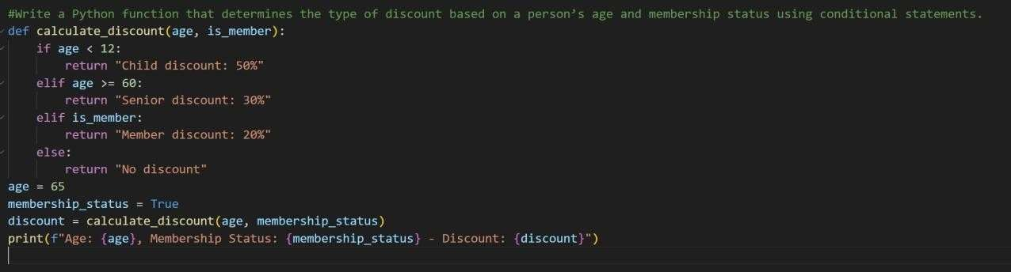

Output:

This program defines a function check_discount that takes two inputs: age and is_member. It first checks if the age is 60 or above to identify a senior citizen. If the person is a senior and also a member, it returns “Senior + Member Discount”; if they are only a senior, it returns “Senior Discount”. If the age is below 60, the function then checks membership status: members get “Member Discount”, and non-members get “No Discount”. The function is called with different values, and the appropriate discount message is printed.

Task Description-5 (Class – Mathematical Opera)
- Ask AI to create a Circle class with methods to calculate area () and circumference () given the radius.
Prompt:Create a Python class Circle that takes radius as input and includes methods to calculate and return the area and circumference of the circle.

Code:
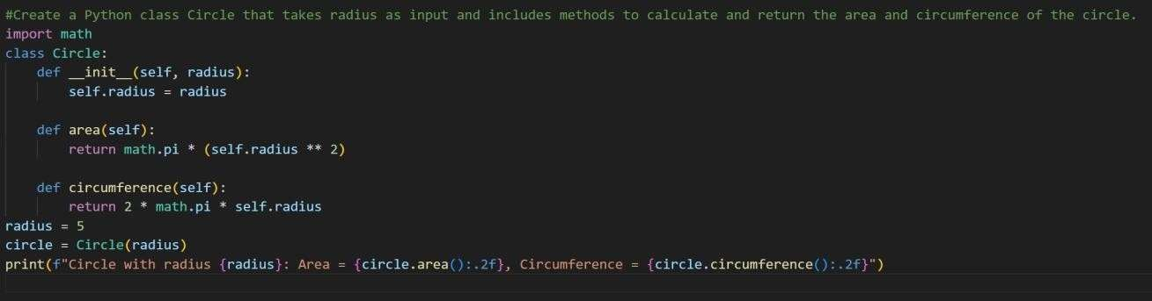

Output:

Code Explanation:

This program imports the math module to use the value of π (pi). It defines a class Circle with an init method that stores the radius of the circle. The area method calculates and returns the area using the formula π × radius × radius.

