ASSIGNMENT 9.5
Name : M. Sprusheeth Rao
Roll Number: 2303A51206 Batch - 04

Problem 1: String Utilities Function
Consider the following Python function:
def reverse_string(text):
return text[::-1] Task:
- Write documentation in:
  - (a) Docstring
  - (b) Inline comments
  - (c) Google-style documentation
- Compare the three documentation styles.
- Recommend the most suitable style for a utility-based string library.
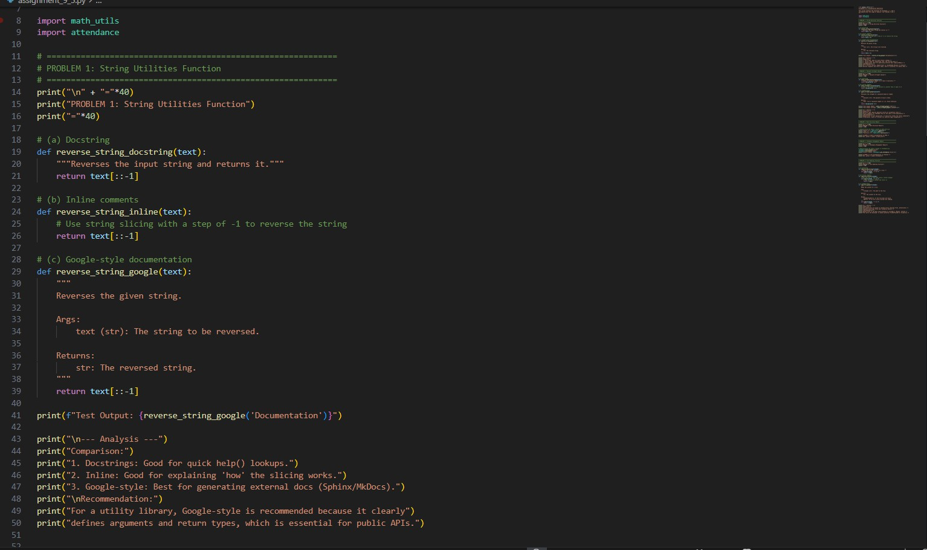
Output:

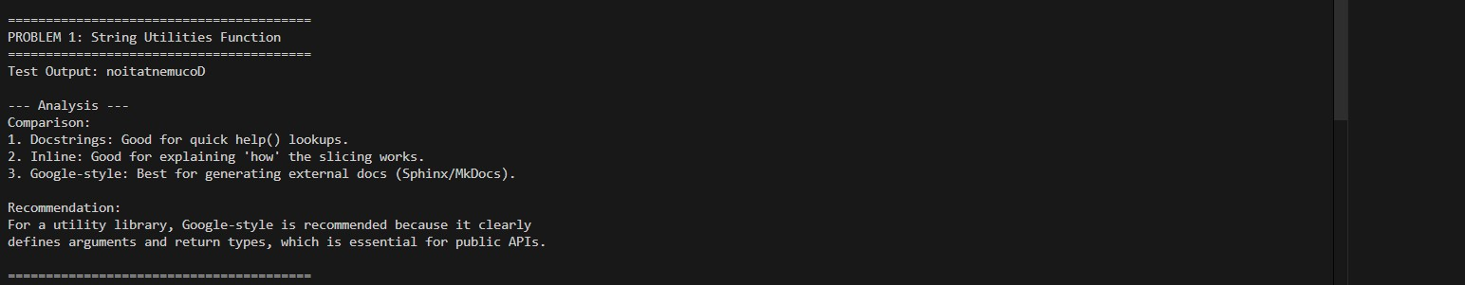

Justification:

- Docstring:
  - Provides a short explanation of what the function does.
  - Useful for quick references via help() in Python.
  - Limitation: Does not specify arguments or return types explicitly.

Inline comments:
  - Explain the logic step by step inside the function.
  - Helps beginners understand how string slicing works ([::-1]).
  - Limitation: Comments are only useful in the code editor; they don’t help automated documentation tools.

Google-style documentation:
  - Specifies the function purpose, arguments, return type, and description.
  - Can be automatically parsed by documentation tools like Sphinx or MkDocs.
  - Best choice for utility libraries or APIs, as it makes usage very clear to other developers.

Recommendation: Google-style is preferred because it clearly defines what input the function expects and what output it produces, which is critical for external developers or automated documentation.

Problem 2: Password Strength Checker Consider the function:
def check_strength(password):
return len(password) >= 8 Task:
- Document the function using docstring, inline comments, and Google style.
- Compare documentation styles for security-related code.
- Recommend the most appropriate style.

Input:
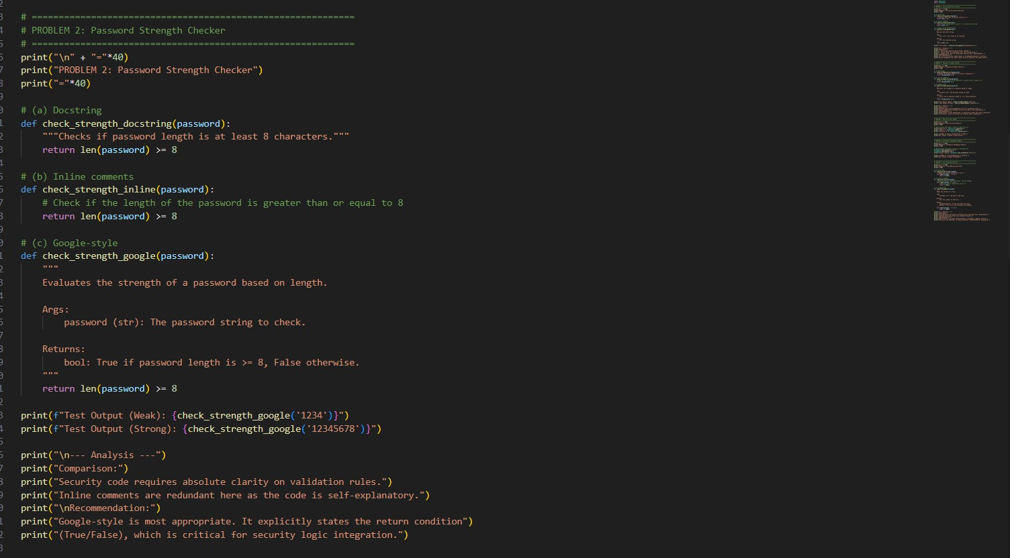
Output:
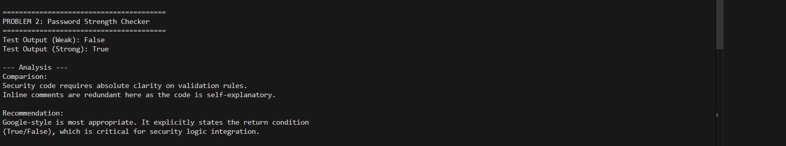

Justification:

- Docstring:
  - Simple description of the function purpose (“checks if password length is >= 8”).
  - Easy for help() lookup.

Inline comments:
  - Explain the comparison operation (len(password) >= 8).
  - Useful for beginners but redundant for experienced programmers since the code is straightforward.

Google-style documentation:

  - Clearly specifies:
    - Argument: password (string)
    - Return type: Boolean
    - Condition for True/False
  - Critical in security-sensitive code, where clarity avoids misinterpretation.
Recommendation: Google-style is best. In security applications, explicit argument and return specifications help prevent logic errors and ensure correct integration with other modules.

Problem 3: Math Utilities Module Task:
- Create a module math_utils.py with functions:

o square(n)

o cube(n)

o factorial(n)

- Generate docstrings automatically using AI tools.

- Export documentation as an HTML file.

Input:
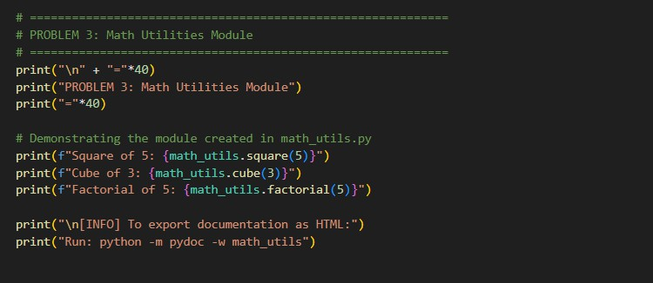

Output:

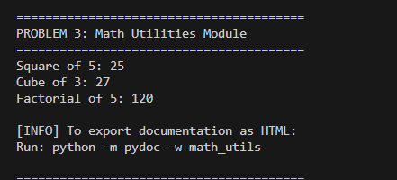

Justification:

  - Demonstrates usage of a custom module (math_utils) with functions like square(), cube(), factorial().
  - Documenting the module allows other developers to understand how to use the functions without reading the source code.
  - Generating HTML documentation with pydoc ensures the module can be published for external use.

Recommendation: Use Google-style or standard docstrings for modules to make them easily documentable. This allows consistent API documentation and easier code maintenance.

Problem 4: Attendance Management Module Task:
- Create a module attendance.py with functions:

o mark_present(student)

o mark_absent(student)

o get_attendance(student)

- Add proper docstrings.

- Generate and view documentation in terminal and browse

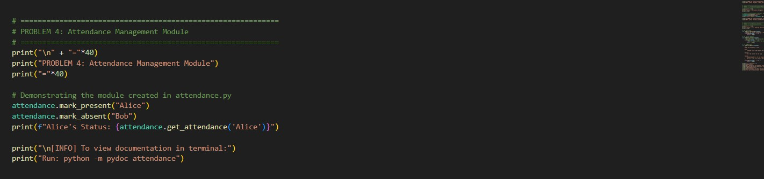

Output:
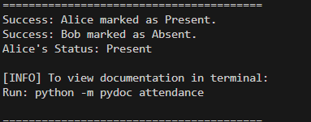

Justification:

  - Demonstrates the module (attendance) for marking attendance.
  - Provides a clear example of how functions like mark_present(), mark_absent(), and get_attendance() can be used.
  - Terminal documentation (python -m pydoc attendance) gives quick access to usage instructions without opening the code.

Recommendation: Google-style documentation is preferred for modules because it helps other developers understand functions, arguments, and expected results clearly. Inline comments are insufficient for API-level understanding.

Problem 5: File Handling Function Consider the function:
def read_file(filename):
with open(filename, 'r') as f:
return f.read() Task:
- Write documentation using all three formats.
- Identify which style best explains exception handling.
- Justify your recommendation.

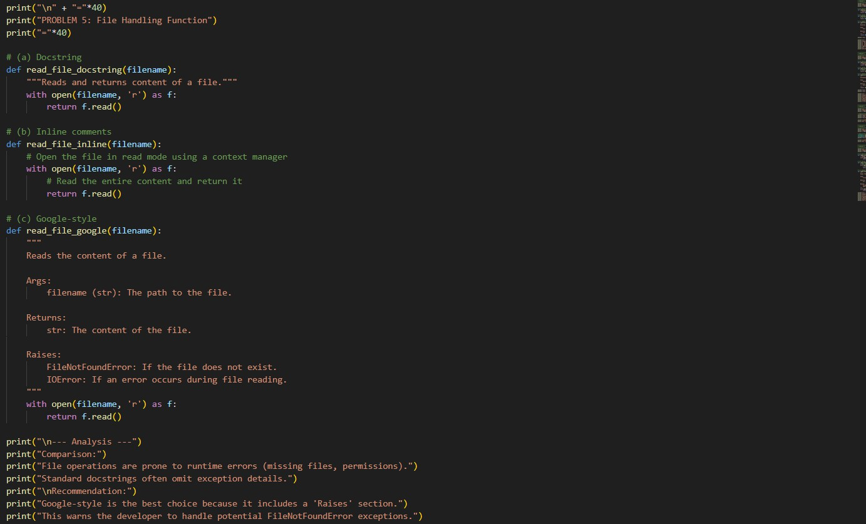
Output:
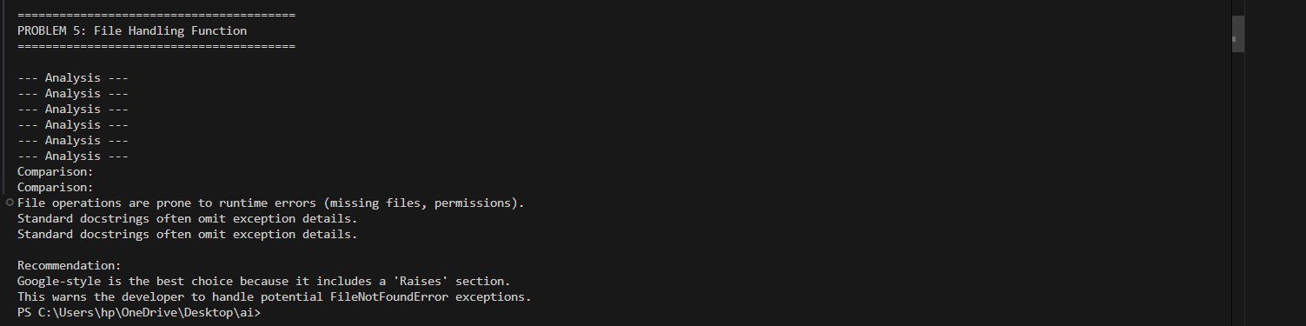

Justification:

  - Docstring:
    - Provides a simple explanation (“reads and returns file content”).
    - Limited because it does not mention possible exceptions like
FileNotFoundError.

Inline comments:
    - Explain each step of opening and reading the file.
    - Useful for beginners but verbose for experienced developers.

Google-style documentation:
    - Includes:
      - Arguments (filename)
      - Return type (str)
      - Potential exceptions (FileNotFoundError, IOError)
    - Essential for file operations, where errors are common.
    - Helps other developers anticipate and handle exceptions properly.

Recommendation: Google-style is the best choice for robust, production-ready file handling functions, because it communicates all necessary details to users, including exceptions.

