

PharmaChain Blockchain Application
For
SAP - Design the Enterprise 2.0

Contributors

- Makarand Karanjalkar Mak@sprytech.uk

- Dina Chiganbayeva Dina.Chiganbayeva@sprytech.uk

- Anuj Palimkar Anuj.Palimkar@sprytech.uk

Table of Contents
Contributors 1
1.0 Introduction 3
1.1 Aim of project 3
1.2 Existing System 3
1.3 Blockchain based supply chain 4
2.0 Design Approach 5
2.1 Functional requirements 5
2.2 Technical requirements 5
2.3 Limitation 6
2.4 Future enhancements 6
3.0 Functionality description 6
4.0 Action and GUI flow of application 8
5.0 Instruction to setup and execute Pharmachain Hyperledger Application 14
5.1 Installing pre-requisites 14
5.2 Installing the development environment 15
5.3 Business network structure and angular UI 16
6.0 Conclusion 18
7.0 Contact contributors 18

Introduction
We have selected to develop a Hyperledger public blockchain based supply chain application to combat counterfeit drugs in the Pharmaceutical industry as a part of SAP challenge to design the enterprise 2.0.
According to the World Health Organisation (WHO), the global pharmaceutical marketplace is worth an estimated 420 billion pounds and 10-15% of the global pharmaceutical market consists of counterfeit drugs and due to this pharmaceutical industry loses nearly 60 billion pounds a year due to counterfeit drugs. We believe blockchain technology will bring traceability and transparency in supply chain using the several customizable and configurable features of blockchain technology.

Aim of project
PharmaChain is a Hyperledger fabric based angular application intended to demonstrate the benefits of blockchain solution implementation in pharmaceutical supply chain in order to view change in ownership of a particular asset (drug). Pharmachain is designed to give users ability to create a pharmaceutical product, transfer it to another user and track the history of transactions taking place. This application mainly focuses to overcome the problems related with counterfeit drugs.

Existing System
There are many challenges with the traditional supply chain of pharmaceutical drugs when it comes to deal with counterfeit drugs, like, every user faces the problem of a lack of traceability through the entire supply chain, manufacturers face problems with the management of all the data involved in the supply chain process, theft or manipulation of shipments is a major issue for distributors, validating and verifying the authenticity of the drugs by the retailer, ensuring the authenticity of a particular drug by the end consumer, also, the process is filled with many documents and data across every step in the supply chain process. Sometimes repetitive documents are created.

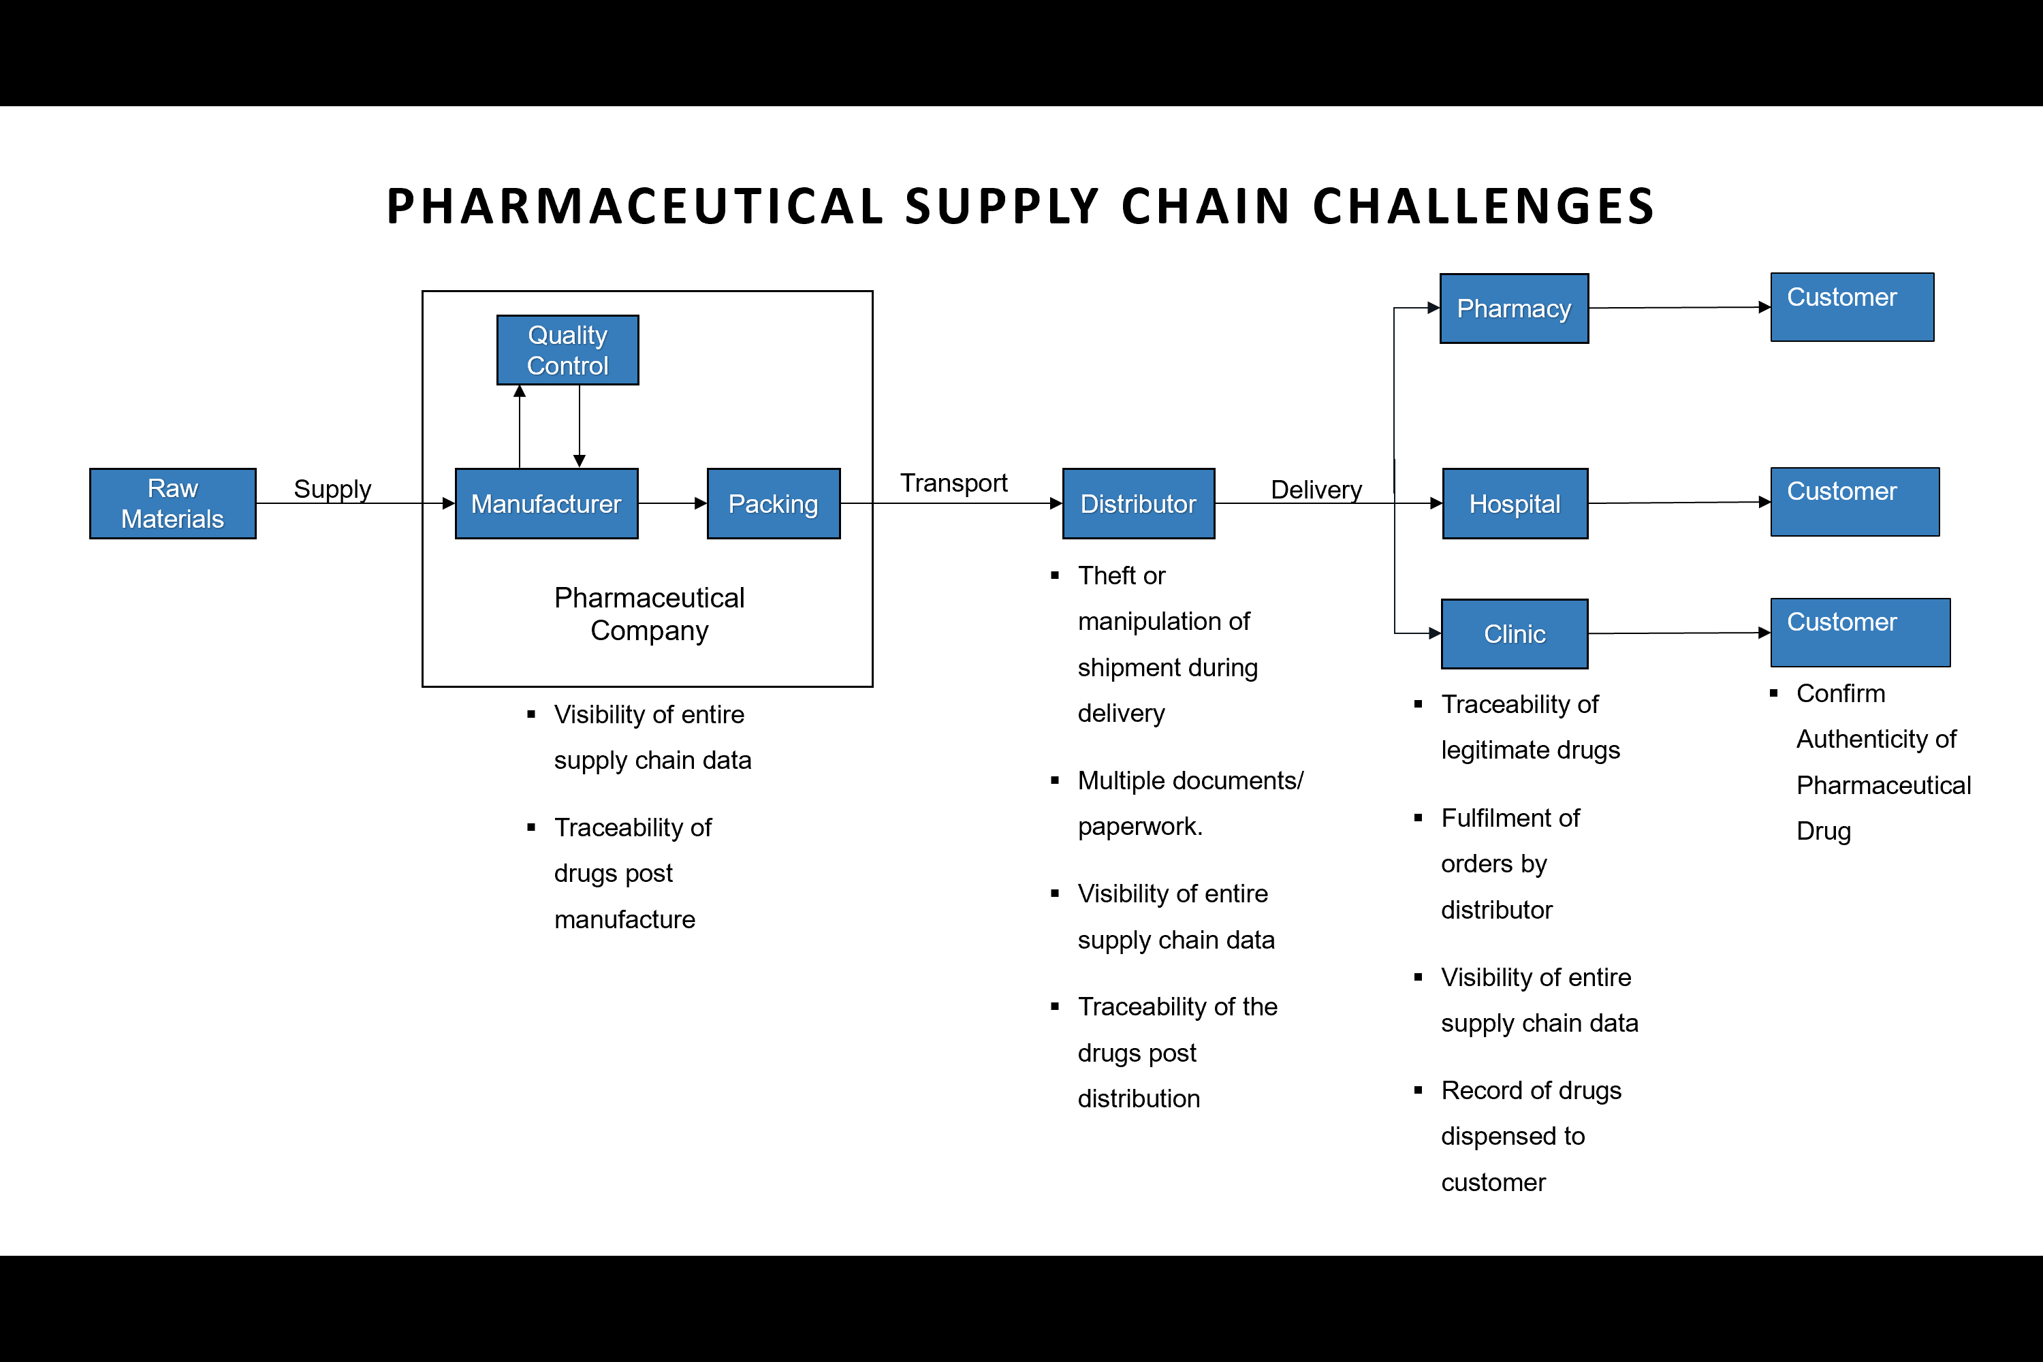

Blockchain based supply chain
Blockchain is chain of blocks that are linked using cryptography. It is based on distributed ledger technology which allows user to share data amongst each other freely. The data stored on Blockchain is immutable. This technology provides transparency, traceability, security, fast access and helps to prevent loads of documentation. These features build trust amongst all participants. Hyperledger Fabric is used in use case. Hyperledger Fabric is designed to develop applications or solutions with a modular architecture. Hyperledger Fabric allows components, such as consensus and membership services, to connect and operate (Figure 1). Its modular and versatile design meets a wide range of industry use cases. It offers a unique consensus approach that delivers scale-based performance while maintaining confidentiality. Pharmachain will bring several benefits to the supply chain, including, verification of the authentic drug for every participant, validation of the data written by any participant on the blockchain, an immutable database, full traceability and tracking of the end to end supply chain data will be possible, access control for who can access the data can be managed by the data owner.
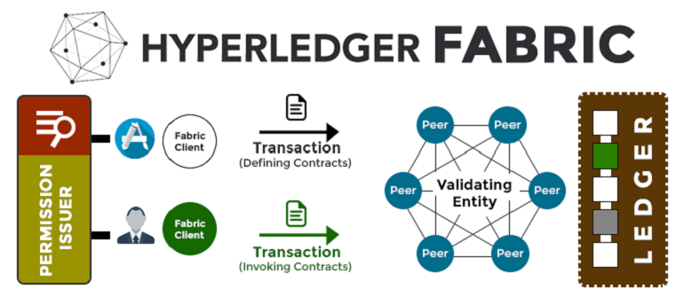

Design Approach

Functional requirements
- Admin should be able to create, update and delete data of the list Admins, Manufacturers, Distributors and Retailers.
- Manufacturer should be able to view list of Admins, Manufacturers, Distributors and Retailers.
- Manufacturer should be able to create new asset (product)
- Manufacturer should be able to view list of products created by him
- Manufacturer should be able to change ownership of asset
- Manufacturer should be able to view all transactions
- Distributor should be able to view list of Admins, Manufacturers, Distributors and Retailers.
- Distributor should be able to view list of products created by manufacturer
- Distributor should be able to change ownership of asset
- Distributor should be able to view all transactions
- Retailer should be able to view list of Admins, Manufacturers, Distributors and Retailers.
- Retailer should be able to view list of products created by manufacturer
- Retailer should be able to view all transactions

Technical requirements
- Operating Systems: Ubuntu Linux 14.04 / 16.04 LTS (both 64-bit), or Mac OS 10.12
- Docker Engine: Version 17.03 or higher
- Docker-Compose: Version 1.8 or higher
- Node: 8.9 or higher (note version 9 is not supported)
- npm: v6.x
- git: 2.9.x or higher
- Python: 2.7.x
- angular/cli version 1.0.1
- A code editor of your choice, we recommend VSCode.

Limitation
- Security: There is no authorization for actors
- Application run on single node

Future enhancements
- Developing of log in page
- Admin will create email id and password for participants to access application
- Implementing the application in a multi-node environment

Functionality description

Page | Functionality | Requirement | Description
Home Page | Admin | Logged in | Access to page for admins
Home Page | Manufacturer | Logged in | Access to page for manufacturers
Home Page | Distributor | Logged in | Access to page for distributors
Home Page | Retailer | Logged in | Access to page for retailers
Admin Page | Admin Card | Logged in | Allows to create, update and delete list of admins.
Admin Page | Manufacturer Card | Logged in | Allows to create, update and delete list of manufacturers
Admin Page | Distributor Card | Logged in | Allows to create, update and delete list of distributors
Admin Page | Retailer Card | Logged in | Allows to create, update and delete list of retailers
Manufacturer Page | View Admin | Logged in | Allows only view the list of admins
Manufacturer Page | View Manufacturer | Logged in | Allows only view the list of manufacturers
Manufacturer Page | View Distributor | Logged in | Allows only view the list of distributors
Manufacturer Page | View Retailer | Logged in | Allows only view the list of retailers
Manufacturer Page | Add Product | Logged in | Allows to create id and name of asset
Manufacturer Page | View Product Data | Logged in | Allows to view list of assets
Manufacturer Page | Transaction Move Product | Logged in | Allow to change the ownership
Manufacturer Page | View transaction | Logged in | Allow to view all transaction
Distributor Page | View Admin | Logged in | Allows only view the list of admins
Distributor Page | View Manufacturer | Logged in | Allows only view the list of manufacturers
Distributor Page | View Distributor | Logged in | Allows only view the list of distributors
Distributor Page | View Retailer | Logged in | Allows only view the list of retailers
Distributor Page | View Product Data | Logged in | Allow to view list of assets
Distributor Page | Transaction Move Product | Logged in | Allow to change the ownership
Distributor Page | View Transaction | Logged in | Allow to view all transaction
Retailer Page | View Admin | Logged in | Allows only view the list of admins
Retailer Page | View Manufacturer | Logged in | Allows only view the list of manufacturers
Retailer Page | View Distributor | Logged in | Allows only view the list of distributors
Retailer Page | View Retailer | Logged in | Allows only view the list of retailers
Retailer Page | View Product Data | Logged in | Allow to view list of assets
Retailer Page | View Transaction | Logged in | Allow to view all transaction
Table 1 : Functionality and page description

Action and GUI flow of application
- Application launches HOME Page which support role-based functionality depending on Actors involved. Figure 1 shows the User Interface for Home Page.
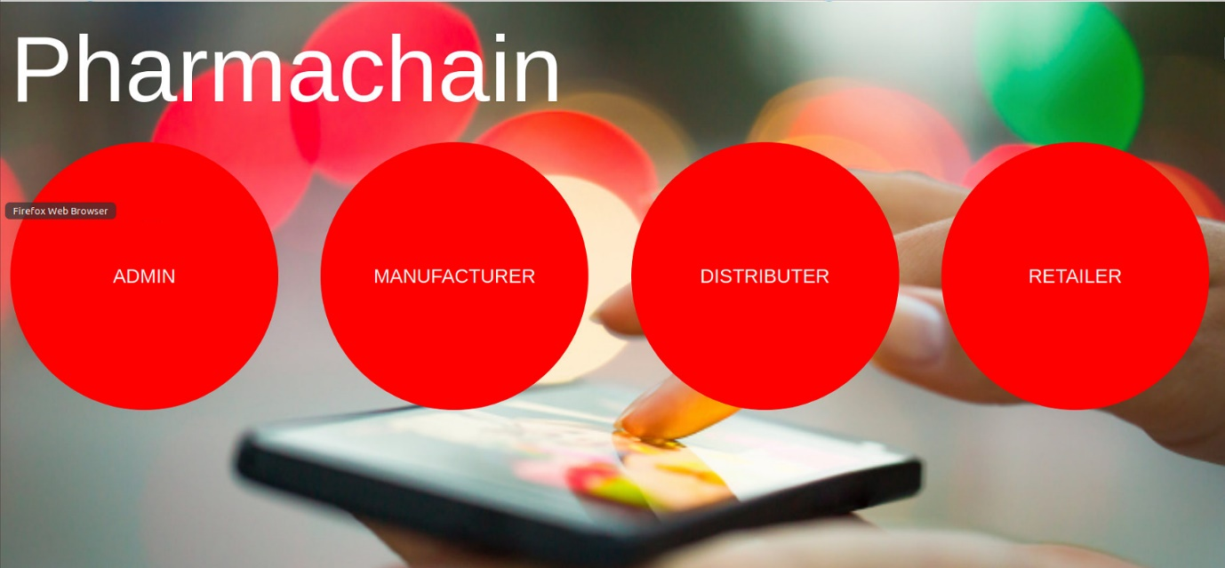
Figure 1: HOME PAGE

- For admin
When an Admin uses the application, he will have access to add new manufacturer, distributor and retailer, which can then access the application. For demo purpose, one manufacturer, one distributor and one retailer are already added in the network. The Figure 2 displays the Admin Page. Figure 3 shows the list of manufacturers added by admin. Figure 4 shows the details required while creating a new participant.
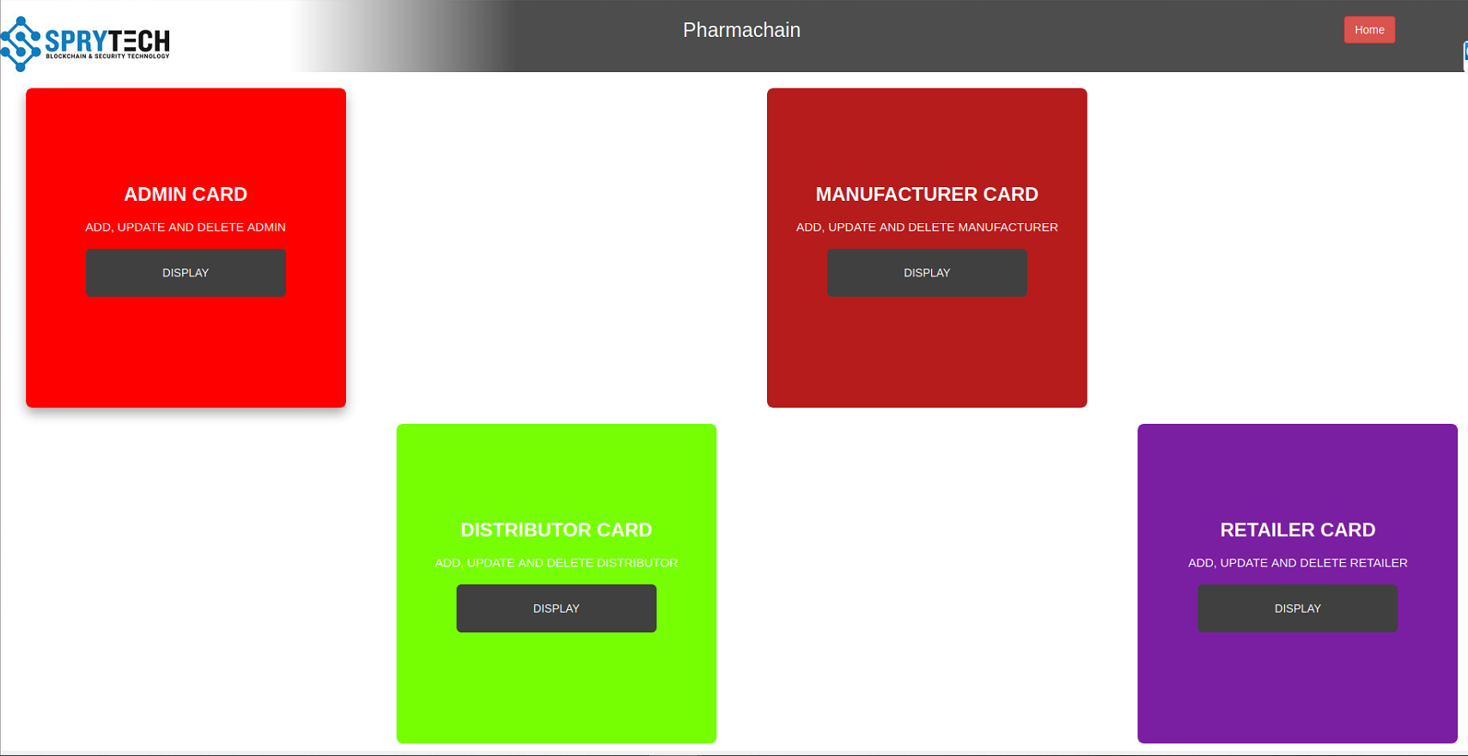

Figure 2: Admin Page

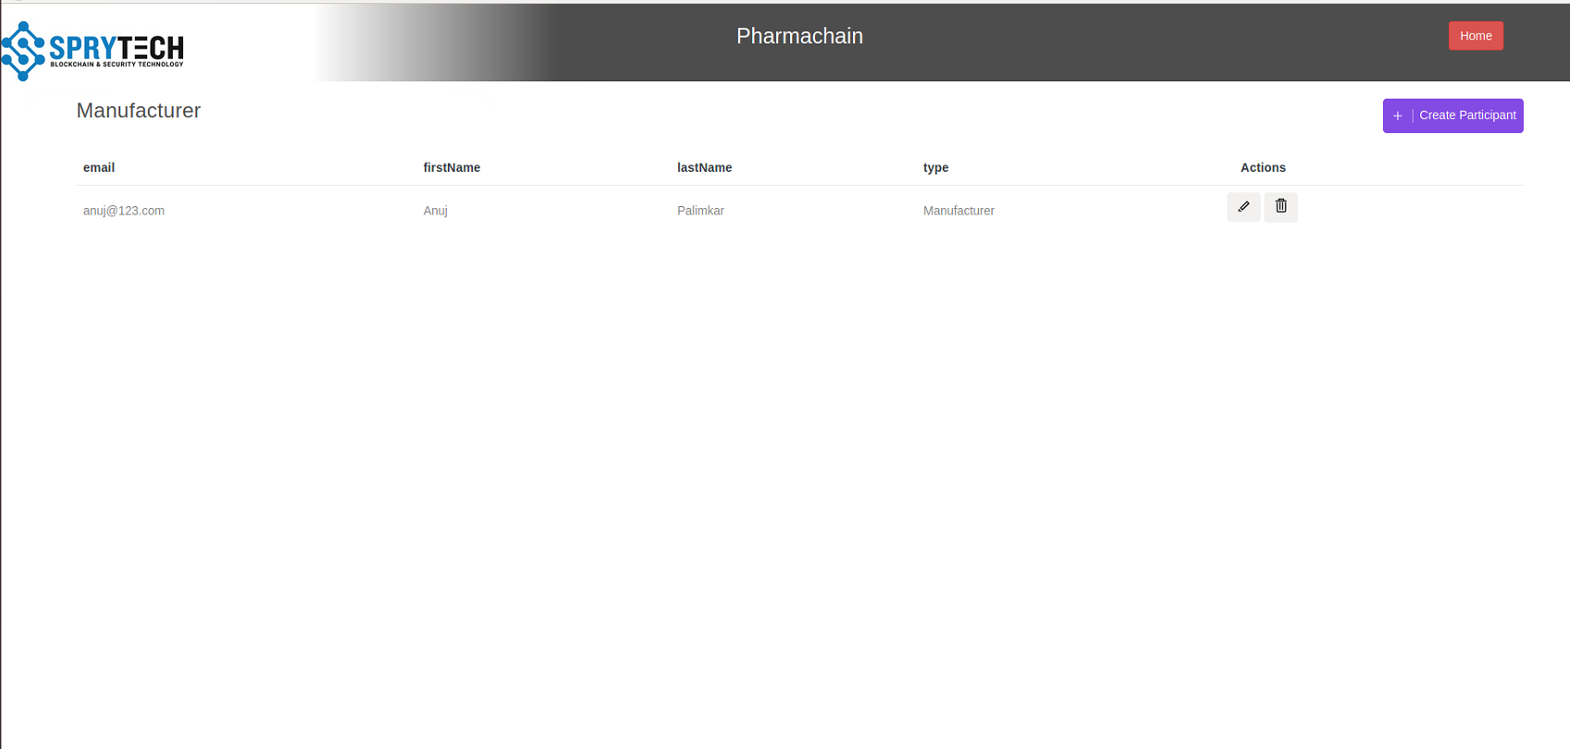
Figure 3:Manufacturer Card Page
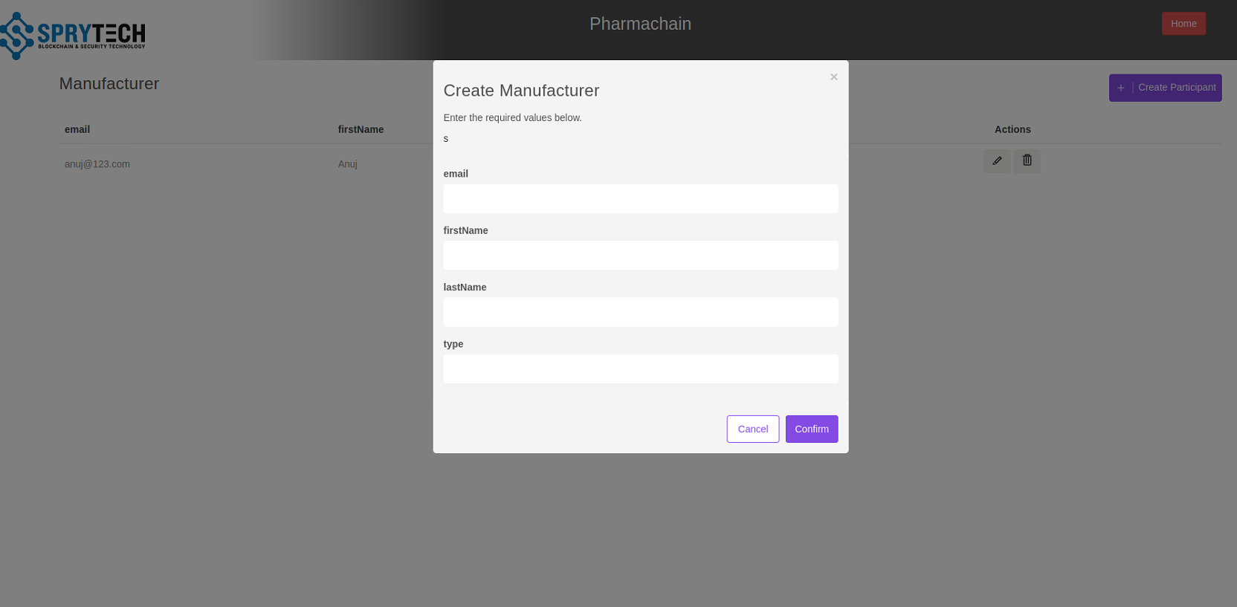
Figure 4: Create Participant

- For Manufacturer:
When a manufacturer use application, he has access to functions like viewing all the retailers, distributors, other manufacturers, admins, list of products. Figure 5 shows Manufacturer page.
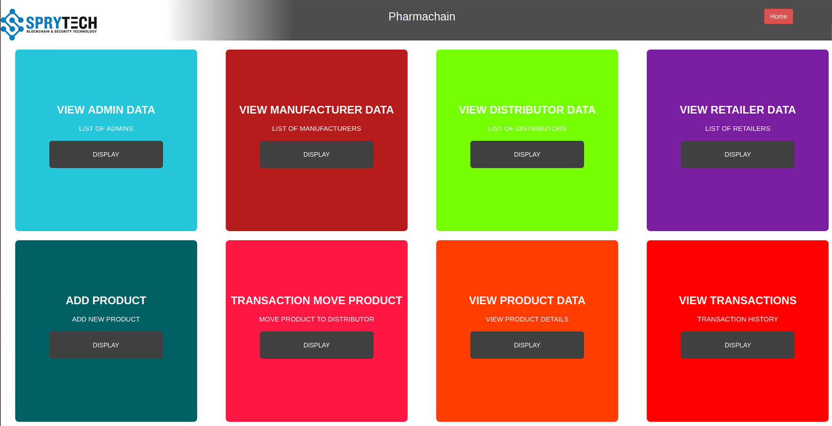
Figure 5: Manufacturer Page

- Add product
Manufacturer is also accessible to add new product which can be then shipped to distributor. Figure 6 displays form for creating new product.
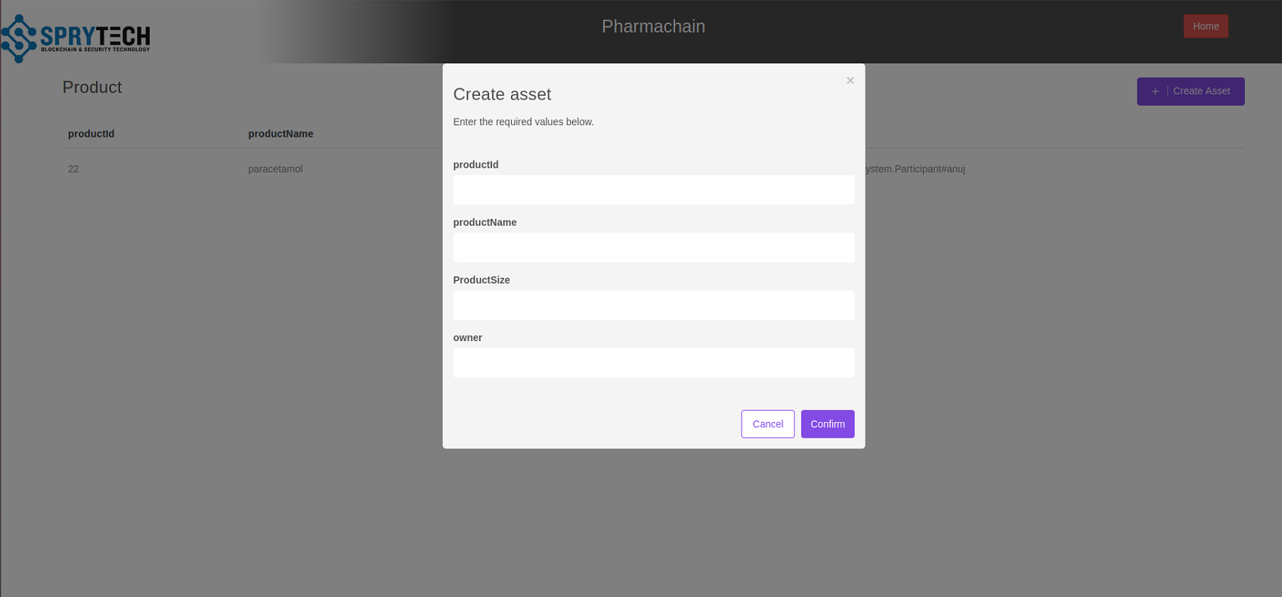
Figure 6: Create Asset (product) under Add Product Page

Create asset form contains product id, product name, product size and owner of particular asset. The owner of product should be from the list of Manufacturers which can be seen in view manufacturer data. After submitting the form all created products can be seen in the view product data. Figure 7 displays the list of products created by manufacturer.

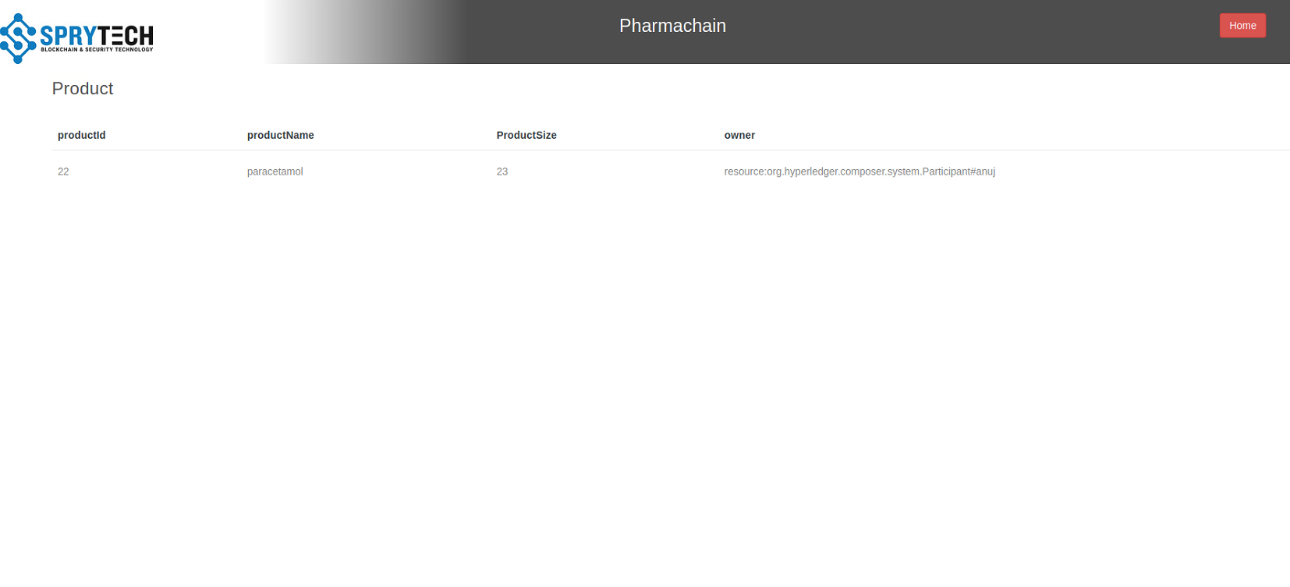
Figure 7: List of Products under View Products Page

- Ship product
Manufacturer is accessible to ship product to distributor by clicking on transaction Move product. Clicking on invoke, (Figure 8) the product with Id 22 which was created by Manufacturer with first name Anuj can be shipped to distributor with first name Dina. List of distributors can be seen in view Distributor data. Figure 9 represents changing of ownership of product 22.

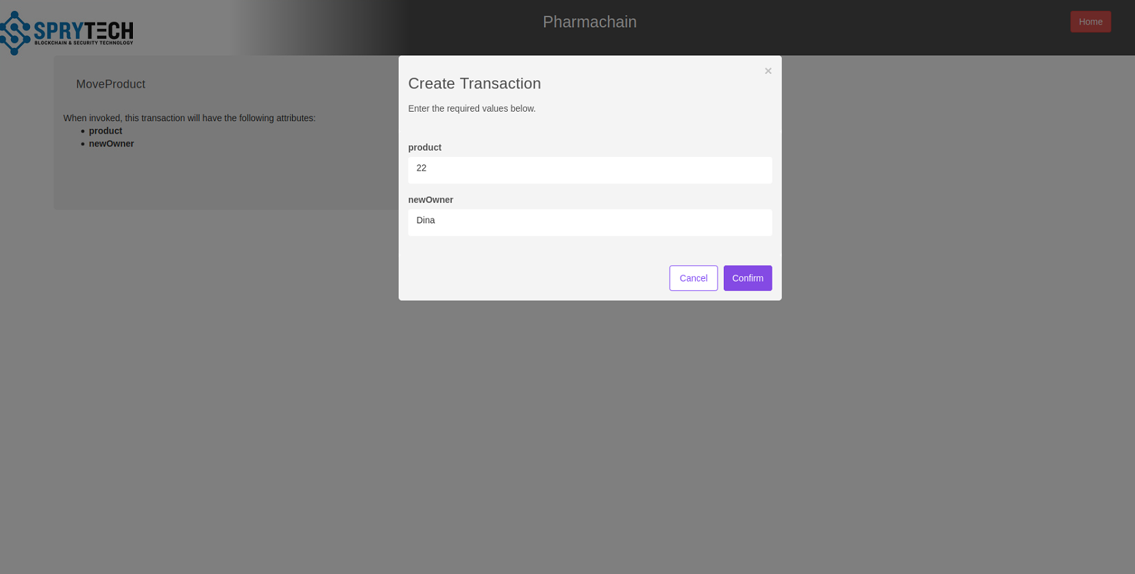
Figure 8: Invoke Transaction under Move Product Page

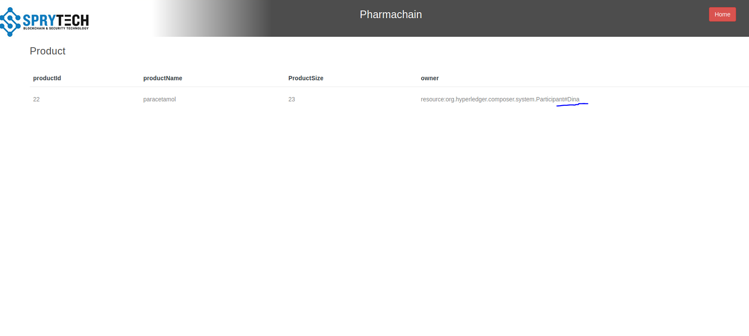
Figure 9: Change of Ownership can be seen under View Products as Highlighted

- View transaction history
Hash and type of transaction can be seen in View Transactions (Figure 10).
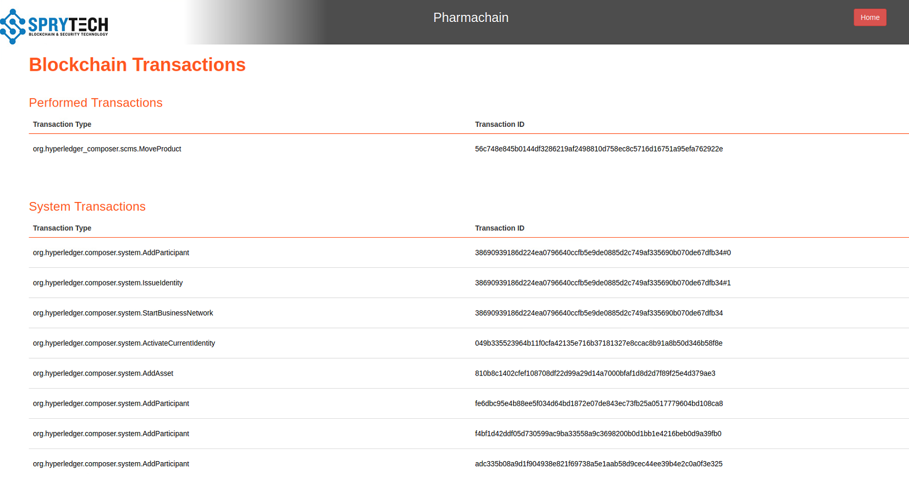
Figure 10: Blockchain Transactions

- For Distributor:
Similarly, Distributor has access to view all lists of participants, can move product to Retailer, view list of products and transaction data. Distributor can not create a product. Figure 11 shows the Distributor page.
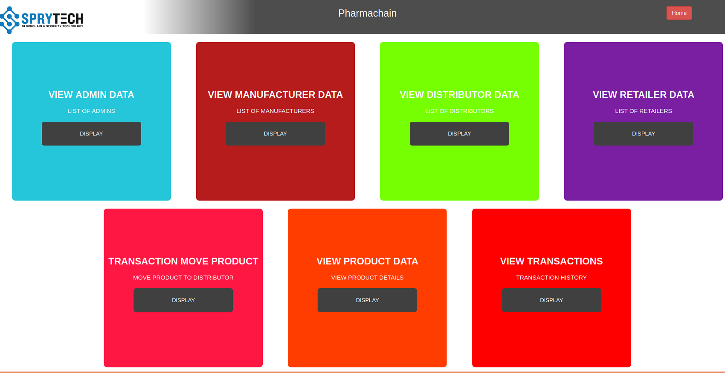
Figure 11: Distributor page

Figure 12 and 13 shows the shipment of product with Id 22 to retailer with first name Joe. List of alll retailers can be seen in view retailer data.
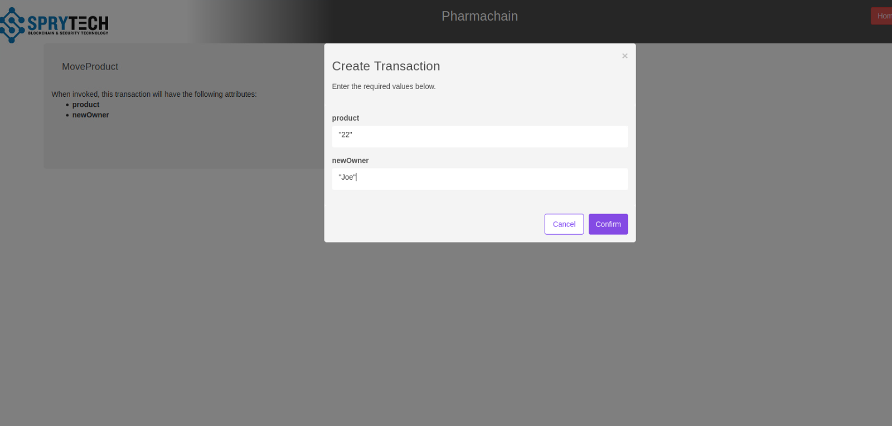
Figure 12: Move product to retailer can be seen under Transaction Move Product
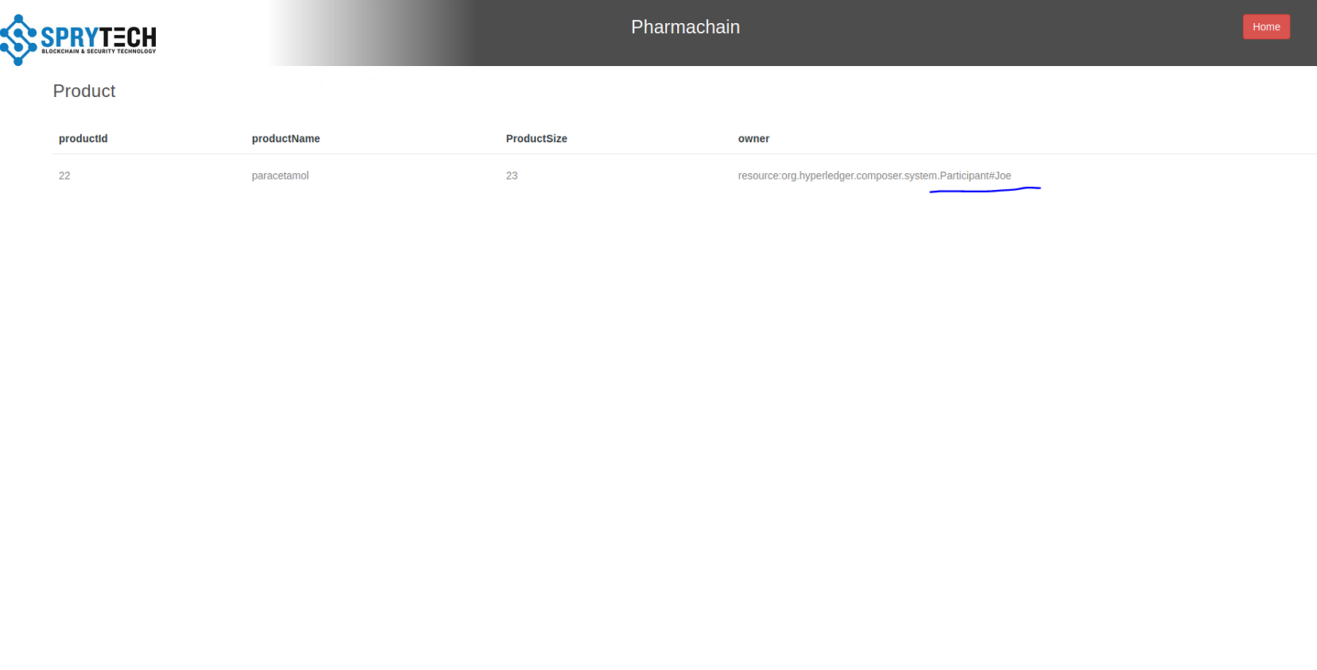
Figure 13 : Change of Ownership can be seen under View Products as Highlighted

- For Retailer:
Similarly, Retailer has access to view list of products, list of admins, list of manufacturers, list of distributors, list of retailers and list of transactions. Retailer doesn’t have any access to create product or move product. Figure 13 displays Retailer page.

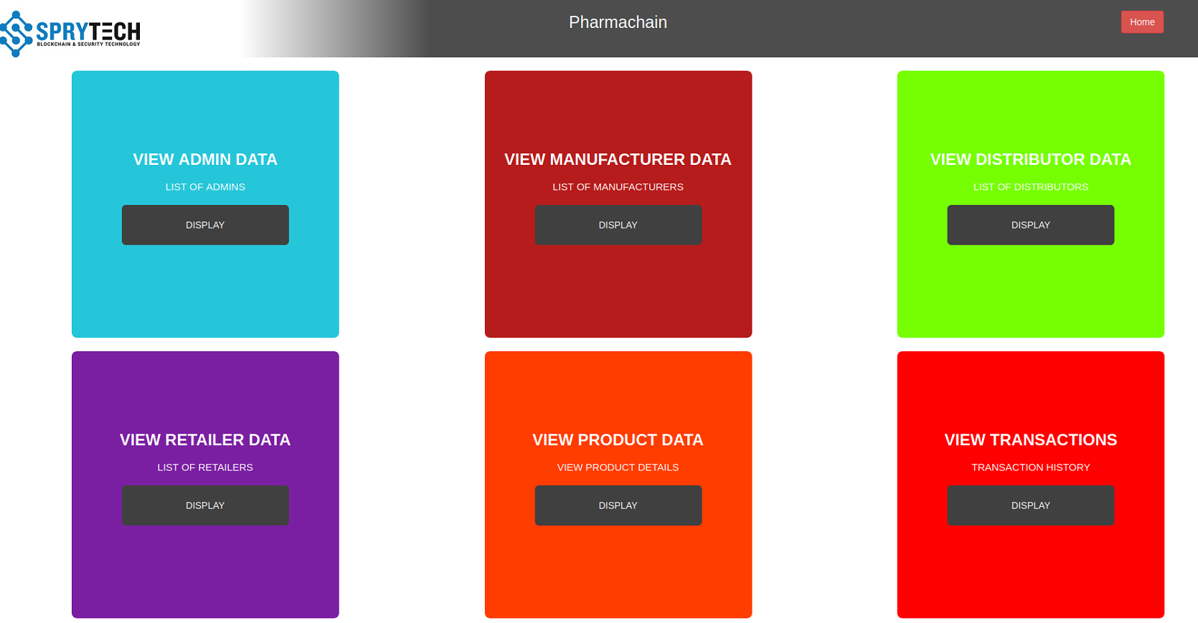
Figure 13: Retailer page

Instruction to setup and execute Pharmachain Hyperledger Application

Installing pre-requisites
Ubuntu:
To run Hyperledger Composer and Hyperledger Fabric, we recommend you have at least 4Gb of memory. The following are prerequisites for installing the required development tools:
- Operating Systems: Ubuntu Linux 14.04 / 16.04 LTS (both 64-bit), or Mac OS 10.12
- Docker Engine: Version 17.03 or higher
- Docker-Compose: Version 1.8 or higher
- Node: 8.9 or higher (note version 9 is not supported)
- npm: v6.x
- git: 2.9.x or higher
- Python: 2.7.x
- A code editor of your choice, we recommend VSCode.

- Download VMware
Go to https://www.vmware.com/products/workstation-player.html and download
install the .exe file.
- Download Ubuntu
Go to https://ubuntu.com/download/desktop and download .iso file
- Run Ubuntu
- Open vmware workstation player
- Under create new virtual machine select installer disc image file
- Browse to downloads and select ubuntu .iso file
- Click next
- Enter credentials to be used for ubuntu machine
- Click next and install the machine.
**If installing Hyperledger Composer using Linux, be aware of the following advice:
- Login as a normal user, rather than root.
- Do not su to root.
- When installing prerequisites, use curl, then unzip using sudo.
- Run prereqs-ubuntu.sh as a normal user. It may prompt for root password as some of it's actions are required to be run as root.
- Do not use npm with sudo or su to root to use it.
- Avoid installing node globally as root.**
- Install Curl
$ sudo apt install curl
- Download pre-requisites
$ curl -O https://hyperledger.github.io/composer/v0.19/prereqs-ubuntu.sh
$ chmod u+x prereqs-ubuntu.sh
- Run Script (prereqs-ubuntu.sh)
$ ./prereqs-ubuntu.sh

Installing the development environment
Follow these instructions to obtain the Hyperledger Composer development tools (primarily used to create Business Networks) and stand up a Hyperledger Fabric (primarily used to run/deploy your Business Networks locally). Note that the Business Networks you create can also be deployed to Hyperledger Fabric runtimes in other environments e.g. on a cloud platform.
- Install the CLI tools
Note that you should not use su or sudo for the following npm commands.
$ npm install -g composer-cli@0.19 //(composer-cli Essential cli tool).
$ npm install -g composer-rest-server@0.19 //(For RESTful API).
$ npm install -g generator-hyperledger-composer@0.19 //(utility for generating assets).
$ npm install -g yo //(install yeoman for applications).
- Install Playground (to view and demonstrate business network).
$ npm install -g composer-playground@0.19
- Set Up IDE
Install VSCode from this URL: https://code.visualstudio.com/download.
Open VSCode, go to Extensions, then search for and install the Hyperledger Composer extension from the Marketplace.
- Install Hyperledger Fabric
Start and enable Docker
$ sudo usermod -a -G docker $USER
$ sudo systemctl start docker
$ sudo systemctl enable docker
$ sudo chmod 666 /var/run/docker.sock
$ curl -sSL http://bit.ly/2ysbOFE | bash -s 1.4.0
- Make Directory of your choice
$ mkdir ~/pharmachain //(pharmachain-directory name). can be changed as required.
- Change directory to created one
$ cd pharmachain //
- Install fabric from GIT
$ curl -O https://raw.githubusercontent.com/hyperledger/composer-tools/master/packages/fabric-dev-servers/fabric-dev-servers.tar.gz
tar -xvf fabric-dev-servers.tar.gz.
- Download Local Hyperledger Fabric runtime
$ export FABRIC_VERSION=hlfv11
$ ./downloadFabric.sh
- Start Fabric
$ ./startFabric.sh
- Generate peer admin card
$ ./createPeerAdminCard.sh

You can stop fabric using
$ ./stopFabric.sh
Playground UI can be accessed using $composer-playground and then browsing to /localhost:8080/

Business network structure and angular UI
Make sure fabric is running and you have created peer admin card mentioned in steps 9 and 10 under installing development environment
- Extract bna file uploaded under source code into folder created in step 5 under installing development environment.
- Open pharmanet folder and find package.json
- Open package.json and update version: 0.3.1-deploy.1 on new version ( for instance 0.3.2-deploy.1)
- Open terminal and navigate to pharmanet folder
$ cd pharmanet
- Create .bna file
$ composer archive create -t dir -n .
- Deploy Business Network
Install Network
$ composer network install --card PeerAdmin@hlfv1 –archiveFile pharmanet@0.3.2-deploy.1.bna
- Start business Network
$ composer network start --networkName pharmanet --networkVersion 0.3.2-deploy.1 --networkAdmin admin --networkAdminEnrollSecret adminpw --card PeerAdmin@hlfv1 --file networkadmin.card
- Import the network administrator identity as a usable business network card
$ composer card import --file networkadmin.card
- Check if network is running properly
$ composer network ping --card admin@pharmanet
- Create angular UI application
$ yo hyperledger-composer:angular
when asked
? Do you want to connect to a running Business Network? Yes
? Project name: pharmaapp
? Description: tracking
? Author name: Dina
? Author email: dina.chiganbayeva@sprytech.uk
? License: Apache-2.0
? Name of the Business Network card: admin@pharmanet (as network card defined before)
? Do you want to generate a new REST API or connect to an existing REST API? Generate new API
? REST server address: http://localhost
? REST server port: 3000
? Should namespaces be used in the generated REST API? Namespaces are not used
Application will be generated
- Replace all contents of pharmaapp folder created in step 10 under business network structure and angular UI with contents of pharmanet2 folder attached under source code.
- Navigate to angular project directory created in step 10 under business network structure and angular UI (pharmaapp)
$ cd pharmaaap
- Run Angular UI
$ npm install
$ npm start
Angular UI will run on /localhost:4200/
REST API will run on /localhost:3000/
Note: In order to make changes in UI, it is necessary to install and use angular/cli version 1.0.1. (nodejs 8.4 version, npm 6 version)
$ npm install -g @angular/cli@1.0.1

Conclusion
To sum up, Pharmachain application demonstrates the features like transparency, security and trust amongst actors in supply chain, tracking of product at any point of time, and need customer will be able to identify if the drug is authentic or not.

Contact contributors

- Makarand Karanjalkar Mak@sprytech.uk

- Dina Chiganbayeva Dina.Chiganbayeva@sprytech.uk

- Anuj Palimkar Anuj.Palimkar@sprytech.uk

