

VS Code extension
For
Atlas City - Catalyst Network

Table of Contents
1.0 Introduction 3
1.1 Features 3
1.2 Requirements 3
1.3 How to use extension an create smart contract project from template 3
1.4 Known Issues 5
1.5 Release Notes 5
2.0 Next Step 6
2.1 Extension creation for VSCode and VSProfessional -Comparisons 6
2.2 Github link 7
3.0 Contact contributors 7

Introduction
We planned to develop a Visual Studio Code IDE extension for creating smart contract projects from templates. This extension provides some simple templates using which developers can build solidity smart contracts.

Features
This extension allows developer to create VS Code project workspace using solidity smart contract template files.

Requirements
- This extension required you to have solidity compiler which gets installed when Catalyst VSCode extension is installed.
- For this extension to work, ESlint extension should be disabled first.

How to use extension an create smart contract project from template
This extension creates an icon in the side bar for navigating to the templates.
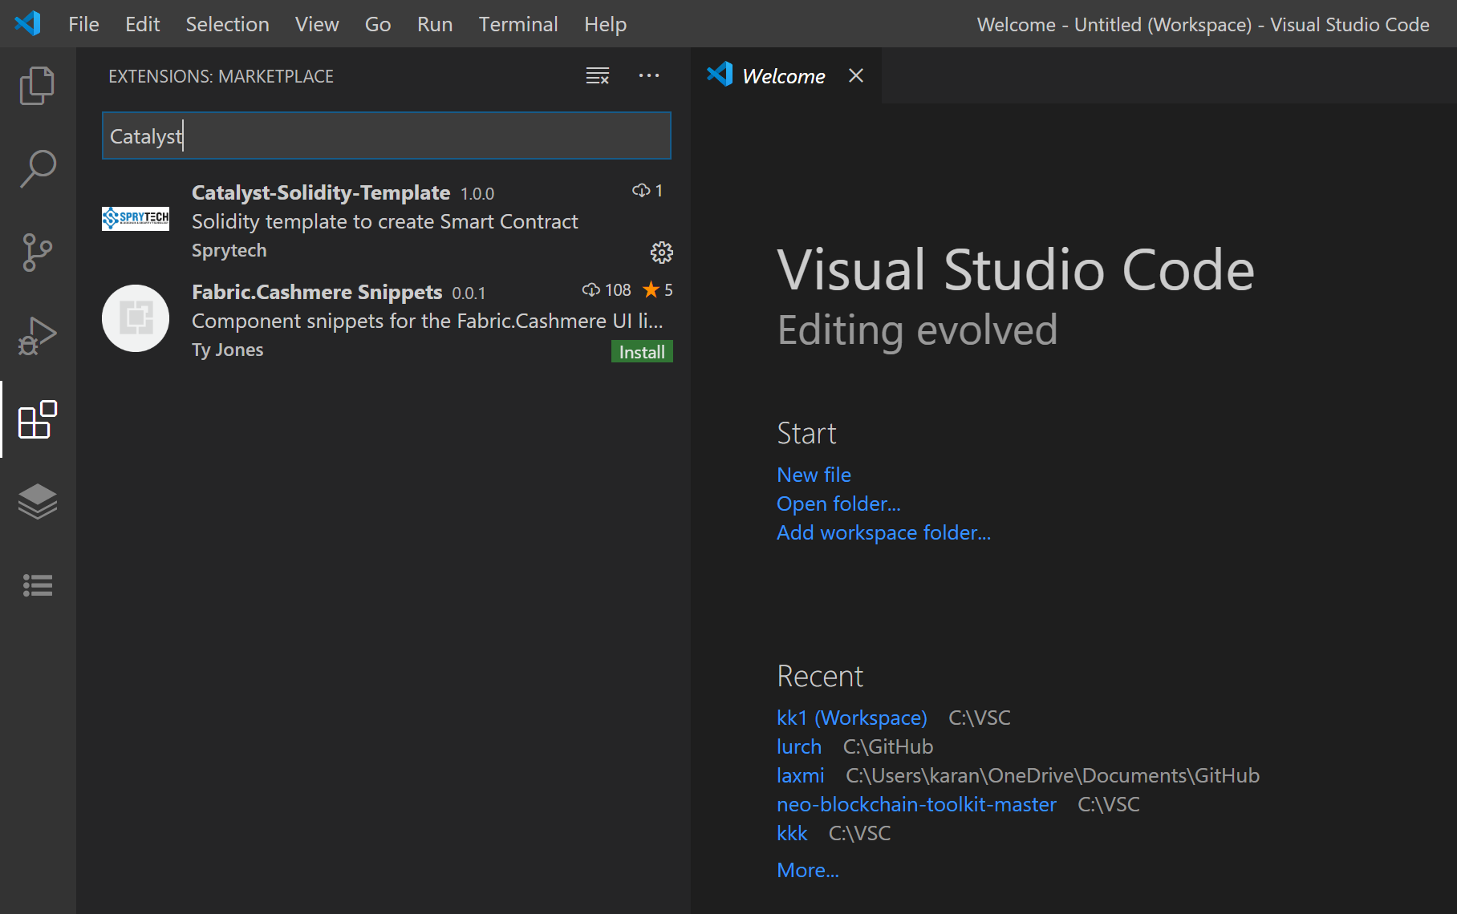
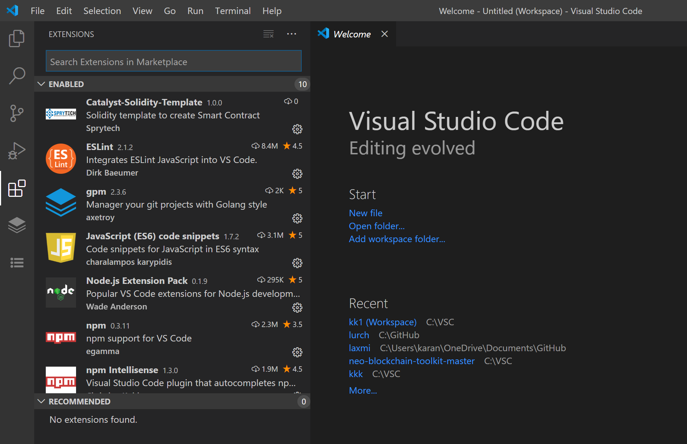
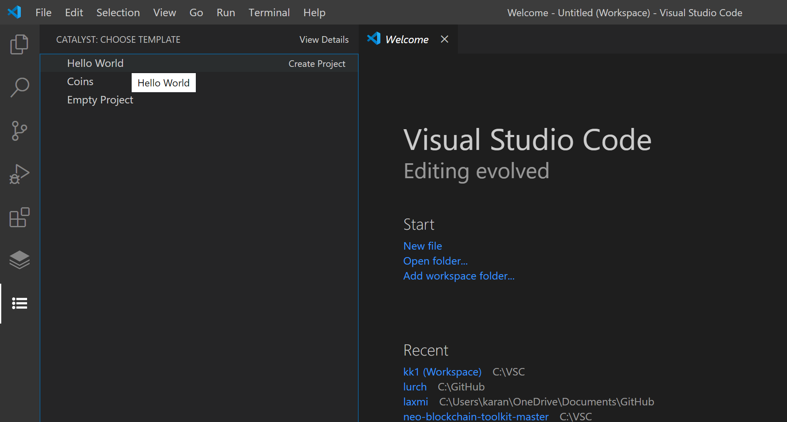
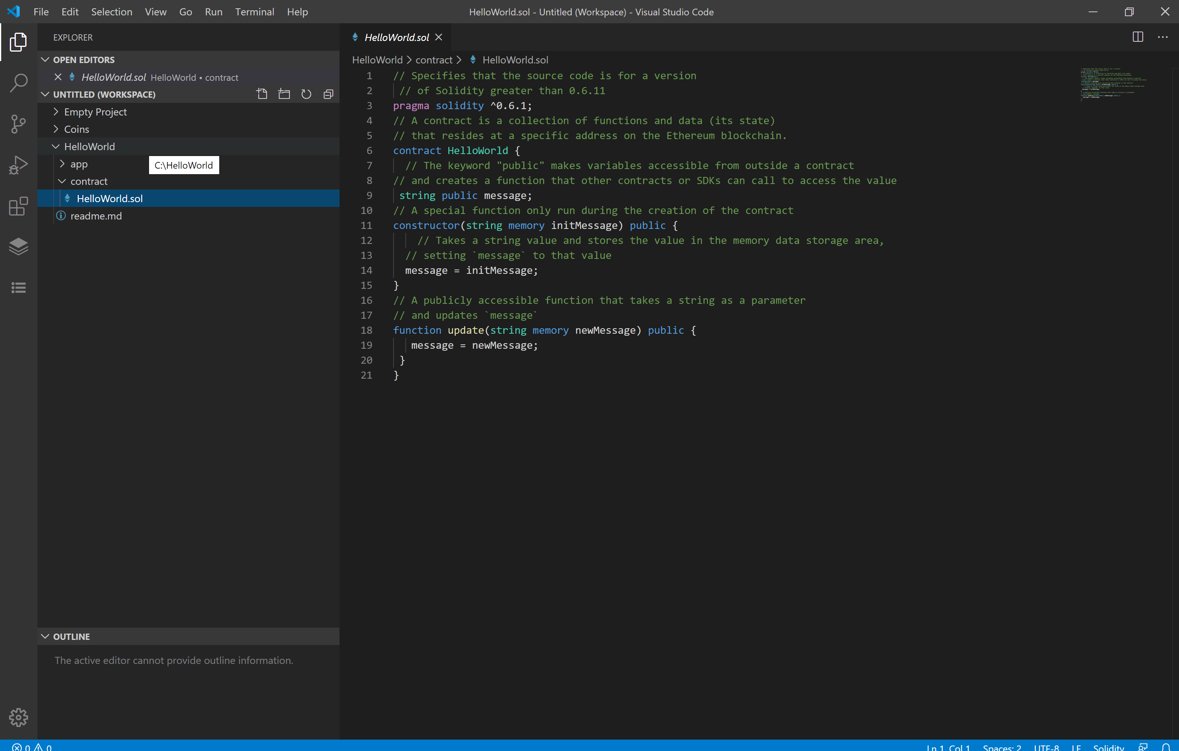

Known Issues
Repeated clicking on templates might give error.

Release Notes
Visual Studio Code IDE extension for creating smart contract projects from templates is completed. We have created full IDE extension for creating smart contract projects from templates
For
- Visual Studio Code
- This is the final development version (V 1.0) of the template extension.
- Updates will come along based on user feedback.

Next Step

We have a plan to Develop VS Code extension for -Deploy smart contract and run transaction over Catalyst testnet and mainnet.
This will make it very convenient for developers familiar with these popular IDEs among developer community. We need information about how to deploy and run transactions on Catalyst Network which is awaited from Atlast City.
We can work on the development of IDE extension for
- Visual Studio Professional- Extension for VS Professional are completely different and have different marketplaces. Comparison with VS Code extension is provided below.
- Remix IDE – We need to explore this in detail
- Ethereum Studio- We need to explore this in detail

Extension creation for VSCode and VSProfessional -Comparisons
- VSCode and VSProfessional both are completely different and have different marketplaces for extensions and plugins.
- VSProfessional uses C# language for development while VSCode uses typescript or javascript.
- The procedure for extension development and publishing it is completely different.
- VSProfessional might have advantage with respect to deployment and running transactions according to our understanding till now, but development process will take time.
- VSCode will prove to be easier for the extension development and to create project from template.

Github link
https://github.com/Chiganbayeva/catalyst-vscode

Contact contributors

- Makarand Karanjalkar Mak@sprytech.uk

- Dina Chiganbayeva Dina.Chiganbayeva@sprytech.uk

- Anuj Palimkar Anuj.Palimkar@sprytech.uk

