Time Cube: Lottery Night
Sean Sikora

Team Roster & Division of Labor

- Sean Sikora
  - This project was completed individually. The assigned partner did not contribute to the development, implementation, or testing of the project.
  - All aspects of the project, including narrative design, implementation in Twine (Harlowe), state system design, testing, and polish, were completed by Sean Sikora.

Story Concept

The idea for this project originated from the “Time Cube” conspiracy theory, specifically its framing of multiple versions of a day existing simultaneously. I used this concept as a structural device to explore a timeline mechanic where different perspectives of the same event can be experienced separately, but only gain meaning when considered together.
From this foundation, the project focuses on themes of perspective and fragmented truth. Rather than presenting a single, objective version of events, the player is given access to partial and sometimes conflicting accounts. The goal is for the player to construct their own understanding, where the insight gained from combining perspectives is greater than any individual version alone.
These ideas take the form of a story centered on a group of coworkers following a lottery win and the sudden death of one member, potentially tied to the winning ticket. The player explores different perspectives from the same day, piecing together events through incomplete and sometimes conflicting accounts. Rather than uncovering a single objective truth, the player forms an interpretation based on how these perspectives align and come together.

To make sure im compliant with rubric lmao
Premise: A group of coworkers experience a lottery win followed by the sudden death of one member. The player revisits the same day from different perspectives to piece together what may have happened.
Theme: Truth is shaped by perspective, and no single account fully captures what actually occurred.
Intended Player Experience: The player should feel uncertain but engaged, forming their own interpretation by comparing incomplete and sometimes conflicting viewpoints.

Story Map Annotation

The story is split into two phases: the morning (discovery) and the evening (reconstruction of the prior night). In each phase, the player chooses between multiple perspectives but cannot view all of them, forcing them forward after a limited number of choices.
These paths reconverge at bottlenecks (Morning-Bottleneck and Evening-Bottleneck), ensuring the story progresses while still allowing variation in what the player sees.
In the final section (Review > Aftermath > Judgment), the player uses what they learned from these perspectives to frame their understanding of events and the outcome. 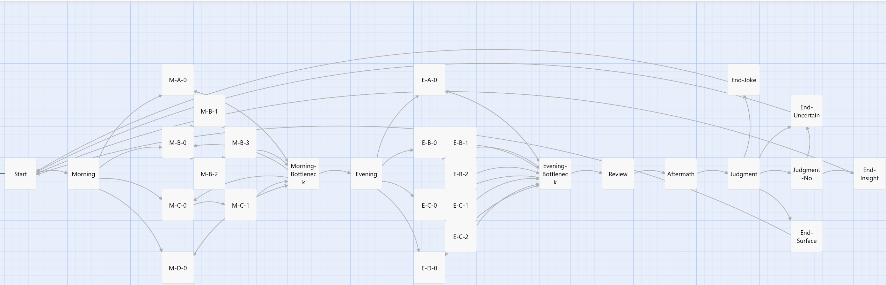
The structure primarily uses a branching tree pattern combined with bottlenecks. The branching occurs when the player selects between different perspectives in both the morning and evening sections, allowing for variation in what information is seen. These branches reconverge at the Morning-Bottleneck and Evening-Bottleneck passages, which serve as controlled progression points.
State is used to determine how the story resolves at the end. In the final section (Review > Judgment), accumulated variables such as $clues_found and key flags determine which endings are available, including Insight, Surface, and Uncertain outcomes. This allows player interpretation, based on what they have seen, to directly affect the conclusion.

Variables

- clues_found
  - Type: Number
  - Initial Value: 0
  - Represents: The amount of concrete evidence the player has gathered about the circumstances of David’s death.
  - Written in: M-B-1 (pressing Samael), M-D-0 (pill bottle), E-B-1 (overheard conversation), E-C-2 (pressing Cassandra), Review
  - Read in: Review, Judgment (ending selection logic)
- saw_pre_coaching
  - Type: Boolean
  - Initial Value: false
  - Represents: Whether the player has learned that Abby spoke to Samael before the morning, suggesting prior coordination.
  - Written in: M-C-1 (Cassandra recounting break room conversation)
  - Read in: M-B-3 (recognizing repeated phrasing)
- heard_sam_sentence
  - Type: Boolean
  - Initial Value: false
  - Represents: Whether the player has heard Samael describe David as “oddly tired,” a key repeated phrase.
  - Written in: M-B-0 (initial conversation with Samael)
  - Read in: M-C-1 (recognizing phrasing repetition)
- saw_A_influence_B
  - Type: Boolean
  - Initial Value: false
  - Represents: Whether the player has connected that Abby is influencing Samael’s account of events.
  - Written in: M-B-3, M-C-1 (when both sides of the phrasing are observed)
  - Read in: E-D-0 (observation of Abby staying close to Samael), Review
- saw_pills
  - Type: Boolean
  - Initial Value: false
  - Represents: Whether the player discovered the pill bottle and receipt, indicating possible cause of death.
  - Written in: M-D-0 (David’s office)
  - Read in: Review
- heard_abby_errand
  - Type: Boolean
  - Initial Value: false
  - Represents: Whether the player has learned that Abby left early after the lottery win, creating a timeline gap.
  - Written in: E-C-0 (Cassandra recalling the night)
  - Read in: Review
- saw_abby_rewrite
  - Type: Boolean
  - Initial Value: false
  - Represents: Whether the player has directly observed Abby instructing Samael on what to say.
  - Written in: E-A-0 (Abby guiding the conversation)
  - Read in: Review
- viewed
  - Type: Array
  - Initial Value: (a:)
  - Represents: Which perspective segments the player has already experienced.
  - Written in: M-A-0, M-B-0, M-C-0, M-D-0, E-A-0, E-B-0, E-C-0, E-D-0
  - Read in: Morning-Bottleneck, Evening-Bottleneck (to limit available choices)

Playtest

Playtest Notes
Tester: Marshall (friend)
Observations:
- He liked the overall concept and the idea of seeing different versions of the same events, especially since he’s into games that do similar things.
- He said the formatting (mainly inconsistent spacing) felt messy and distracting at times, which made it harder to stay focused.
- He thought the payoff at the end was underwhelming compared to the buildup.
- He felt the timers were too long and slowed things down too much.

Revisions Made:
- Cleaned up spacing and formatting in several passages to make things easier to read.
- Shortened the timing on delayed text so it doesn’t drag as much.
Observation Not Acted On:
He suggested changing the prose and writing style. I didn’t make major changes there due to time and because the tone was intentional for the fragmented perspective.

