Micro-Trak LCD to RJ-45 Adaptor Board

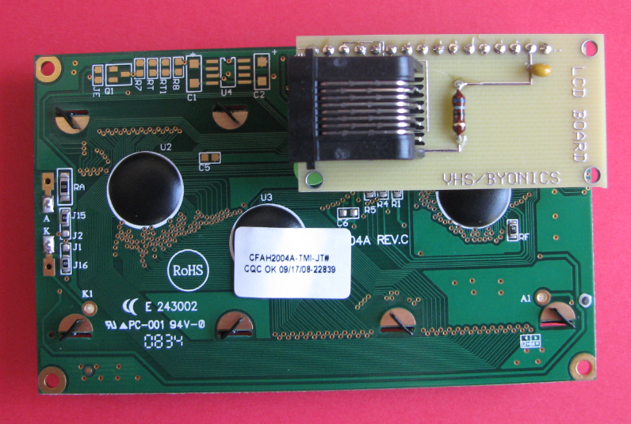
The Micro-Trak LCD daughter board provides a simple means of connecting the Crystalfonz and other compatible LCD modules to the Micro-Trak TT4, and can also be used to simplify connections to other devices. The adaptor board is sold unassembled, to allow the user to modify the connections for their particular applications

Only two components need be soldered to the PC board ( as shown in photo at right) a .1 microfarad capacitor and a 68 Ohm resistor used to set the backlight level . A 16 pin header is included to facilitate the simplest possible installation. This is accomplished by directly soldering the header to both the adaptor board and the LCD module. Locations for standoffs have been placed on three corners of the board, one inline with the LCD mounting hole, to allow more rigid mounting options if desired. The holes will accommodate a 2-56 screw.

When mounting the daughter board to the LCD module, be sure that the back of the daughter board does not come into contact with electronic or mechanical portions of the LCD module. Although a simple 16 pin header is included, you may choose to use a 16 pin SIP socket (not included) and mating headers to make the module removable.

Notice the orientation of the module in regards to the LCD board. Do not attempt to reverse the module to allow the connector to be placed into another orientation. This will almost certainly ruin the LCD module

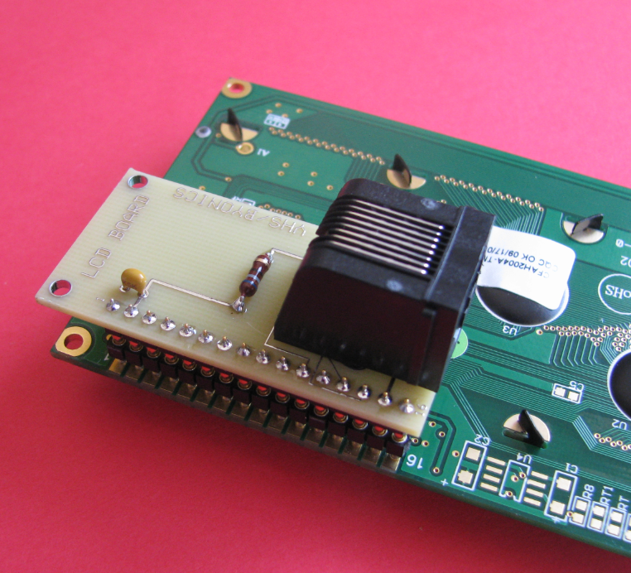
The LCD module when assembled in the fashion shown, allows you to directly plug the device into a Micro-Trak TT4. Keep in mind though that there are multiple wiring schemes for cables using RJ-45 connectors, and you must be sure to use a cable with a straight thru connection. This means that as you hold the cable in your hands, looking at the gold connection side, the same color wire will be on each side. (See photo below)

(Module shown with 16 pin SIP sockets and headers)

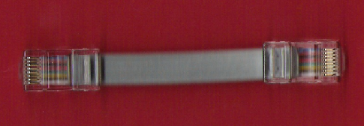

Note the orientation of the wires within the RJ-45 patch cord. Looking at the same sides of both connectors, the wires go straight thru to the opposing side. Make sure your cable does not have a “twist” in ANY of the wires within.

Printed Circuit Board Design and Pin Assignments
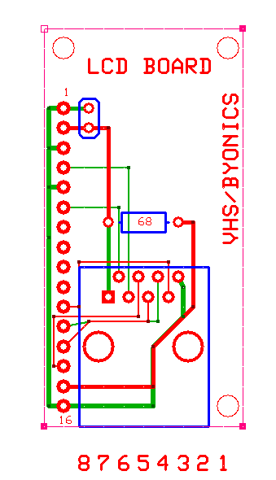
To the left is a representation of the printed circuit board looking from the top and having an “X-ray” view of the traces.

Ordinarily, there will be no reason for the end user to ever have to worry about how pins are assigned and utilized, since the device is “plug-and-play” with the Micro-Trak TT4. On the assumption that some people will wish to adapt on or a pair of these boards to another device, such as a TT4, the connections are identified for clarity.

RJ-45 Atmega 644 pin LCD module
Pin 8 +5 Volts N/A pin 2
Pin 7 Data 27 pin 6
Pin 6 Data 26 pin 4
Pin 5 Data 25 pin 14
Pin 4 Data 24 pin 13
Pin 3 Data 23 pin 12
Pin 2 Data 22 pin 11
Pin 1 Ground N/A pins 1, 3, 5, 16

