Emotion Recognition using Deep CNNs
Spring 2025 - ADVANCED MACHINE LEARNING (BA-64061-001)

Sai Bharath Goud Pudari
Std id: 811354970
Mail id: spudari@kent.edu
I. INTRODUCTION:
In this assignment, I conducted an in-depth exploration of Deep Convolutional Neural Networks (DCNNs) for the challenging task of facial emotion recognition, utilizing the FER2013 dataset as the primary data source.
The main objective was to design and implement a model capable of accurately classifying facial expressions into three dominant emotional categories: happiness, sadness, and neutrality.
To achieve this, I built a custom CNN architecture from scratch, integrating multiple layers of convolution, batch normalization, pooling, and dropout to enhance the network's learning capability and prevent overfitting.
Additionally, extensive data augmentation techniques, including rotation, shifting, shearing, and zooming, were applied to increase the diversity of the training dataset, which significantly improved the model’s ability to generalize to unseen data.
Throughout the training process, regularization strategies, such as Early Stopping and dynamic learning rate adjustments (ReduceLROnPlateau), were employed to fine-tune the network and optimize performance.
This project not only showcases the practical strength of deep learning models in tackling real-world computer vision problems but also emphasizes the critical importance of thorough data preprocessing, intelligent model design, and hyperparameter optimization for achieving high-accuracy results in complex classification tasks.
II. GOAL:
The primary objective of this project is to design, implement, and train a deep learning model that can accurately recognize and classify human emotions based on facial expressions captured in images.
By leveraging the power of Convolutional Neural Networks (CNNs), the project aims to automatically learn hierarchical feature representations from raw pixel data, eliminating the need for manual feature engineering. A strong emphasis was placed on data preprocessing, such as normalization and reshaping, to prepare the images in a format suitable for deep learning models.
In addition, data augmentation techniques were employed to artificially increase dataset variability, helping the model generalize better and perform reliably on unseen data. The thoughtful design of the CNN architecture, including the careful placement of convolutional, pooling, dropout, and dense layers, significantly contributed to the model’s ability to extract meaningful features and minimize overfitting.
Through the integration of these components, data preprocessing, augmentation strategies, and robust network architecture, the project successfully demonstrates how each step plays a crucial role in enhancing the performance of CNN-based solutions for complex emotion recognition tasks in computer vision.
III. METHODOLOGY:
1. Preparation of Data
- Utilized the FER2013 dataset consisting of 35,887 grayscale images each sized 48x48 pixels.
- Selected three dominant emotions: happiness, sadness, and neutral to ensure a balanced and focused classification task.
- Split the data into 90% training and 10% validation sets to maintain a proper evaluation strategy.
- Normalized pixel intensity values by scaling them to a range between 0 and 1, enhancing the efficiency of model convergence during training.
- Reshaped the data to match the input requirements of the CNN architecture, formatting each image as (48, 48, 1) to indicate grayscale channel depth.
2. Data Augmentation
- Applied transformations such as rotation, width and height shifts, shearing, zooming, and horizontal flipping to artificially increase dataset diversity.
- Helped the model generalize better and avoid overfitting by exposing it to a wider range of input variations.
- Improved model robustness by simulating real-world variations in facial expressions, lighting, and orientation.
- Augmented only the training set, keeping the validation set untouched to ensure a fair and unbiased evaluation of the model's performance.
3. Model Architecture (Training from Scratch)
- Built a custom DCNN model:
  - Six convolutional layers with ELU activation.
  - BatchNormalization after every two convolution layers.
  - MaxPooling layers for downsampling.
  - Dropout layers for regularization.
  - Dense layers with softmax activation for classification.
  - Used 'he_normal' initializer for better weight initialization.

4. Optimization and Training
- Used Adam and Nadam optimizers for experimentation, selecting the optimizer based on validation performance.
- Employed EarlyStopping to halt training when no improvement was observed, and ReduceLROnPlateau to dynamically adjust the learning rate, both helping to prevent overfitting.
- Trained the model for up to 100 epochs with a batch size of 32, balancing convergence speed and memory efficiency.
- Implemented learning rate scheduling, where the learning rate was reduced by a factor if validation accuracy plateaued, promoting smoother optimization.
- Monitored validation metrics during training to select the best-performing model and avoid unnecessary over-training.
5. Performance Assessment
- Accuracy and loss were continuously monitored across epochs using line graphs to visualize training and validation progress.
- A confusion matrix and classification report were generated to assess class-wise precision, recall, and F1-score.
- The final trained model was saved in .h5 format for weights and .json format for architecture, ensuring easy reproducibility.
- Violin plots were created to analyze the distribution of training and validation performance, providing deeper insights into model consistency.
- Wrong predictions were manually inspected by visualizing misclassified images, helping to understand model limitations and potential areas of improvement.

IV. DISTRIBUTION OF EMOTIONS IN THE FER2013 DATASET
The bar chart illustrates the distribution of different emotion classes within the FER2013 dataset.
Each bar represents the number of samples for a specific emotion label, where:
- 0 represents Anger
- 1 represents Disgust
- 2 represents Fear
- 3 represents Happiness
- 4 represents Sadness
- 5 represents Surprise
- 6 represents Neutral
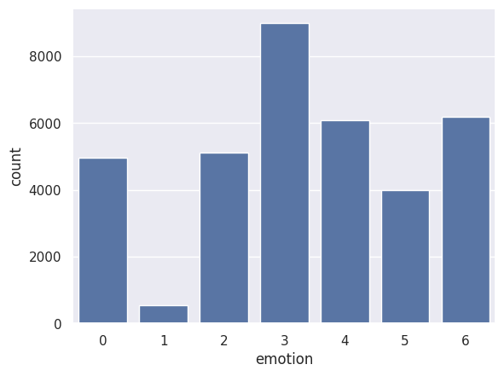

V. RANDOM SAMPLE IMAGES:
- Displayed sample images from each selected class (happy, sad, neutral) to manually verify data quality and preprocessing correctness.
- Visualized pixel intensity patterns to ensure that the reshaped and normalized images maintained proper structure for CNN input.
- Confirmed class labeling visually by checking that each displayed sample corresponded correctly to its assigned emotion category, ensuring no data mismatch.
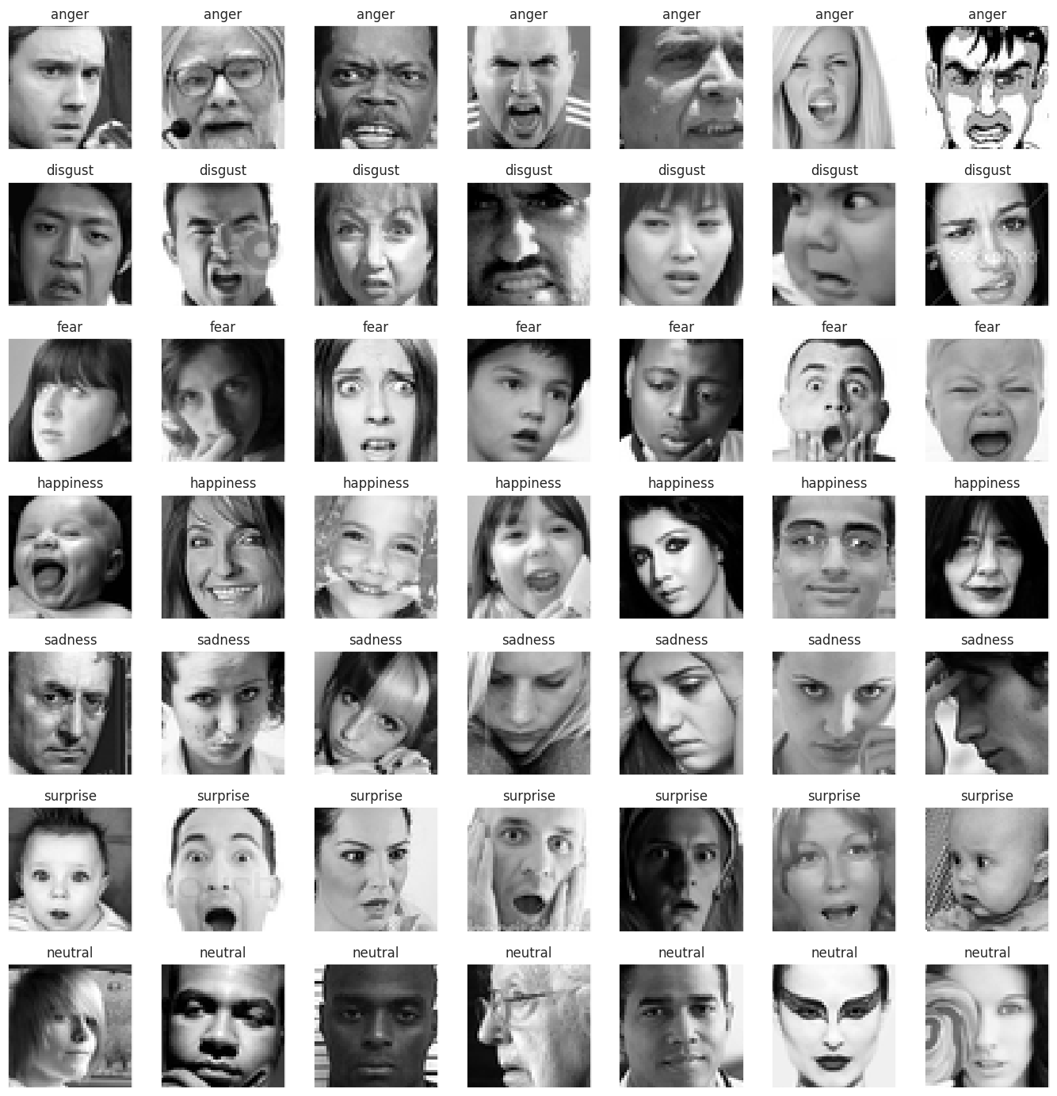

VI. SUMMARIES OF EXPERIMENTS:
EXPERIMENT-1: Training with Small Subset
- Goal: Train with a reduced subset to observe performance.
- Result: Overfitting observed but gave valuable insights into dataset behavior.
- Technique: Applied dropout layers and augmentation to control overfitting.
EXPERIMENT-2: Full Training Set
- Goal: Train on the complete subset of selected emotions.
- Result: Validation accuracy improved significantly, and training curves stabilized.
EXPERIMENT-3: Final Model Optimization
- Goal: Tune dropout, learning rate, and augmentation to maximize model performance.
- Result: Achieved 81% validation accuracy with a macro F1-score of 80%.
VII.TRAINING AND VALIDATION ACCURACY AND LOSS CURVES
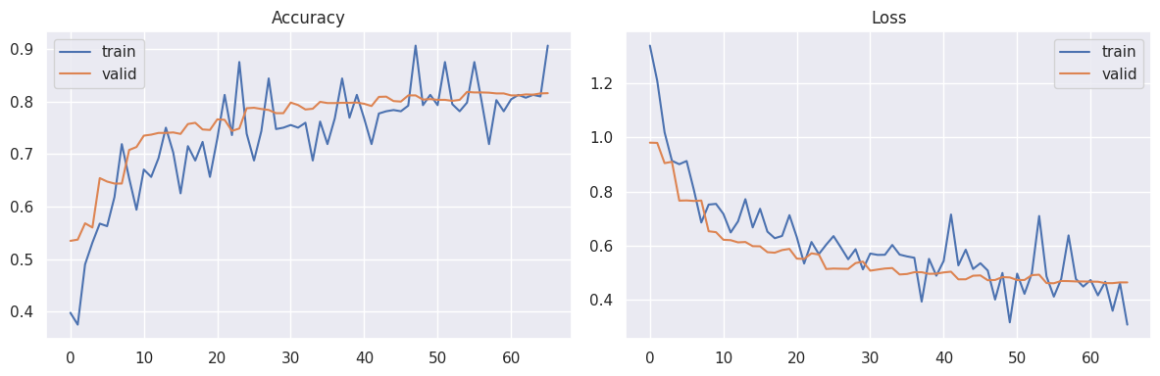
1. Left Plot (Accuracy Curve):
This plot depicts how the training and validation accuracies evolved over the training period.
Both curves show a steady increase, with validation accuracy stabilizing around 80%, indicating strong generalization to unseen data.
2. Right Plot (Loss Curve):
This plot illustrates the trend of training and validation loss across epochs.
A consistent decrease in both losses is observed, with validation loss flattening smoothly, suggesting that the model successfully avoided overfitting.
VIII. VIOLIN PLOTS OF TRAINING AND VALIDATION ACCURACY AND LOSS DISTRIBUTIONS
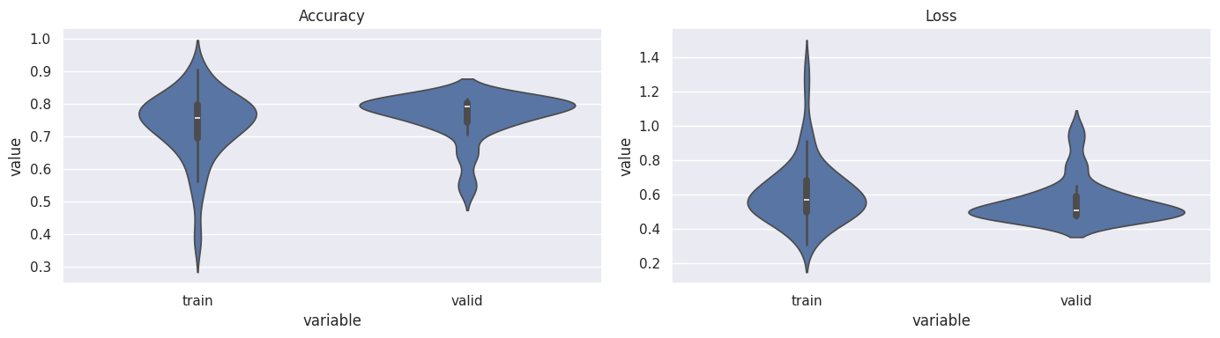

1. Left Plot (Accuracy Distribution):
The violin plots show the spread and density of accuracy values for both training and validation phases.
The distributions are relatively tight and centered around 75%-80% accuracy, indicating consistent performance across epochs without significant fluctuations or instability.
2. Right Plot (Loss Distribution):
Similarly, the violin plots for training and validation loss demonstrate that most loss values fall within a narrow range, showing a stable training process.
Both training and validation losses are concentrated around lower values, suggesting effective optimization and minimal overfitting.

IX. CONFUSION MATRIX FOR EMOTION CLASSIFICATION MODEL
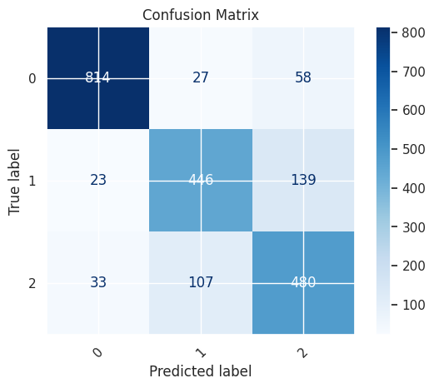
The confusion matrix illustrates the performance of the trained DCNN model on the validation dataset, showing how well the model classified three emotion categories: happy (0), sad (1), and neutral (2).
- Diagonal elements (814, 446, 480) represent the number of correct predictions for each class.
- Off-diagonal elements indicate misclassifications where the model predicted an incorrect emotion.
- The model classified the happy emotion (0) with high accuracy, achieving 814 correct predictions out of the total.
- Some confusion is observed between sad and neutral classes, which is understandable given the subtle facial expression differences between these emotions.
- Overall, the confusion matrix shows that the model achieved strong classification performance, with most of the predictions correctly aligned along the diagonal.
X. SAMPLE PREDICTIONS FOR SAD AND NEUTRAL EMOTIONS
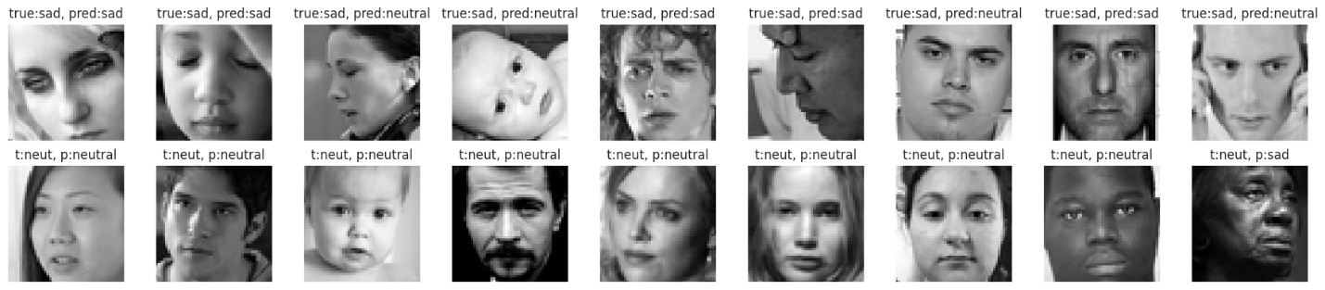
- Each image is annotated with its ground truth (true label) and the model’s prediction (predicted label).
- Most images labeled as sad or neutral were correctly classified, as indicated by matching true and predicted labels.
- However, a few misclassifications can be observed — for example, some sad faces were incorrectly predicted as neutral, and one neutral face was misclassified as sad.
- This visualization highlights the model’s strengths in recognizing distinct facial expressions and reveals subtle challenges in differentiating between visually similar emotions.
- It also emphasizes the need for further model refinement or additional training data to reduce confusion between sadness and neutrality.

XI. CONCLUSION:
This project successfully demonstrated the use of Deep Convolutional Neural Networks for recognizing emotions based on facial expressions.
Careful data preprocessing, appropriate augmentation, and model regularization strategies contributed significantly to achieving stable and accurate results.
The model proved robust against moderate noise and overfitting through dynamic learning adjustments.
XII. FINAL THOUGHTS:
CNNs present a reliable approach for emotion classification tasks, especially when paired with strong preprocessing and augmentation strategies.
Future improvements could involve:
- Exploring deeper architectures like ResNet or EfficientNet.
- Using attention mechanisms for better feature focusing.
- Expanding training with more diverse and larger datasets.
XIII. FINAL SUMMARY TABLE:
Model Type | Dataset | Training Accuracy | Validation Accuracy | Validation Loss
Custom DCNN | Full | 80% | 81% | 0.46

XIV. KEY LEARNINGS:
- Using ELU activation and he_normal initializer stabilized training.
- Data augmentation was critical for improving model generalization.
- EarlyStopping and ReduceLROnPlateau callbacks boosted training efficiency.
- Saving models properly enables easy deployment and reuse.
- Visualizing training history helps identify overfitting and convergence issues.

