Weekly field report
The demo route held up. Twelve visits and three handoffs were logged. See the field guide for the routine.
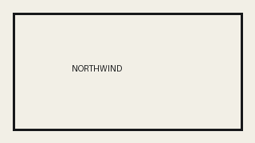
Site | Visits
Northwind | 12
Night crew owns the handoff.

