Weekly field report
The demo route held up. Twelve visits and three handoffs were logged. See the field guide.

What changed
- Retry the demo route early.
- Send the revised deck before Friday.
- Check the mobile layout on the dispatch page.
- Ask the night crew about the handoff.
Site | Visits
Northwind | 12
Contoso merged the two rows into one cell.

Route map
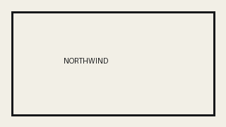
Gate opens at 8, bring the deck.
Said "hello" and spaced words.

