**Name: - Namrata Agarwal**

**Email: -** [**namratagarwal24@gmail.com**](mailto:namratagarwal24@gmail.com)

**No: - 7219252406**

**Course: - BBA (CA)**

**import 'package:flutter/material.dart';**

**void main() {**

**runApp(LoginPage());**

**}**

**class LoginPage extends StatelessWidget {**

**@override**

**Widget build(BuildContext context) {**

**return MaterialApp(**

**debugShowCheckedModeBanner: false,**

**home: Scaffold(**

**appBar: AppBar(**

**title: Text(''),**

**),**

**body: Container(**

**color: Color(0xff310e95), // Set background color to blue**

**padding: EdgeInsets.all(30.0),**

**child: Column(**

**crossAxisAlignment: CrossAxisAlignment.start,**

**children: [**

**Text(**

**'Welcome Back!',**

**style: TextStyle(**

**fontSize: 24.0,**

**fontWeight: FontWeight.bold,**

**color: Colors.white, // Text color is white**

**),**

**),**

**SizedBox(height: 20.0),**

**Text(**

**'Log into your account',**

**style: TextStyle(**

**fontSize: 18.0,**

**color: Colors.white, // Text color is white**

**),**

**),**

**SizedBox(height: 20.0),**

**TextFormField(**

**decoration: InputDecoration(**

**labelText: 'Email ID',**

**labelStyle: TextStyle(**

**color: Colors.white), // Label text color is white**

**),**

**),**

**SizedBox(height: 10.0),**

**TextFormField(**

**obscureText: true,**

**decoration: InputDecoration(**

**labelText: 'Password',**

**labelStyle: TextStyle(**

**color: Colors.white), // Label text color is white**

**),**

**),**

**SizedBox(height: 20.0),**

**Row(**

**mainAxisAlignment: MainAxisAlignment.spaceBetween,**

**children: [**

**Spacer(),**

**TextButton(**

**onPressed: () {**

**// Add functionality for 'Forgot Password?'**

**},**

**child: Text(**

**'Forgot Password?',**

**style:**

**TextStyle(color: Colors.white), // Text color is white**

**),**

**),**

**],**

**),**

**SizedBox(height: 10.0),**

**Column(**

**crossAxisAlignment: CrossAxisAlignment.stretch,**

**children: [**

**ElevatedButton(**

**onPressed: () {**

**// Add functionality for login button**

**},**

**child: Text('Login'),**

**style: ElevatedButton.styleFrom(**

**primary: Colors.orange,**

**),**

**),**

**SizedBox(height: 10.0),**

**Row(**

**mainAxisAlignment: MainAxisAlignment.center,**

**children: [**

**Text(**

**"Don't have an account? ",**

**style: TextStyle(**

**color: Colors.white), // Text color is white**

**),**

**TextButton(**

**onPressed: () {**

**// Add functionality for 'Sign Up'**

**},**

**child: Text(**

**'Sign Up',**

**style: TextStyle(**

**color: Colors.white), // Text color is white**

**),**

**),**

**],**

**),**

**],**

**),**

**],**

**),**

**),**

**),**

**);**

**}**

**}**

**Output:-**

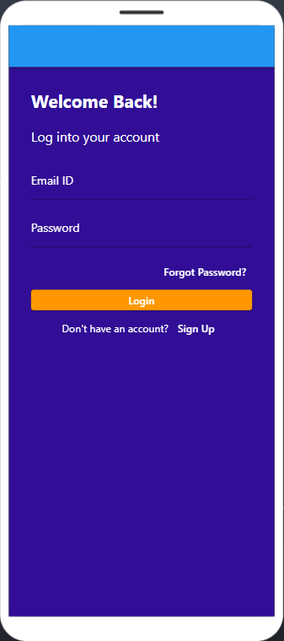

import 'package:flutter/material.dart';

class DashboardScreen extends StatelessWidget {

@override

Widget build(BuildContext context) {

return Scaffold(

appBar: AppBar(

title: Text('My Dashboard'),

leading: Builder(

builder: (BuildContext context) {

return IconButton(

icon: const Icon(Icons.menu),

onPressed: () {

Scaffold.of(context).openDrawer();

},

);

},

),

actions: [

IconButton(

icon: Icon(Icons.person),

onPressed: () {

// Navigate to Profile Screen or perform profile-related actions

},

),

IconButton(

icon: Icon(Icons.notifications),

onPressed: () {

// Navigate to Notifications Screen or perform notification-related actions

},

),

],

),

drawer: Drawer(

// Drawer content

child: ListView(

children: [

DrawerHeader(

child: Text('Drawer Header'),

decoration: BoxDecoration(

color: Colors.blue,

),

),

ListTile(

title: Text('Drawer Item 1'),

onTap: () {

// Handle drawer item tap

},

),

ListTile(

title: Text('Drawer Item 2'),

onTap: () {

// Handle drawer item tap

},

),

],

),

),

body: Padding(

padding: const EdgeInsets.all(16.0),

child: Column(

crossAxisAlignment: CrossAxisAlignment.stretch,

children: [

// User Section

Row(

mainAxisAlignment: MainAxisAlignment.spaceBetween,

children: [

Column(

crossAxisAlignment: CrossAxisAlignment.start,

children: [

CircleAvatar(

// Add your profile picture logic here

radius: 30,

backgroundImage: NetworkImage(

'https://example.com/path-to-your-image.jpg'),

),

Text('Hello Thomson', style: TextStyle(fontSize: 16)),

],

),

// Add any additional user-related information or actions here

],

),

SizedBox(height: 16),

// Quick Actions

GridView.count(

crossAxisCount: 4,

shrinkWrap: true,

physics: NeverScrollableScrollPhysics(),

children: [

_buildQuickAction('Bills', Icons.receipt, () {

// Handle Bills action

}),

_buildQuickAction('Disconnect', Icons.power_settings_new, () {

// Handle Disconnect action

}),

_buildQuickAction('Transfer', Icons.swap_horiz, () {

// Handle Transfer action

}),

_buildQuickAction('Services', Icons.build, () {

// Handle Services action

}),

_buildQuickAction('Complaints', Icons.error, () {

// Handle Complaints action

}),

_buildQuickAction('Updates', Icons.update, () {

// Handle Updates action

}),

_buildQuickAction('Connections', Icons.link, () {

// Handle Connections action

}),

_buildQuickAction('Outage', Icons.signal_wifi_off, () {

// Handle Outage action

}),

],

),

SizedBox(height: 16),

// Existing Bill Payment Option with Icon

ElevatedButton.icon(

onPressed: () {

// Navigate to Bill Payment Screen

Navigator.pushNamed(context, '/bill_payment');

},

icon: Icon(Icons.payment),

label: Text('Bill Payment'),

),

SizedBox(height: 16),

// Existing Account Management Option with Icon

ElevatedButton.icon(

onPressed: () {

// Navigate to Account Management Screen

Navigator.pushNamed(context, '/account_management');

},

icon: Icon(Icons.account_circle),

label: Text('Account Management'),

),

SizedBox(height: 16),

// New Feature Access with Icon

ElevatedButton.icon(

onPressed: () {

// Navigate to the New Feature Screen

Navigator.pushNamed(context, '/new_feature');

},

icon: Icon(Icons.star),

label: Text('New Feature'),

),

],

),

),

);

}

Widget _buildQuickAction(String title, IconData icon, Function() onPressed) {

return InkWell(

onTap: onPressed,

child: Column(

children: [

Icon(icon, size: 32),

SizedBox(height: 8),

Text(title),

],

),

);

}

}

class BillPaymentScreen extends StatelessWidget {

@override

Widget build(BuildContext context) {

return Scaffold(

appBar: AppBar(

title: Text('Bill Payment'),

),

body: Center(

child: Text('Bill Payment Screen'),

),

);

}

}

class AccountManagementScreen extends StatelessWidget {

@override

Widget build(BuildContext context) {

return Scaffold(

appBar: AppBar(

title: Text('Account Management'),

),

body: Center(

child: Text('Account Management Screen'),

),

);

}

}

class NewFeatureScreen extends StatelessWidget {

@override

Widget build(BuildContext context) {

return Scaffold(

appBar: AppBar(

title: Text('New Feature'),

),

body: Center(

child: Text('New Feature Screen'),

),

);

}

}

void main() {

runApp(MaterialApp(

home: DashboardScreen(),

routes: {

'/bill_payment': (context) => BillPaymentScreen(),

'/account_management': (context) => AccountManagementScreen(),

'/new_feature': (context) => NewFeatureScreen(),

},

));

}

