ECHOSEED
Backend Contract & API Specification
3D Articulation Speech Therapy Platform — Hindi Phonetics (हिन्दी वर्णमाला)
Backend architecture, full REST API contract, real-time events, database schema, security, and compliance requirements. Frontend UI/UX content is intentionally excluded from this document.
Version 1.0 — Backend Architecture Draft

1. Purpose of This Document
This document defines the backend contract for EchoSeed. The backend is responsible for:
- User authentication and authorization
- Managing Therapist, Student, and Parent accounts
- Managing student profiles and Hindi phoneme/letter content
- Managing practice sessions and pronunciation attempts
- Recording and evaluating attempt results
- Maintaining consecutive failure counts and triggering the 5-failure therapist alert
- Managing therapist 3D-video unlocks and sending real-time notifications
- Storing therapist session notes and maintaining student progress history
- Providing analytics to parents and therapists
- Separating identifying information from clinical/practice data
- Providing APIs consumed by the frontend
The backend is responsible for persistent data, business rules, authorization, event processing, and synchronization between users. Frontend presentation, interaction, and client-side rendering are out of scope for this document.

2. System Architecture

2.1 High-Level Architecture
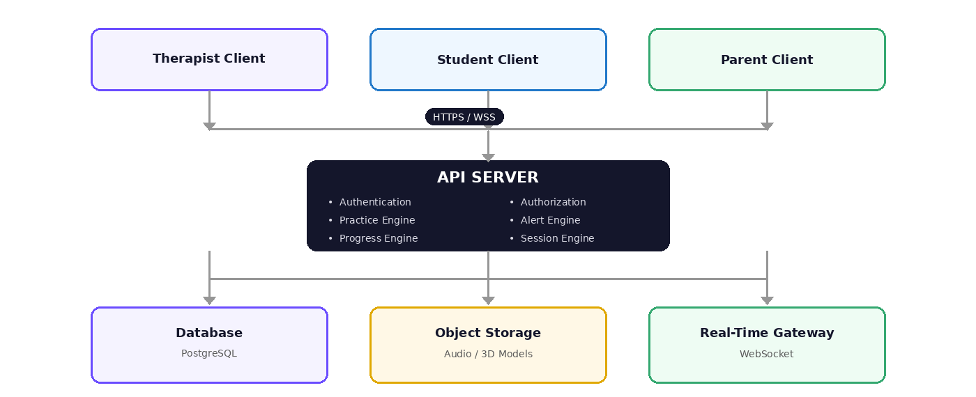
Figure 1 — Client apps connect over HTTPS/WSS to a single API server, which coordinates the database, object storage, and real-time gateway.

2.2 Recommended Technology
Layer | Recommendation
Backend runtime | Node.js, Express.js or Fastify, REST API, WebSocket/Socket.IO for real-time events
Database | PostgreSQL (preferred — strongly related entities); MongoDB acceptable for early prototype only
Authentication | JWT-based, refresh-token mechanism, Argon2 or bcrypt password hashing, role-based authorization
File storage | AWS S3 / Cloudflare R2 / Supabase Storage — audio and media NOT stored in the database, only metadata + secure references
Real-time | WebSocket / Socket.IO for therapist alerts, session updates, unlock notifications

3. User Roles

3.1 Therapist
- View assigned students, schedules, and practice history
- Receive struggle alerts; review failed attempts and phoneme performance
- Open the 3D articulation studio; unlock 3D guidance
- Start live sessions; send guidance to a student; add session notes; review progress

3.2 Student
- View assigned phonemes; explore Hindi letters; listen to pronunciation audio
- Start practice sessions; submit pronunciation attempts; receive evaluation results
- View therapist-unlocked 3D guidance; continue assisted practice; view personal progress

3.3 Parent
- View child's progress, practice frequency, and struggle events
- Receive 3D unlock notifications; view therapist notes; launch home-practice sessions

4. Authentication Contract
POST /api/v1/auth/register
Request:
{ "name": "Example User", "email": "user@example.com",
"password": "secure-password", "role": "therapist" }
Allowed roles: therapist | parent | student

Response:
{ "success": true, "data": { "userId": "usr_12345", "name": "Example User", "role": "therapist" } }
POST /api/v1/auth/login
Request: { "email": "user@example.com", "password": "secure-password" }
Response:
{ "success": true, "data": {
"accessToken": "JWT_TOKEN", "refreshToken": "REFRESH_TOKEN",
"user": { "id": "usr_12345", "name": "Example User", "role": "therapist" }
}}

4.1 Authentication Rules
Every protected API request must contain: Authorization: Bearer <access_token>
The backend must validate: token validity, token expiration, user existence, account status, user role, and resource ownership/assignment. A student must never be able to access another student's data simply by changing an ID in the API request.

5. Student Management
GET /api/v1/students — filters: ?phoneme=क ?status=struggling ?search=name
{ "success": true, "data": [{
"studentId": "stu_001", "displayName": "Student A",
"status": "struggling", "activeAlerts": 1, "currentTargets": ["क", "ख"] }] }
GET /api/v1/students/:studentId
{ "success": true, "data": {
"studentId": "stu_001", "displayName": "Student A",
"assignedTherapist": "therapist_001", "targetPhonemes": ["क", "ख", "ग"],
"progress": { "mastered": 8, "ongoing": 3, "struggling": 2 } } }

6. Hindi Phoneme API
The backend provides phoneme content as metadata — it must not be hard-coded in any client.
GET /api/v1/phonemes
{ "id": "ph_k", "character": "क", "name": "Ka", "category": "Sparsh",
"exampleWord": "कबूतर", "exampleMeaning": "Pigeon", "audioUrl": "/media/phonemes/ka.mp3",
"articulation": { "tongue": "back elevation", "lips": "neutral", "jaw": "neutral", "airflow": "oral" } }
GET /api/v1/phonemes/:phonemeId — full articulation detail
{ "id": "ph_k", "character": "क", "name": "Ka", "category": "Sparsh",
"audio": { "normal": "/media/ka-normal.mp3", "slow": "/media/ka-slow.mp3" },
"articulation": { "tonguePosition": "velar", "lipPosition": "neutral",
"jawPosition": "neutral", "airflowDirection": "oral" },
"video": { "available": true, "previewUrl": "/media/ka-preview.mp4" } }

7. Practice Sessions & Attempt Evaluation
POST /api/v1/practice/sessions
Request: { "studentId": "stu_001", "phonemeId": "ph_k", "mode": "independent" }
Response: { "sessionId": "prs_1001", "status": "active", "startedAt": "..." }
POST /api/v1/practice/sessions/:sessionId/attempts
Request:
{ "attemptNumber": 1, "targetPhoneme": "क", "recognizedText": "क",
"recognitionConfidence": 0.87,
"audioFeatures": { "durationMs": 740, "dominantFrequency": 1250, "spectralCentroid": 1820 },
"mouthFeatures": { "mouthOpenRatio": 0.32, "lipSpread": 0.41, "jawPosition": 0.27 } }

Response:
{ "attemptId": "att_001", "result": "pass",
"consecutiveFailures": 0, "therapistAlertTriggered": false }

7.1 Evaluation Pipeline
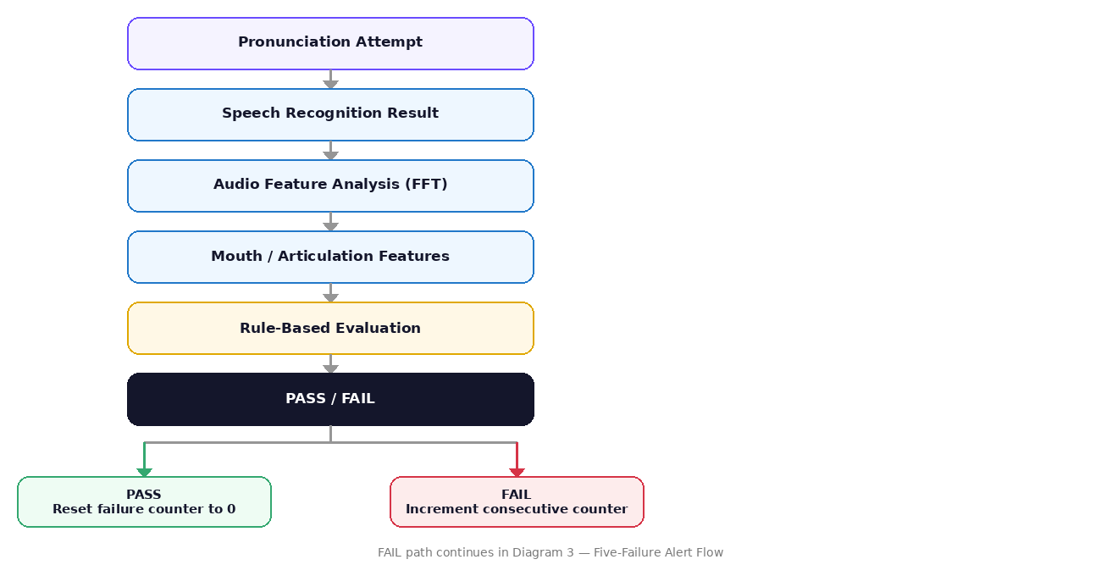
Figure 2 — Every attempt runs through speech recognition, audio and mouth feature analysis, and rule-based evaluation before the failure counter updates.

8. Five-Consecutive-Failure Rule
This is one of the primary backend business rules.
failureCount += 1
if failureCount < 5 -> continue normal practice
if failureCount == 5 -> the backend must:
1. Create a struggle alert
2. Associate the alert with the student and the phoneme
3. Record the triggering attempt
4. Notify the assigned therapist
5. Notify the parent if configured
6. Mark the practice state as therapist_review_required
7. Prevent duplicate alerts for the same five-failure sequence

PASS -> failureCount = 0 (the counter is CONSECUTIVE, not cumulative)

Example:
FAIL->1 FAIL->2 PASS->0 FAIL->1 FAIL->2 FAIL->3 FAIL->4 FAIL->5 -> ALERT
Critical implementation requirement
The backend must NOT blindly trust a client-provided failure count. The client should never send { "failureCount": 5 } and expect the server to trust it. The server must calculate the consecutive count from the stored attempt sequence — this is the single most important rule in this entire specification, since it's what makes the alert system tamper-resistant and reliable when a client goes offline or has a bug.

8.1 Alert Flow
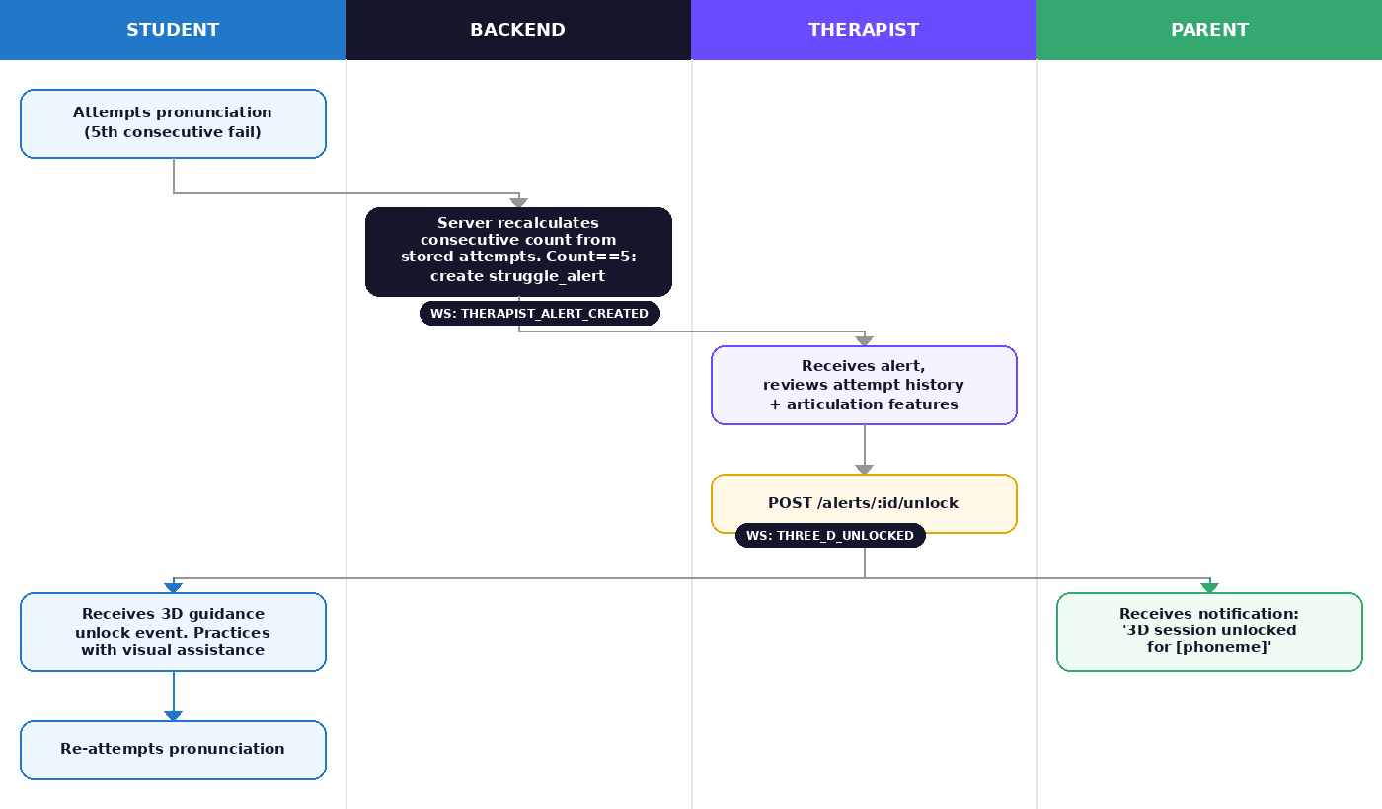
Figure 3 — The full alert loop across Student, Backend, Therapist, and Parent, including the two WebSocket events that drive it.

9. Struggle Alert & 3D Unlock APIs
GET /api/v1/alerts
{ "alertId": "alt_001", "studentId": "stu_001", "studentName": "Student A",
"phoneme": "क", "failureCount": 5, "severity": "struggle",
"status": "pending", "createdAt": "..." }
GET /api/v1/alerts/:alertId
{ "alertId": "alt_001", "phoneme": "क", "failureCount": 5,
"triggerAttemptId": "att_005", "recentAttempts": [ 5 fail records ], "status": "pending" }
POST /api/v1/alerts/:alertId/unlock
Request: { "contentId": "3d_ka_001", "message": "Practice tongue position using the 3D guide." }
Response: { "unlockId": "unl_001", "studentId": "stu_001", "phonemeId": "ph_k",
"contentId": "3d_ka_001", "status": "active", "unlockedBy": "therapist_001" }
Frontend then receives real-time event: 3D_SESSION_UNLOCKED
GET /api/v1/phonemes/:phonemeId/articulation-content
{ "phoneme": "क", "modelUrl": "/models/ka-mouth.glb",
"animationUrl": "/animations/ka-articulation.json", "videoUrl": "/videos/ka-articulation.mp4",
"airflow": { "enabled": true, "direction": "oral", "nasal": false },
"tongue": { "position": "velar", "elevation": "high" } }

10. Live Sessions & Notes
POST /api/v1/sessions
{ "studentId": "stu_001", "type": "live_articulation" } -> { "status": "waiting_for_student" }
POST /api/v1/sessions/:sessionId/start -> { "status": "in_progress" } [event: THERAPIST_SESSION_STARTED]
POST /api/v1/sessions/:sessionId/push-content
{ "contentType": "3d_articulation", "contentId": "3d_ka_001", "phonemeId": "ph_k" }
POST /api/v1/sessions/:sessionId/notes
{ "note": "...", "recommendation": "Continue slow-paced practice for क." }

11. Parent & Progress Analytics
GET /api/v1/parents/me/children | GET /api/v1/students/:studentId/progress
{ "studentId": "stu_001",
"phonemes": { "mastered": 8, "ongoing": 3, "struggling": 2 },
"practice": { "totalSessions": 24, "totalAttempts": 186, "successfulAttempts": 141 },
"generalizationScore": 72 }
GET /api/v1/students/:studentId/practice-frequency
[ { "date": "2026-09-01", "sessions": 2, "attempts": 14 },
{ "date": "2026-09-02", "sessions": 1, "attempts": 8 } ]
Mastery status configuration (must NOT be hard-coded)
{ "masteryThreshold": 0.85, "minimumAttempts": 10 }
-- This is an ENGINEERING threshold, not a clinical claim.
-- Final clinical thresholds must be defined/approved by a qualified SLP.
Generalization Score progression
Isolated Sound -> Syllable -> Word -> Phrase -> Sentence -> Connected Speech
{ "phoneme": "क", "levels": {
"isolated": 0.95, "syllable": 0.88, "word": 0.81, "phrase": 0.74, "sentence": 0.68 } }

12. Root-Cause Diagnostic API
GET /api/v1/diagnostics/:studentId
{ "studentId": "stu_001", "suspectedFeatures": [{
"feature": "tongue_tip_control", "confidence": 0.82,
"affectedPhonemes": ["त", "द", "न"] }] }
Articulatory Feature Knowledge Base (example entries)
{ "phoneme": "क", "features": { "place": "velar", "tongue": "dorsum",
"lip": "neutral", "jaw": "neutral", "airflow": "oral" } }
{ "phoneme": "न", "features": { "place": "alveolar", "tongue": "tip",
"lip": "neutral", "jaw": "neutral", "airflow": "nasal" } }
Diagnostic Engine Pipeline
Attempt history + Audio features + Mouth features + Phoneme features
-> Feature comparison -> Threshold/rule evaluation
-> Candidate articulatory causes -> Confidence calculation
-> Explainable diagnostic result (stores EVIDENCE, not just a label)
Compensatory Pass
Audio evaluation PASS + Mouth/articulation evaluation INCORRECT = not automatically a clinical diagnosis. Stored for therapist review:
{ "audioResult": "pass", "visualResult": "deviation_detected",
"combinedResult": "compensatory_pass_candidate" }

13. Audio Upload Contract
A two-step upload process keeps large audio files off the main API server.
Step 1: POST /api/v1/audio/upload-url
Response: { "uploadUrl": "SIGNED_UPLOAD_URL", "fileId": "aud_001", "expiresIn": 300 }

Step 2: Frontend uploads audio directly to object storage.

Step 3: POST /api/v1/audio/complete
{ "fileId": "aud_001", "sessionId": "prs_1001", "attemptId": "att_001" }
Audio Metadata
{ "fileId": "aud_001", "format": "webm", "durationMs": 740,
"sampleRate": 48000, "channels": 1, "sizeBytes": 48120, "createdAt": "..." }
-- Do not store raw audio permanently without a defined reason, consent,
-- retention policy, and appropriate security controls.

14. Real-Time WebSocket Contract
Connection: wss://api.echoseed.example/ws — after authentication, users join role-specific rooms (therapist:therapist_001, student:stu_001, parent:parent_001).
Event | Fired When | Payload (key fields)
STUDENT_FAILURE_THRESHOLD | 5 consecutive failures reached | alertId, studentId, phoneme, failureCount
THERAPIST_ALERT_CREATED | New struggle alert created | alertId, studentId, phoneme
THREE_D_UNLOCKED | Therapist unlocks 3D content | unlockId, phonemeId, contentId
SESSION_STARTED | Live session begins | sessionId
CONTENT_PUSHED | Therapist pushes content mid-session | sessionId, contentId
PROGRESS_UPDATED | Mastery status changes | studentId, phonemeId, masteryStatus

15. Database Structure
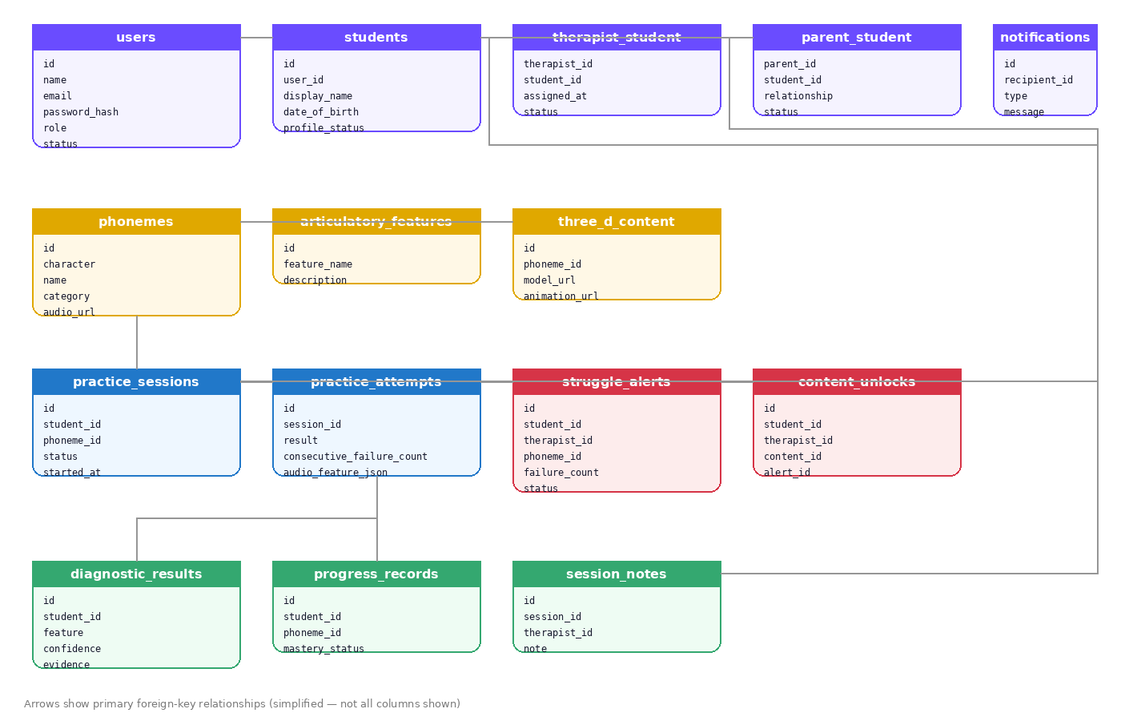
Figure 4 — Simplified entity relationships across identity, phoneme content, and practice/clinical data.

15.1 Data Separation Principle
Identity Data Practice / Clinical Data
-------------- -------------------------
name phoneme attempts
email audio features
date of birth mouth features
parent relationship diagnostic results
progress
therapist notes

Connected only via internal student_id references.
This reduces unnecessary exposure of identifying information.

16. Authorization Matrix
Feature | Therapist | Student | Parent
Own profile | Yes | Yes | Yes
View assigned students | Yes | No | Own child only
Start practice | No | Yes | No
Submit attempt | No | Yes | No
View own progress | Yes | Yes | Own child
View alerts | Yes | Own status only | Own child
Unlock 3D | Yes | No | No
Push 3D content | Yes | No | No
Start live session | Yes | Accept | No
Add therapist notes | Yes | No | No
View therapist notes | Own records | Approved records | Own child
Manage phoneme content | Admin/Therapist | No | No

17. Security, Privacy & Compliance

17.1 Authentication & Authorization
- Passwords never stored as plain text — Argon2 or bcrypt
- Short-lived access tokens, refresh-token rotation
- Every resource request verifies ownership/assignment — never trust a client-supplied studentId, parentId, or therapistId without server-side checks

17.2 Audio Security
- HTTPS everywhere; encrypted object storage; signed URLs for private files
- No permanent public audio URLs; retention policy; delete recordings when no longer required
- Audit record for sensitive access where appropriate

17.3 Audit Logging
Logged actions: LOGIN, STUDENT_VIEW, ALERT_VIEW, THREE_D_UNLOCK,
SESSION_START, NOTE_CREATED, AUDIO_ACCESS, PROFILE_UPDATED

{ "userId": "therapist_001", "action": "THREE_D_UNLOCK",
"resourceId": "unl_001", "timestamp": "2026-09-10T11:00:00Z" }

17.4 Rate Limiting
Login: 5 failed attempts / minute / IP
General API: 100 requests / minute / user
Practice attempt: reasonable application-specific limit
File upload: size and frequency limits

17.5 Clinical Safety Boundary
Terminology Requirement
The backend must not represent automated results as definitive medical diagnoses unless the system has undergone required clinical validation and regulatory assessment. Prefer: evaluation, result, candidate, suspected feature, confidence, recommendation, therapist review. Avoid: medical diagnosis, confirmed disorder, clinical diagnosis — unless appropriately validated.

17.6 Children's Data & Privacy
- Parent/guardian consent workflows where applicable
- Data minimization, encryption in transit and at rest, access control
- Defined data retention and deletion workflow
- Legal/compliance review for the deployment jurisdiction before real-world deployment
- The prototype must clearly distinguish itself from a production clinical platform until that review is complete

18. Development Phases
Phase | Scope
1. Backend Foundation | Node.js server, PostgreSQL, authentication, user roles, basic API structure, environment configuration
2. Student Practice | Phoneme API, practice sessions, attempt storage, failure counter (server-side), basic progress
3. Therapist Workflow | Therapist-student assignment, alert API, five-failure trigger, therapist dashboard APIs, 3D unlock
4. Real-Time System | WebSocket, therapist alerts, student unlock notifications, session events, parent notifications
5. Analytics | Progress aggregation, practice frequency, mastery tracking, generalization tracking
6. Diagnostic Engine | Articulatory feature knowledge base, audio/mouth feature evaluation, explainable rule engine, root-cause clustering
7. ML Integration (future) | Labeled speech dataset -> preprocessing -> wav2vec2 fine-tuning -> validation -> classifier -> inference API. Represent as implemented ONLY after the model is actually trained, evaluated, and validated.

18.1 Future ML API (not yet built)
POST /api/v1/ml/evaluate
Request: { "attemptId": "att_001", "audioFileId": "aud_001" }
Response: { "predictedPhoneme": "क", "classification": "correct",
"confidence": 0.91, "modelVersion": "wav2vec2-v1" }
-- Backend must store the model version used per prediction for reproducibility.

19. Definition of Done — Backend MVP
Authentication
- Registration works · Login works · JWT auth works · Role-based authorization works
Student
- Student profile API · Phoneme API · Practice session API · Attempt API
Five-Failure Engine
- Failure count calculated server-side · Consecutive failures tracked · PASS resets counter · 5th consecutive failure creates an alert · Duplicate alerts prevented
Therapist
- Alerts appear · Alert details accessible · Can unlock 3D content · Can start sessions · Can add notes
Student-side events
- Receives unlocked-content event · Can access unlocked 3D content · New attempts stored
Parent
- Can access child's permitted progress · Practice frequency available · Unlock notifications work · Therapist notes available where permitted
Security
- HTTPS · Password hashing · Authorization checks · Private audio storage · Signed file URLs · Rate limiting · Audit logging

20. Final Architectural Principle
The frontend should display and interact; the backend should validate, remember, authorize, and coordinate. The child interacts with the frontend. The therapist manages the intervention. The parent observes approved progress. The backend connects all three roles while maintaining a single reliable source of truth.

Practice -> Detect -> Alert -> Review -> Assist -> Re-practice -> Measure Progress

Document Control
Any change to an API endpoint, request/response schema, authentication method, event name, database relationship, or business rule should be documented here before being implemented.
Version: 1.0 — Status: Backend Architecture Draft

