FedRAMP® (High System Security Plan (SSP)
for Important HR System (IHRS)
John Smith
Cloud Service Provider (CSP) Signatures
By signing this System Security Plan (SSP), we agree that it is complete and is the current version to be used for the security assessment.

<Sign Here>
Name | Jane Cloudy |  | Date | 06/01/2025
Title | Director of Clouds
Cloud Service Provider |  | Initech

System Owner
The following individual is identified as the system owner or functional proponent/advocate for this system. The system owner is the official responsible for the overall procurement, development, integration, modification, or operation and maintenance of an information system.
Table 4.1 <Insert CSO Name> Owner
System Owner Information
Name | Eugene Belford
Title | Director of HR
Company / Organization | Gibson Systems
Phone Number | 555-555-5555
Email Address | eugene@gibson.com

Assignment of Security Responsibility

ISSO (or Equivalent) Point of Contact
Name | Bill Lumberg
Title | ISSO, HR
Company / Organization | Gibson Systems
Phone Number | 555-555-5551
Email Address | bill@gibson.com

Illustrated Architecture and Narratives
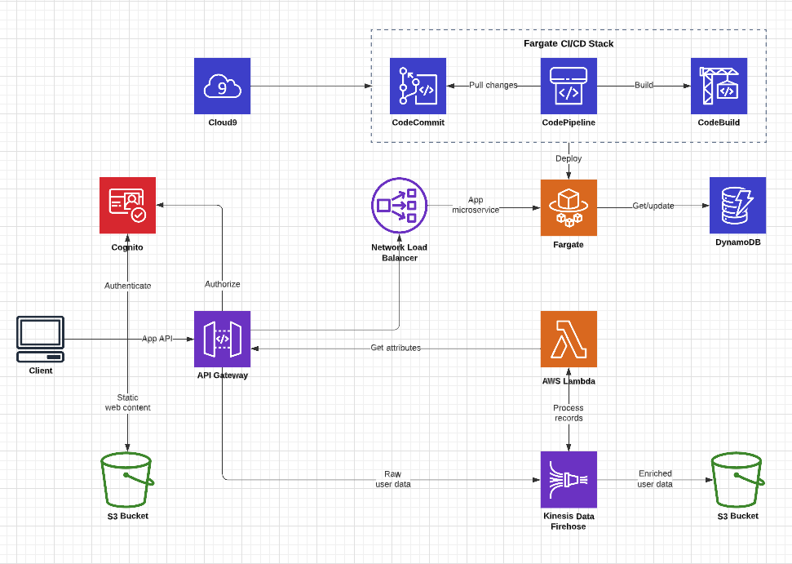
This system is a cloud-native, serverless-first web application built on AWS that combines managed CI/CD, containerized microservices, and event-driven data processing.

Development begins in Cloud9, where code changes are committed to AWS CodeCommit. Those changes automatically trigger a Fargate-based CI/CD pipeline using CodePipeline and CodeBuild, which builds and deploys updated container images to AWS Fargate. This ensures consistent, automated deployments without managing servers.

From a user perspective, clients access the application through a browser. Static web content (the frontend) is served directly from an S3 bucket, while API calls are routed through API Gateway. User authentication is handled by Amazon Cognito, which authenticates users and authorizes API requests before they are allowed into the system.

Once authorized, API requests flow through API Gateway and are routed either to backend compute or to application services. Requests targeting the core application logic are forwarded through a Network Load Balancer to a Fargate-hosted microservice, which implements the main business functionality. This service can read from or update DynamoDB, which acts as the system’s low-latency operational data store.

For event and data-processing workloads, the system uses an event-driven pipeline. Raw user or application data is sent from API Gateway into Kinesis Data Firehose, enabling reliable, scalable ingestion. AWS Lambda functions process these incoming records—enriching, transforming, or deriving additional attributes—and the resulting enriched data is stored in a separate S3 bucket for analytics, reporting, or downstream consumption.

AC-2 What is the solution and how is it implemented?

Control Implementation
The system enforces account management controls to ensure that access to system resources is restricted to authorized users, roles, and services.
End-user authentication and authorization are handled through Amazon Cognito, which manages user account creation, modification, disabling, and deletion in accordance with documented access approval procedures. Users authenticate through Cognito user pools and receive time-limited tokens that are validated by Amazon API Gateway before access to backend services is granted.
System and service accounts are managed using AWS Identity and Access Management (IAM). IAM roles are used exclusively for service-to-service access (e.g., API Gateway to Lambda, Fargate to DynamoDB, Lambda to Kinesis and S3), eliminating the use of long-lived static credentials. Administrative access to AWS resources is restricted to authorized personnel and protected by multi-factor authentication (MFA).
Account lifecycle activities, including account creation, modification, disabling, and removal, are logged using AWS CloudTrail. Periodic reviews are conducted to validate continued need for access, and accounts are promptly disabled or removed when access is no longer required.
Customer Responsibility
The customer is responsible for:
- Defining account provisioning, approval, and termination procedures
- Managing Cognito user pool configurations and user lifecycle actions
- Assigning and reviewing IAM roles and permissions in accordance with least privilege
- Enforcing MFA for privileged accounts
- Performing periodic access reviews
- Retaining and reviewing audit logs related to account activity
AWS is responsible for the underlying operation and availability of Cognito, IAM, and CloudTrail services.

SC-13 What is the solution and how is it implemented?

Control Implementation
The system employs cryptographic mechanisms to protect the confidentiality and integrity of information in transit and at rest.
All external and internal communications are encrypted using TLS 1.2 or higher, including client access to API Gateway, service-to-service communication through the Network Load Balancer, and integrations with AWS-managed services. Encryption is enforced using AWS-provided endpoints and configurations.
Data at rest is encrypted using AWS Key Management Service (KMS) with FIPS 140-2 validated cryptographic modules. Encryption at rest is enabled for Amazon S3, DynamoDB, and Kinesis Data Firehose. AWS Lambda environment variables and application secrets are protected using AWS encryption mechanisms and IAM-controlled access.
Cryptographic key generation, storage, protection, and rotation are handled through AWS KMS. The system relies exclusively on AWS-managed cryptographic services and does not implement custom cryptographic algorithms or libraries.

Customer Responsibility
The customer is responsible for:
- Enabling and configuring encryption settings for all supported AWS services
- Managing KMS key policies, access controls, and rotation settings
- Ensuring TLS is enforced for all application endpoints
- Verifying that only AWS-approved cryptographic services are used
- Documenting cryptographic protections in the System Security Plan
AWS is responsible for the implementation and validation of the underlying cryptographic modules and encryption mechanisms.

SI-2 What is the solution and how is it implemented?

Control Implementation
The system identifies, reports, and remediates information system flaws in a timely and controlled manner.
Application code changes are managed through AWS CodeCommit and deployed using an automated CI/CD pipeline consisting of CodePipeline and CodeBuild. Security patches and fixes are incorporated into updated container images and deployed to AWS Fargate, allowing rapid remediation without manual server access.
The system leverages containerized microservices and serverless components to support efficient redeployment of patched code. Identified vulnerabilities—whether discovered through vulnerability scanning, dependency analysis, or vendor security advisories—are prioritized based on severity and addressed within defined remediation timelines.
AWS-managed services (including API Gateway, Lambda, DynamoDB, S3, Kinesis, and Fargate) are patched and maintained by AWS under the shared responsibility model. Evidence of remediation activities, including build logs and deployment records, is retained to support continuous monitoring and assessment activities. Exceptions or delayed remediation actions are documented and managed through formal risk acceptance procedures.
Customer Responsibility
The customer is responsible for:
- Monitoring vulnerability sources and scan results relevant to application code and dependencies
- Prioritizing and remediating identified flaws within established timelines
- Updating application code, container images, and configurations through the CI/CD pipeline
- Tracking remediation status and documenting exceptions or risk acceptances
- Maintaining evidence of flaw remediation activities
AWS is responsible for patching and maintaining the underlying infrastructure and managed service components.

