Article
Aspect-Based Sentiment Analysis of Malaysian FinTech eWallet Applications: A Comparative Study of Touch ’n Go, GrabPay and ShopeePay
Sia Poh Xiang ¹, Lim Chin Chen ², Shi Hong Yi ³ and Joshua Wong Yong ^{4,}
¹ Sia Poh Xiang; 1211108363@student.mmu.edu.my
² Lim Chin Chen; 1211108626@student.mmu.edu.my
³ Shi Hong Yi; 1211108962@student.mmu.edu.my
⁴ Joshua Wong Yong; joshua.wong.yong@student.mmu.edu.my
Featured Application
Financial technology (fintech) local review-analysis system a multilingual review-analysis system. The application examines feedback received from users of the mobile-payment technologies, namely Touch 'n Go eWallet, GrabPay and ShopeePay, as examples in the Malaysia Tech Scene. It categorizes the overall sentiment and the major aspect of the review and displays the overall patterns in an interactive Streamlit interface.
Abstract
Malaysia's technology industry has well-known reputation of financial technology platform, including mobile e-wallets. The platforms are inundated with Appstore feedback, but human review of multilingual feedback is time consuming and doesn't always distinguish between general sentiments and specific comments about the feature in question. This project involves creating a local sentiment and aspect classification system for Touch 'n Go eWallet, GrabPay and ShopeePay. 7,815 English and Bahasa Malaysia reviews have retrieved from the Malaysian Google Play Store, cleaned them, pseudo-labelled them for sentiment with XLM-RoBERTa and balanced them to 1980 reviews. Then, each review was classified with one dominant aspect using a local facebook/bart-large-mnli zero-shot classifier. A bert-base-multilingual-cased model was fine-tuned jointly for three classes of sentiment and five classes of aspects, exported to ONNX, and deployed in a 3-page Streamlit app. The sentiment head's accuracy and weighted F1 on the held-out test set were 71.46% and 71.54% respectively, and the aspect head's accuracy and weighted F1 on the held-out test set were 51.77% and 50.17% respectively. Combined exact match accuracy was 38.64%. The system exemplifies a holistic local NLP process in the financial technology industry of Malaysia, however, the pseudo-labels of low confidence aspects, the scarcity of reward classes and the lack of human gold labels reduce the strength and generalisability of the results.
Keywords: sentiment analysis; aspect classification; financial technology; eWallet; multilingual BERT; zero-shot classification; ONNX; Malaysia Tech Scene

1. Introduction
Financial technology is a crucial aspect of Malaysia's tech landscape. eWallet applications bundle the mobile software, digital payment facilities, identity verification systems, online transactions, and customer support services into a single user-facing platform. They use these technologies to transfer, pay merchants, reload, settle bills, get cashback, and provide account support. App store reviews offer real-time feedback about transaction failures, usability issues, support experiences, and satisfaction levels. But the reviews are quite multilingual, informal, and short, with emojis and sometimes some spelling variations, repeated characters, and mixing English with local language (Bahasa Malaysia). These properties make keyword counting (as performed by humans) unreliable and slow.
Sentiment analysis is analysing an opinion as positive, neutral, or negative, while aspect-based sentiment analysis tries to relate sentiment to the specific feature of a product or a service. The recent works have demonstrated that multilingual Transformer encoders can acquire linguistic knowledge from relatively high-resource settings [1, 2], and generative and prompt-based ABSA methods can model multiple subtasks in a single framework [3-5]. Zero-shot approaches are also applicable when it is not possible to have manually annotated aspect labels [6, 7]. Given these developments, a practical pipeline is suggested with the use of pretrained teacher models to build pseudo-labels and a smaller task-specific model for deployment.

1.1. Problem Statement
In the financial technology field in Malaysia, public e-Wallet reviews provide valuable insights into the reliability and usability of mobile-payment technologies. However, these reviews are not coded uniformly by hand, given the limited number of reviews and their variations. Not all-star ratings correspond exactly to the language in a review, and a bad star rating can apply to things such as reliability of payment, UI, rewards, or customer support. Labels can be obtained from existing cloud APIs, but these APIs have limits on the number of labels that can be returned and require network connectivity and dependence on an external service, resulting in non-reproducibility. Therefore, the project aims to address the need to have a local technology-based system that can process Malaysian e-wallet reviews, predict the sentiment level of e-wallet reviews, assign a category of dominant aspect from the reviews, and present interpretable and aggregate patterns without relying on an external inference API, which requires payment.

1.2. Objectives
- To gather and preprocess a financial technology review corpus focusing on Malaysia, from Touch 'n Go eWallet, GrabPay and ShopeePay.
- To obtain pseudo-labels for sentiment (three classes) and aspect (five categories) through local teacher models.
- Find the optimal single dual-head multilingual BERT model to predict sentiment and aspect in one forward pass.
- To make a comparison of both heads using accuracy, precision, recall, F1-score, confusion matrices, and combined exact-match accuracy.
- To export the trained model to ONNX and deploy it as an interactive Streamlit application that features emoji-smart analysis and comparison visualizations.

1.3. Scope and Contributions
This project falls in the category of technology (Malaysia Tech Scene) and will study e-Wallet applications as financial technology products, which are the integration of mobile interfaces, payment infrastructure, account services, and promotional features. The study has been restricted to the Malaysian region for public Google Play reviews and the three mobile payment apps used, namely Touch 'n Go e-Wallet, GrabPay, and ShopeePay. Sentiment is represented by positive, neutral, and negative classes. General dimensions include aspects of payment, user interface, service, rewards, and general. The implementation focuses on one aspect per review and adds the review level sentiment but cannot predict the sentiment of multiple aspects within a single review. As a result, the system can be considered an ABSA or dual-task sentiment and aspect classification system.
The main contribution is an end-to-end locally executable NLP pipeline that processes user responses to Malaysian financial technology: targeted data collection, multilingual cleaning of the data, handling of emoji, pseudo-labelling by teachers in both languages, construction of a balanced dataset, fine-tuning on mBERT (dual head), ONNX conversion, and interactive deployment. The system is used to obtain feedback on payment reliability, interface quality, customer service, and digital rewards, which is organized through sentiment and aspect classification to help technology-product teams. Pseudo-label quality and class imbalance are also explicitly considered as methodological constraints in the report, instead of seeing automatically generated labels as the gold standard.

2. Literature Review

2.1. Multilingual Transformer Sentiment Classification
Martin et al. used multilingual BERT to fine-tune Swahili sentiment classification and proved that a pre-trained multilingual encoder is suitable to be fine-tuned for a limited-resources language [1]. Azhar and Khodra further adapted mBERT for Indonesian ABSA and found it to have better generalization compared to previous feature-based methods [2]. The relevance of these studies to Malaysian app reviews is since the collection includes English, code-switching, and informal vocabulary of the Bahasa Malaysia language. They agree to keep the casing in place and not make all the text lower case, for example, by using bert-base-multilingual-cased.

2.2. Aspect-Based Sentiment Analysis
The focus of generative ABSA research has shifted from individual classifiers. Zhang et al. defined ABSA as a generation task [3] and Yan et al. introduced a unified framework using BART for multiple subtasks of ABSA [4]. Li et al. added sentimental knowledge to prompt-based learning—SentiPrompt [5] The present coursework system is weaker in producing aspect-opinion modelling than these studies, but the studies do require annotated data for specific tasks or more complex training targets. The current project takes a less complex, category-level formulation, which is more feasible with the data and computation available.

2.3. Zero-Shot and Weakly Supervised Labelling
To help facilitate the zero-shot transfer, Shu et al. translated the ABSA tasks as natural language inference [6]. Deng et al. demonstrated that, and they could learn aspect-level sentiment information from document-level reviews, given no examples in a zero-shot scenario [7]. This work inspires the application of BART-large-MNLI as a local aspect teacher. However, a zero-shot label will still be a model-generated hypothesis. Before the labels can be considered reliable supervision, confidence scores and agreement with a separate keyword method should be analysed.

2.4. Reproducibility, Instruction Learning and Recent LLM Evaluation
The PyABSA framework was proposed by Yang et al. as a modular architecture that they believe would enhance the reproducibility of ABSA models and data [8]. Scaria et al. applied instruction learning for sample-efficient improvement for multiple subtasks in ABSA [9]. Later research has investigated the hybrid teaching models based on instruction [10] and applied large language models for multilingual or multi-task ABSA [11, 12]. These studies reveal that there are better models available but also showcase the need for clear task descriptions and good claims. The focus of the present project is on transparency of the local pipeline, rather than on the large model performance.

2.5. Research Gap
The literature examined shows opinions on curated benchmark datasets with human labels, while the current application works with public Malaysian financial technology reviews and does not have a human-labelled aspect corpus. Hence, it is not the invention of a new ABSA algorithm but building a reproducible local workflow for Malaysia's technology field to gather, preprocess, weakly label, train, and deploy a multilingual algorithm. The methodological challenge here is that the given system's performance is subject to the quality and balance of its pseudo-labels. This report therefore assesses the output of the model, as well as diagnostics of label generation.

2.6 Summary Table
Year | Study | Approach | Relevance to This Project
2021 | Martin et al. [1] | mBERT sentiment classification | Supports multilingual transfer in a low-resource language.
2021 | Azhar and Khodra [2] | mBERT for Indonesian ABSA | Relevant to a linguistically related Southeast Asian context.
2021 | Zhang et al. [3] | Generative ABSA | Shows unified generation of aspect and sentiment structures.
2021 | Yan et al. [4] | Unified BART ABSA | Demonstrates sequence-to-sequence unification of ABSA subtasks.
2021 | Li et al. [5] | Sentiment-aware prompt tuning | Shows the value of explicit sentiment knowledge.
2022 | Shu et al. [6] | Zero-shot ABSA through NLI | Directly motivates NLI-style zero-shot aspect labelling.
2022 | Deng et al. [7] | Zero-shot aspect sentiment | Uses document-level supervision for aspect-level transfer.
2022 | Yang et al. [8] | PyABSA framework | Emphasises modularity and reproducibility.
2023 | Scaria et al. [9] | Instruction learning for ABSA | Shows instruction-tuned sample efficiency.
2024 | Jayakody et al. [10] | Hybrid Instruct-DeBERTa | Combines extraction and classification components.
2024 | Wu et al. [11] | Zero-shot multilingual ABSA with LLMs | Finds promise but also limitations in zero-shot multilingual settings.
2024 | Zhou et al. [12] | Comprehensive LLM evaluation | Highlights the importance of task formulation and evaluation design.

3. Materials and Methods

3.1. End-to-End Workflow
Figure 1 presents the implemented pipeline. Public reviews are collected from three Malaysian Google Play listings. The text is normalised and tokenised, and emoji information is retained. XLM-RoBERTa supplies review-level sentiment pseudo-labels. The dataset is balanced by application and sentiment, BART-large-MNLI assigns one aspect pseudo-label, and a shared mBERT encoder is jointly fine-tuned for both tasks. The final network is exported to ONNX and loaded by Streamlit for local inference.

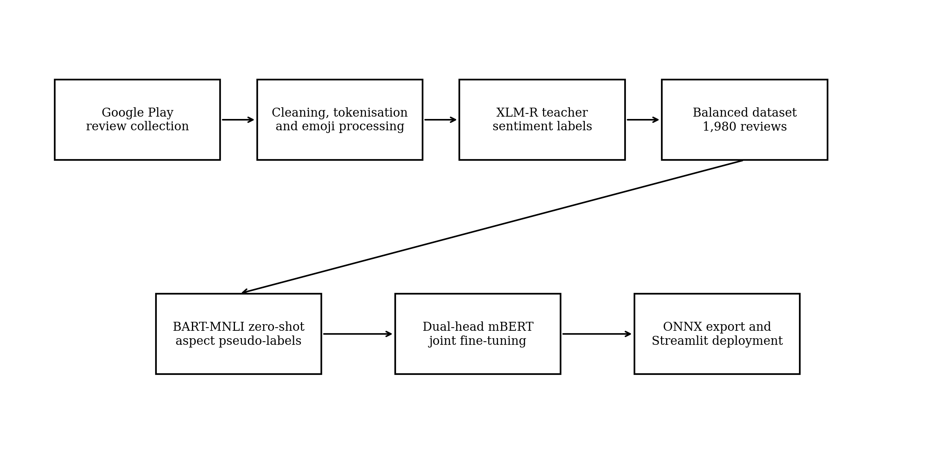
Figure 1. End-to-end data, labelling, training and deployment workflow.

3.2. Data Collection
Reviews were collected with the Python google-play-scraper library from the Malaysia region without an API key. The targeted applications were Touch 'n Go eWallet (my.com.tngdigital.ewallet), GrabPay through the Grab application (com.grabtaxi.passenger), and ShopeePay through the Shopee Malaysia application (com.shopee.my). Multiple collection strategies were used to increase coverage of neutral, positive and negative star ratings. The collection included English and Bahasa Malaysia reviews dated from 17 August 2021 to 27 June 2026.
Table 1. Raw review distribution before preprocessing and balancing.
Application | Raw total | Positive by stars | Neutral by stars | Negative by stars
Touch 'n Go eWallet | 2,607 | 1,084 | 504 | 1,019
GrabPay | 2,515 | 1,068 | 484 | 963
ShopeePay | 2,693 | 1,143 | 546 | 1,004
Total | 7,815 | 3,295 | 1,534 | 2,986

The raw file contained nine fields: review identifier, user name, review content, star score, helpful-vote count, review date, application name, normalised source name and star-derived sentiment. Personally identifying user names were not used as model features. Only the review text and application-level metadata were needed for the NLP pipeline.

3.3. Data Preprocessing
The preprocessing script applied a sequence of deterministic cleaning operations. ftfy repaired malformed Unicode, HTML entities were decoded, URLs and HTML tags were removed, control characters were eliminated, repeated characters were reduced, and whitespace was normalised. Casing and punctuation were preserved because mBERT is cased and informal punctuation may contain sentiment cues. NLTK tokenisation was applied, after which English stopwords and Malaysian conversational fillers were removed while polarity-bearing terms were retained.
Emoji characters were extracted before model training. A small positive and negative emoji lexicon generated an auxiliary emoji tone signal for application display. Emoji processing is an advanced application feature rather than a replacement for the Transformer prediction. The preprocessing stage also generated keyword indicators for payment, interface, service and rewards; these indicators were retained for comparison with the later zero-shot aspect teacher.

3.4. Sentiment Pseudo-Labelling and Dataset Balancing
The pretrained cardiffnlp/twitter-xlm-roberta-base-sentiment model, which is based on the XLM-RoBERTa cross-lingual representation architecture [13], was used as a sentiment teacher to assign positive, neutral or negative labels. These model-generated labels were compared with star-derived sentiment as a diagnostic but were used as the primary training target. Agreement was 1,182 of 1,980 final reviews, or 59.7%, indicating that textual sentiment and rating-derived sentiment were not interchangeable. The disagreement may reflect mixed reviews, rating-text mismatch, domain shift or teacher error.
The final dataset was balanced to 220 reviews for each sentiment class within each application. Therefore, each application contributes 660 reviews and each sentiment contributes 660 reviews, for a total of 1,980. This design prevents the student model from learning a dominant app-sentiment distribution. It also means that the balanced dataset cannot be used to claim that one application has a naturally higher positive-review rate than another. Any dashboard 'winner' based on the balanced labels is a tie-breaking artefact rather than evidence of market superiority.
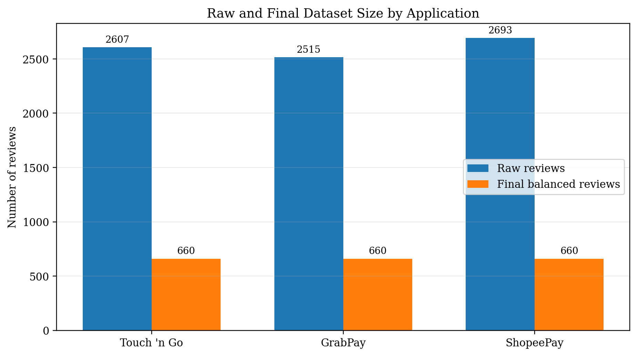
Figure 2. Raw review counts and final balanced review counts by application.

3.5. Knowledge Representation
The cleaned corpus was stored in comma-separated-value format. The final ABSA-labelled file contains 19 columns, including original content, cleaned text, token representations, emoji information, sentiment, star-derived sentiment, keyword aspect indicators, BART aspect labels, aspect confidence and the combined label. The combined label concatenates the dominant aspect and review sentiment, producing 15 possible strings such as payment_negative, ui_positive and rewards_neutral. The dual-head model does not train directly on the concatenated string; it learns the sentiment and aspect targets through separate output heads.
Table 2. Sentiment and aspect label definitions used by the project.
Task | Label | Operational meaning
Sentiment | negative | Complaint, dissatisfaction or adverse experience.
Sentiment | neutral | Balanced, factual, uncertain or weakly polarised review.
Sentiment | positive | Praise, satisfaction or favourable experience.
Aspect | payment | Payments, reloads, transfers, transactions and reliability.
Aspect | UI | Interface, navigation, usability, login and application behaviour.
Aspect | service | Customer support, verification, dispute or response quality.
Aspect | rewards | Cashback, vouchers, promotions, points and campaign benefits.
Aspect | general | Broad feedback without a clear dominant supported aspect.

3.6. Zero-Shot Aspect Pseudo-Labelling
The current aspect-labelling script uses facebook/bart-large-mnli as a local zero-shot natural-language-inference classifier based on the BART sequence-to-sequence architecture [14]. Candidate labels are payment, ui, service, rewards and general, and the hypothesis template is 'This review is about {}'. Inference is processed in batches of 16 with a checkpoint every 50 rows. The class with the highest entailment score is selected as the single dominant aspect, and the associated score is retained as aspect_confidence.
The resulting distribution was imbalanced: 588 UI reviews, 489 service reviews, 469 payment reviews, 384 general reviews and 50 rewards reviews. Mean confidence was 0.3613, 75.3% of rows had confidence below 0.40, and the BART label agreed with the earlier keyword label for only 679 reviews (34.3%). These diagnostics indicate substantial pseudo-label uncertainty and are important when interpreting the student model's aspect accuracy.
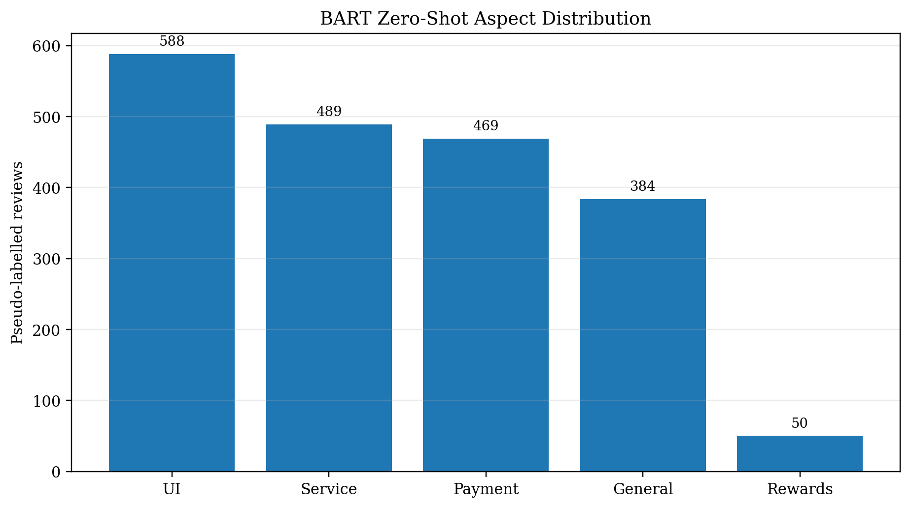
Figure 3. Distribution of BART zero-shot aspect pseudo-labels in the final dataset.

3.7. Data Splitting
The training script first held out 20% of the 1,980 reviews as a test set using sentiment stratification and random state 42. The remaining 80% was split again with 10% used for validation, producing 1,425 training reviews, 159 validation reviews and 396 test reviews. Sentiment stratification resulted in 132 test examples for each sentiment class. Aspect was not used for stratification, which produced an uneven aspect test distribution: payment 87, UI 122, service 97, rewards 7 and general 83. This design protects sentiment balance but does not guarantee reliable aspect-level estimates for minority classes.

3.8. Dual-Head mBERT Architecture
The student model is bert-base-multilingual-cased, based on the bidirectional Transformer architecture introduced by BERT [15], with a shared 12-layer encoder and two independent linear heads. The 768-dimensional pooled output is mapped to three sentiment logits and five aspect logits. The embedding layer and the lower six Transformer layers are frozen to reduce training cost, while the upper layers and both heads are fine-tuned. For each batch, categorical cross-entropy is calculated for both tasks and the two losses are added. This multi-task arrangement allows both predictions to be produced in one forward pass.

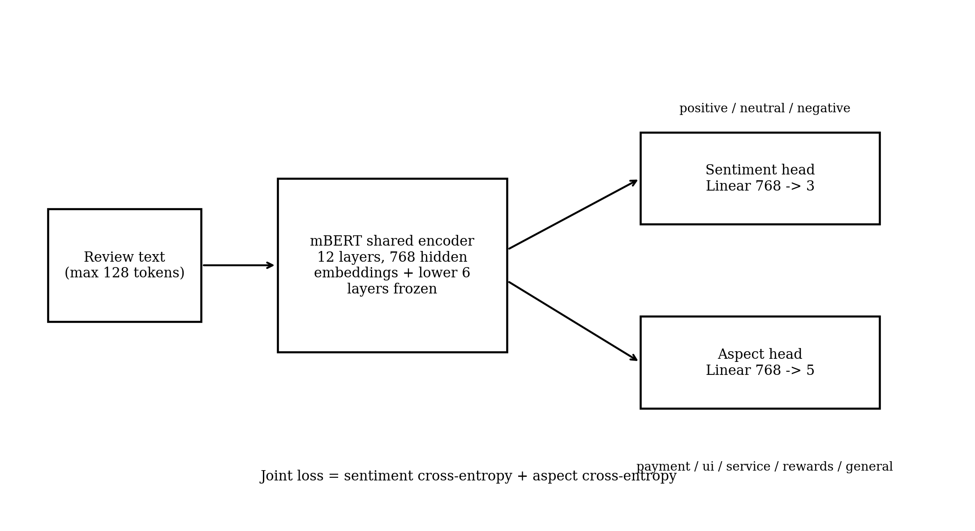
Figure 4. Shared mBERT encoder with separate sentiment and aspect classification heads.

3.9. Training Configuration and Evaluation
Table 3. Dual-head mBERT training configuration.
Parameter | Value
Base model | bert-base-multilingual-cased
Maximum sequence length | 128 tokens
Batch size | 16
Maximum epochs | 5
Learning rate | 2 x 10^-5
Weight decay | 0.01
Warm-up steps | 100
Early-stopping patience | 2 epochs
Frozen components | Embeddings and lower six encoder layers
Random state | 42
Device | GPU
Recorded training time | 159.96 seconds (approximately 2.7 minutes)

AdamW algorithm was applied for optimization with a linear warm-up and decay schedule. Checkpoint that yielded minimum loss on validation data was loaded prior to test evaluation. Metrics such as accuracy, per-class precision, recall and F1-score, macro and weighted averages and confusion matrices were used for each head. Combined exact match accuracy was the ratio of test samples where both aspects and sentiments were predicted correctly.

3.10. ONNX Export and Deployment
The selected checkpoint was exported to ONNX opset 14 with input names input_ids and attention_mask and output names sentiment_logits and aspect_logits. Batch size and sequence length were declared as dynamic axes. The export script used sample reviews to compare PyTorch and ONNX class predictions, and the ONNX model was validated with the ONNX checker. The final ONNX file is approximately 678.75 MB and is loaded by ONNX Runtime in the Streamlit application.
The application contains three pages. The Sentiment Analyser accepts review text and an application choice, applies the same cleaning rules, detects emoji tone, runs one dual-head ONNX inference and displays both labels with confidence scores. The Comparison Dashboard presents dataset-level sentiment, aspect, heatmap and word-cloud visualisations. The About page summarises the Technology domain, dataset, methodology, metrics and advanced features. Figure 5 presents representative screenshots of the implemented Streamlit interface, including multilingual single-review analysis, the balanced-data dashboard and the project information page.
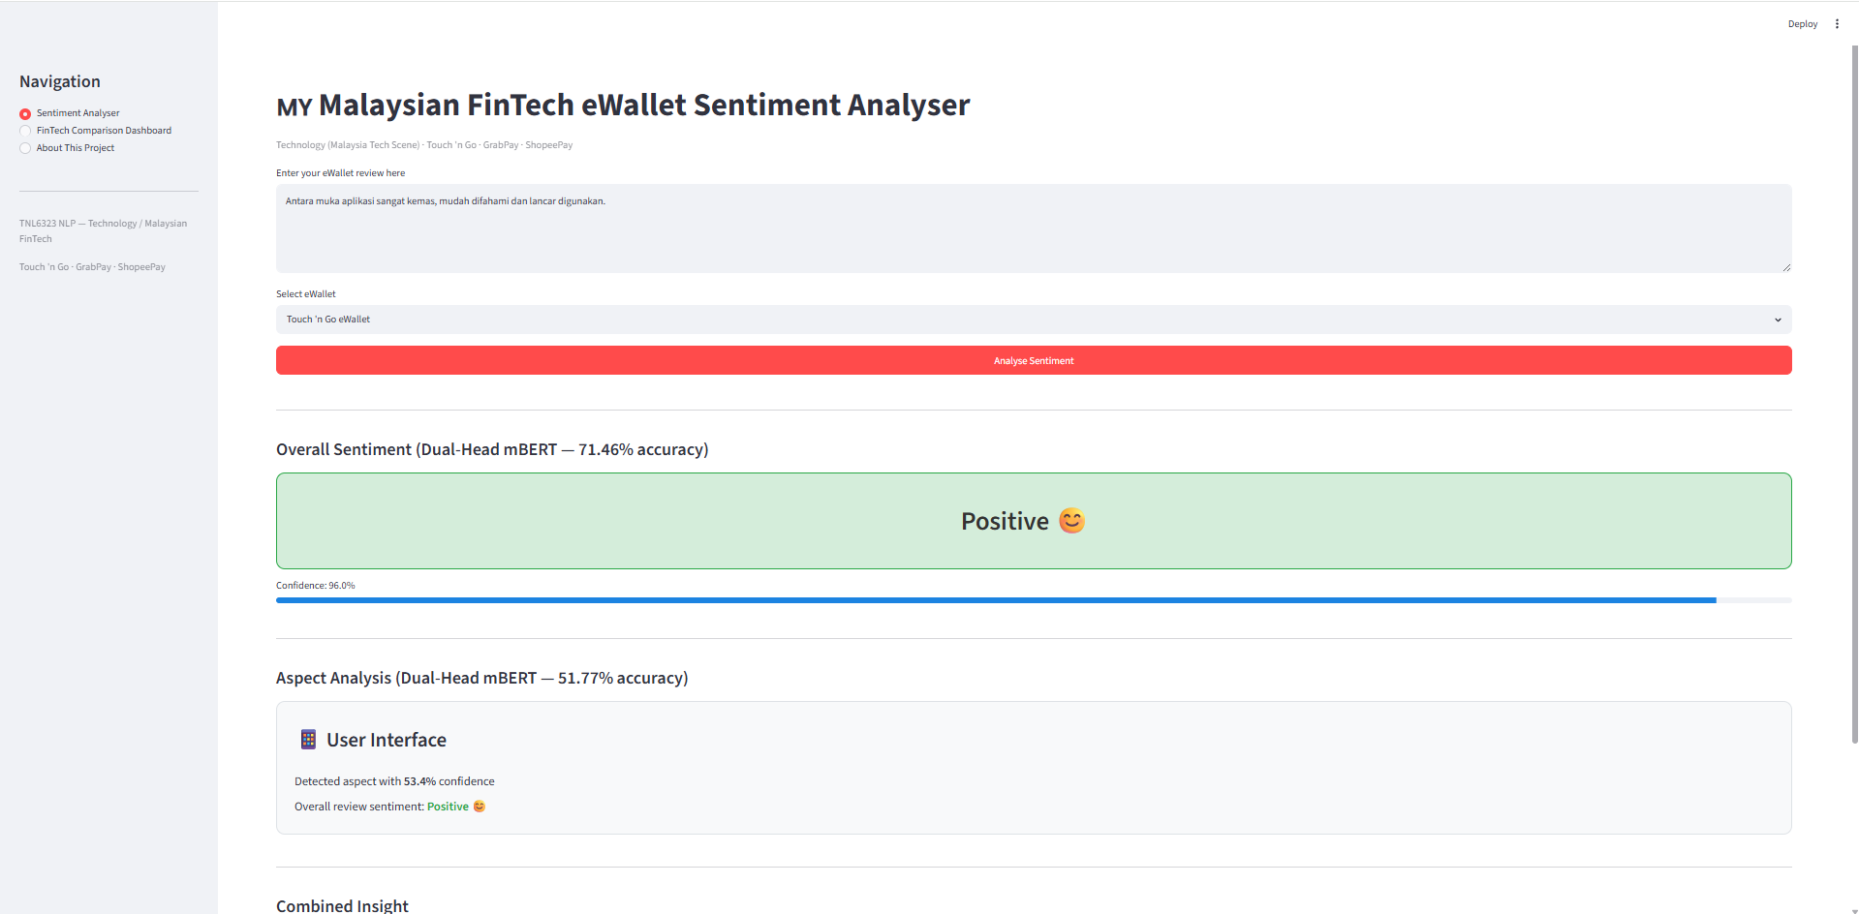
(a) Bahasa Malaysia review classified as Positive with User Interface as the dominant aspect.

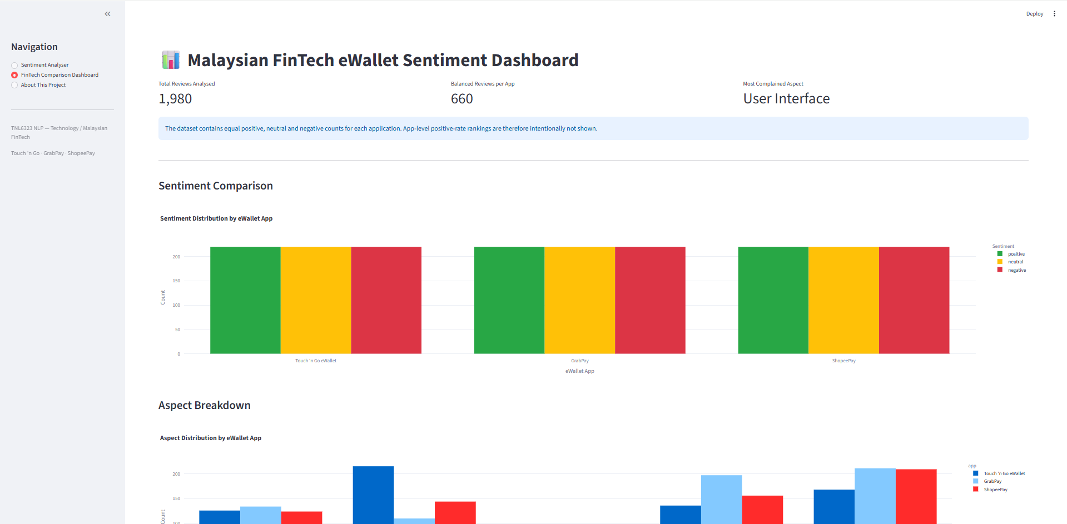
(b) Malaysian FinTech eWallet dashboard showing the balanced review counts and aspect distributions.

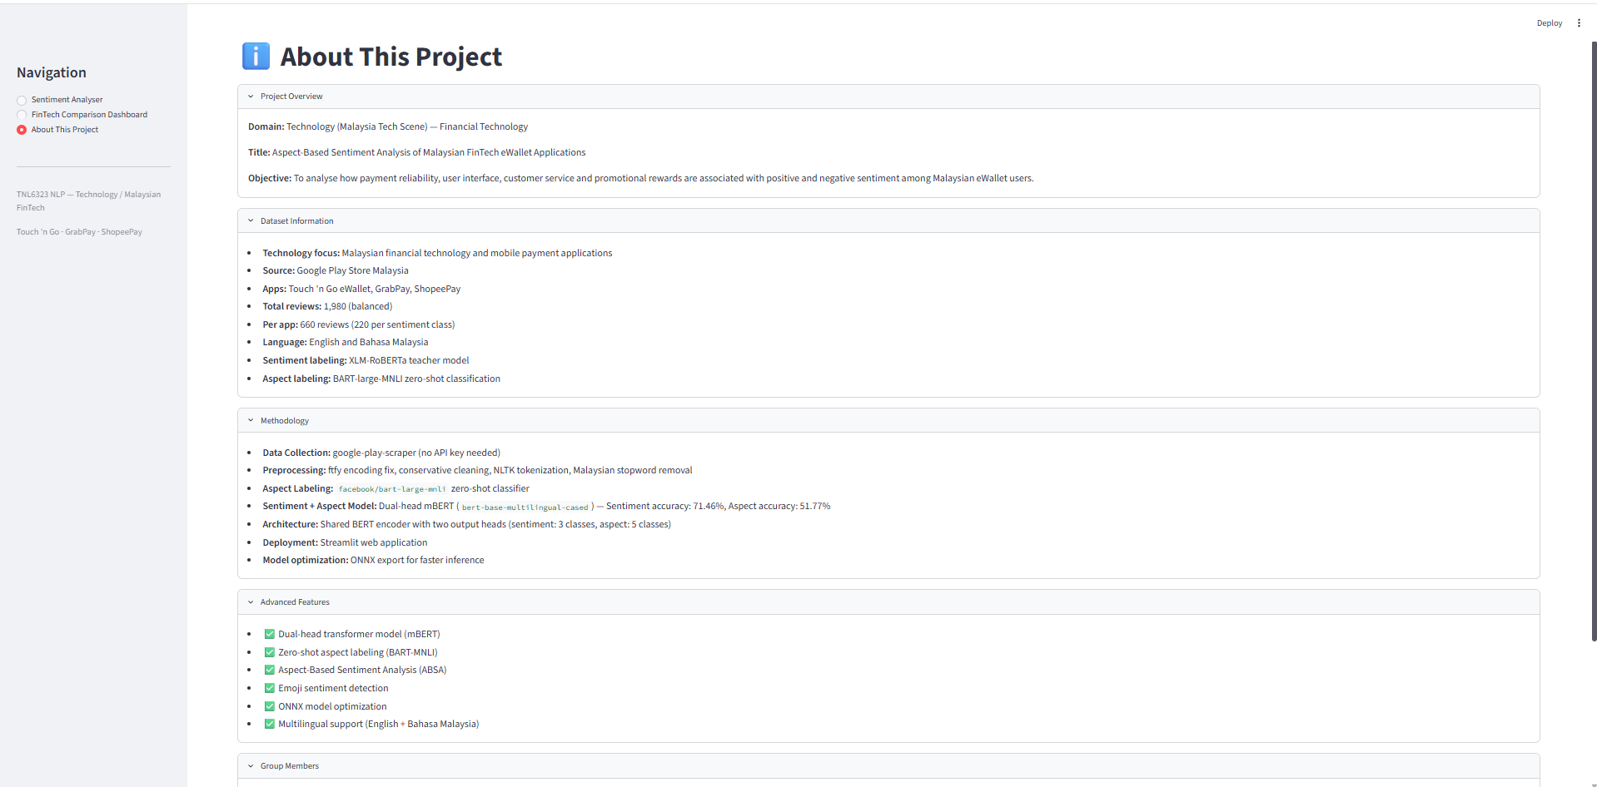
(c) Technology-aligned project overview, dataset information, methodology and advanced features.
Figure 5. Streamlit deployment interface: (a) Bahasa Malaysia review classified as positive sentiment with user interface as the dominant aspect; (b) Malaysian FinTech eWallet dashboard showing balanced review counts and aspect distributions; and (c) Technology-aligned project overview, dataset information, methodology and advanced features.

3.11. Ethical and Reproducibility Considerations
The data comes from reviews in an app store that is publicly available and there is no need to interact directly with participants. User IDs appear in the source file but are not needed for the modelling and hence should not be included in the final report. The project should be referred to as the analysis of the publicly available reviews rather than conducting a survey of individuals. The reproducibility of the study can be achieved via locally running scripts for scraping, cleaning, pseudo-labelling, training and deployment; the use of fixed label maps; random state and model metrics saved in the report. Large weights of mBERT and ONNX models are not stored on GitHub due to exceeding the maximum file size allowed.

4. Results

4.1. Dataset and Pseudo-Label Diagnostics
Table 4. Dataset and pseudo-label quality diagnostics.
Diagnostic | Value | Interpretation
Raw reviews | 7,815 | Public Malaysian Google Play corpus.
Final reviews | 1,980 | Balanced by application and sentiment.
Sentiment/star agreement | 1,182 / 1,980 (59.7%) | Moderate correspondence between teacher text labels and rating labels.
Mean BART aspect confidence | 0.3613 | Low average confidence.
Aspect confidence below 0.40 | 75.3% | Most aspect labels are uncertain.
Keyword/BART aspect agreement | 679 / 1,980 (34.3%) | Low agreement between two weak labelling methods.
Rewards pseudo-labels | 50 | Severe minority class before splitting.

Achieving balance among the classes is easily achieved and more than meets the coursework criteria, with an additional guarantee that there is balance of sentiments for all three applications. Nonetheless, the balancing operation deliberately eliminates the presence of any natural disparity among the applications. The low scores for BART and low agreement with the keyword-generated aspect labels indicate that aspect labels contribute significantly to the supervisory noise. Thus, the performance should be viewed in terms of pseudo-labelled data.

4.2. Model Performance
Table 5. Test-set performance of the dual-head mBERT model.
Output | Accuracy | Weighted F1 | Macro F1 | Test support
Sentiment head | 71.46% | 71.54% | 71.52% | 396
Aspect head | 51.77% | 50.17% | 39.96% | 396
Combined exact match | 38.64% | - | - | 396

An accuracy of 71.46% was obtained by the sentiment head. Sentiment prediction performed best for positive reviews with a precision of 0.80, recall of 0.77 and F1-score of 0.79. The F1-score for negative sentiment was 0.69 while the F1-score for neutral sentiment was 0.67. The aspect head obtained an accuracy of 51.77% and a weighted F1-score of 50.17%. However, the macro F1-score for the aspect head was approximately 0.40 because its performance was inconsistent across the different aspect classes. The combined exact-match accuracy was 38.64%, meaning that both the sentiment and aspect predictions were correct for the same review in 38.64% of the test samples.
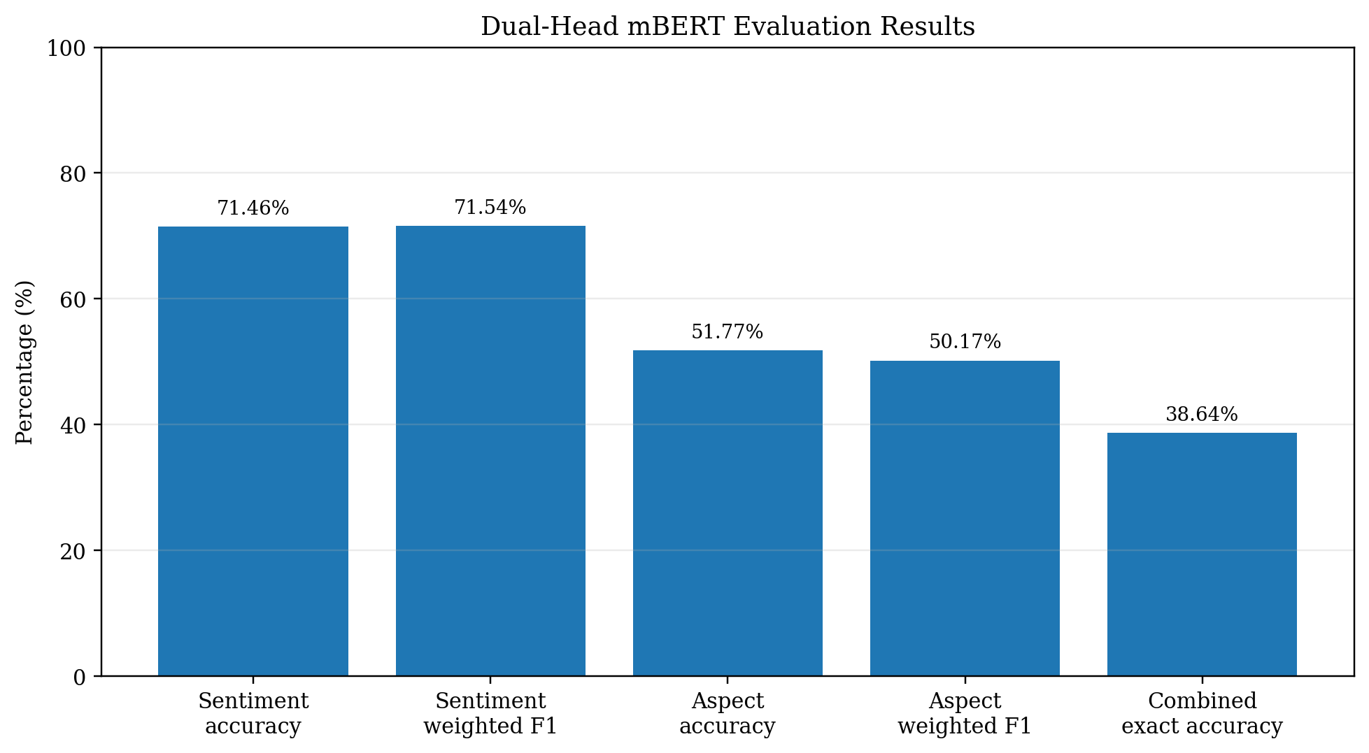
Figure 6. Accuracy and weighted F1 results for the sentiment and aspect heads, including combined exact-match accuracy.

4.3. Sentiment Error Analysis
From the sentiment confusion matrix shown in Figure 7, it can be observed that the positive sentiment class is more separable than other classes. From the 132 positive review samples in the test set, there were 102 correct classifications, 17 were incorrectly classified as negative reviews and 13 as neutral reviews. The neutral sentiment class was mostly confused between negative and positive sentiment classes. This could be due to the presence of comments which do not express any evaluation but rather describe any functionality problems. Furthermore, 35 negative reviews were classified as neutral reviews.
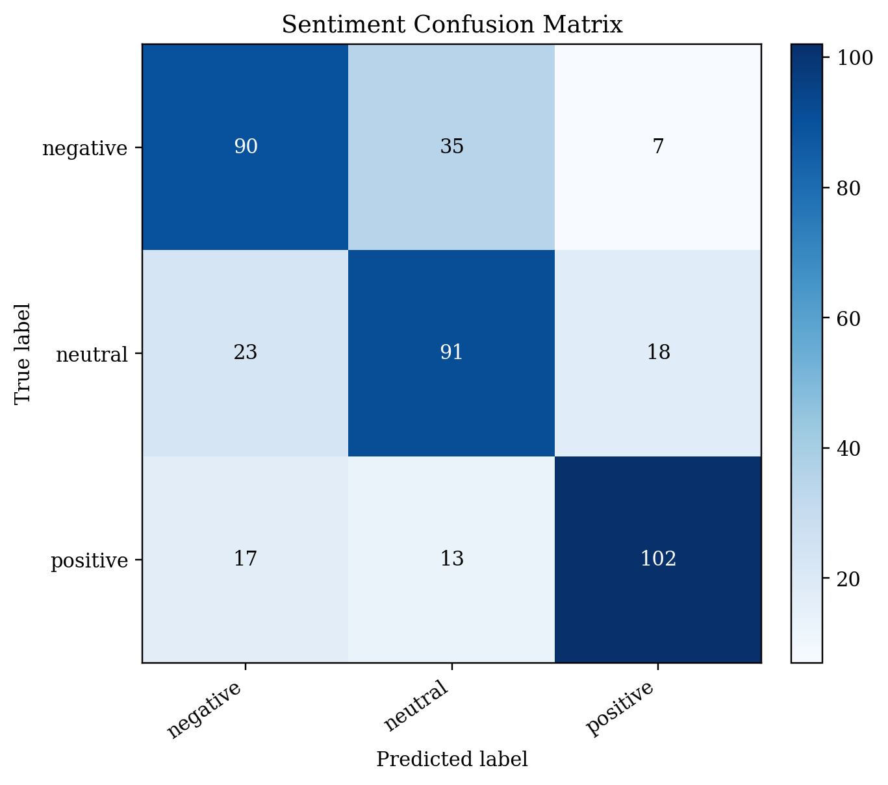
Figure 7. Sentiment-head confusion matrix on the 396-review test set.

4.4. Aspect Error Analysis
The F1-scores for the payment, UI and service aspects were 0.63, 0.55 and 0.52 respectively. However, the F1-score for the general aspect was lower at 0.31, showing that it was more difficult to classify. The rewards aspect had only seven reviews in the test set and obtained zero precision, recall and F1-score because the classifier did not correctly predict any rewards-related reviews. Furthermore, the aspect confusion matrix shows that some general and service reviews were incorrectly classified as UI. This may be due to overlapping review concerns, such as login issues, application crashes and customer support experiences.
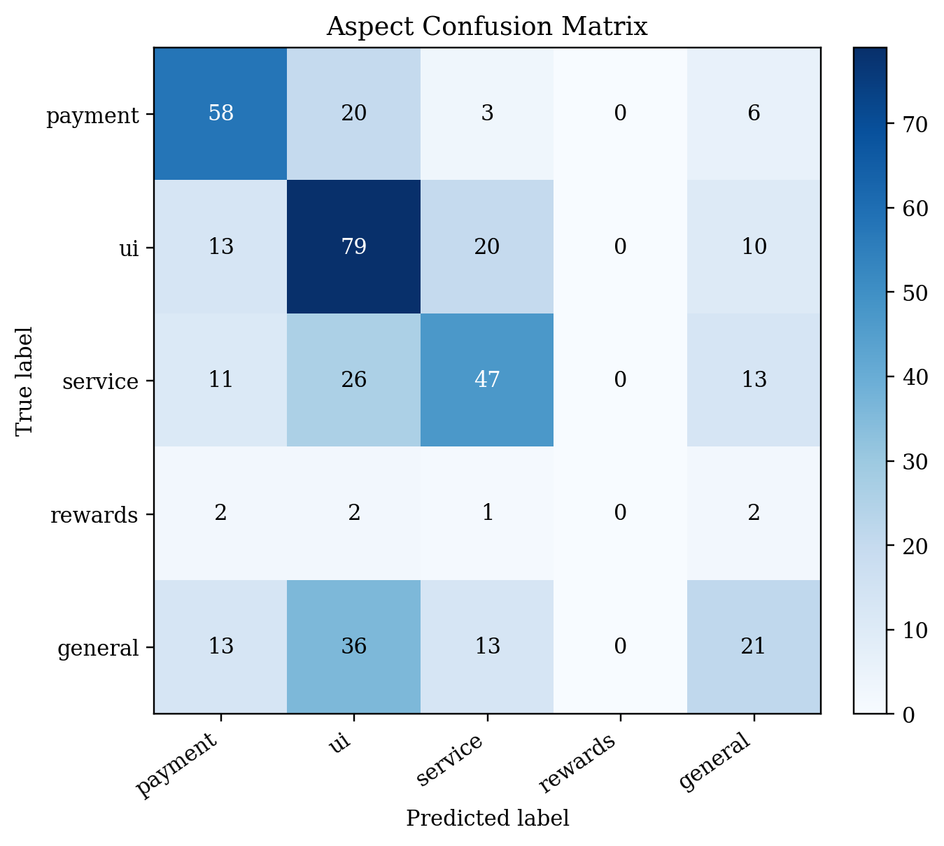
Figure 8. Aspect-head confusion matrix. The rewards class has only seven test examples and no correct predictions.

4.5. Deployment Outcome
The training pipeline produced a file of the dual-head PyTorch checkpoint, tokenizer configuration, model-results file and the dual-output ONNX model. The Streamlit application uses cached resources to load the ONNX session and tokenizer, cleans the input, calculates softmax confidence for the two heads and displays a composite natural-language insight. The dashboard also loads the labelled dataset and the created charts. These results confirm that model training, export and interface integration are connected. Any first time or memory consumption results should preferably be shown in the final video and not said to be "lightweight" — even if the ONNX model is treated like that.

4.6. Achievement of Objectives
- Data collection and preprocessing were completed for 7,815 raw reviews and a 1,980-review balanced corpus.
- Local teacher models generated sentiment and aspect pseudo-labels without requiring a paid inference API.
- A single shared mBERT model produced both sentiment and aspect outputs.
- Evaluation included overall, class-level and combined metrics, exposing the weakness of the rewards aspect.
- The final model was exported to ONNX and integrated with a three-page Streamlit application.

5. Discussion

5.1. Interpretation of the Findings
The gap between sentiment and aspect performance is related to the quality of the supervision. The sentiment classes were deliberately balanced and stratified in the test split, and the XLM-R teacher provided a direct three-way polarity decision for each review. In contrast, the aspect labels were created from five overlapping hypotheses, had low confidence, and were not stratified during splitting. Therefore, the model’s 51.77% aspect accuracy should be interpreted by considering both the limitations of the student model and the uncertainty within the training targets. Improving the teacher labels is likely to produce a larger benefit than simply increasing the number of training epochs.
The combined exact-match accuracy of 38.64% should not be compared directly with single-task accuracy because it is the intersection of two predictions. Even when each head performs moderately well, the probability that both heads are correct for the same review is lower. For application use, both confidence values should be displayed, and lower-confidence aspect predictions should be treated as suggestions rather than definitive diagnoses.

5.2. Product and Business Interpretation
The system can be used to structure text of a product team for review. Payments negative reviews can be due to issues with transactions or reloading, UI negative reviews can be due to navigation, authentication or stability issues, assessments of the service could be because of delays in answering to your calls and assessments of cashbacks or vouchers could be due to rewards related reviews. The dashboard can show the dominance of the categories analysed from the corpus and show you some example language to investigate.
The balanced dataset should not be utilized to arrange the three applications based on the proportion of positive reviews. The reviews have been carefully given a positive, neutral or negative rating to each application – 220 have been given to each. To have a meaningful market comparison would require analysing an unbalanced, time-limited sample that would be representative of the naturally occurring distribution of the data, while providing control for collection strategy, application version, and volume of review performed. While comparing the app is helpful for creating a visualisation and to identify the category of exploration, it is not a statement to endorse better eWallets.

5.3. Relationship to Prior Work
Unlike benchmark-based generative ABSA approaches [3-5], the proposed model adopts a single aspect per review approach. Unlike the zero-shot approaches which test on benchmark datasets manually annotated for ABSA [6,7,11], the proposed BART teacher is employed in generating labels for training a downstream mBERT model student. This approach is computationally feasible and eliminates the need to use any external API; however, it multiplies teacher errors. Selection of multilingual encoder is based on previous studies done on mBERT [1,2]. Modular scripts and saving configuration were motivated by PyABSA [8].

5.4. Limitations
- Pseudo-labels are not human-annotated gold labels. Reported metrics measure agreement with teacher-generated targets.
- The BART aspect teacher has mean confidence 0.3613, and 75.3% of labels are below 0.40 confidence.
- One dominant aspect is assigned per review. Reviews discussing several aspects with different sentiments are simplified.
- Aspect splitting is not stratified. The rewards class has only seven test examples and zero F1.
- Only one train/validation/test split is used, with no cross-validation or repeated random seeds.
- No separate baseline classifier is evaluated, so the added value of the dual-head architecture is not isolated experimentally.
- The final corpus is artificially sentiment-balanced and cannot estimate natural app-level sentiment prevalence.
- The corpus is limited to three Google Play listings and may not represent iOS users, merchant feedback or all Malaysian demographic groups.
- The 678.75 MB ONNX model is suitable for local demonstration but should not be described as lightweight or production-grade.
- Sarcasm, implicit sentiment, code-switching, misspellings and application-specific terms remain difficult.

5.5. Recommended Future Work
Development should start with label quality in the future. Examples should be considered for all aspects, confidence bands, sentiment and application and should be reviewed by a stratified human audit. If the accuracy is low, or if there is a dispute about the label, the label can be adjusted and the model are retrained. A multilabel aspect detection or aspect-sentiment pair extraction would be more representative of those reviews which refer to multiple features. Rewards can be stratified by class, balanced sampling applied or loss weighting can be used; aspect stratified will be used if appropriate.
Evaluation should be comprised of a conventional baseline, repeated seeds or cross validation, confidence calibration, and per language results. A raw, naturally distributed corpus is suitable to use for descriptive comparisons of apps, whereas the balanced corpus is suitable for training the controlled models. Smaller multilingual encoder or model compression, quantization, might shrink ONNX model size and startup time. It is also important to monitor CPU inference latency, and to conduct structured usability testing with typical users in the future, for deployment evaluation.

6. Conclusions
In the project, a full-fledged technology domain sentiment analysis workflow for mobile eWallet applications with a focus on Malaysia has been implemented. Reviews have been gathered, cleaned and converted public Google Play reviews of Touch 'n Go eWallet, GrabPay and ShopeePay into a balanced training corpus of 1,980 reviews. This eWallet review puts the project into Malaysia's financial technology (fintech) landscape, which extends to mobile software, digital payments, user-friendliness of interfaces, customer support, and reward systems. XLM-RoBERTa was used to obtain three-class sentiment pseudo-labels, BART-large-MNLI was used to obtain five-category aspect pseudo-labels, and a dual-head mBERT model was trained to obtain both pseudo-labels. The resulting model gave a sentiment accuracy of 71.46%, aspect accuracy of 51.77%, and combined exact-match accuracy of 38.64%, which was then exported to ONNX for a three-page Streamlit application.
The major drawback of this project is the reliability and imbalance of the aspect pseudo-labels. Therefore, the system is presented as a working prototype of an academic system for organizing feedback on eWallet and not as a working decision system or a final ranking of the providers of e-wallets in Malaysia. The most useful step that follows is a controlled human validation, coupled with aspect-balanced retraining and additional more stringent repeated analyses.

Supplementary Materials: The source code for the scraping, preprocessing, BART la-belling, dual-head mBERT training and Streamlit application, as well as cleaned data, generated charts and model-result files, are available in the GitHub repository. To avoid file-size limits and to include large trained weights, these are not included in GitHub and should be provided in the archive file that is submitted or trained locally.
Author Contributions: Conceptualization, Methodology, Software, Validation, Investigation, Data curation, Visualisation, Writing-Original draft preparation, Writing-Review and editing, Project administration: Sia Poh Xiang, Lim Chin Chen, Shi Hong Yi, Joshua Wong Yong. Data collection, preprocessing, pseudo-labelling, model training, application development, testing, analysis, document preparation, and presentation preparation for the applications were equally done by all the authors. Each author has read and approved the manuscript submitted.
Funding: This project did not receive any external funding.
Institutional Review Board Statement: Not applicable The project did not recruit any participants, instead analysing publicly available reviews within the app-store.
Informed Consent Statement: Not applicable.
Data Availability Statement: Project code and data submitted at the scale of the project is available in the course repository (https://github.com/Spx12345/TNL). Final trained model weights are not uploaded to GitHub due to size restrictions on files.
Acknowledgments: We would like to thank the TLN6323 Natural Language Processing teaching team and open-source communities that maintain Hugging Face Transformers, PyTorch, ONNX Runtime, Streamlit and google-play-scraper.
Conflicts of Interest: The authors declare no conflicts of interest.

Abbreviations
The following abbreviations are used in this manuscript:
MDPI | Multidisciplinary Digital Publishing Institute
DOAJ | Directory of open access journals
ABSA | Aspect-Based Sentiment Analysis
BART | Bidirectional and Auto-Regressive Transformers
BERT | Bidirectional Encoder Representations from Transformers
F1 | Harmonic mean of precision and recall
mBERT | Multilingual BERT
NLI | Natural Language Inference
NLP | Natural Language Processing
ONNX | Open Neural Network Exchange
UI | User Interface
XLM-R | Cross-lingual Language Model-RoBERTa

References
- Martin, G.L.; Mswahili, M.E.; Jeong, Y.-S. Sentiment Classification in Swahili Language Using Multilingual BERT. arXiv 2021, arXiv:2104.09006.
- Azhar, A.N.; Khodra, M.L. Fine-tuning Pretrained Multilingual BERT Model for Indonesian Aspect-based Sentiment Analysis. arXiv 2021, arXiv:2103.03732.
- Zhang, W.; Li, X.; Deng, Y.; Bing, L.; Lam, W. Towards Generative Aspect-Based Sentiment Analysis. In Proceedings of the 59th Annual Meeting of the Association for Computational Linguistics and the 11th International Joint Conference on Natural Language Processing, 2021; pp. 504-510.
- Yan, H.; Dai, J.; Ji, T.; Qiu, X.; Zhang, Z. A Unified Generative Framework for Aspect-Based Sentiment Analysis. In Proceedings of the 59th Annual Meeting of the Association for Computational Linguistics and the 11th International Joint Conference on Natural Language Processing (Volume 1: Long Papers), Online, August 2021; pp. 2416–2429. doi:10.18653/v1/2021.acl-long.188.
- Li, C.; Gao, F.; Bu, J.; Xu, L.; Chen, X.; Gu, Y.; Shao, Z.; Zheng, Q.; Zhang, N.; Wang, Y.; Yu, Z. SentiPrompt: Sentiment Knowledge Enhanced Prompt-Tuning for Aspect-Based Sentiment Analysis. arXiv 2021, arXiv:2109.08306.
- Shu, L.; Xu, H.; Liu, B.; Chen, J. Zero-Shot Aspect-Based Sentiment Analysis. arXiv 2022, arXiv:2202.01924.
- Deng, P.; Yuan, J.; Zhao, Y.; Qin, B. Zero-shot Aspect-level Sentiment Classification via Explicit Utilization of Aspect-to-Document Sentiment Composition. arXiv 2022, arXiv:2209.02276.
- Yang, H.; Zhang, C.; Li, K. PyABSA: A Modularized Framework for Reproducible Aspect-based Sentiment Analysis. arXiv 2022, arXiv:2208.01368.
- Scaria, K.; Gupta, H.; Goyal, S.; Sawant, S.A.; Mishra, S.; Baral, C. InstructABSA: Instruction Learning for Aspect Based Sentiment Analysis. arXiv 2023, arXiv:2302.08624.
- Jayakody, D.; Malkith, A.V.A.; Isuranda, K.; Thenuwara, V.; de Silva, N.; Ponnamperuma, S.R.; Sandamali, G.G.N.; Sudheera, K.L.K. Instruct-DeBERTa: A Hybrid Approach for Aspect-based Sentiment Analysis on Textual Reviews. arXiv 2024, arXiv:2408.13202.
- Wu, C.; Ma, B.; Zhang, Z.; Deng, N.; He, Y.; Xue, Y. Evaluating Zero-Shot Multilingual Aspect-Based Sentiment Analysis with Large Language Models. arXiv 2024, arXiv:2412.12564.
- Zhou, C.; Song, D.; Tian, Y.; Wu, Z.; Wang, H.; Zhang, X.; Yang, J.; Yang, Z.; Zhang, S. A Comprehensive Evaluation of Large Language Models on Aspect-Based Sentiment Analysis. arXiv 2024, arXiv:2412.02279.
- Conneau, A.; Khandelwal, K.; Goyal, N.; Chaudhary, V.; Wenzek, G.; Guzman, F.; Grave, E.; Ott, M.; Zettlemoyer, L.; Stoyanov, V. Unsupervised Cross-lingual Representation Learning at Scale. In Proceedings of ACL, 2020; pp. 8440-8451.
- Lewis, M.; Liu, Y.; Goyal, N.; Ghazvininejad, M.; Mohamed, A.; Levy, O.; Stoyanov, V.; Zettlemoyer, L. BART: Denoising Sequence-to-Sequence Pre-training for Natural Language Generation, Translation, and Comprehension. In Proceedings of the 58th Annual Meeting of the Association for Computational Linguistics, Online, July 2020; pp. 7871–7880. doi:10.18653/v1/2020.acl-main.703.
- Devlin, J.; Chang, M.-W.; Lee, K.; Toutanova, K. BERT: Pre-training of Deep Bidirectional Transformers for Language Understanding. In Proceedings of the 2019 Conference of the North American Chapter of the Association for Computational Linguistics: Human Language Technologies, Volume 1 (Long and Short Papers), Minneapolis, MN, USA, June 2019; pp. 4171–4186. doi:10.18653/v1/N19-1423.
Disclaimer/Publisher’s Note: The statements, opinions and data contained in all publications are solely those of the individual author(s) and contributor(s) and not of MDPI and/or the editor(s). MDPI and/or the editor(s) disclaim responsibility for any injury to people or property resulting from any ideas, methods, instructions or products referred to in the content.

