# SpyTeam 3030

##### (Working Title)

SpyTeam 3030 1

(Working Title) 1

Summary 2

Game Goals 2

Key Features 2

Target Audience 2

Game & Platform Structure 3

Main Characters 4

Art Direction 5

Production Plan 7

Appendix I: Production Estimates 7



## Summary

SpyTeam 3030 is both a game and digital series. In the year 3030, the planet is running low on natural resources due to the discovery of natural *Telecrystals*… a source of infinite energy.

In rare cases, some humans have developed *Telesense* – the power to control nature through telekinesis.

Now, the King of the World needs a world-class team of scientists, engineers, athletes, and spies to become the next super-secret agency to defend the planet’s last natural resources against the evil Dethcorps.

## Game Goals

1. Create a dual media platform that can be used for any game and any video content & aggregate usage data.
2. Learn the relationship between interactivity and linear story.
3. Create a short commercially viable MVP.
4. Create a closer relationship between the GamePipe Lab and the School of Cinematic Arts
5. Equity for any developer wanting to be on full time

## Key Features

* Dual platform for game & digital show
* PC/Mobile/Tablet
* *League of Legends* meets *Hearthstone (aka Clash Royale)*
* Watching TV show unlocks in-game content
* Strategic deck building to enhance playability
* Short matches tailored for mobile/tablet experience
* Earn in-game money to spend on upgrades to characters

## Target Audience

The target audience for Spyteam 3030 is a healthier mid-core version of the audience for *Clash Royale;* any fan of strategy card brawler games like *Hearthstone*, or mobile MOBA *Vainglory*. The game is very similar in gameplay to *Clash Royale* and similar in tone with the TV Shows *Captain Planet, Thundercats, Voltron, & Transformers*. Any fan of 80s and 90s action cartoons will feel at home watching the show and playing the game.

## Game & Platform Structure

Gameplay pits two players against each other inside a battle arena. There are 5 zones or “lanes” on each side – Earth, Water, Ice, Sky and Base. The objective of the game is to destroy your opponent’s Base.

Each player has command over 5 Spies, all of whom have their own strengths and weaknesses in these 5 lanes. Cards positioned in a shuffled deck will be played out to enhance each of the 5 team members with special tools, weapons, or vehicles to gain an advantage on the battlefield.

For example, in the Sky lane, if you play the Bomber card with Fly Gal, she can strike any lane or your opponent’s base from above. However, if you play the Spy Plane card with Fly Gal, you can see the next few cards your opponent is about to play.

If your Spy runs out of HP, they are teleported back to the homebase, leaving your lane vulnerable to attack. You can re-deploy your spy into the field once you re-gain enough tele-crystals.

Tele-Crystals are your source of power for playing cards at various costs. Tele-Crystals replenish over time. The more powerful cards cost more tele-crystals. You can deploy several spies in one lane, but you can only have a maximum of five Spies in play in the arena at one time. Gameplay will last around 3-4 minutes.

Below is the diagram of the platform’s interaction between video content and the deck building aspect of the game, as well as the experience loop.

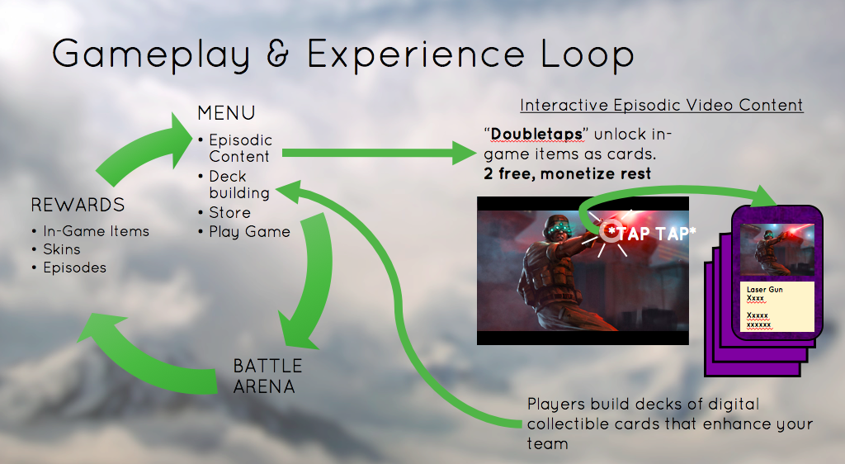

## Main Characters

Dr. Carl Drago AKA HONCHO

* Leader of the SpyTeam
* Former spy for the King of the World, now runs a worldwide scientific research facility
* Can control the elements of nature with his mind through a force-like power called “Tele-sense”
* Widower after his nemesis killed his wife, Ilana, many years ago
* No known weaknessses

Steve Drago AKA STEVE

* Only son of Carl Drago
* His father took him out of school at an early age
* Former Pro Football Linebacker
* Gentle Giant
* Not Tele-sensitive (that we know)
* Known weaknesses include Smooth Jazz and Brain Freeze

DeeDee Stone, Phd. AKA STONEFISH

The brains of the SpyTeam

* Went from orphan to world’s leading Hydrophysicist
* Has a pet dolphin named Derek
* Trained by Shaolin Monks
* Once dated Admiral Broadside
* Chip on her shoulder
* Weaknesses include logical fallacies, fear of heights, birds

Durham Bullhorn AKA FREEZER

* SpyTeam’ best field agent
* Former spy for King of the World
* Master of disguise
* 10 time Gold Medal winning Winter Olympic Triathlete
* Tele-sensitive in arctic climates
* Insecure and self-deprecating
* Allergic to dairy, hot climates

Jessie Lin AKA FLY GAL

* The Beauty of the SpyTeam
* Highest ranked former pilot for Air-Chief Jetblast
* Master mechanic
* Flirty
* Overbearing Parents
* Gets sea sick all too often, won’t stop talking about boys

Marco DeVario AKA BUZZKILL

* Financial mastermind of the SpyTeam
* Runs operations at ST HQ
* Harvard Business School
* Tele-sensitive, but only when he’s had his coffee
* Dislikes politicians, pop stars, and cooking shows
* Very gullible, will believe anything

## Art Direction

The first thing players will see is the menu, with the option to either play the game or watch the series. I envision this being a very simple and straightforward menu, similar to Vainglory.

The essential pieces to the game will be the game arena (1) the main playable characters (5) the villains (5) and the cards (numerous). I envision the characters and the arena to be very low poly, high design similar to Squenix’s *Lara Croft GO.*

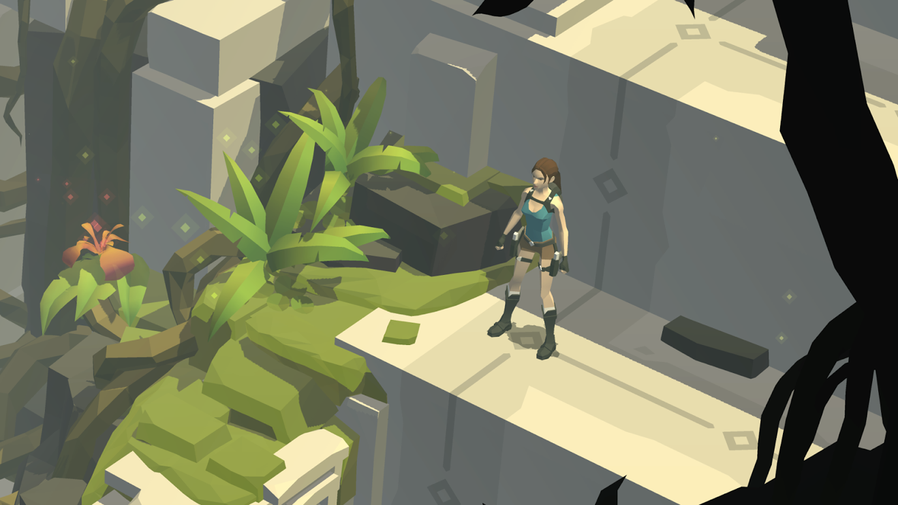

I am also a fan of the player pieces from Hitman Go, seen below. Perhaps these could reduce the amount of animations needed and would just smash into the other pieces like Hearthstone.

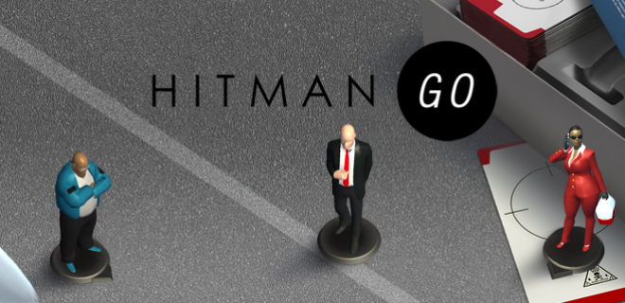

The Arena is a rough Hexagon split down the middle. One team of five on each side. Each lane is different by its visual environment. There are mid-lane bases in each lane that you must destroy in order for you to destroy the base.

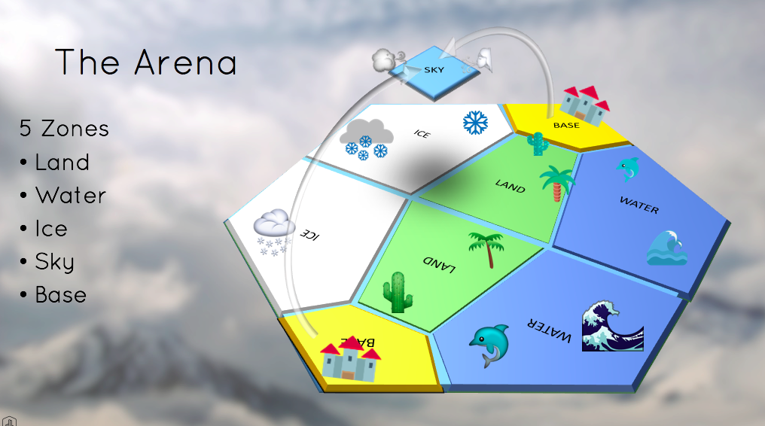

As for the series, I envision the same assets that are developed for this game to be used as assets used in the TV series. For close up visuals on low-poly models, I’m planning on using 2D animations superimposed over these models.

## Production Plan

I would like to use a monthly milestone agile production methodology. I want to start first with the outline of the platform, and then use that to determine the structure of the rest of the project. Ideally by the start of Fall 2016, there will already be a platform in place, and the game (and video content if there are parties interested in producing) will be the main focus for this AGP. The first step would be game mechanics, followed by character design, asset design, and environment design.

## Appendix I: Production Estimates

|  |  |  |  |
| --- | --- | --- | --- |
| **Task:**  **Level environment**  **- Modeled, textured**  **Level Objects**  **- Modeled, textured**  **Dynamic Objects (Characters, Cards)**  **- Model, texture, animation.**  **Game Feature, Simple (Deckbuilding)**  **- Core Mechanic (programming)**  **- Model & Texture**  **- Rig & Animation**  **Main Characters**  **- Animation** | **Estimation (days):**  **10**  **4**  **20**  **30**  **4**  **4**  **5** | **Task:**  **Platform Feature, Complex (Interactive video)**  **- Programming**  **- Animation**  **AI, Complex**  **- Model & Texture**  **- Rig**  **- Animation**  **- Behavior**  **UI and HUD**  **- HUD Element (e.g. Health Meter)**  **- UI Menu**  **Visual FX**  **- Particle FX**  **- Shader FX**  **- Physics FX** | **Estimation (days):**  **10**  **2**  **10**  **4**  **10**  **20**  **3**  **5**  **4**  **2**  **2** |
|  |  |  |  |