Basics
1)It is quite difficult to pass state to child components and if we have tree then passing state from top most component to last component is very difficult. So we need state management like redux where we create a state in single location and all other components access state from that location.

2)Store in redux
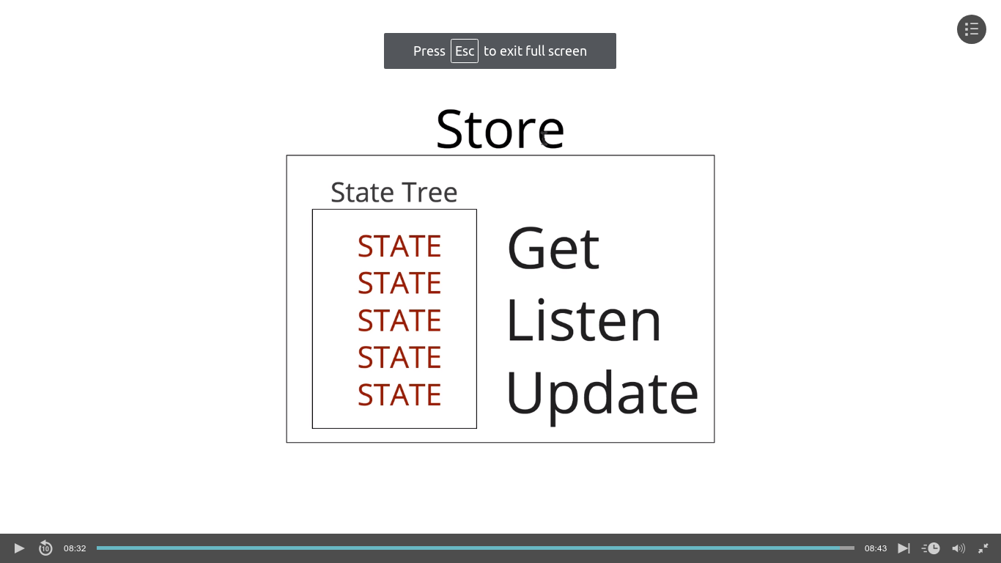
it has state tree, method to get ,liisten and update state

3)first create a basic react app using create-react-app

4)Then install redux
npm install --save redux react-redux
5)The Redux store is fundamental: the state of the whole application lives inside the store.

First create a store
1- const store = createStore();
running now will give error because createStore expects reducer. So lets create reducer and pass it inside store
In Redux reducers produce the state. The state is not something you create by hand.
A reducer is just a Javascript function. A reducer takes two parameters: the current stateand an action
function reducer() {
return 'State';
}

const store = createStore(reducer);

2- to get the state of our store we use store.getState()
now lets log our state
function reducer() {
return 'State';
}

const store = createStore(reducer);

console.log(store.getState());

3)now create action
Redux actions are nothing more than Javascript objects.containing type and payload

function reducer() {
return 'State';
}

const store = createStore(reducer);

console.log(store.getState());

const action = {
type:'changeState',
payload:{
newState:'New state'
}
}

4)Now let send this action to the store using store.dispatch(action);

5)Updating the store
reducer takes two parameter i.e initial state and the action
reducers listen to every action and act accordingly
function reducer(state, action) {
if(action.type === 'changeState') {
return action.payload.newState;
}
return 'State';
}

const store = createStore(reducer);

console.log(store.getState());

const action = {
type:'changeState',
payload:{
newState:'New state'
}
}

store.dispatch(action);

console.log(store.getState());

here first we created a store which takes a reducer, now reducer is a function which checks actions and change state, action is a object with type and payload properties

6)Full Example -
Now lets expand our example by making a store as object with products and users
for this we require 2 reducers for products and users so we will combine them using single reducer and pass to store, to combine them we will need combine reducer
import { combineReducers,createStore } from 'redux';

import React from 'react';
import ReactDOM from 'react-dom';
import './index.css';
import App from './App';
import registerServiceWorker from './registerServiceWorker';

import { combineReducers,createStore } from 'redux';

function productsReducer(state=[], action) {
return state;
}

function userReducer(state='', action) {
return state;
}

const allReducers = combineReducers({
products: productsReducer,
user: userReducer
});

const store = createStore(allReducers);

console.log(store.getState());

ReactDOM.render(<App />, document.getElementById('root'));
registerServiceWorker();

7)To set initial state of our app
const store = createStore(allReducers,{
products:[{name:'iPhone'}],
user:'Akash'
});

8)To enable redux dev tools , add 3rd parameter to create store
const store = createStore(
allReducers,
{
products:[{name:'iPhone'}],
user:'Akash'
},
window.devToolsExtension && window.devToolsExtension()
);

Level up tuts basic
1)first create react app

2)only install redux first
npm install redux

3)goto app.js

4)import createStore
import {createStore} from 'redux';

5)Below export default write

//Create a reducer wihich is basically a function returning some value
const hello = () => {
return 'Hello'
};

//Create a store and pass it a reducer
const store = createStore(hello);

//Log store
console.log(store);

//Log store.getState
console.log(store.getState());

logging store will give object with dispatch, getstate, replace reducer,subscribe, symbol
dispatch is used to dispatch action, getState has our store’s state , subscribe is not usually used in react as it refreshes component on state change which react already does

6)Now tipically we want state to be object but in above eg it just returns string hello
so change
const hello = () => {
return {welcome:'Hello'}
};

7)Large eg -

//Create default state
const defaultState = {
welcome: 'hi',
otherState: 'Other State',
someOtherState: 'someOtherState'
};

//Create reducer and pass in defaultstate as default parameter and action
//use spread operator as not using it will return only that state
const greeting = (state = defaultState,action) => {
switch(action.type) {
case 'GREET_ME':
return {...state,welcome: 'Hello Akash'};
case 'GREET_WORLD':
return{...state,welcome:'Hello World'};
default:
return state;
}
};

//create store
const store = createStore(greeting);

console.log(store.getState());
//op-
//Object {welcome: "hi", otherState: "Other State", someOtherState: "someOtherState"}

store.dispatch({
type: 'GREET_ME'
});

console.log(store.getState());
//op-
//Object {welcome: "Hello Akash", otherState: "Other State", someOtherState: "someOtherState"}

8)Dispatching multiple actions
const defaultState = {
welcome: 'hi',
otherState: 'Other State',
someOtherState: 'someOtherState'
};

const greeting = (state = defaultState,action) => {
switch(action.type) {
case 'GREET_ME':
return {...state,welcome: `Hello ${action.name}`};
case 'GREET_WORLD':
return{...state,welcome:'Hello World'};
default:
return state;
}
};

const store = createStore(greeting);

console.log(store.getState());

//First action dispatch
store.dispatch({
type: 'GREET_ME',
name: 'Akash'
});

console.log(store.getState());

//Second action dispatch
store.dispatch({
type: 'GREET_ME',
name: 'Omi'
});

console.log(store.getState());

Level up app extension
1)Connect Redux to React -
Open our movie db app and
npm install redux react-redux
react-redux is a small package that connects some of the things from redux to react and make it easy to get state and dispatch actions from other components

2)Import Provider which is basically just a component from react-router
import { Provider } from 'react-redux';

3)Then wrap your entire app inisde Provider tag, ie main app where main page or index page, in this case app.js where all our routes are present.

4)Provider takes two things ie props called store={} and children i.e out main app logic
Provider basically makes store available and redux functionality available to its children via Connect
Note that Connect and Provider are part of react-redux and not redux

5)Now provider takes store so lets create store and basic redicer as we creaed before and pass it to provider.
Full Eg -

import React, { Component } from 'react';
import {
BrowserRouter as Router,
Route,
Switch,
Link,
} from 'react-router-dom';

import { Provider } from 'react-redux';
import { createStore } from 'redux';

import './App.css';
import MoviesList from './MoviesList';
import MovieDetail from './MovieDetail';
import logo from './logo.css';

const hello = () => {
return 'hello'
};

const store = createStore(hello);

const App = () => (
<Provider store={store}>
<Router>
<div className="App">
<header className="App-header">
<Link to="/" style={{ textDecoration: 'none' }}>
<h1 className="logo">Latest Movies</h1>
</Link>
</header>
<Switch>
<Route exact path="/" component={MoviesList} />
<Route path="/:id" component={MovieDetail} />
</Switch>
</div>
</Router>
</Provider>
);

export default App;

6)Now go to react dev tools and see out state
$r.props.store.getState()
"hello"

7)Now we will create root reducer which will combine all our reducer
1- create file called rootReducer.js in src folder
2-To combine reducer we need
import { combineReducers } from 'redux';

3-Now rootReducer file will just combine reducers, but first we need to create reducers so create one more file called reducer.js
4-Now we are creating a toggle message button so inside reducer.js put

const initialState = {
messageVisibility: false,
};

export default function (state = initialState, action) {
const { type } = action;

switch(type) {
case 'TOGGLE_MESSAGE':
return state;
default:
return state;
}
}

5- now inside rootReducer.js, combine it
import { combineReducers } from 'redux';

import message from './reducer';

const rootReducer = combineReducers({
message,
});

export default rootReducer;

6-inside app.js import root reducer
import rootReducer from './rootReducer';

pass it to createStore
const store = createStore(rootReducer);

7- Now we have set up our store, reducers
next we will use Connect to use state

8- Create a new file called Toggle.js with following and add it to app.js and also add toggle button in app.js
import React from 'react';

const Toggle = () => {
return (
<div>
<button>Toggle</button>
</div>
);
};

export default Toggle;

9-To get messageVisibility state inside out Toggle.js file , first import connect
import { connect } from 'react-redux';

10-add
export default connect()(Toggle);

11) Now we want only selected items from our store into our toggle component and not entire store
so we do -
const mapStateToProps = state => ({
messageVisibility: state.message.messageVisibility,
});

export default connect(mapStateToProps)(Toggle);

now messageVisibility: state.message.messageVisibility,
above line mean messageVisibility as a prop name and state.message.messageVisibility, as state is our state, message is reducer and messageVisibility is that state name

12) Now add toggeler inside component i.e && conditional
const Toggle = (props) => {
return (
<div>
{
props.messageVisibility &&
<p>You will be seeing this if redux action is toggled</p>
}
<button>Toggle</button>
</div>
);
};

13)Now we can use messageVisibility as a normal props

8)Dispatching actions from component
1- Because of connect, dispatch method is directly available to our component so we dont have to do store.dispatch()
eg – (inside props dispatch is available because of connect)
import React from 'react';
import { connect } from 'react-redux';

const Toggle = (props) => {
return (
<div>
{
props.messageVisibility &&
<p>You will be seeing this if redux action is toggled</p>
}
<button onClick = {() => {
props.dispatch({
type: 'TOGGLE_MESSAGE',
})
}}
>Toggle</button>
</div>
);
};

const mapStateToProps = state => ({
messageVisibility: state.message.messageVisibility,
});

export default connect(mapStateToProps)(Toggle);

9)Action reducers - Action reducer is simply a file where we store all our actions which can be reused
eg -
create a file name actions
add -
const toggleMessage = () => {
return(
{
type: 'TOGGLE_MESSAGE',
})
};

export {toggleMessage};

then in toggle.js import actions.js and
<button onClick = {() => {
props.dispatch(toggleMessage());
}}
>Toggle</button>

Note - execute toggleMessage as actions are objects and passing only toggleMessage will be function

10)Bind action creators
instead of writing dispatch
<button onClick = {() => {
props.dispatch(toggleMessage());
}}

we ca do is
<button onClick = {toggleMessage}

but for that we have to bind action creator to dispatch

eg -
first -

import {bindActionCreators} from 'redux';

then change button
<button onClick = {props.toggleMessage}
>Toggle</button>

then

const mapDispatchToProps = dispatch => bindActionCreators({
toggleMessage,
},dispatch);

then add in export
export default connect(mapStateToProps,mapDispatchToProps)(Toggle);

