Basics
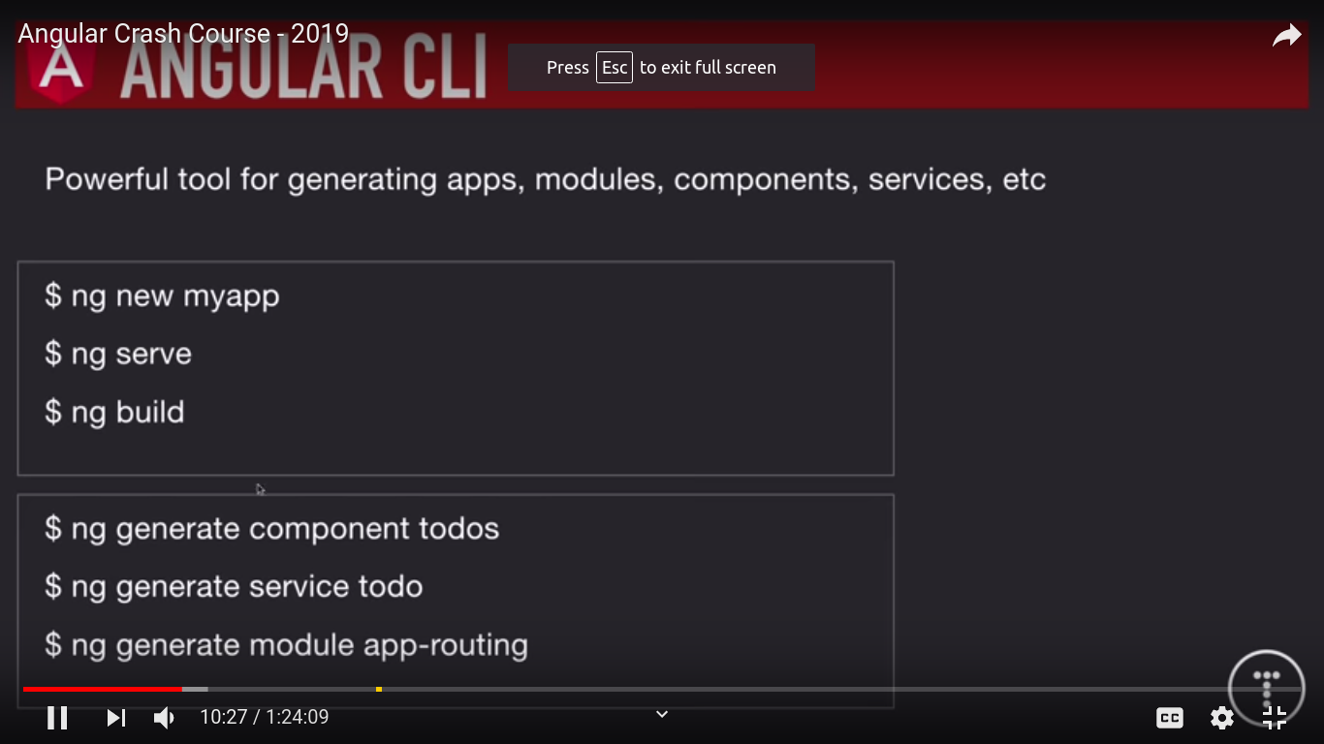

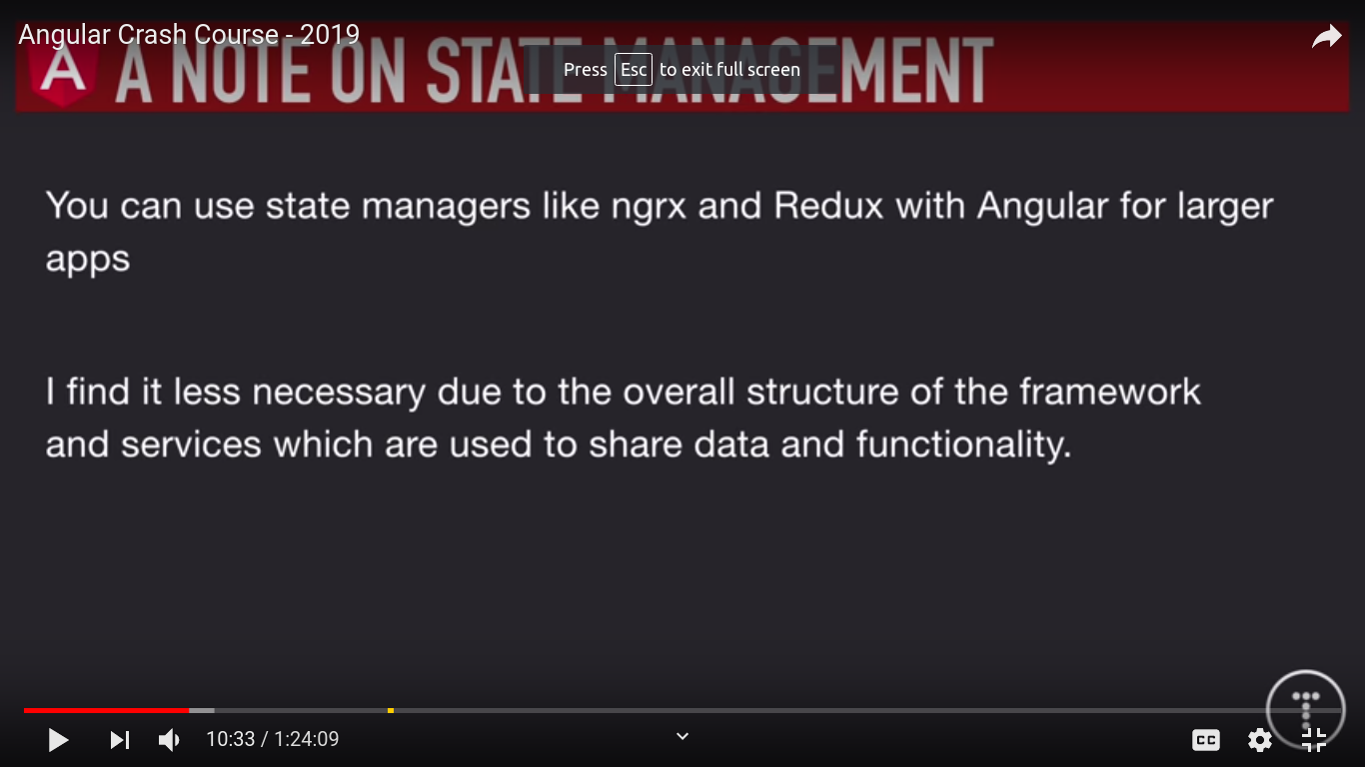

Setup And first app
1 - first install cli
npm install -g @angular/cli

2 – create new app using -
ng new angular-crash-todolist

3 – open app
ng serve –open

4 – In scr --> index.html is entry point like in react
we can load bootstrap here but there is a file called angular.json where we can include static assets and assets like bootstrap link

5 – Inside app folder , we will create all our components , services etc

6 – app.module.ts
is a file where we enter all components details

7 - Create new component in components folder
ng generate component components/Todos

8 – Inside app folder , create a folder called models and inside it create a file Todo.ts
export class Todo {
id:number;
title:string;
completed:boolean
}

inside todos.component.ts we can create a type of variable called todos which is array of type Todo

export class TodosComponent implements OnInit {

todos:Todo[];

constructor() { }

ngOnInit() {
this.todos = [
{
id:1,
title:"Todo One",
completed:false
}
]
}

9 – Passing data to child component
<app-todo-item *ngFor="let todo of todos" [todo]="todo"> </app-todo-item>

here app-todo-item is child component and we are loopong todos property and passing todo

now in child component.ts , to accept this value from parent
import Input in ts file and then inside class use @Input to define type of input comming

import { Component, OnInit,Input } from '@angular/core';
import { Todo } from 'src/app/models/Todo';

@Component({
selector: 'app-todo-item',
templateUrl: './todo-item.component.html',
styleUrls: ['./todo-item.component.css']
})
export class TodoItemComponent implements OnInit {

@Input() todo:Todo

constructor() { }

ngOnInit() {
}

}

10 – To give global style
src->app->style.css

11 – Dynamic Classes [ngClass]

<div [ngClass]="setClasses()">
<p>
<input type="checkbox" />
{{ todo.title }}
<button class="del">x</button>
</p>
</div>

in ts file create a method setClasses
import { Component, OnInit,Input } from '@angular/core';
import { Todo } from 'src/app/models/Todo';

@Component({
selector: 'app-todo-item',
templateUrl: './todo-item.component.html',
styleUrls: ['./todo-item.component.css']
})
export class TodoItemComponent implements OnInit {

@Input() todo:Todo

constructor() { }

ngOnInit() {
}

// Set Classes dynamically
setClasses() {
let classes = {
todo:true,
"is-complete":this.todo.completed
}

return classes
}

}

12 – Events in angular
events uses () round brackets

<div [ngClass]="setClasses()">
<p>
<input (change)="onToggle(todo)" type="checkbox" />
{{ todo.title }}
<button (click)="onDelete(todo)" class="del">x</button>
</p>
</div>

in ts file , create onToggle and onDelete methods

import { Component, OnInit,Input } from '@angular/core';
import { Todo } from 'src/app/models/Todo';

@Component({
selector: 'app-todo-item',
templateUrl: './todo-item.component.html',
styleUrls: ['./todo-item.component.css']
})
export class TodoItemComponent implements OnInit {

@Input() todo:Todo

constructor() { }

ngOnInit() {
}

// Set Classes dynamically
setClasses() {
let classes = {
todo:true,
"is-complete":this.todo.completed
}

return classes
}

// onToggle
onToggle(todo){
console.log("onToggle");
}

// onDelete
onDelete(todo){
console.log("onDelete");
}
}

13) Generate service
ng g s services/Todo

define service called getTodos

import { Injectable } from '@angular/core';

@Injectable({
providedIn: 'root'
})
export class TodoService {

constructor() { }

getTodos(){
return [
{
id:1,
title:"Todo One",
completed:false
},
{
id:2,
title:"Todo Two",
completed:false
},
{
id:3,
title:"Todo Three",
completed:false
}
]
}
}

Using service in component ts file
first import that service
import { TodoService } from "../../services/todo.service";

Then inject service in constructor
constructor(private todoService: TodoService) {}

Then use it

ngOnInit() {
this.todos = this.todoService.getTodos();
}

Full eg -

import { Component, OnInit } from "@angular/core";
import { TodoService } from "../../services/todo.service";
import { Todo } from "../../models/Todo";
@Component({
selector: "app-todos",
templateUrl: "./todos.component.html",
styleUrls: ["./todos.component.css"]
})
export class TodosComponent implements OnInit {
todos: Todo[];

constructor(private todoService: TodoService) {}

ngOnInit() {
this.todos = this.todoService.getTodos();
}
}

14) Http Module
1 – Goto app.module.ts file
import { HttpClientModule } from "@angular/common/http";

imports: [BrowserModule, AppRoutingModule, HttpClientModule],

In service , import http module and headers module
import { HttpClientModule, HttpHeaders } from "@angular/common/http";
import { Observable } from "rxjs";

Then inject in constructor
constructor(private http: HttpClient) {}

getTodos(): Observable<Todo[]> {
return this.http.get<Todo[]>(this.todosUrl);
}

To use service
ngOnInit() {
this.todoService.getTodos().subscribe(todos => {
this.todos = todos;
});
}

subscribe is like then

complete eg – service.js

import { Injectable } from "@angular/core";
import {
HttpClientModule,
HttpHeaders,
HttpClient
} from "@angular/common/http";
import { Todo } from "../models/Todo";
import { Observable } from "rxjs";

@Injectable({
providedIn: "root"
})
export class TodoService {
todosUrl: string = "https://jsonplaceholder.typicode.com/todos";

constructor(private http: HttpClient) {}

getTodos(): Observable<Todo[]> {
return this.http.get<Todo[]>(this.todosUrl);
}
}

